Title: | Hazard-Analysis-Guided Safety and Licensing Basis for Digital-Twin-Enabled Reactor Automation
Technical Topic Area: | Topic Area 11 – Licensing , Safety, and Security
PI: | Willam Charlton (University of Texas)
Collaborators: | Cole Gentry (University of Texas)
 | Adam Williams (Sandia National Laboratory)

Identification and Significance of Problem or Opportunity

Digital-twin (DT) technologies are rapidly maturing in nuclear applications, enabling faster-than-real-time state estimation, predictive “what-if” planning, and increasingly capable supervisory or autonomous control functions. As DTs become tightly integrated with reactor monitoring and control, they create new opportunities for advanced operation, particularly for research reactors where operational agility and flux tailoring are central to mission throughput. DT-informed control could, for example, improve flux and power shaping to reduce local fuel or structural stress while maintaining desired output, optimize power maneuvers (e.g., ascent to full power and recovery from disturbances), mitigate or damp xenon-driven power oscillations and tune irradiation conditions to maximize experiment or medical isotope production. Such digital-twin-based predictive control capabilities are currently being developed at the University of Texas at Austin (UT) for potential future control of the UT Nuclear Engineering Teach Laboratory (NETL) TRIGA research reactor [1] as illustrated in the examples provided in Figures 1 and 2.

At the same time as potentially enabling improved system performance, DT-driven supervisory and autonomous control introduces novel safety and licensing challenges that are not captured by traditional control-system qualification approaches focused primarily on component reliability or nominal control performance. Experience from other safety-critical domains (e.g., aviation automation and advanced control rooms) highlights recurring socio-technical failure modes that can emerge when operators interact with predictive, adaptive, or partially autonomous systems: mode confusion (misunderstanding what the automation is doing or why), miscalibrated trust (over-reliance on DT guidance when validity is degraded, or under-reliance when it is correct), automation surprise, information overload, and degraded situation awareness, particularly under abnormal or ambiguous sensor conditions. DT systems also create additional technical pathways to hazard, including silent model drift, stale or biased state estimates, out-of-distribution operating conditions, and mismatches between DT confidence indicators and true model validity. As DT capabilities move closer to operator-facing use and control relevance, the core question becomes not simply “is the DT accurate?” but “can the combined human–DT–control system be shown to operate safely across credible fault and misuse scenarios, and can those safety arguments be made auditable for licensing?”

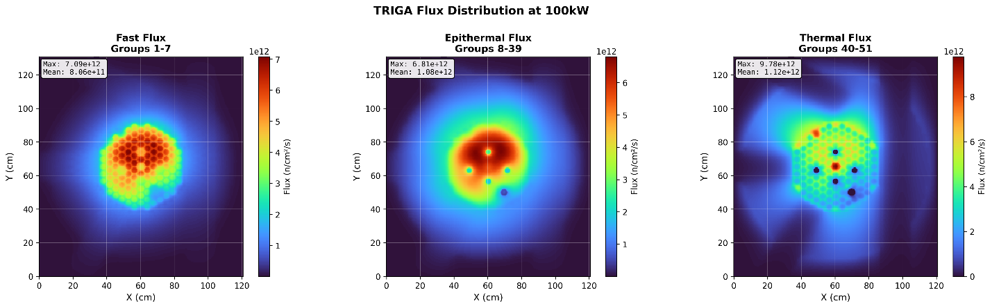
Figure 1: Example Real-time ROM Flux Predictions [1]

This project seeks to address that gap by developing and demonstrating a repeatable safety analysis and mitigation methodology for DT-enabled supervisory and autonomous reactor control, using maturing UT DT capabilities and the NETL TRIGA as a reference application environment. The work will apply a systems-theoretic hazard analysis approach—treating safety as a control problem across a socio-technical system—to identify unsafe control actions and causal scenarios, derive implementable safety constraints (e.g., guardrails on automation authority, validity-aware displays and procedures, and fail-safe fallback modes), and validate mitigations through operator-in-the-loop evaluations on representative operational scenarios. The outcome will be a concrete, transferable foundation for establishing safety and licensing bases for DT-driven control functions, helping move DT adoption from capability-driven demonstrations to safety-informed deployment.

Technical Approach

UT is in the process of introducing a non-safety-related power control rod as a means of improving day-to-day TRIGA operations. This project will use this non-safety-related autonomously-controlled rod as a realistic, low-risk reference function for developing and demonstrating a safety-informed methodology for digital-twin-enabled control. The digital twin will command the shaping rod only within pre-defined limits (e.g., position/rate bounds and operational envelopes), while all existing reactor protection functions, scram logic, and licensed safety limits remain unchanged.

As part of this project, UT will apply STPA-like [4] hazard analysis methods to treat safety as a control problem across the full socio-technical system: the digital twin, the control logic, the plant instrumentation and actuators, the operator interface, and operating procedures. We will (i) define the DT-enabled control structure for the shaping rod (automation modes, feedback paths, operator roles, and assumptions), (ii) identify unsafe control actions and causal scenarios (including mode confusion, automation surprise, miscalibrated trust, stale or biased state estimates, model validity loss, and degraded sensing/communications), and (iii) derive explicit, implementable safety constraints and requirements. These outputs will be maintained as traceable artifacts (hazards → constraints → mitigations → tests), enabling a clear safety case for how identified risks are prevented, detected, or mitigated.
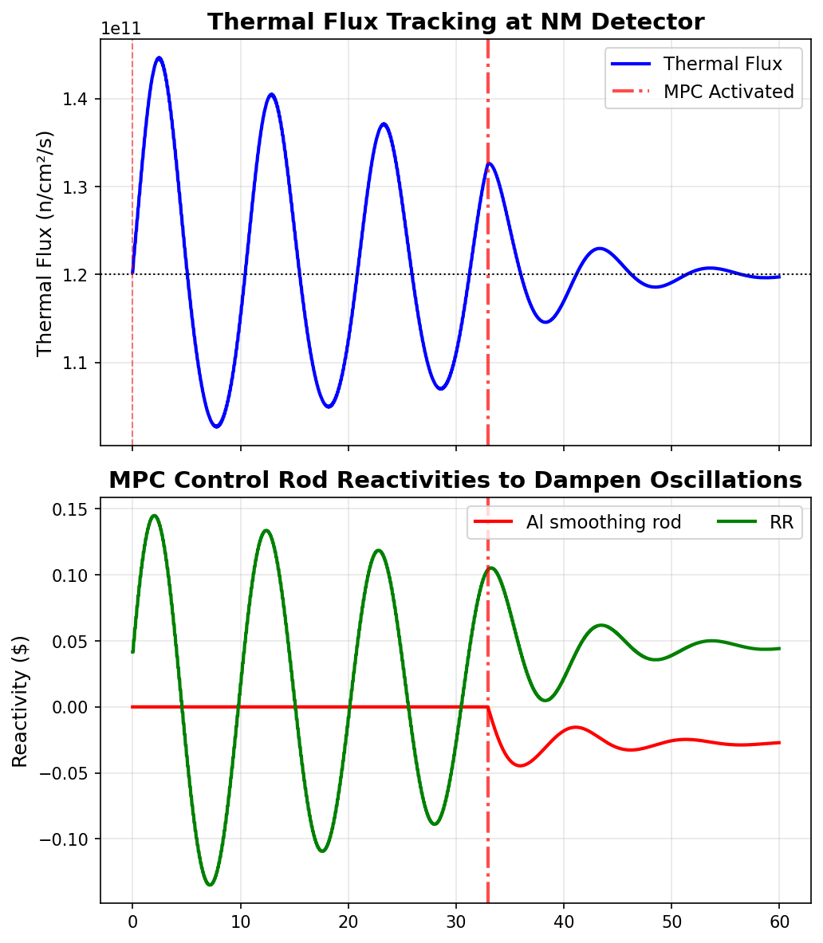
Figure 2: Example of Autonomous Controls for Oscillation Dampening [1]

From the hazard analysis results, UT will consider and implement mitigations spanning multiple layers, such as those considered by Winther and Sarshar [3], emphasizing changes that can be practically adopted in operator-facing DT deployments. Where appropriate, mitigations will be designed to “fail safe” by degrading gracefully to conventional manual operation without increasing operator burden during off-normal conditions.

Finally, we will demonstrate the efficacy of these mitigations through a structured evaluation campaign that intentionally introduces non-safety-significant failure modes and degraded-information scenarios while monitoring safety-relevant behavior. This will include fault-injection tests such as stale or delayed sensor streams, biased measurements, communications dropouts, out-of-distribution operating conditions, and DT validity loss. Success criteria will include stable and bounded control actions, correct transitions to fallback modes, timely detection of inconsistency, and appropriate operator responses, quantified via before/after comparisons of baseline DT-enabled control versus DT-enabled control with hazard-analysis-derived mitigations. The project will culminate in a repeatable, transferable demonstration that systems-theoretic hazard analysis and explicit guardrail-focused control-loop design can support the safe deployment of DT-enabled control functions, providing a foundation for broader adoption and future licensing-oriented discussions.

Anticipated Benefits

This project will directly support DOE Topic Area 11 by establishing a practical, repeatable safety and licensing-basis methodology for digital-twin-enabled control functions, addressing a growing gap in how advanced digital technologies are evaluated for safe and secure nuclear operation. The work will produce transferable safety artifacts that enable a defensible safety case for DT-enabled automation and help reduce regulatory uncertainty around credible deployment practices, particularly for systems where hazards can arise from software behavior, degraded data, and human–automation interaction. In the near term, the methodology will improve operational effectiveness and confidence for DT-assisted power/flux shaping in the research reactor community while demonstrating how DT-based automation can be introduced without expanding risk. Longer term, the resulting framework provides a foundation for safety-informed adoption in more complex settings, including advanced reactors and remote or minimally staffed operations (e.g., microreactors and space power systems), by supplying a credible pathway for hazard identification, constraint-based mitigation, and auditable verification of increasingly autonomous DT-enabled operating modes.

Technical Objectives

The technical objectives of this work are to: (1) develop a repeatable, STPA-like systems-theoretic hazard analysis workflow tailored to operator-facing digital twins and DT-enabled control functions, including explicit control-structure modeling, identification of unsafe control actions, and derivation of traceable safety constraints and requirements; (2) apply the methodology to a non-safety-related digital-twin-controlled power-shaping rod at the UT TRIGA, producing a defensible hazard log and mitigation set that addresses both technical and human–automation failure modes; (3) implement and integrate mitigations spanning control-loop guardrails, user interface cues, and operator procedures/training to reduce mode confusion, miscalibrated trust, and degraded situational awareness; (4) design and execute an evaluation campaign, including operator-in-the-loop scenarios and intentional non-safety-significant fault, to quantify before/after safety and performance outcomes; and (5) deliver reusable artifacts (templates, checklists, validation test patterns, and guidance) that enable broader adoption of the methodology for future DT-based control deployments in research reactors and, ultimately, advanced and remote-access reactor concepts.

Work Plan

- Task 1 — Define the DT-enabled shaping function and evaluation scenarios:
UT will scope the non-safety-related power-shaping rod use case, including operational objectives, authority limits, interfaces to the digital twin, and assumptions about operator roles and procedures. UT will define a scenario suite spanning routine planning, disturbance response, and degraded-information conditions, and will establish success metrics.

- Task 2 — Conduct hazard analysis and derive safety constraints:
UT will develop the control-structure model and perform a hazard analysis to identify unsafe control actions and causal scenarios relevant to DT-enabled control.
- Task 3 — Implement mitigations and integrate guardrailed DT control:
UT will implement mitigation strategies derived from the hazard analysis. UT will integrate these changes into the DT workflow and prepare test harnesses for fault injection and repeatable evaluation.
- Task 4 — Validate via operator-in-the-loop studies and fault-injection testing:
UT will execute a structured before/after evaluation comparing baseline DT-enabled shaping to the mitigated implementation.
- Task 5 — Generalize methodology and deliver transition artifacts:
UT will package reusable artifacts that enable broader adoption: hazard-analysis templates, checklists, example control-structure models, safety-constraint patterns, and a validation playbook for DT-enabled control functions.

Estimated Project Cost and Timeframe
The budget for this project will be $1M over 3 years. A preliminary timeframe to execute the tasks described above is shown as follows:

Task | Year 1 |  |  |  | Year 2 |  |  |  | Year 3
 | Q1 | Q2 | Q3 | Q4 | Q1 | Q2 | Q3 | Q4 | Q1 | Q2 | Q3 | Q4
1
2
3
4
5

Artificial Intelligence Use Disclosure and Disclaimer
Portions of this application were developed with the assistance of AI tools to support organizing and editing of the narrative content. All technical content, claims, plans and representations have been reviewed and approved by the applicant, who remains solely responsible for the accuracy and completeness of the submission, the capability to perform the work described, and compliance with intellectual property and third-party rights.

References:
- "University of Texas at Austin Nuclear Engineering Teaching Laboratory TRIGA Research Reactor", August 2023, https://www.nrc.gov/docs/ML2327/ML23279A146.pdf
- J. Ross, et al., “Initial Validation of the TRIGA Real-Time Digital Twin at the University of Texas at Ausin”, PHYSOR 2026, (in preparation)
- R. Winther, S. Sarshar, “Safe Use of AI as Part of the Control Loop in Nuclear Facilities”, ANS Proceedings, Chicago, IL, June 15-18, 2025
- N. Leveson, J. Thomas, “STPA Handbook” (2018) http://psas.scripts.mit.edu/home/get_file1.php?name=STPA_Handbook.pdf
Sandia National Laboratory Collaboration

Sandia brings unique and essential capabilities to this effort through its long-standing expertise in safety analysis, risk-informed decision support, and evaluation of complex socio-technical systems where human–automation interaction is safety-relevant. This project’s central contribution is not merely demonstrating a digital-twin-enabled control function, but establishing a defensible, repeatable hazard analysis and mitigation methodology for operator-facing digital twins and DT-enabled control. Sandia’s role will therefore focus on independent technical oversight to ensure the hazard analysis is rigorous, the derived safety constraints are well-posed and implementable, and the evaluation approach supports conclusions that generalize beyond a single demonstration.

Sandia’s primary contributions will be threefold:

- Hazard Analysis Rigor and Review. Sandia will provide guidance on the application of STPA-like systems-theoretic hazard analysis, reviewing control-structure models, unsafe control action identification, and causal scenario development to ensure completeness and defensibility for complex human–automation–software interactions.

- Mitigation Strategy Guidance. Sandia will advise on mitigation design patterns appropriate for DT-enabled control, helping ensure that mitigations are practical, auditable, and aligned with safety-informed deployment principles.

- Evaluation and Generalization Support. Sandia will review the operator-in-the-loop and fault-injection evaluation plan to ensure metrics, scenarios, and study structure are sufficient to support credible before/after conclusions, and will help frame the resulting artifacts so they can transfer to future DT deployments beyond the UT TRIGA.

Adam Williams:

Dr. Adam Williams brings directly relevant expertise in cyber-physical nuclear systems, complex risk, and human–system engineering that aligns well with this project’s focus on safety-informed deployment of operator-facing digital twins and DT-enabled control. As a Principal R&D Systems Engineer and recognized SME, he has extensive experience leading risk- and security-oriented technical efforts for DOE/NNSA and other sponsors, including vulnerability assessment and system-level evaluation of complex socio-technical systems. His Ph.D. in Engineering Systems and Human-Systems Engineering from MIT is particularly relevant to applying STPA-like, systems-theoretic hazard analysis and designing mitigations that address human–automation interaction risks. In this collaboration, Dr. Williams would provide independent oversight to ensure hazard analysis rigor, help shape defensible safety constraints and mitigations for DT-enabled control, and support evaluation design to maximize generalizability beyond the single TRIGA demonstration.

University of Texas

UT Austin will lead the project’s technical execution and provide the end-to-end capabilities required to develop, integrate, and validate a safety-informed digital-twin-enabled control function in a realistic reactor operations environment. UT brings established strengths in nuclear digital twinning, and reactor systems modeling, anchored by the UT TRIGA facility and its experienced operations staff, which together provide a unique, high-consequence test bed for controlled evaluation of human–automation interactions. UT will perform the primary R&D effort, including building the DT-enabled control loop and interfaces, executing the STPA-like hazard analysis, and translating results into implementable mitigations spanning guardrailed control logic, validity-aware interface cues, and operator procedures/training. UT will also design and run the operator-in-the-loop and fault-injection evaluation campaign using representative operating scenarios and intentional non-safety-significant failures, leveraging the facility’s instrumentation and operational procedures to ensure realism. Collectively, UT’s combination of digital twin development capability, reactor operations infrastructure, and evaluation capacity positions the team to deliver both a credible demonstration and reusable artifacts that can transfer to future DT-enabled control deployments.

William Charlton:

Dr. William Charlton is the John J. McKetta Energy Professor at UT Austin and Director of the NETL. He is an expert in the application of nuclear science and engineering to national security including nuclear nonproliferation, counter-proliferation, security, and deterrence. He has taught courses (specifically from a technical aspect) on nuclear nonproliferation and deterrence, nuclear security system design and analysis, nuclear forensics, and nuclear detection. Additionally, he has over 15 years of technical expertise in the design, development, testing, and evaluation of technological solutions for nuclear threats. Dr. Charlton brings extensive experience managing large, sponsor-driven technical programs and leading organizations focused on nuclear safety and security, which equips him to provide strong governance, risk management, and stakeholder engagement for a project aimed at establishing a defensible safety methodology for emerging digital twin capabilities.

Cole Gentry:

Dr. Cole A. Gentry is a Senior Engineering Scientist at the University of Texas at Austin whose research centers on nuclear reactor digital twins and machine-learning-enabled reduced-order modeling for simulation acceleration. He brings a strong modeling-and-simulation background grounded in production reactor analysis and code development, with prior roles at Oak Ridge National Laboratory, BWX Technologies, and Zachry Nuclear supporting high-fidelity reactor simulation workflows and software qualification. His combined experience in plant operations as a reactor engineer a the Sequoyah Nuclear Facility, advanced reactor modeling, and ML-driven surrogate development positions him to contribute to the project’s technical execution, including DT integration, scenario-based evaluation, and development of DT-enabled control functions suitable for realistic reactor operations contexts.

