Tracking ID:
Topic Area: 13 - Artificial Intelligence for Nuclear Energy
Principal Investigator: Kevin T. Clarno (UT Austin)
Collaborators: Jeongwon Seo (UT Austin), Majdi Radaideh (Univ. Michigan)

Project Summary and Mission Relevance

The successful deployment of advanced nuclear reactors depends on real-time monitoring and control systems capable of high-fidelity accuracy. Currently, the nuclear industry faces a dual barrier: the prohibitive computational latency of high-fidelity physics solvers and the black-box nature of modern Deep Learning surrogates like Multi-Layer Perceptrons (MLPs) [1].

Conventional neural networks often lack the transparency required for regulatory licensing and struggle to adapt to non-linear transients, e.g., Xenon-135 oscillations and fuel depletion, without exhaustive retraining. This project introduces Kolmogorov–Arnold Networks (KANs) [2] as a transformative AI paradigm to bridge this gap, providing an interpretable, adaptive, and physically grounded framework for reactor operational control .

The core innovation lies in leveraging the unique mathematical structure of KANs to manage dimensionality and maximize interpretability. While standard AI models often over-complicate multivariate relationships, which may result in a symbolic complexity trap, reactor operations are primarily governed by a few high-leverage actuators, most notably control rod positions. By mapping these primary operational actuators directly to global core states using 1D learned splines, our framework extracts human-readable analytical forms. This results in a transparent, glass-box diagnostic tool that offers clear physical insights into flux tilts and reactivity margins, addressing a critical requirement for safety-critical environments.

Furthermore, the project extends beyond static mapping to Reactor Dynamics Reconstruction. Utilizing KANs’ superior performance in modeling rate-of-change directly on spline-based edges, we will reconstruct complex core transients in real-time. By integrating lightweight updating algorithms, such as the Ensemble Kalman Filter (EnKF) [3], [4], we aim to deliver a Digital Twin that evolves alongside the hardware throughout the fuel cycle. This effort directly supports the DOE-NE mission to accelerate reactor deployment through frontier AI, utilizing a dual-testbed approach that validates against real TRIGA Mk-II [5] data and demonstrates scalability on HTGR [6] geometries.

Technical Background: The Case for KANs in Reactor Physics

2.1. Limitations of the MLP Paradigm
Traditional MLPs utilize fixed activation functions at the nodes, which forces the network to learn smooth physical distributions, e.g., cosine flux shapes, through massive data redundancy. In nuclear applications, this results in high data hunger and an inability to provide symbolic explanations for predictions. Furthermore, the rigid structure of MLPs makes them unsuitable for online state adaptation; any drift in reactor parameters typically necessitates a full, computationally expensive retraining cycle.

2.2. The KAN Advantage: Splines and Symbolic Clarity
Kolmogorov–Arnold Networks replace fixed node activations with learnable univariate functions on the edges. This structural shift allows KANs to achieve superior accuracy with 10–100x fewer parameters than MLPs. In the context of reactor physics, this efficiency is not merely a computational gain but a path to symbolic transparency. Because the model utilizes localized B-spline bases, it can naturally capture sharp gradients, e.g., those found near control rod tips or heterogeneous assembly interfaces, with minimal training data.

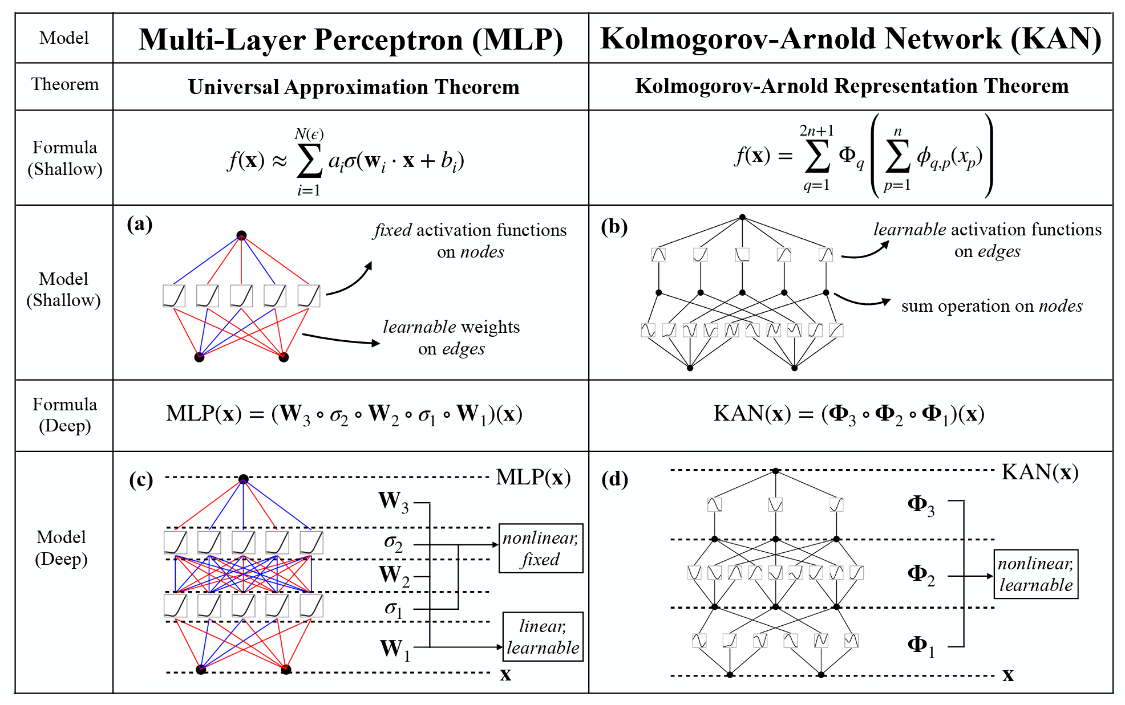
Figure 1. MLPs vs. KANs [2]

2.3. Dimensionality Management and Temporal Dynamics
A significant challenge in nuclear AI is the curse of dimensionality. However, KANs excel in regimes where the effective input space is physically constrained. By focusing on primary actuators, e.g., control rods, flow, temperature, the KAN avoids generating over-convoluted expressions. Additionally, KANs are uniquely capable of Dynamics Reconstruction through Temporal-KANs (T-KANs) [7], which learn the underlying differential equations governing core transients by treating time as a functional dependency, rather than a mere sequence index.

Technical Objectives

Objective 1: Mapping Operational Knobs to Flux and Power Maps
The team will develop KAN architectures designed to map primary control variables, specifically control rod bank positions, to 3D flux and power distributions. The goal is to produce a model that not only predicts local peaking factors but can be reduced to an analytical expression verified against established neutronic harmonics.

Objective 2: Multi-Scale Demonstration (TRIGA and HTGR)
- Tier 1 (TRIGA): Validate the KAN framework using a combination of real historical operational data and synthetic high-fidelity data from the [Lead University] TRIGA Mk-II reactor.
- Tier 2 (HTGR): Demonstrate the scalability of the KAN paradigm in complex advanced reactor geometries, handling the heterogeneities of prismatic or pebble-bed cores where traditional regression fails.

Objective 3: Real-time Adaptive Dynamics Reconstruction
We will implement an online state-estimation framework using EnKF. Due to the low parameter count of KANs, we can update the spline coefficients in real-time as the core undergoes Xenon transients or fuel depletion. This ensures the surrogate remains an accurate “Living Model” that adapts to the physical core's aging and operational history without manual recalibration.

Objective 4: Evaluation of Interpretability and Operational Safety
The project will quantify the interpretability score of KAN surrogates compared to black-box MLPs. We will demonstrate how symbolic forms extracted from KANs can be used by operators for pre-step validation, predicting the effect of a rod movement before the physical action is taken, thereby enhancing the safety and defensibility of AI-augmented operations.

Anticipated Benefits

If successful, this work will deliver a new class of reactor surrogates that provide significant advantages over traditional MLPs and lookup tables:
- Verifiable and Defensible Models for Licensing: Unlike opaque MLPs, KANs allow for the extraction of analytical symbolic forms. This enables researchers and operators to verify that the model has captured the underlying neutronic physics, e.g., flux mode shapes or rod-worth behavior, directly addressing the black-box barrier in nuclear regulatory environments.
- Superior Efficiency in Managed Dimensions: By focusing on the core’s primary operational knobs, e.g., control rod positions, KANs avoid the “Symbolic Complexity Trap.” The resulting models are extremely parameter-efficient, often 10–100x smaller than equivalent MLPs, while maintaining higher accuracy in mapping actuators to global core states.
- Real-Time Dynamics Reconstruction: The project will provide a unique capability to reconstruct and predict core transients, e.g., Xenon-135 oscillations, burnup drifts, in real-time. By utilizing KANs’ strengths in time-series modeling, the surrogate acts as a dynamic signature of the reactor, offering foresight into transient safety margins.
- Adaptive Living Digital Twins: The low parameter count of KAN architectures allows for the implementation of lightweight online updating via EnKF. This ensures the surrogate evolves with the actual reactor state across the fuel cycle, providing an adaptive tool that remains accurate without the need for periodic, high-cost retraining.
- Broad Portability and Scalability: By demonstrating success on both a research reactor (TRIGA) and an advanced reactor concept (HTGR), this work will prove the portability of KAN-based surrogates across diverse spectral environments and complex geometries.

Work Plan

Task 1 — Benchmark Suite and Multi-Fidelity Data Generation
Establish a comprehensive benchmark suite for the TRIGA Mk-II and HTGR systems. This includes:
- (i) Generating high-fidelity synthetic training data with production solvers, e.g., MPACT [8], SCALE [9].
- (ii) Curating real operational datasets from the UT TRIGA reactor for final-stage validation.
- (iii) Defining metrics for interpretability, symbolic complexity, and computational speed.

Task 2 — KAN Model Formulation and Static Core Mapping
Develop KAN architectures optimized for mapping control rod positions to static core features.
- Implement B-spline based architectures that map primary operational actuators directly to flux/power distributions.
- Conduct symbolic regression tests to extract analytical expressions and verify physical consistency against known neutronic harmonics.

Task 3 — T-KANs for Dynamics Reconstruction
Extend the KAN paradigm to model the temporal evolution of the core.
- Develop T-KANs that learn the rate-of-change of safety-critical variables, e.g., reactivity, peaking factors.
- Train the models to reconstruct complex transients, specifically focusing on Xenon oscillations and burnup history, treating time as an explicit functional dependency.

Task 4 — Online Update Framework and Operational Validation
Integrate the KAN surrogates into a real-time operational dashboard.
- Implement an EnKF to update spline coefficients in-situ based on reactor instrumentation.
- Perform exhaustive comparative studies against traditional MLPs and polynomial fits to quantify improvements in accuracy, diagnostic value, and update efficiency.
- Package the KAN-Nuclear Framework as a reproducible artifact for the nuclear modeling community.

Estimated Project Timeframe

The budget for this project will be $1M over 3 years. A preliminary timeframe to execute the tasks described above is shown as follows:

Task | Year 1 |  |  |  | Year 2 |  |  |  | Year 3
 | Q1 | Q2 | Q3 | Q4 | Q1 | Q2 | Q3 | Q4 | Q1 | Q2 | Q3 | Q4
1
2
3
4

References

[1] I. Goodfellow, Y. Bengio, and A. Courville, Deep Learning. MIT Press, 2016.
[2] Z. Liu et al., “KAN: Kolmogorov-arnold networks.” 2025. [Online]. Available: https://arxiv.org/abs/2404.19756
[3] R. E. Kalman, “A new approach to linear filtering and prediction problems,” J. Basic Eng., vol. 82, no. 1, pp. 35–45, Mar. 1960, doi: 10.1115/1.3662552.
[4] G. Evensen, “Sequential data assimilation with a nonlinear quasi-geostrophic model using Monte Carlo methods to forecast error statistics,” J. Geophys. Res. Oceans, vol. 99, no. C5, pp. 10143–10162, 1994.
[5] General Atomics, “TRIGA reactor and fuel description,” General Atomics, 1996.
[6] I. A. E. Agency, “Status of high temperature gas cooled reactor technology,” IAEA, Vienna, TECDOC-1645, 2010.
[7] R. Genet and H. Inzirillo, “TKAN: Temporal kolmogorov-arnold networks.” 2025. [Online]. Available: https://arxiv.org/abs/2405.07344
[8] B. K. Kochunas, B. S. Collins, S. G. Stimpson, D. E. Jabaay, and others, “VERA core simulator: MPACT user’s manual,” Consortium for Advanced Simulation of Light Water Reactors (CASL), Oak Ridge, TN, CASL-U-2016-1094-000, 2016.
[9] W. A. Wieselquist and R. A. Lefebvre, SCALE 6.3.2 User Manual. Oak Ridge, TN: UT-Battelle, Oak Ridge National Laboratory, 2024.

University of Texas at Austin (Lead Organization)

The University of Texas at Austin (UT Austin) will serve as the lead institution, providing overall project management and driving the technical development of the Kolmogorov-Arnold Network (KAN) framework. UT Austin’s primary focus is on the near-term operational demonstration of the KAN paradigm. Key responsibilities include:
- Methodology Development: Leading the design and implementation of KAN and Temporal-KAN (T-KAN) architectures tailored for nuclear reactor physics.
- Testbed 1 Execution (TRIGA): Building high-fidelity datasets using both real operational history from the UT TRIGA Mk-II reactor and synthetic data generated via the Texas Advanced Computing Center (TACC) LoneStar6 supercomputer.
- Adaptive Systems: Developing the Ensemble Kalman Filter (EnKF) integration for online updating of KAN spline coefficients to track Xenon transients and fuel depletion.
- Operational Prototyping: Delivering the final integrated digital twin prototype and conducting performance assessments against traditional black-box models.

Jeongwon Seo:

Dr. Jeongwon Seo is Postdoctoral Fellow at the University of Texas at Austin, specializing in the study of Nuclear Reactor Digital Twins, Machine-Learning-based Reduced Order Modeling (ROM), and Verification, Validation, and Uncertainty Quantification (VVUQ). He earned his Ph.D. in Nuclear Engineering from Purdue University, where his research focused on bridging the gap between high-fidelity physics simulations and real-time operational requirements through innovative AI methodologies.

Prior to his current role, Dr. Seo developed expertise in reactor physics and data-driven modeling during his doctoral studies at Purdue University. He also holds an M.S. in Nuclear Physics (with honors) from Lomonosov Moscow State University and a B.A. in Applied Chemistry from the Korea Military Academy. His research involved the development of novel regression frameworks using Softmax-based Deep Neural Networks, specifically designed to enhance interpretability and physical consistency in nuclear applications.

Dr. Seo’s professional background is distinguished by his experience with a wide array of industry-standard nuclear codes and high-performance computing. He has successfully led the development of the TRIGA Digital Twin web application at UT Austin, establishing real-time data pipelines that leverage the TACC LoneStar6 supercomputer for large-scale synthetic data generation and GPU-accelerated training.

University of Michigan (Collaborating University)

The University of Michigan will lead the scalability and generalization efforts, ensuring the KAN paradigm is robust enough for complex advanced reactor designs. Key responsibilities include:
- Testbed 2 Execution (HTGR): Developing and validating KAN models for High-Temperature Gas-cooled Reactor (HTGR) geometries, focusing on complex prismatic or pebble-bed configurations.
- Scalability Analysis: Demonstrating the model’s ability to handle the heterogeneities and spectral variations inherent in advanced reactor designs where traditional regression often fails.
- Cross-Class Comparison: Providing comparative insights into how KAN structures and training strategies differ across research (TRIGA) and advanced (HTGR) reactor classes.

Majdi Radaideh (Univ. Michigan):

Dr. Majdi Radaideh is an Assistant Professor at the University of Michigan. His expertise lies in the intersection of nuclear reactor engineering, computational science, and advanced machine learning. Dr. Radaideh has led numerous efforts in applying AI to reactor design optimization, uncertainty quantification, and autonomous control. His role in this project leverages his experience in scaling machine learning models to handle the complexities of advanced reactor geometries like HTGRs.

