Title: | Interpretable, Adaptive KAN Surrogates for Reactor Digital Twins
Technical Topic Area: | Topic Area 13 - Artificial Intelligence for Nuclear Energy
PI: | Majdi Radaideh (University of Michigan)
Collaborators: | Jeongwon Seo (University of Texas)
 | Cole Gentry (University of Texas)

Identification and Significance of Problem or Opportunity

Faster-than-real-time (FTRT) reduced-order models (ROMs) and digital twins (DTs) are emerging as enabling technologies for advanced reactor operations, supporting improved maneuver planning, real-time prediction of core state evolution, and partially automated or autonomous control functions. UT and others are actively developing such capabilities, and their value proposition is clear: they can bring high-fidelity predictive insight, as illustrated in Figure 1, into operational decision-making loops where full physics solvers are too slow to be practical. However, as ROMs move closer to operator-facing and control-relevant use, they face a persistent challenge: achieving an acceptable balance between speed, accuracy, generalizability, and, most crucially, transparency/defensibility. In safety-critical environments, it is not sufficient for a surrogate to be fast and accurate “on average”; operators, designers, and regulators must be able to understand how the model is responding to changes in reactor state and whether its behavior is consistent with physical expectations across credible operating regimes.

Traditional deep learning surrogates (e.g., multi-layer perceptrons and related architectures) can achieve excellent predictive performance when trained on sufficiently broad datasets, often providing strong speed, accuracy, and apparent generalization. Yet they typically do so at the cost of interpretability: the learned mapping from operational inputs to core responses is opaque, difficult to validate mechanistically, and challenging to adapt online as reactor conditions evolve. Kolmogorov–Arnold Networks (KANs) [2] offer a promising alternative architecture that may close this gap. KANs provide a structural pathway to models that remain highly expressive and computationally efficient while also enabling direct inspection of the learned functional relationships. This creates an opportunity to retain the primary advantages of neural surrogates, FTRT evaluation, high accuracy, and potential generalization, while substantially improving transparency and reducing model complexity. In addition, the relatively low-parameter, structured form of KANs may make them better suited to lightweight online adaptation, enabling a “living” ROM that can be updated as reactor conditions change over time due to effects such as fuel depletion and evolving reactivity feedback.

This project will develop and demonstrate KAN-based ROMs as an interpretable and adaptive foundation for reactor digital twins. The central goal is to produce models that can predict key core states rapidly while also providing human-auditable structure, supporting physical sanity checks, improved defensibility for operational use, and efficient updating across transient and fuel-cycle evolution. If successful, the work will establish a new class of glass-box reactor surrogates that reduces the black-box barrier to deploying ML-enabled ROMs in operational and safety-relevant contexts.
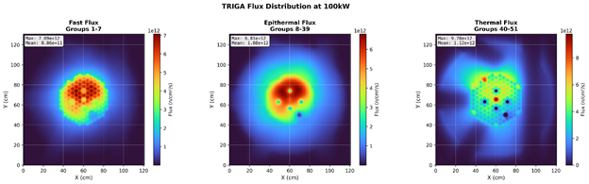
Figure 1: Example FTRT ROM Flux Predictions [1]

Technical Approach

KANs are a recently introduced alternative to conventional multilayer perceptrons (MLPs) in which the usual scalar “weights” on edges are replaced by learnable univariate functions (often represented with spline bases). This structural choice is motivated by the Kolmogorov–Arnold representation theorem and is attractive for scientific modeling because it can yield parameter-efficient surrogates whose learned input–output relationships are more directly inspectable and amenable to symbolic simplification than typical black-box NNs. The differences between the two methods are summarized in Figure 2.

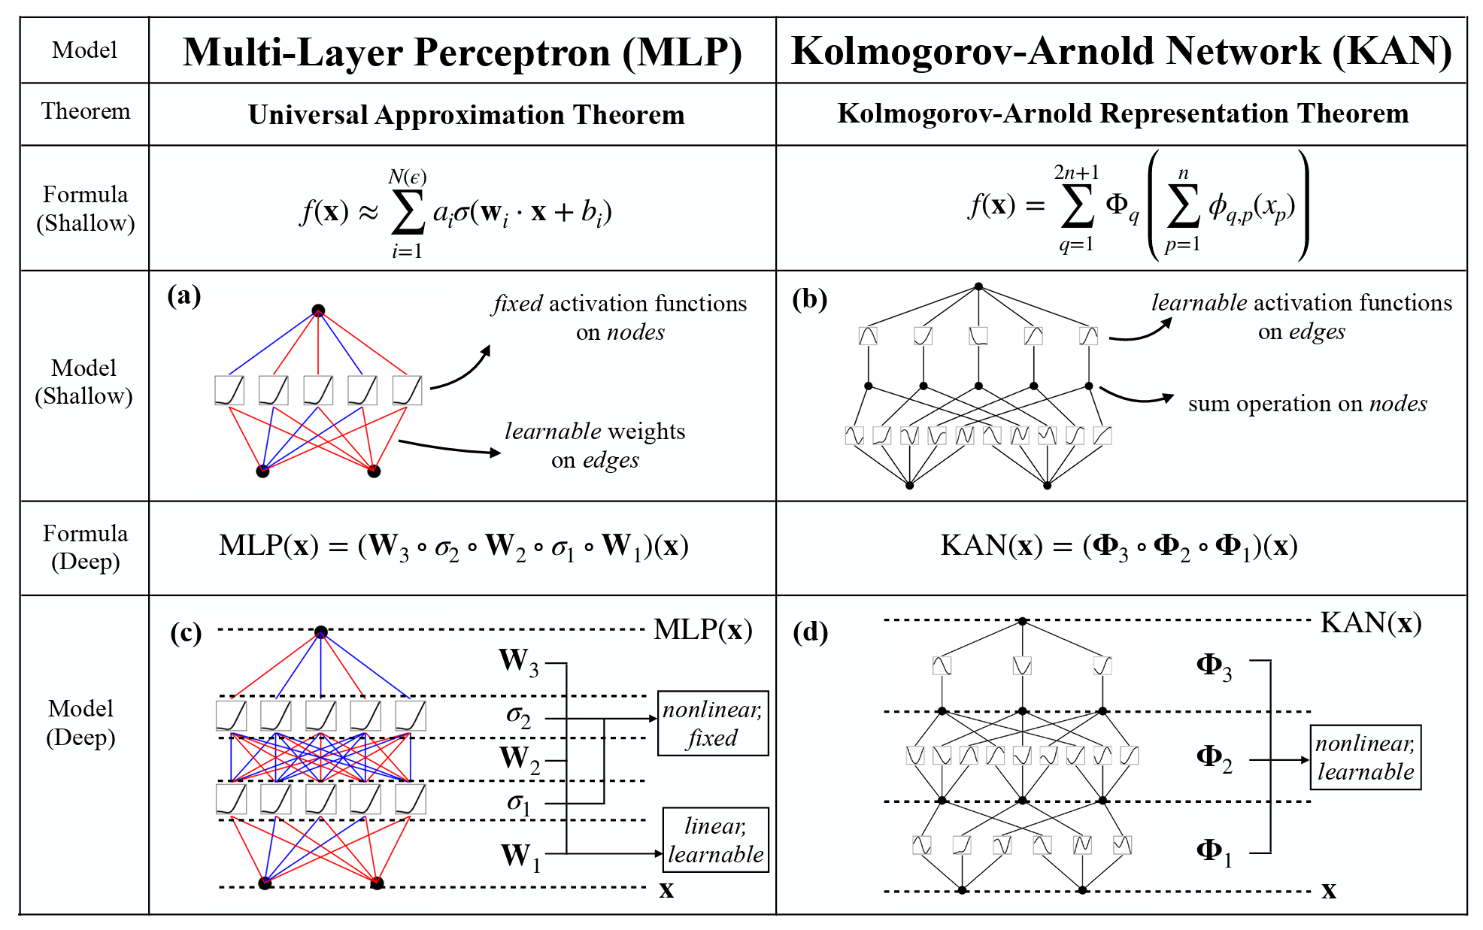
Figure 2: Summary of differences between conventional MLPs and KANs

KANs have begun to appear in nuclear contexts specifically as a mechanism for “opening the black box” via symbolic regression and improved explainability [3]; a study led by our Co-PI (Radaideh) team. However, to our knowledge, prior KAN demonstrations in nuclear energy have largely emphasized scalar or low-dimensional response prediction (e.g., system-level quantities), rather than high-dimensional field outputs such as full-core power/flux distributions that are most valuable for operational planning, margin management, and localized constraint monitoring. This project targets that gap by developing KAN-based ROMs that map a small set of operational “knobs” (e.g., control rod bank positions and a limited set of state descriptors) to spatially resolved power/flux distributions. The key hypothesis is that reactor power/flux fields are often well represented by a small number of dominant spatial modes, which makes them a natural fit for KAN-style representations that can capture nonlinear actuator-to-mode couplings while remaining compact and human-auditable.

Finally, the project will extend beyond static mapping to adaptive “living” models that remain valid as the reactor evolves (burnup drift, xenon dynamics, changing worth curves). Because KANs can be relatively low-parameter compared to deep MLP surrogates, we will investigate lightweight online updating using data-assimilation techniques such as the Ensemble Kalman Filter (EnKF) [4, 5] to update selected spline parameters (and/or low-dimensional latent coefficients) using available plant measurements. This creates an interpretable, updateable ROM/digital-twin workflow: (i) a KAN provides FTRT field predictions and an inspectable mapping from actuators to core response, and (ii) EnKF-style updates maintain calibration as the core state drifts over time, reducing the need for expensive retraining while improving defensibility for operational use.

Anticipated Benefits

If successful, this project will deliver a new class of frontier AI reactor surrogates that directly addresses a key barrier to operational use of ML in nuclear systems: the limited transparency and defensibility of black-box models. By using KANs to learn compact, human-auditable mappings from operational actuators to spatially resolved power/flux distributions, the work enables rapid “what-if” prediction, real-time margin awareness, and operator-usable explanations of why predicted behavior occurs, capabilities aligned with DOE’s goal of AI/ML that enhances reactor operations and accelerates deployment. The low-parameter KAN structure also supports lightweight online adaptation (e.g., EnKF-based updates) so the surrogate can evolve with xenon dynamics and depletion-driven drift across the fuel cycle, reducing reliance on expensive retraining while improving robustness in real operating environments. Collectively, these outcomes advance AI-enabled digital twins that are practical for high-throughput analysis and decision support, while improving the credibility of ML surrogates for future licensing-relevant applications in both research and advanced reactor contexts.

Technical Objectives

The technical objectives of this work are to: (1) develop KAN architectures and training pipelines tailored to reactor-physics reduced-order modeling, emphasizing parameter efficiency and interpretability; (2) demonstrate KAN-based surrogates that map a small set of operational inputs and state descriptors (e.g., control rod positions and key conditions) to spatially resolved reactor responses, including power/flux distribution representations, control rod worths, and / or derived margin metrics; (3) quantify predictive performance and computational speed relative to conventional surrogates while also evaluating interpretability through symbolic simplification and stability under extrapolation; (4) develop an online adaptation capability using data-assimilation methods such as the Ensemble Kalman Filter (EnKF) to update selected KAN parameters and maintain accuracy under depletion and nonlinear transients (e.g., xenon dynamics) without full retraining; and (5) validate the approach on a tiered demonstration set spanning UT TRIGA [6] research reactor and a representative advanced reactor geometry (e.g., HTGR, MSR), producing reusable datasets, models, and documentation to enable follow-on digital twin and control applications.

Work Plan

- Task 1 — Benchmark definition and multi-fidelity data generation:
Define the target inputs/outputs and operating envelopes for the KAN-ROM (e.g., control rod configurations, key state descriptors, and spatial power/flux outputs). Generate multi-fidelity training and validation datasets using high-fidelity simulation for TRIGA and a representative alternative advanced reactor configuration, and curate any available operational/measurement data needed for later-stage calibration. Establish evaluation metrics for accuracy, runtime, robustness to extrapolation, and interpretability.
- Task 2 — KAN model formulation for spatial reactor responses:
Develop KAN architectures and output representations suitable for high-dimensional fields, including modal/low-rank encodings of power/flux distributions with KAN-predicted coefficients. Train and validate models across the defined operating space, compare against baseline surrogates (MLPs and / or standard regression/ROM approaches), and extract human-auditable functional relationships to assess interpretability and physical consistency. Furthermore, explainability tools typically used for MLPs, such as SHAP [7], will be applied to the KAN framework to provide rigorous sensitivity analysis of the input features, leveraging KAN's inherent interpretability alongside established diagnostic metrics.
- Task 3 — Online adaptation using EnKF-style updating:
Implement an Ensemble Kalman Filter (or closely related filter) to update selected KAN parameters/latent coefficients using sparse measurements and operational observables. Demonstrate adaptation under representative drifting conditions (xenon dynamics, depletion/burnup progression, and configuration changes), quantify how online updating improves accuracy and reduces retraining needs, and characterize stability and “do no harm” behaviors when measurements are noisy or partially missing.
- Task 4 — End-to-end demonstrations and transition artifacts:
Perform integrated demonstrations on the TRIGA and alternative advanced reactor tiers, reporting predictive fidelity, speedup, interpretability, and adaptability across held-out cases and transient scenarios.

Estimated Project Cost and Timeframe
The budget for this project will be $1M over 3 years. A preliminary timeframe to execute the tasks described above is shown as follows:

Task | Year 1 |  |  |  | Year 2 |  |  |  | Year 3
 | Q1 | Q2 | Q3 | Q4 | Q1 | Q2 | Q3 | Q4 | Q1 | Q2 | Q3 | Q4
1
2
3
4

Artificial Intelligence Use Disclosure and Disclaimer
Portions of this application were developed with the assistance of AI tools to support organizing and editing of the narrative content. All technical content, claims, plans and representations have been reviewed and approved by the applicant, who remains solely responsible for the accuracy and completeness of the submission, the capability to perform the work described, and compliance with intellectual property and third-party rights.

References:
- J. Ross, et al., “Initial Validation of the TRIGA Real-Time Digital Twin at the University of Texas at Ausin”, PHYSOR 2026, (in preparation)
- Z. Liu et al., “KAN: Kolmogorov-arnold networks.” 2025. [Online]. Available: https://arxiv.org/abs/2404.19756
- N. Panczyk, O. Erdem, M. Radaideh, “Opening the AI black-box: Symbolic regression with Kolmogorov–Arnold Networks for advanced energy applications”, Energy and AI, 22, 2025
- R. E. Kalman, “A new approach to linear filtering and prediction problems,” J. Basic Eng., vol. 82, no. 1, pp. 35–45, Mar. 1960, doi: 10.1115/1.3662552.
- G. Evensen, “Sequential data assimilation with a nonlinear quasi-geostrophic model using Monte Carlo methods to forecast error statistics,” J. Geophys. Res. Oceans, vol. 99, no. C5, pp. 10143–10162, 1994.
- "University of Texas at Austin Nuclear Engineering Teaching Laboratory TRIGA Research Reactor", August 2023, https://www.nrc.gov/docs/ML2327/ML23279A146.pdf
- S. M. Lundberg and S. I. Lee, “A Unified Approach to Interpreting Model Predictions,” Advances in Neural Information Processing Systems 30, pp. 4765–4774, 2017.

University of Michigan

UM will lead overall project execution and will lead the advanced-reactor demonstration arm of the project, applying the KAN-based ROM methodology to a representative next-generation reactor concept (e.g., HTGR or MSR) to test scalability beyond the TRIGA domain. UM will leverage its prior experience with KAN modeling in nuclear-energy contexts through their recent study (Ref. [3] in the narrative) to inform architecture selection, training strategies, and interpretability assessment (e.g., symbolic simplification and sensitivity consistency), and will generate and curate the multi-fidelity simulation datasets needed to evaluate accuracy, robustness, and computational efficiency for more complex geometries and spectra. This complementary demonstration provides an essential proof of portability and ensures that project outcomes generalize to the operational needs of emerging commercial systems. KAN will also be integrated as part of pyMAISE (Michigan Artificial Intelligence Standard Environment), which will allow fast, direct one-to-one comparisons between KAN and other regression models, while also enabling real-time deployment within digital0twin applications. pyMAISE is maintained by the University of Michigan Co-PI.

A. Majdi Radaideh:

Prof. Majdi Radaideh is a tenure-track Assistant Professor at the University of Michigan with dual appointments in Nuclear Engineering and Radiological Sciences and Computer Science and Engineering. Prof. Radaideh leads the AIMS lab (Artificial Intelligence and Multiphysics Simulations), funded through more than $3.3M in external funding of his share during the first three years of his appointment. AIMS focuses on the intersection between nuclear reactor design, multiphysics modeling and simulation, advanced computational methods, and machine learning algorithms to drive advanced reactor research and improve the sustainability of the current reactor fleet. He completed his B.Sc. in nuclear engineering from the Jordan University of Science and Technology, M.S. and Ph.D. in nuclear engineering from the University of Illinois at Urbana Champaign with two minors in computational science & engineering and applied statistics. After graduation, he held different R&D appointments at MIT and ORNL, where he completed his postdoctoral studies and collaborated with different national labs and industry partners. Prof. Radaideh has collaborated and worked on 5+ DOE/NEUP/IRP projects, and he is currently the PI and Co-PI on four NEUP projects from DOE-NE and one project from the U.S. NRC with a significant AI/ML components that are related to this grant. He has received numerous early career awards for his research, including the 2025 ANS 40 Under 40, 2025 Ted Quinn Early Career Award in Nuclear I&C, 2025 ANS Mathematics & Computation Young Member’s Research Achievement Award, 2023 DOE-NE Distinguished Early Career Award, and 2019 ANS National Mark Mills Award for the best PhD thesis work in nuclear engineering. Radaideh has authored 110+ publications, including 55+ journal papers, where he was the first/major author in 30+ journal papers.

Prof. Majdi I. Radaideh will provide key expertise in AI-enabled multiphysics simulation and advanced reactor modeling that directly supports the project’s KAN-based reduced-order modeling goals and the advanced-reactor demonstration at UM. As the lead of the AIMS Lab, his work sits at the intersection of machine learning and reactor modeling/simulation, positioning him to guide the KAN architecture design, training strategy, and interpretability assessment needed to produce glass-box surrogates rather than black-box predictors. His extensive experience with nuclear analysis codes, parallel computing, and software engineering is particularly relevant for (i) generating and managing the multi-fidelity training datasets required for spatial power/flux mapping in an advanced reactor configuration (e.g., HTGR/MSR), (ii) implementing scalable ML workflows and uncertainty/robustness studies, and (iii) ensuring the resulting models are computationally efficient and reproducible.

University of Texas

UT will focus on the TRIGA-based digital-twin demonstration, leveraging existing expertise in reactor digital twins and ML-enabled reduced-order modeling, access to the UT NETL TRIGA reactor and operational history for realistic validation, and the Texas Advanced Computing Center (TACC) for high-throughput training and multi-fidelity benchmarking. UT will develop and evaluate KAN-ROM capabilities in an operator-relevant setting, including mapping operational actuators to spatial power/flux representations and integrating online adaptation concepts (e.g., filter-based parameter updates) to maintain fidelity across xenon and depletion-driven drift. UT’s role ensures that the work remains grounded in deployable digital-twin workflows and produces reusable artifacts (datasets where permissible, scripts, and model documentation) that support transition to broader reactor applications.

Cole Gentry:

Dr. Cole A. Gentry will lead the UT contribution to the KAN-based digital twin effort, bringing a strong combination of reactor digital twin development, ML-based reduced-order modeling, and production reactor analysis experience. As a Senior Engineering Scientist specializing in nuclear digital twins and ML ROMs, Dr. Gentry will direct development of the KAN surrogate workflow for mapping key operational actuators to reactor responses relevant to operations and planning. His prior work at ORNL on VERA/CASL and SCALE/POLARIS provides direct familiarity with high-fidelity reactor simulation toolchains used to generate and validate training/benchmark datasets, while his industry experience at BWXT on advanced reactor analysis tool development and code qualification supports a pragmatic focus on robustness, defensibility, and transition-ready implementation. Dr. Gentry’s earlier experience as a commercial Reactor Engineer at the Sequoyah Nuclear Plant further strengthens the project’s operational grounding, ensuring that model outputs, interfaces, and validation metrics remain aligned with operator-relevant decision support.

Jeongwon Seo:

Dr. Jeongwon Seo, a postdoctoral Fellow at the University of Texas at Austin, will contribute directly to the project’s core technical work on digital twin implementation, ML-based reduced-order modeling, and VVUQ. He has hands-on experience bridging high-fidelity reactor simulations with real-time operational needs, and at UT he has already led development of the TRIGA digital twin web application—including the real-time data pipelines and workflows needed to support live-state synchronization and rapid prediction. His background in verification, validation, and uncertainty quantification will be especially important for this proposal’s emphasis on defensible, interpretable surrogates, enabling rigorous evaluation of KAN performance and development of clear domain-of-validity guidance. Finally, his demonstrated use of TACC resources (e.g., LoneStar6) for large-scale synthetic data generation and GPU-accelerated training positions him to execute the high-throughput training/benchmarking required for KAN model development and for integrating lightweight online-updating concepts in a reproducible, well-documented workflow.

