Title: | ML-Assisted Convergence Acceleration for Reactor Multiphysics Solvers
Technical Topic Area: | Topic Area 9 - Modeling and Simulation
PI: | Cole Gentry (University of Texas)
Collaborators: | Cody Permann (INL)

Identification and Significance of Problem or Opportunity

High-fidelity multiphysics simulation tools such as the MOOSE framework [1] and its reactor-physics applications (e.g., Griffin [2]) are increasingly essential for analysis, design, and licensing support of next-generation nuclear reactors, where tight coupling between neutronics, thermal-hydraulics, and materials behavior is required to capture feedback and operational transients with credible fidelity. However, these coupled calculations commonly rely on iterative nonlinear solution strategies (e.g., fixed-point/Picard coupling with damping and other convergence controls), and the overall computational cost can be dominated not by a single physics solve but by the number of iterative loops, and their associated iterations, required to converge the coupled system, as illustrated conceptually in Figure 1. This iteration burden becomes a critical bottleneck for the emerging high-throughput workflows that advanced reactor programs increasingly depend on, such as uncertainty quantification, design optimization, and large-scale synthetic data generation to train reduced-order models (ROMs) and digital twins, where thousands of repeated multiphysics evaluations may be required.

This project addresses that opportunity by developing ML-assisted convergence acceleration methods that operate “in the loop” as an advisor to the existing physics solver. Rather than replacing established nonlinear algorithms or changing the underlying governing equations, the proposed approach will learn to adjust iteration-control parameters on the fly, such as relaxation factors and related mixing/acceleration settings, based on signatures in the iteration history (e.g., stagnation, oscillation, slow modes). By adaptively selecting more effective iteration controls in real time, the project aims to reduce iteration counts and wall-clock time while preserving solver correctness and robustness, thereby enabling faster and more practical use of MOOSE/Griffin-class multiphysics tools in high-throughput nuclear engineering workflows.

Technical Approach

A recent proof-of-principle for ML-assisted nonlinear-solver acceleration was demonstrated by V. Silva, et al. [3] in the porous-media domain by coupling an ML model directly to the nonlinear iteration loop to dynamically choose a relaxation parameter during the solve, as summarized in Figure 2. The key idea is not to replace the physics solver, but to learn a mapping from problem/iteration descriptors to a solver “control knob” that reduces oscillation/stagnation and lowers iteration count. This established that “ML as an in-the-loop advisor” can be practical and beneficial, at least for a specific PDE class and a specific tuning lever.
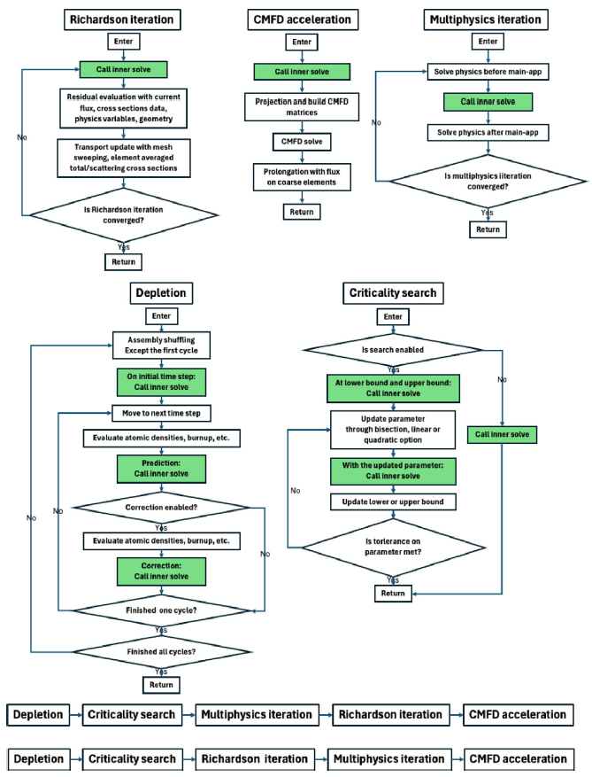
Figure 1: Illustration of the depletion algorithm in Griffin [2]

However, it remains an open and important question whether this paradigm generalizes to reactor physics (neutronics) and tightly coupled nuclear multiphysics, where convergence pathologies can be driven by strong feedbacks, disparate time scales, nonlinear material behavior, and coupling-induced oscillations. Moreover, relaxation is only one of several iteration controls that practitioners routinely tune by hand; the research opportunity is to determine which additional parameters are effective to manipulate, in what, and what training signals/features are necessary to make the ML advisor robust across regimes rather than overfit to a single problem type. The project will therefore develop a generalized “solver advisor” concept for MOOSE-based multiphysics by designing reactor-relevant feature sets, defining conservative guardrails (rollback/trust-region acceptance tests), and benchmarking which control actions provide reliable speedups without sacrificing robustness.
To demonstrate and quantify impact in a nuclear context, we will integrate these ML-driven iteration-control capabilities into a multiphysics workflow (ex: Griffin) and evaluate performance on a structured progression of reactor problems with increasing complexity. We will leverage established CASL/VERA progression problems [4] (ranging from pin-cell to larger 3-D configurations) as a representative benchmark ladder to test generalization across geometry/physics complexity and to provide a familiar basis for comparisons. The end result will be a reusable implementation pattern for ML-assisted convergence acceleration, supported by an evidence-based assessment of which iteration controls are worth manipulating, when they help, when they hurt, and how to deploy them safely in high-throughput nuclear multiphysics workflows.

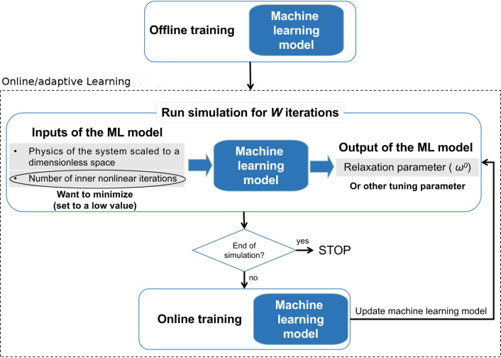
Figure 2: Example online/adaptive learning acceleration for nonlinear PDE solvers [3]

Anticipated Benefits

If successful, this project will deliver a practical capability for reducing nonlinear iteration counts and wall-clock time in tightly coupled reactor multiphysics calculations, directly improving the throughput of high-fidelity simulation workflows. By using ML as a conservative in-the-loop advisor to adapt iteration controls based on problem descriptors and convergence signatures, the approach is expected to mitigate oscillatory or stagnating convergence behavior while preserving the physics solver as the source of truth and maintaining baseline tolerance requirements. These improvements would lower the computational cost of repeated multiphysics evaluations that are central to DOE-NE priorities, such as uncertainty quantification, design optimization, and large-scale synthetic data generation for ROMs and digital twins, thereby accelerating advanced reactor analysis and enabling broader use of high-fidelity multiphysics tools in time- and resource-constrained studies.
Technical Objectives

The technical objectives of this work are to: (1) design and implement an ML-assisted convergence “advisor” that integrates cleanly with MOOSE nonlinear solve loops and coupled multiphysics workflows (with Griffin as a primary target); (2) identify and parameterize a set of solver control degrees of freedom that can be safely and effectively manipulated on-the-fly (e.g., relaxation/mixing parameters and selected acceleration/restart controls), along with reactor-relevant feature sets derived from iteration history and problem descriptors; (3) develop robust training and deployment strategies for these advisors, including conservative guardrails such as rollback/trust-region acceptance criteria to ensure “do no harm” behavior and graceful fallback to baseline solvers; (4) quantify iteration-count and runtime reductions on a progression of reactor physics and multiphysics benchmark problems including sensitivity to regime changes and coupling strength; and (5) deliver a reusable, documented MOOSE-friendly module/plugin pattern and benchmarking artifacts that enable broader adoption and future extension to additional physics domains and solver configurations.

Work Plan

- Task 1 — Baselines, benchmarks, and convergence diagnostics
Select a collection of reactor physics and coupled multiphysics benchmark problems (e.g., CASL/VERA progression-style cases) and establish baseline solver configurations, iteration counts, and wall-clock performance. Instrument the nonlinear solve loop to log iteration-history features (residual norms, component-wise residuals where available, oscillation/stagnation indicators, step acceptance, and coupling metrics) and define success criteria (tolerances, robustness, “do no harm” constraints).
- Task 2 — ML-advisor prototype for online control of iteration parameters
Implement an initial ML advisor that adjusts a single iteration control parameter (i.e. relaxation factor) on-the-fly using iteration-history signatures and problem descriptors, with conservative guardrails to ensure stability. Train and tune the advisor using a mix of offline and controlled online learning in simplified cases, then demonstrate iteration/runtimes reductions on intermediate benchmark problems.
- Task 3 — Expand the controllable parameter set and orchestration logic:
Evaluate which additional iteration controls can be safely manipulated beyond a single relaxation factor. Develop a policy that selects among a small menu of solver actions, quantify when each action helps or hurts, and refine feature engineering and training procedures to generalize across regimes.
- Task 4 — Integrated multiphysics demonstrations and robustness assessment:
Apply the advisor to tightly coupled Griffin-based multiphysics problems and quantify speedups across operating regimes, coupling strengths, and mesh/parameter variations. Perform robustness studies to ensure graceful fallback behavior and document conditions where the advisor should be disabled or constrained.

- Task 5 — Packaging, transition artifacts, and dissemination:
Deliver a MOOSE-friendly module/plugin implementation, configuration templates, and reproducible benchmarking scripts/logs that allow others to evaluate and adopt the approach. Produce guidance on recommended features, guardrails, and tuning practices, and summarize results and limitations in a final report and archival publication.

Estimated Project Cost and Timeframe
The budget for this project will be $1M over 3 years. A preliminary timeframe to execute the tasks described above is shown as follows:

Task | Year 1 |  |  |  | Year 2 |  |  |  | Year 3
 | Q1 | Q2 | Q3 | Q4 | Q1 | Q2 | Q3 | Q4 | Q1 | Q2 | Q3 | Q4
1
2
3
4
5

Artificial Intelligence Use Disclosure and Disclaimer
Portions of this application were developed with the assistance of AI tools to support organizing and editing of the narrative content. All technical content, claims, plans and representations have been reviewed and approved by the applicant, who remains solely responsible for the accuracy and completeness of the submission, the capability to perform the work described, and compliance with intellectual property and third-party rights.

References:
- L. Harbour, et al., “4.0 MOOSE: Enabling massively parallel Multiphysics simulation”, SoftwareX, 31, (2025)
- Y. Wang, et al. “Griffin: A MOOSE-based reactor physics application for multiphysics simulation of advanced nuclear reactors”, Annals of Nuclear Energy, 211, (2025)
- V. Silva, et al., “Online learning to accelerate nonlinear PDE solvers: Applied to multiphase porous media flow”, Artificial Intelligence in Geosciences, 6, (2025)
- A. Godfrey, “VERA Core Physics Benchmark Progression Problem Specifications”, Oak Ridge National Laboratory, CASL-U-2012-0131-004, 2014

Idaho National Laboratory

NL will provide technical oversight and guidance to ensure the proposed ML-assisted convergence acceleration aligns with real MOOSE/Griffin solver practices and deployment constraints. As the home of MOOSE and a key steward of Griffin and related NEAMS workflows, INL is uniquely positioned to advise on appropriate integration points in the nonlinear solve loop, identify solver parameters that are both impactful and safe to manipulate, and help define credible benchmark configurations and performance/robustness expectations. INL will also support technology transition by reviewing implementation choices for maintainability, encouraging compatibility with established MOOSE/PETSc solver options, and guiding a pathway for incorporation into NEAMS toolchains if the approach proves reliable and broadly beneficial.

University of Texas

UT Austin will lead the project’s technical execution, leveraging its strengths in nuclear machine learning, digital-twin-enabled workflows, and high-throughput computational studies. UT will implement the ML “advisor” methods, develop the feature engineering and guardrail logic required for safe in-the-loop deployment, and conduct systematic benchmarking on reactor physics and multiphysics progression problems. UT will also utilize the Texas Advanced Computing Center (TACC) to enable large-scale training, parameter sweeps, and robustness testing across regimes—activities that are essential for demonstrating generalization and for producing reproducible datasets, scripts, and transition-ready artifacts for the broader MOOSE/Griffin community.

