Title: | Digital Twin for Medical Isotope Planning Irradiation Campaigns for the TRIGA
Technical Topic Area: | Topic Area 10 - Modeling and Simulation
PI: | Benjamin Collins (University of Texas)
Collaborators: | Soha Aslam (University of Texas)
 | William Charlton (University of Texas)

Identification and Significance of Problem or Opportunity

Faster-than-real-time (FTRT) digital twins (DTs) for nuclear reactors are rapidly transitioning from research prototypes to deployment-ready capabilities, and UT is actively developing such DT functionality for the University of Texas Nuclear Engineering Teaching Laboratory (NETL) TRIGA reactor [1, 2]. Enabled by reduced-order models informed by high-fidelity physics and operational data, these DTs can provide predictive insights that were historically impractical in real time, such as near-term forecasts of reactor state evolution and increasingly high-resolution representations of core behavior (e.g., full-core high-resolution power/flux distributions). This creates a new opportunity to improve reactor operations by bringing predictive, scenario-based “what-if” capability directly into the operator workflow, supporting more informed decisions during routine maneuvers and off-normal conditions.

At the same time, the nuclear industry is likely still years away from broadly adopting fully autonomous reactor control optimized by DTs, due to conservative operational cultures, verification and validation burdens, and the need for clear licensing pathways. However, there is a highly valuable and near-term path forward: digital-twin-enabled operator guidance and semi-autonomous control that remains explicitly human-in-the-loop. In this paradigm, the DT does not replace the operator or reactor protection system; instead, it provides a predictive planning and guidance layer that can help define control strategies, monitor execution, and reduce operator workload while maintaining conservative safety posture. Such DT predictive capabilities currently being developed at the University of Texas (UT) are illustrated in Figures 1 and 2.

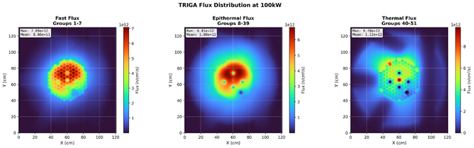
Figure 1: Example Real-time ROM Flux Predictions [1]

This proposal addresses that near-term opportunity by developing and demonstrating a DT-driven semi-autonomous operations capability on the UT NETL TRIGA reactor. Operators will use the DT to automatically generate control plans that achieve specified time-dependent objectives, such as a target power-versus-time maneuver or desired flux at experiment locations versus time, subject to operational constraints. During execution, the DT will continuously compare measured plant behavior against the planned trajectory and provide real-time corrective guidance when deviations occur, analogous to GPS navigation corrections. By formalizing “plan–execute–monitor–correct” operation around an FTRT DT, the project aims to improve maneuver quality, repeatability, and throughput for research reactor experiment support while providing a practical, stepwise pathway toward more advanced DT-enabled automation in the future.

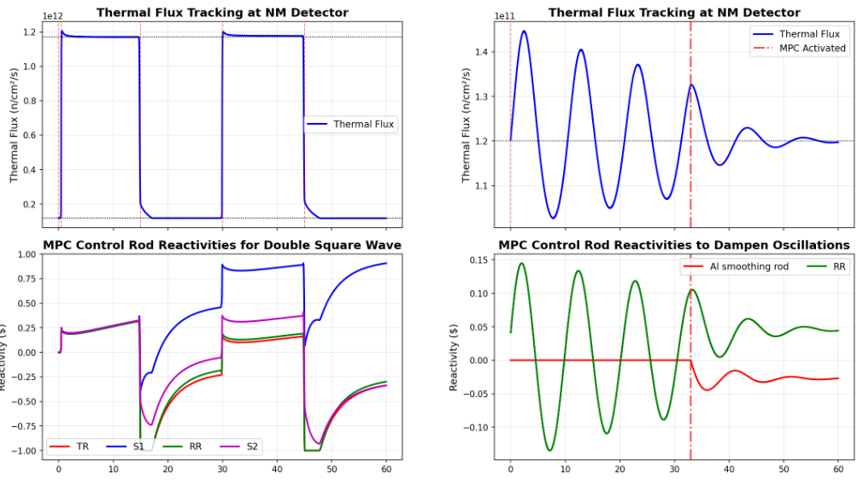
Figure 2: Automated plans for double square wave maneuver (left) and oscillation damping (right) [1]

Technical Approach

UT will deploy the FTRT TRIGA DT as an operator-facing capability on a dedicated control-room workstation with a real-time data interface to plant instrumentation. The DT will continuously assimilate measured signals (e.g., power indication(s), rod position) to update its current state estimate and produce short-horizon predictions under candidate control actions. The deployment will support two complementary operational modes: (i) an Advisory/Planning mode that enables operators to simulate “what-if” maneuvers and automatically generate candidate control trajectories to meet time-dependent objectives while honoring operational constraints, and (ii) an Execution/Assist mode that monitors deviation from the planned trajectory and provides closed-loop replanning guidance when observed behavior departs from expectation. This keeps the operator explicitly in command authority while introducing a structured “plan–execute–monitor–correct” workflow around the DT.

Because DT performance can degrade under off-nominal conditions, a key thrust will be developing and validating DT validity and confidence communication for operator-facing use. UT will define metrics that indicate when the DT is operating outside its expected domain (e.g., untrained operating regions, anomalous sensor patterns, model mismatch signatures, or elevated uncertainty) and present these indicators in the GUI alongside guidance recommendations. The project will include development of procedures and training guidance describing how operators should respond when DT validity degrades (e.g., revert to standard operating practice, request more conservative plans, or suspend assist mode), with emphasis on ensuring that uncertainty indicators lead to appropriate action rather than confusion or over-reliance.

The system will be deployed and evaluated through a combination of real operations use and structured testing. UT will document utility in day-to-day contexts where DT advisory support is expected to provide near-term benefit, and will conduct controlled studies in which operators attempt representative and intentionally challenging maneuvers with and without DT assistance. Where feasible, the study will include operators with differing experience levels to assess usability, learning curve, and robustness of the assist concepts. The evaluation will also include targeted tests in known DT challenge regimes (conditions where predictive accuracy is reduced or uncertainty increases) to assess whether validity indicators and operator guidance lead to safe, conservative behavior. The outcome is a validated, operator-centered deployment pattern and reusable software/integration artifacts that can inform adoption of DT-based guidance and semi-autonomous assist capabilities at other research reactors and, longer-term, more advanced platforms.

Anticipated Benefits

This project will deliver a near-term deployable digital-twin operator guidance capability for the UT NETL TRIGA reactor, directly supporting DOE Topic Area 10 priorities in measuring, monitoring, and controls by integrating real-time plant instrumentation with faster-than-real-time prediction to improve operational decision-making. The workstation deployment will couple live sensor streams to the DT to provide time-synchronized state awareness, predictive maneuver planning, and conservative semi-autonomous assist functions that remain explicitly human-in-the-loop, demonstrating how digital twins can complement instrumentation and enable more advanced control behaviors without requiring full autonomy. Because TRIGA facilities share common operating modes and maneuver challenges, the resulting integration pattern will be broadly transferable to other TRIGA reactors to improve experiment support, irradiation scheduling, and isotope-production throughput. The project will also produce reusable software, validation/evaluation protocols, and a practical deployment roadmap that helps prepare broader adoption of DT-enabled monitoring and control concepts in more demanding settings, including non-TRIGA research reactors and longer-term applications in advanced and remote-access reactor concepts where reliable, uncertainty-aware automation is a key enabler.

Technical Objectives

The technical objectives of this work are to: (1) deploy the UT TRIGA faster-than-real-time digital twin on a dedicated control-room workstation with real-time data interfaces to plant instrumentation to support synchronized state estimation and short-horizon prediction; (2) develop an operator-centered GUI that enables time-dependent maneuver planning and execution support through closed-loop replanning guidance when measured behavior deviates from the nominal plan; (3) develop and integrate DT validity/uncertainty indicators and domain-of-applicability metrics, along with associated operator procedures, to ensure guidance is used appropriately and degrades conservatively when the DT is extrapolating or sensing is degraded; (4) demonstrate and quantify performance and usability through structured operational evaluations—including maneuver trials with and without DT assistance, across representative and challenging scenarios and (where feasible) across varied operator experience levels—using metrics such as tracking/repeatability, constraint-margin compliance, time-to-completion, intervention frequency, and operator workload/acceptance; and (5) package reusable software, configuration templates, and evaluation guidance to support transfer of the DT operator-assistant capability to other TRIGA facilities and provide a scalable foundation for broader application to additional research and power reactor platforms.

Work Plan

- Task 1 — Define operational use cases, requirements, and evaluation metrics:
UT will define the scope of DT-enabled advisory and bounded-assist functions for the UT NETL TRIGA, focusing on operationally relevant, non-safety-related maneuver support. This task will establish functional requirements and interfaces to plant instrumentation. UT will also define the evaluation plan and success metrics and usability measures.
- Task 2 — Control-room workstation deployment and real-time data integration:
UT will deploy the digital twin on a dedicated control-room workstation and implement robust, time-synchronized data interfaces to plant sensors and control state.
- Task 3 — Develop operator-facing GUI and planning capability:
UT will design and implement a human-centered GUI that supports (i) planning and (ii) execution monitoring. The planning module will enable operators to specify time-dependent targets and review candidate DT-generated control trajectories and predicted responses. Iterative design will incorporate operator feedback to ensure usability, clarity, and alignment with operational workflow.
- Task 4 — Implement execution assist and closed-loop replanning guidance:
UT will implement the execution/assist functionality that monitors deviation between measured plant behavior and the planned trajectory and provides real-time corrective guidance via closed-loop replanning.

- Task 5 — Develop and validate DT validity/uncertainty communication and operator procedures:
UT will develop domain-of-applicability and uncertainty/validity indicators to communicate when the DT is operating in regimes where predictive fidelity is reduced (e.g., extrapolation beyond training, degraded sensing, elevated mismatch signatures). These indicators will be integrated into the GUI and paired with operator guidance and training materials describing appropriate response behaviors.
- Task 6 — Demonstration and evaluation campaign; transition artifacts:
UT will conduct structured demonstrations and operator studies comparing maneuver performance with and without DT assistance across representative and intentionally challenging scenarios. UT will quantify improvements and limitations using the defined metrics, including maneuver repeatability, workload, and operator acceptance/trust calibration relative to DT validity cues. Final deliverables will include the workstation deployment configuration, GUI and guidance modules, logging/replay tools and recommended best practices intended to enable adoption at other TRIGA facilities and inform extension to additional reactor platforms.

Estimated Project Cost and Timeframe
The budget for this project will be $1M over 3 years. A preliminary timeframe to execute the tasks described above is shown as follows:

Task | Year 1 |  |  |  | Year 2 |  |  |  | Year 3
 | Q1 | Q2 | Q3 | Q4 | Q1 | Q2 | Q3 | Q4 | Q1 | Q2 | Q3 | Q4
1
2
3
4
5
6

Artificial Intelligence Use Disclosure and Disclaimer
Portions of this application were developed with the assistance of AI tools to support organizing and editing of the narrative content. All technical content, claims, plans and representations have been reviewed and approved by the applicant, who remains solely responsible for the accuracy and completeness of the submission, the capability to perform the work described, and compliance with intellectual property and third-party rights.

References:
- "University of Texas at Austin Nuclear Engineering Teaching Laboratory TRIGA Research Reactor", August 2023, https://www.nrc.gov/docs/ML2327/ML23279A146.pdf
- J. Ross, et al., “Initial Validation of the TRIGA Real-Time Digital Twin at the University of Texas at Ausin”, PHYSOR 2026, (in preparation)
Natura Resources

Natura Resources will provide valuable industry perspective to ensure the DT-enabled guidance and semi-autonomous assist concepts developed on the UT TRIGA align with practical needs and constraints of emerging commercial reactor deployments. As an MSR developer, Natura can offer direct feedback on operator workflows, maneuver planning needs, and deployment considerations that become increasingly important when transitioning from a university research reactor environment toward commercial operations. This collaboration also helps position the project as a stepping stone from research-reactor demonstrations to power-reactor applicability, capturing lessons that may generalize to more complex operational settings. In addition, Natura’s participation is strengthened by continuity of personnel: John Ross—who developed the initial UT digital twin implementation and an early control-room GUI—will provide targeted guidance on DT integration and operator-facing interface considerations, helping accelerate development and improve usability of the deployed workstation tool.

John Ross:

Dr. John Ross is a recent UT Austin Ph.D. graduate who played a central role in developing the original UT TRIGA digital twin and an initial operator-facing GUI for DT-based monitoring. His deep, first-hand familiarity with the existing DT architecture, data interfaces, and control-room usability considerations will accelerate implementation of the proposed advisory and bounded-assist capabilities and help ensure the work builds directly on proven UT DT foundations rather than starting from scratch. Now at Natura Resources, he also provides a natural bridge from the UT TRIGA demonstration to emerging commercial-reactor needs, helping shape the semi-autonomous control concepts and software patterns in a way that is adaptable and transferable beyond the specific UT TRIGA configuration.

University of Texas

UT Austin will lead the project’s technical execution and perform the primary development, integration, and evaluation work required to deliver an operator-facing digital-twin guidance and bounded-assist capability. UT brings established expertise in nuclear digital twinning and reduced-order modeling, along with the unique advantage of direct access to the UT NETL TRIGA reactor and its operational staff, providing a realistic environment to design, deploy, and test the workstation-based DT system in representative operating workflows. This combination of DT development capability and an on-site reactor testbed enables rapid iteration, credible validation through real maneuvers and controlled studies, and production of reusable software and deployment artifacts that can be transferred to other facilities.

Ben Collins:

Dr. Benjamin S. Collins is a Senior Engineering Scientist at UT Austin with deep expertise in reactor physics, high-fidelity multiphysics simulation, and nuclear software development, making him well suited to lead this effort. He brings more than two decades of experience across national laboratories, academia, and industry, including senior leadership roles at Oak Ridge National Laboratory where he served as Group Lead for Reactor Multiphysics and was a principal architect of the MPACT reactor physics code and the VERA core simulator. As Chief Technology Officer of Veracity Nuclear, he continues to lead development of advanced modeling and reactor design tools, and his record includes more than 200 publications and technical reports and multiple widely used software contributions. In this project, Dr. Collins will provide overall technical leadership and ensure that the DT-enabled guidance and bounded-assist capabilities are implemented with rigorous reactor-physics grounding, robust software engineering practices, and a clear pathway toward broader applicability beyond the UT TRIGA demonstration.

Soha Aslam:

Soha to fill in

