Title: | Physics-Informed Machine Learning for Self-Shielding Neutronics
Technical Topic Area: | Topic Area 9 - Modeling and Simulation
PI: | Cole Gentry (University of Texas)
Collaborators: | Nicholas Luciano (University of Texas)
 | TBD (ORNL)

Identification and Significance of Problem or Opportunity

Deterministic multi-group (MG) neutron transport and lattice physics solvers remain prominent tools for reactor analysis workflows due to their favorable combination of accuracy, speed, and coupling flexibility at full-core scale. However, MG solvers such as the SCALE TRITON sequence [1] and the MPACT reactor simulator [2] rely on MG cross-section libraries that must accurately reflect both energy and effective spatial self-shielding through region- or pin-wise treatment of heterogeneous materials. In practice, the predictive capability of MG deterministic solvers is often bounded not by the transport solver itself but by the quality and applicability of the processed cross sections used to represent resonance physics.

Cross-section processing and resonance self-shielding are traditionally handled using established methods such as the Bondarenko approach [3], subgroup/probability table methods [4], and continuous-energy (CE) slowing-down treatments such as CENTRM within SCALE workflows [1]. These methods have enabled decades of robust deterministic simulation; however, several trends are creating new pressure on traditional self-shielding workflows:

- High-fidelity heterogeneity at scale. Modern core calculations methods, such as seen with MPACT, deal with large numbers of highly-resolved pin-cell regions (i.e., thousands of individual pin cells or subregions). In such settings, repeated resonance self-shielding evaluations can become a major computational and workflow bottleneck, especially when embedded in iterative depletion, optimization, or uncertainty quantification loops.
- Spectral portability limitations. Bondarenko and subgroup methods depend on pre-generated parameter libraries (i.e., background cross-section grids, probability tables, subgroup levels) constructed to be accurate across some intended range of spectra and material environments. Libraries optimized for one reactor class (e.g., LWR thermal spectra) may degrade when applied to substantially different environments (e.g., HTGR spectra, salt-fueled systems, fast-spectrum cores). A common response is to increase energy resolution or expand parameter tabulations, but that typically increases memory footprint and runtime costs for downstream transport solutions.
- Growing demand for high-throughput cross-section evaluation. Emerging workflows, such as design space exploration, embedded digital twins, and uncertainty quantification, place a premium on fast, repeated evaluation of self-shielded behavior across many compositions, temperatures, and heterogeneous configurations. This motivates approaches that can preserve physical consistency while improving evaluation speed and generality.

These challenges reveal an opportunity for improvement in the methodologies pertaining to the cross-section processing layer of deterministic MG solvers, particularly with regards to the
slowing-down/self-shielding step that underpins resonance treatment.

Technical Approach

Neural networks (NNs) and operator learning methods have shown strong promise across multiple nuclear engineering applications, including pin-power prediction [5], nodal parameter estimation for reduced-order neutronics [6], neural-operator approaches for real-time inference [7], and real-time digital twin validation activities [8]. These successes suggest that ML can learn complex mappings efficiently when trained over broad parameter spaces. For resonance self-shielding, there is an especially compelling reason to consider ML: many established self-shielding techniques are, at their core, sophisticated interpolation and parameterization strategies. They rely on precomputed tables and approximations to represent how spectra and effective cross sections change with composition, temperature, and background environment. An NN model can be viewed as a higher-capacity, multidimensional generalization of this idea, potentially offering rapid evaluation across higher-dimensional parameter spaces than conventional tabulations.

However, purely data-driven ML approaches are often limited by the availability and scope of labeled training data. High-fidelity labels (e.g., CE reference solutions) are expensive to generate, particularly across the broad spaces of isotopic vectors, temperatures, and heterogeneous configurations needed for generalizable cross-section processing. Physics-Informed Neural Networks (PINNs) address this bottleneck by embedding governing equations and constraints directly into the training objective, reducing reliance on large, labeled datasets. Surveys of physics-guided and physics-informed learning highlight this paradigm as a pathway to extrapolation beyond narrow training distributions and improved physical consistency [9]. For resonance self-shielding, the continuous-energy slowing-down equation and associated balance/transport constraints offer a natural candidate for PINN residual enforcement. Preliminary results from The University of Texas at Austin on applying PINNs to resonance self-shielding are shown in Figure 1.

This project will develop physics-informed models (PINNs and, where appropriate, physics-informed neural operators (PINOs)) to compute the slowing-down flux spectrum (continuous-energy or fine-energy) for resonance treatment. By learning the flux spectrum that drives effective cross-section formation, the resulting approach has a direct pathway to producing self-shielded MG data.

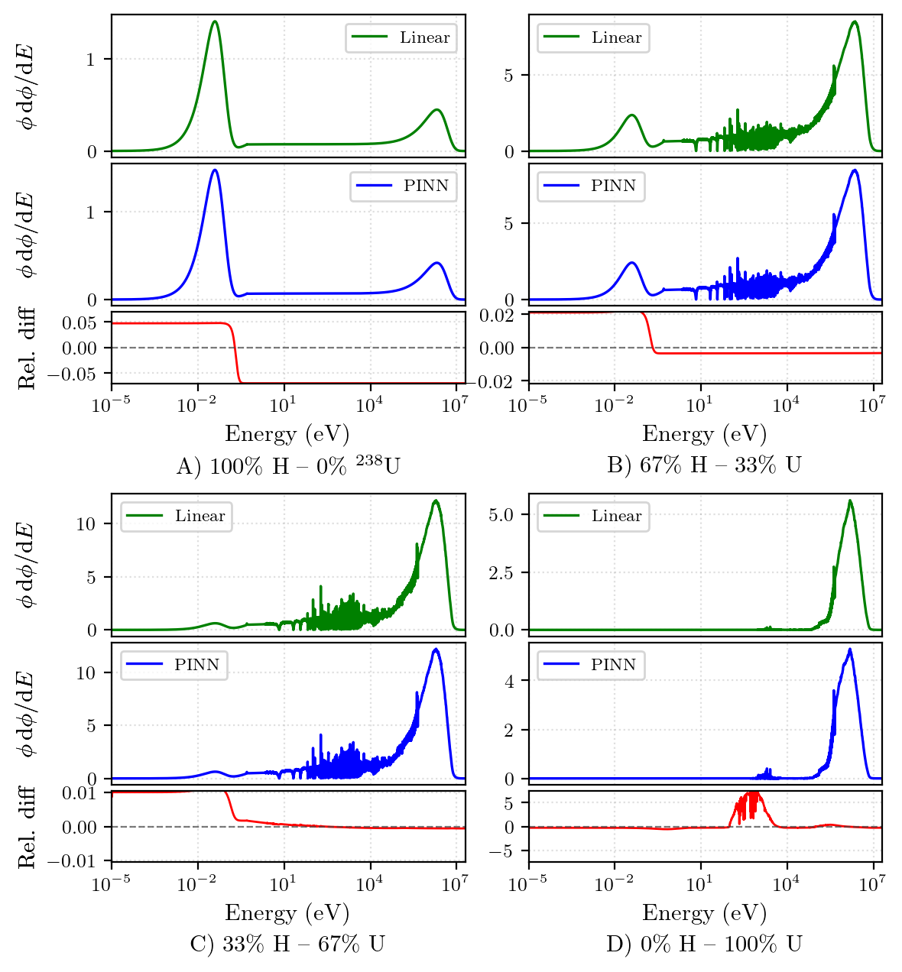
Figure 1 Comparisons of the pointwise fluxes per unit lethargy on the 18,800 group energy grid for four mixtures of hydrogen and uranium-238 as computed by the linear baseline solver and the PINN. The relative discrepancy between each is also shown.
Conceptually, the method proceeds as follows:

- Formulate the slowing-down problem (and any simplifying assumptions appropriate for a given stage) in a way that yields a residual equation suitable for PINN training.
- Train a model that predicts the flux spectrum $ϕ(E)$(and in heterogeneous cases $ϕ(E,r)$) conditioned on problem parameters (isotopic vector, temperature, region definitions, and simple geometric descriptors).
- Use the predicted flux to compute effective self-shielded MG cross sections and/or self-shielding factors.
- Depending on rigor needs, outputs will either drive downstream MG solves directly or warm-start conventional iterative self-shielding to cut runtime
Anticipated Benefits

If successful, this work will deliver:

- Fast-evaluation self-shielding solvers suitable as drop-in accelerators for cross-section processing workflows. Once trained, physics-informed models can evaluate slowing-down solutions rapidly compared to repeated deterministic or CE treatments, enabling high-throughput self-shielding in heterogeneous lattice problems.
- Reduced reliance on dense tabulations and heuristic interpolation (in stand-alone mode). When deployed as a replacement for conventional self-shielding procedures, the learned continuous mapping (or operator) across composition/temperature/region space can essentially remove the dependence on narrowly tuned background cross-section grids and probability tables, improving portability across reactor classes.
- Enablement of high-throughput analysis. Faster self-shielding evaluation supports uncertainty quantification, optimization, iterative design loops, and repeated lattice calculations—workflows increasingly important for advanced reactor development and operational digital twin contexts.

More broadly, the project positions physics-informed ML where it can have outsized leverage: improving the fidelity and efficiency of the multigroup cross sections on which deterministic diffusion and transport analyses depend. This directly strengthens the reliability of downstream deterministic simulation rather than attempting to compensate for cross-section limitations at later stages.

Work Plan

Task 1 — Benchmark Suite + Reference Baselines
Establish the canonical homogeneous and 1D heterogeneous self-shielding problem set, parameter ranges (composition/temperature/region geometry), and evaluation metrics (spectrum error, reaction-rate integrals, self-shielding factors, derived MG XS, runtime). Generate reference solutions using (i) CE-MC anchors for a curated subset and (ii) conventional BONAMI/CENTRM-type workflows for systematic comparisons.

Task 2 — Physics-Informed Model Formulation + Homogeneous Demonstration
Develop PINN/PINO formulations for the slowing-down/self-shielding residuals, including stable training strategies (energy/lethargy representations, adaptive sampling near resonances, loss balancing). Train models for homogeneous mixtures to predict the continuous/fine-energy flux $ϕ(E)$conditioned on isotopic vector and temperature, and derive effective self-shielded quantities.

Task 3 — Heterogeneous 1D Multi-Region Models + End-to-End XS Generation
Extend the approach to canonical 1D heterogeneous resonance problems with multiple regions (unique compositions/temperatures) and interface constraints, targeting prediction of $ϕ(E,r)$. Demonstrate generation of MG cross sections suitable for downstream lattice physics.
Task 4 — Workflow Use Modes, Integration Prototypes, and Transition Artifacts
Demonstrate two operational modes: (i) direct mode (model outputs used as the self-shielding solution feeding MG condensation/lattice steps) and (ii) assisted mode (model outputs warm-start conventional iterative schemes to reduce iterations/time-to-tolerance). Package reproducible artifacts (benchmarks, scripts, model cards, domain-of-validity guidance) and document insertion points for cross-section processing workflows.

Estimated Project Cost and Timeframe

The budget for this project will be $1M over 3 years. A preliminary timeframe to execute the tasks described above is shown as follows:

Task | Year 1 |  |  |  | Year 2 |  |  |  | Year 3
 | Q1 | Q2 | Q3 | Q4 | Q1 | Q2 | Q3 | Q4 | Q1 | Q2 | Q3 | Q4
1
2
3
4

References:
- W. A. Wieselquist, R. A. Lefebvre, and Eds. “SCALE 6.3.2 User Manual.” Technical Report ORNL/TM-2024/3386, Oak Ridge National Laboratory (2024).
- A. Graham, et al. “MPACT 4.4 Theory Manual.” Technical Report ORNL/SPR-2023/3090, Oak Ridge National Laboratory (2023)
- I. Bondarenko. Group Constants for Nuclear Reactor Calculations. Consultants Bureau (1964).
- R. J. J. Stammler and et al. “HELIOS Methods.” Technical report, Studsvik Scandpower (2003)
- F. Shriver, C. Gentry, and J. Watson. “Prediction of Neutronics Parameters Within a Two Dimensional Reflective PWR Assembly Using Deep Learning.” Nuclear Science and Engineering,
- M. Ravichandran, C. A. Gentry, and M. Bucci. “Investigation Into the Use of Machine Learning Assisted Prediction of Nodal Parameters for Reduced Order Neutronic Simulation Models.” In Mathematics Computation (MC) 2021, pp. 1013–1022.
- K. Kobayashi and S. B. Alam. “Deep neural operator-driven real-time inference to enable digital twin solutions for nuclear energy systems.” Scientific Reports, volume 14, p. 2101 (2024). URL https://doi.org/10.1038/s41598-024-51984-x. volume 195, pp. 626–647
- J. R. Ross, et al. “Initial Validation of the TRIGA Real-Time Digital Twin at the University of Texas at Austin.” In PHYSOR 2026. Torino, USA (2026).
- S. A. Faroughi, et al. “Physics-Guided, Physics-Informed, and Physics-Encoded Neural Networks and Operators in Scientific Computing: Fluid and Solid Mechanics.” Journal of Computing and Information Science in Engineering, volume 24, p. 040802 (2024). URL https://doi.org/10.1115/1.4064449.
ORNL Collaboration

ORNL brings unique and essential capabilities to this effort because of its deep, long-standing leadership in multi-group deterministic reactor analysis and cross-section processing, including development, maintenance, and community support for production tools and workflows such as SCALE and MPACT. This positions ORNL to provide high-value technical guidance on the specific problem we are targeting: self-shielding and slowing-down treatments that must ultimately produce cross sections suitable for downstream deterministic transport and lattice physics calculations.

ORNL’s primary contributions will be threefold:

- Technical Oversight and Domain Guidance. ORNL will provide independent review and guidance to ensure that the physics-informed formulations (PINNs/PINOs), canonical problem definitions, and evaluation metrics remain aligned with real production needs and known pitfalls in resonance treatment. ORNL experts will help shape validation expectations so that results are not only academically promising but credible to the deterministic methods community.

- Benchmarking and Evaluation Rigor. ORNL will advise on the selection and construction of representative benchmark cases and performance metrics that reflect how self-shielding is actually used in production workflows. This includes ensuring comparisons to established approaches (e.g., BONAMI/CENTRM-type sequences) are fair, meaningful, and framed in terms of the quantities that matter for downstream solvers (reaction-rate integrals, self-shielding factors, effective MG cross sections, runtime/robustness).

- Technology Transition Pathway into SCALE Workflows. A core benefit of ORNL collaboration is the presence of a realistic transition path beyond a one-off prototype. ORNL will help translate “lessons learned” into adoption-ready artifacts, such as recommended canonical benchmarks for regression testing, workflow integration concepts, and best-practices guidance, so that successful methods can be positioned for incorporation into established cross-section processing pipelines. Even if near-term integration is initially a “wrapper/accelerator” rather than a full replacement of existing methods, ORNL involvement ensures that the project produces outputs that are compatible with real user needs and software sustainment practices.

TBD:

University of Texas

UT Austin will lead the project’s technical execution, leveraging its strengths in computational neutronics, machine learning, and prior experience developing models and workflows relevant to nuclear digital-twin and surrogate modeling contexts. UT will be responsible for the “heavy lifting” required to develop, train, and validate the proposed PINN/PINO approaches for slowing-down/self-shielding.

UT Austin’s primary contributions include:

- Primary R&D and Model Development. UT will formulate the physics-informed learning approach for slowing-down and resonance self-shielding, implement PINN/PINO architectures, develop stable training strategies for resonance regions, and construct the full training and evaluation pipeline. UT will also lead the progressive scale-up from homogeneous mixtures to canonical 1D heterogeneous shielding problems, including handling multi-region constraints and the computation of derived quantities (self-shielded MG cross sections and group constants).

- Dataset Generation and Multi-Fidelity Benchmarking. UT will generate training and benchmarking datasets spanning isotopic vectors, temperatures, and heterogeneous configurations, and will execute systematic comparisons against CE-MC reference solutions and established self-shielding methods. This includes designing controlled generalization tests to evaluate whether the approach truly improves portability across spectral environments.

- High-Performance Computing for Training and Testing. UT will leverage the Texas Advanced Computing Center (TACC) to support the computational demands of dataset generation (including any high-fidelity reference cases), physics-informed training, and extensive hyperparameter/sensitivity studies. Access to TACC enables practical exploration of multiple model classes (PINNs and PINOs), stability strategies, and large-scale parameter sweeps needed to demonstrate robustness and reproducibility.

Cole Gentry:

Dr. Cole A. Gentry is Senior Engineering Scientist at the University of Texas at Austin, specializing in the study of Nuclear Reactor Digital Twins and Machine-Learning-based Reduced Order Modeling.
Prior to this position, Dr. Gentry worked as a contract Software Development Engineer for Zachry Nuclear's Numerical Advisory Solutions Group and as a Computational Nuclear Engineer both at BWX Technologies, Inc. and Oak Ridge National Laboratory. At BWXT, Dr. Gentry worked primarily on reactor analysis tools development and code qualification for the various BWXT HTGR designs. At Oak Ridge National Laboratory, Dr. Gentry focused primarily on the development and testing of Light Water Reactor (LWR) and advanced reactor simulation capabilities in both the CASL core simulator VERA and the SCALE lattice physics code POLARIS. Dr. Gentry also led a development effort in applying neural networks to reactor simulations.
Dr. Gentry graduated from the University of Tennessee with a B.S. in Nuclear Engineering and worked as a Reactor Engineer at the Sequoyah Nuclear Facility for two years before returning to the University of Tennessee to earn his M.S. and Ph.D. in Nuclear Engineering. His graduate work consisted of analysis of Fully Ceramic Micro-Encapsulated (FCM) Light Water Reactor (LWR) fuel for deep burnup applications, as well as adaptation of the traditional LWR Two-Step procedure to a plate fueled Advanced High Temperature Reactor (AHTR).

Nicholas Luciano:

Nick to add

