Table of Contents
ADR-002: Hyperledger Fabric for Multi-Facility Immutable Audit
Context
Decision
Alternatives Considered
Architecture
Multi-Facility Network (Target State)
Chaincode (Smart Contracts)
Consequences
Positive
Negative
Mitigations
Implementation Path
References

ADR-002: Hyperledger Fabric for Multi-Facility Immutable Audit
Status: Proposed Date: 2026-01-14 Decision Makers: Ben, Team

Context
Nuclear reactor operations require immutable, tamper-proof audit trails for:
- Regulatory compliance (NRC 10 CFR 50.9)
- Non-repudiation of operator logs (Reactor Ops Log)
- Chain of custody for evidence packages
- Multi-facility attestation (commercialization target)
We need a solution that:
- Provides cryptographic immutability
- Supports multi-organization consensus (future facilities)
- Uses permissioned access (not public blockchain)
- Aligns with Apache 2.0 licensing requirements

Decision
We will use Hyperledger Fabric as the blockchain infrastructure, designed for multi-facility from day 1 even if initially only one facility participates.
For single-facility development, we may use Immudb as a lightweight alternative that can later feed into Fabric.

Alternatives Considered
Option | Pros | Cons | Verdict
Hyperledger Fabric | Enterprise-grade, multi-org, smart contracts | Complex deployment | ✅ Selected
Immudb | Lightweight, fast, SQL-like | Single-org only, less "blockchain credibility" | ✅ Dev/staging
Amazon QLDB | Managed, simple | Proprietary, AWS lock-in | ❌
Ethereum L2 | Public verification | Overkill, gas costs, public exposure | ❌

Architecture

Multi-Facility Network (Target State)
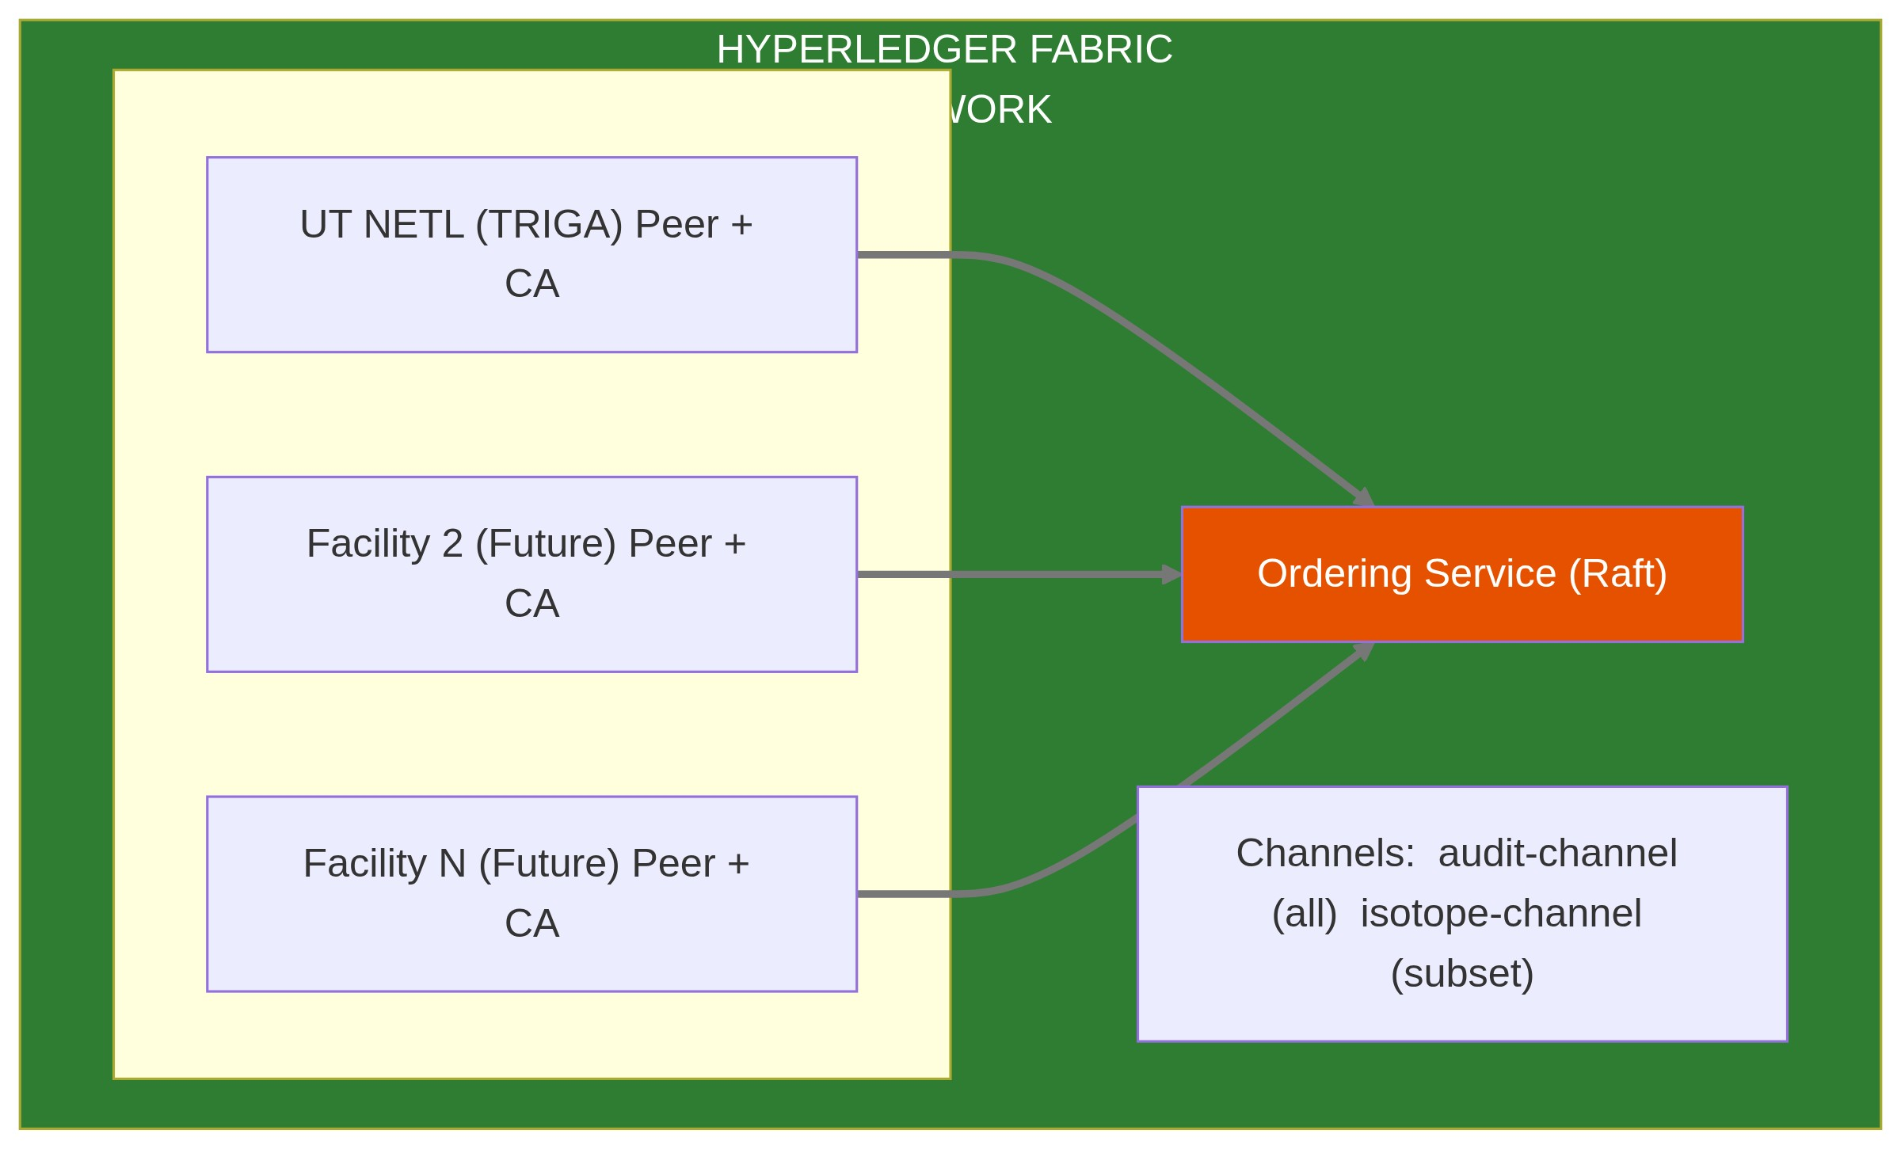

Chaincode (Smart Contracts)
- Audit Chaincode - Log all audit events, verify inclusion
- OpsLog Chaincode - Immutable operator log entries with signatures
- Evidence Chaincode - Hash manifests for audit packages

Consequences

Positive
- Cryptographic proof of audit trail integrity
- Multi-facility consensus without central authority
- Smart contracts encode audit rules
- NRC-defensible records ("blockchain-backed")
- Commercialization differentiator

Negative
- Complex infrastructure (peers, orderers, CAs)
- Requires Fabric expertise or learning curve
- Higher latency than simple database (consensus overhead)

Mitigations
- Use Immudb for development/single-facility MVP
- Fabric network deployed via Helm charts
- Start with single-org Fabric, add orgs incrementally
- Document Fabric operations runbooks

Implementation Path
- Phase 1: Immudb for local development and early MVP
- Phase 2: Single-org Fabric network (UT NETL only)
- Phase 3: Multi-org capability (when second facility onboards)
- Phase 4: Cross-facility channels (isotope tracking, etc.)

References
- Hyperledger Fabric Docs
- - K8s deploymentHyperledger Bevel
- - Lightweight immutable databaseImmudb

