Table of Contents
ADR-003: Data Lakehouse with Iceberg, DuckDB, and Superset
Context
Decision
Alternatives Considered
Architecture
Data Tiers
Consequences
Positive
Negative
Mitigations
Test-Driven Approach
Streaming-First Architecture
References

ADR-003: Data Lakehouse with Iceberg, DuckDB, and Superset
Status: Proposed Date: 2026-01-14 Decision Makers: Ben, Team

Context
The current data architecture across digital twin repositories is fragmented:
- CSV files in various directories
- JSON files for logs and metadata
- PostgreSQL/TimescaleDB for some time-series
- No unified query layer
- No data versioning or time-travel
We need a modern data platform that:
- Supports Bronze/Silver/Gold data tiers
- Provides ACID transactions and time-travel
- Enables self-service analytics
- Uses open formats (no vendor lock-in)
- Can scale from laptop to TACC cluster

Decision
We will implement a lakehouse architecture using:
- Apache Iceberg - Open table format with ACID, time-travel, schema evolution
- DuckDB - Embedded analytics engine (local/single-node)
- Trino - Distributed query engine (when scale requires)
- Apache Superset - Self-service BI and dashboards
- dbt-core - SQL transformations (Bronze → Silver → Gold)
- Dagster - Pipeline orchestration

Alternatives Considered
Component | Selected | Alternative | Reason
Table format | Iceberg | Delta Lake | Iceberg more vendor-neutral, better catalog support
Embedded query | DuckDB | SQLite | DuckDB has columnar storage, better analytics
Distributed query | Trino | Spark SQL | Trino lighter weight, better for interactive
BI tool | Superset | Metabase | Superset Apache 2.0, more customizable
Orchestration | Dagster | Airflow | Dagster software-defined assets, better UX

Architecture
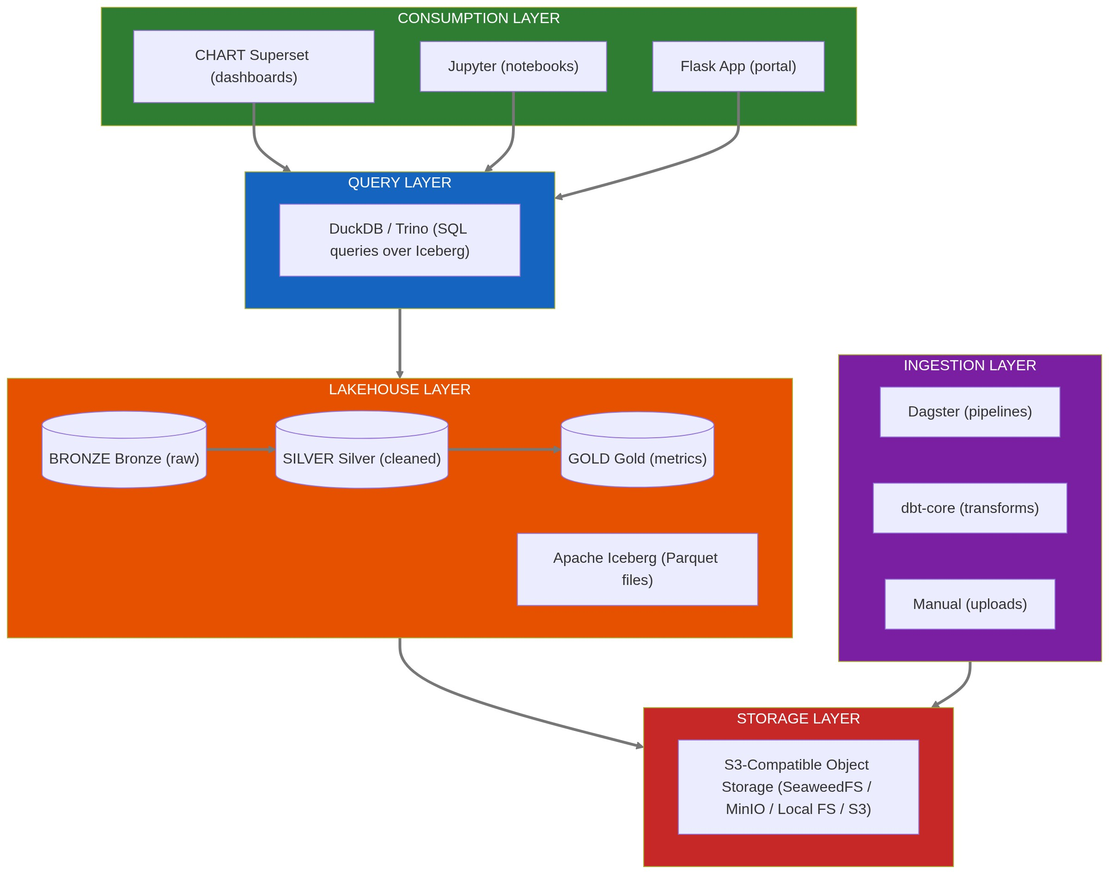

Data Tiers
Tier | Purpose | Retention | Example
Bronze | Raw data exactly as received | 7+ years | serial_data_raw
Silver | Cleaned, validated, typed | 7+ years | reactor_timeseries_clean
Gold | Aggregated, analytics-ready | 7+ years | reactor_hourly_metrics

Consequences

Positive
- Open formats prevent vendor lock-in
- Time-travel enables regulatory lookback queries
- DuckDB runs on laptop for development
- Superset enables stakeholder self-service
- dbt provides testable transformations

Negative
- More components to operate than simple Postgres
- Iceberg catalog adds complexity
- Team needs to learn dbt, Dagster patterns

Mitigations
- Start with DuckDB + local files, add Trino when needed
- Use managed Iceberg catalog (REST catalog)
- Provide dbt model templates and examples

Test-Driven Approach
Superset dashboard scenarios drive data model design:
- Define dashboard requirements
- Derive Gold table schemas
- Write dbt tests that must pass
- Implement Bronze → Silver → Gold pipeline
- Validate with working dashboard

Streaming-First Architecture
This lakehouse architecture is designed for streaming-first operation. See for the full approach:ADR 007: Streaming-First Architecture
- Primary path: Event streaming (Kafka/Redpanda) → Real-time subscribers → WebSocket push
- Secondary path: Events → Iceberg Bronze → dbt aggregations (batch fallback)
The event-sourcing pattern in the lakehouse (all changes captured as events) enables:
- Real-time UI updates as the default
- Batch processing for historical aggregations and disaster recovery
- Graceful degradation when streaming is unavailable
See Tech Spec §4.8 for implementation details.

References
- Apache Iceberg
- DuckDB
- Apache Superset
- dbt-core
- Dagster
- Tech Spec §4.8: Event-Driven Architecture

