Table of Contents
ADR-004: Infrastructure as Code with Terraform, Kubernetes, and Helm
Context
Decision
Infrastructure Standards
Alternatives Considered
Architecture
Directory Structure
Consequences
Positive
Negative
Mitigations
Exception: Hyperledger Fabric
References

ADR-004: Infrastructure as Code with Terraform, Kubernetes, and Helm
Status: Proposed Date: 2026-01-14 Decision Makers: Ben, Team

Context
Neutron OS needs to run on multiple environments:
- Local development (individual laptops)
- TACC HPC (Frontera, Lonestar6 Kubernetes)
- Cloud providers (AWS, GCP, Azure) for commercialization
We need infrastructure that:
- Is reproducible and version-controlled
- Runs identically across environments
- Avoids vendor lock-in
- Supports GitOps workflows

Decision
We will standardize on:
- Terraform - Infrastructure provisioning
- Kubernetes - Container orchestration (all environments)
- Helm - Kubernetes package management
- K3D - Local Kubernetes clusters (lightweight K3s in Docker)
We will NOT use Docker-Compose for any environment.

Infrastructure Standards
✅ Use | ❌ Avoid
Terraform | CloudFormation, ARM templates, Pulumi
Kubernetes | Docker Swarm, Nomad
Helm | Kustomize-only, raw manifests
K3D (local) | Docker-Compose, Minikube
S3-compatible storage | Provider-specific storage APIs

Alternatives Considered
Area | Selected | Alternative | Reason
IaC | Terraform | Pulumi | Terraform more mature, larger community
Local K8s | K3D | Minikube, Kind | K3D faster, lighter, K3s compatible
Packaging | Helm | Kustomize | Helm better for templating, dependencies
Compose | None | Docker-Compose | Not K8s-native, different semantics

Architecture
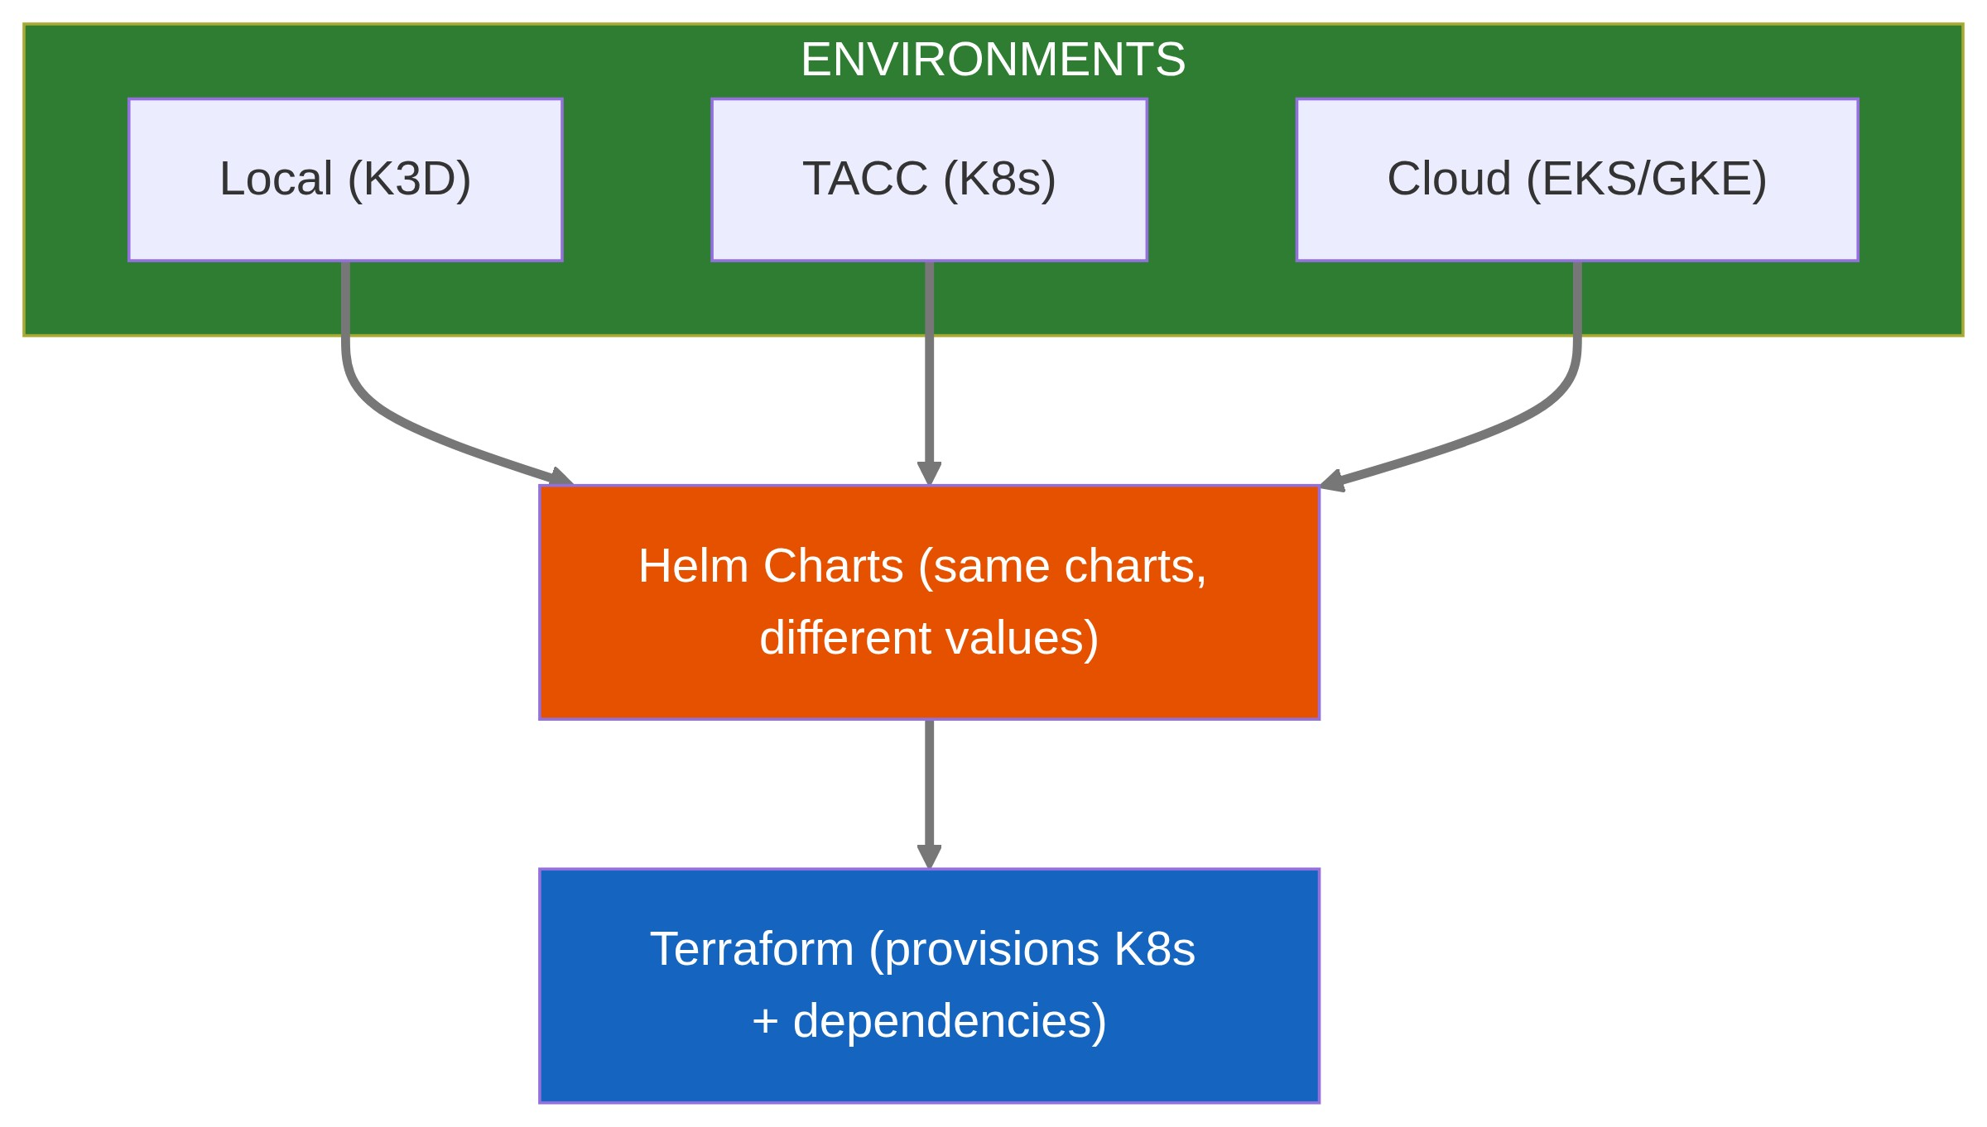

Directory Structure
infra/
├── terraform/
│ ├── modules/
│ │ ├── k8s-cluster/ # Cloud-agnostic cluster
│ │ ├── storage/ # S3-compatible storage
│ │ └── networking/ # VPC, DNS, etc.
│ └── environments/
│ ├── local/ # K3D (no-op Terraform)
│ ├── tacc/ # TACC-specific
│ └── cloud/ # AWS/GCP/Azure
│
├── helm/
│ ├── charts/
│ │ ├── neutron-lakehouse/
│ │ ├── neutron-fabric/
│ │ └── neutron-keycloak/
│ └── values/
│ ├── local.yaml
│ ├── tacc.yaml
│ └── prod.yaml
│
└── k3d/
├── cluster-config.yaml
└── registries.yaml

Consequences

Positive
- Same deployment manifests work everywhere
- GitOps-ready (Argo CD, Flux compatible)
- Team learns one set of tools
- Easy to replicate environments

Negative
- K3D requires Docker (but not Docker-Compose)
- Terraform state management complexity
- Helm chart maintenance overhead

Mitigations
- Use Terraform Cloud or S3 backend for state
- Helm chart versioning with semantic versioning
- Document local setup in docs/development/

Exception: Hyperledger Fabric
Hyperledger Fabric's official development tooling uses Docker containers directly. We accept this exception for chaincode development only. Production Fabric deployment will use Kubernetes via .Hyperledger Bevel

References
- Terraform
- Kubernetes
- Helm
- K3D
- K3s

