Table of Contents
ADR-006: MCP Server for Agentic Data Access
Context
Decision
Tool Categories
Architecture
Implementation
Alternatives Considered
Comparison with DeepLynx MCP
Consequences
Positive
Negative
Mitigations
Implementation Plan
Relationship to Search/AI Module
References

ADR-006: MCP Server for Agentic Data Access
Status: Proposed Date: 2026-01-15 Decision Makers: Ben, Team Inspired By: INL DeepLynx Nexus deeplynx.mcp/ implementation

Context
AI agents and LLM-powered applications need programmatic access to Neutron OS data. Currently, data access requires:
- Direct SQL queries (requires schema knowledge)
- Custom API endpoints (requires development effort per use case)
- Manual data export (not suitable for automation)
INL's DeepLynx Nexus has implemented an early MCP (Model Context Protocol) server that exposes tools for AI agents to query projects and records. This pattern is worth adopting.
The Model Context Protocol (MCP) is Anthropic's open standard for connecting AI assistants to external data sources and tools. It provides a standardized way for LLMs to:
- Discover available tools
- Execute queries with proper parameters
- Receive structured responses

Decision
We will implement a Python MCP server exposing Neutron OS data and operations as tools for AI agents.

Tool Categories
Category | Tools | Purpose
Query | query_reactor_timeseries, query_simulation_outputs, search_elog_entries | Read data from lakehouse
Semantic | semantic_search_meetings, find_similar_scenarios | Vector search via pgvector
Metadata | list_projects, get_schema, list_tables | Discovery and schema info
Predict | get_dt_prediction, compare_prediction_actual | Digital twin outputs
Write | create_elog_entry, log_meeting_action_item | Controlled data creation

Architecture
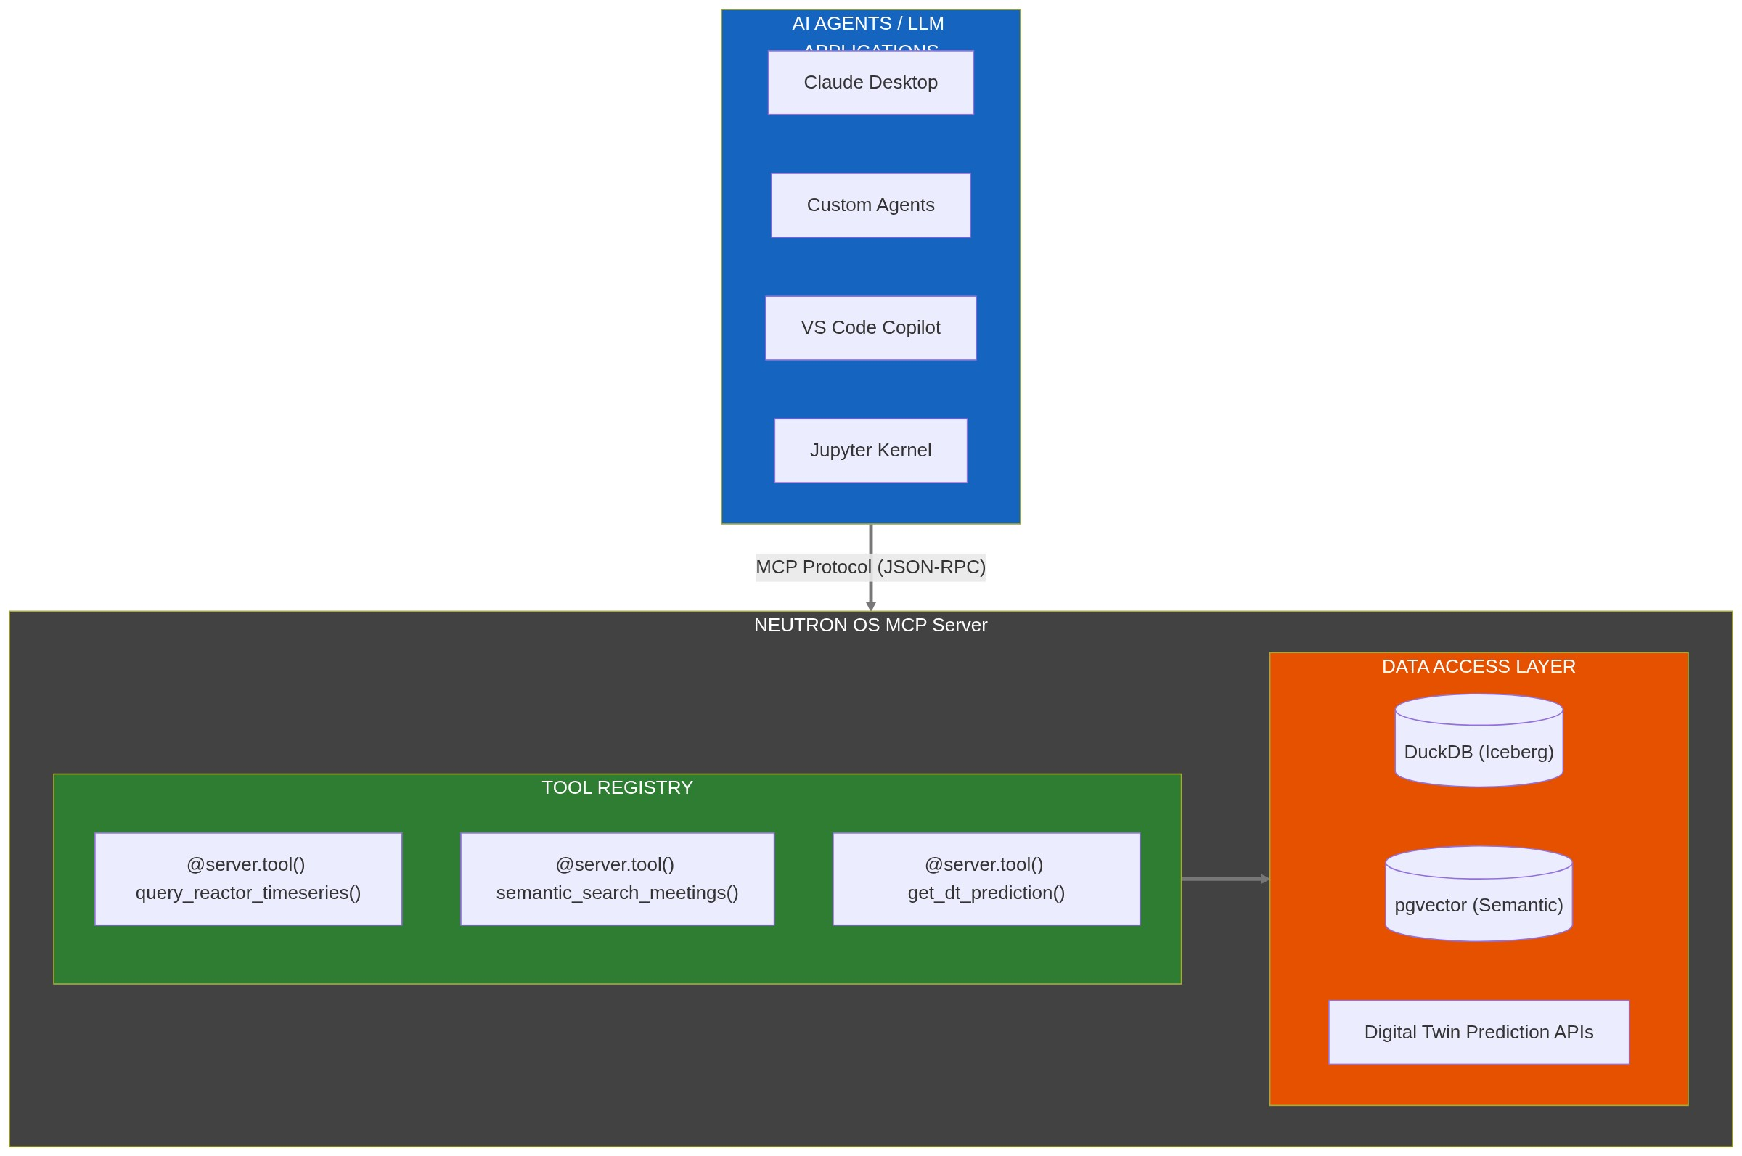

Implementation
# services/mcp-server/neutron_os_mcp/server.py
from mcp.server import Server
from mcp.types import Tool, TextContent
import duckdb
server = Server("neutron-os")
async def query_reactor_timeseries(
reactor_id: str,
metric: str,
start_time: str,
end_time: str,
limit: int = 1000
) -> list[TextContent]:
"""
Query reactor time-series data from the lakehouse.
Args:
reactor_id: Reactor identifier (e.g., 'TRIGA-001')
metric: Metric to query (e.g., 'power_kw', 'temp_fuel_c')
start_time: ISO timestamp start
end_time: ISO timestamp end
limit: Max rows to return
Returns:
Markdown table of results
"""
sql = f"""
SELECT timestamp, {metric}
FROM gold.reactor_metrics
WHERE reactor_id = ?
AND timestamp BETWEEN ? AND ?
ORDER BY timestamp
LIMIT ?
"""
conn = duckdb.connect('/path/to/lakehouse')
result = conn.execute(sql, [reactor_id, start_time, end_time, limit]).fetchdf()
return [TextContent(type="text", text=result.to_markdown())]
async def search_elog_entries(
query: str,
facility: str | None = None,
limit: int = 10
) -> list[TextContent]:
"""
Semantic search over elog entries using pgvector embeddings.
Args:
query: Natural language search query
facility: Optional facility filter
limit: Max results
Returns:
Relevant elog entries with similarity scores
"""
# Implementation uses pgvector for semantic search
...
async def get_dt_prediction(
digital_twin: str,
prediction_type: str,
horizon_seconds: int = 60
) -> list[TextContent]:
"""
Get current digital twin prediction for reactor state.
Args:
digital_twin: Which DT to query ('triga', 'msr', 'mit_loop', 'offgas')
prediction_type: What to predict ('power', 'temperature', 'xe_concentration')
horizon_seconds: How far ahead to predict
Returns:
Prediction with uncertainty bounds
"""
...

Alternatives Considered
Alternative | Reason Not Selected
GraphQL API | LLMs generate SQL better than GraphQL; adds complexity
REST endpoints only | No standardized tool discovery; harder for agents
Direct database access | Security risk; no rate limiting; no audit
DeepLynx adoption | Different data model; C# stack doesn't fit our team

Comparison with DeepLynx MCP
Aspect | DeepLynx MCP | Neutron OS MCP
Language | C# | Python
Data Model | Graph (records/edges) | SQL (Iceberg tables)
Tools | ProjectTools, RecordTools | Query, Semantic, Predict tools
Auth | Inherited from DeepLynx | API keys + RLS

Consequences

Positive
- AI agents can query data without schema knowledge
- Standardized interface for all LLM applications
- Audit trail of agent queries
- Rate limiting and access control at tool level

Negative
- New service to maintain
- Must keep tools in sync with schema changes
- Potential for expensive queries if not bounded

Mitigations
- Auto-generate tool docs from schema
- Enforce query limits in tool implementations
- Log all tool invocations for audit

Implementation Plan
Phase | Deliverable | Timeline
1 | Query tools (read-only) | Week 1-2
2 | Semantic search tools | Week 3
3 | Digital twin prediction tools | Week 4
4 | Write tools (with approval flow) | Week 5-6

Relationship to Search/AI Module
The MCP Server is the technical foundation for the planned Search/AI module (see ). The module will provide:Executive PRD
Capability | MCP Foundation | User-Facing Feature
RAG | semantic_search_* tools | Natural language queries over facility docs
Workflow Agents | Write tools + approval flow | AI-assisted data entry, meeting summarization
Tuned LLMs | Domain context via tools | Nuclear-specific terminology understanding

The Search/AI module is configured off by default but builds on MCP infrastructure that exists for all facilities.

References
- Model Context Protocol Specification
- DeepLynx MCP Implementation
- mcp Python SDK
- Tech Spec §1.5: Application Modules

