Table of Contents
ADR 007: Streaming-First Architecture with Batch Fallbacks
Context
Why Streaming-First Matters for Commercial Scale
Constraints Reconsidered
Technology Evaluation
Real-Time Transport Protocol Selection
Event Streaming Infrastructure Selection
Decision
Consequences
Positive
Negative
Trade-offs Accepted
Technical Implementation
Event-Driven Core
UI Pattern: "Live" as Default
Latency Targets
Batch Fallback Strategy
Module-Specific Streaming Implementation
API Design Patterns
WebSocket-First (Primary)
REST for Initial Load & Fallback
Server-Sent Events for Simple Displays
Infrastructure
Managed Services (Recommended)
Self-Hosted Alternative (Air-Gapped / Cost-Sensitive)
Migration Path
Affected Components
References

ADR 007: Streaming-First Architecture with Batch Fallbacks
Date: 2026-01-21 Status: Proposed Deciders: Ben Booth, UT Computational NE Team

Context
Neutron OS needs to handle data from multiple sources with varying latency requirements:
- Reactor telemetry: Safety-critical, benefits significantly from real-time updates
- Operations logs: Concurrent console editing, shift handoffs, compliance tracking
- Experiment status: Real-time position availability, instant approval notifications
- Production orders: Customer-facing status updates, delivery tracking
The question: Should we build for batch and retrofit streaming later, or build streaming-first?

Why Streaming-First Matters for Commercial Scale
Today's research reactors generate megabytes of data per day. Tomorrow's commercial fleet will generate petabytes. A single operator may manage dozens of units across multiple sites, each streaming thousands of sensor channels. The architecture decisions we make now determine whether we can scale to that reality.
Streaming-first enables capabilities that batch architectures cannot retrofit:
Capability | Why Streaming Is Required
Fleet-wide anomaly correlation | Detect patterns across 50 units in real-time; batch delays miss transients
Instant safety limit propagation | Updated operating envelope flows to all systems in <1 second
Coordinated load-following | Grid demand response requires sub-second coordination across units
Predictive maintenance at scale | ML models need live sensor feeds to detect degradation before failure
Regulatory real-time audit | NRC moving toward continuous monitoring; batch reports won't satisfy

Streaming-first means:
- Real-time is the default, not a future enhancement
- Every data change propagates immediately to all subscribers
- Batch processing exists as a fallback for cost optimization and historical analysis
- The UI assumes live data; staleness is the exception, not the norm
This architecture handles one research reactor today and fifty commercial units tomorrow—without rewrites.

Constraints Reconsidered
- Nick's feedback: "We'd ideally get live streaming, but currently we just upload the data after-hours due to cost."
○ Reframe: Nick wants streaming; cost was the blocker with existing tools. We can solve this.
- Budget reality: Real-time infrastructure (Kafka, streaming compute) adds complexity
○ Reframe: Managed services eliminate ops burden. Cost is ~$200-400/month for our scale.
- UX requirement: Users must understand data freshness to make safe decisions
○ Reframe: With streaming-first, "Live" is the default indicator. Staleness warnings only appear when something is wrong.

Technology Evaluation

Real-Time Transport Protocol Selection
Why WebSockets? We evaluated all major options:
Protocol | Latency | Browser Support | Bidirectional | Verdict
WebSocket | ~10ms | ✅ Universal | ✅ Yes | Selected for interactive UIs
Server-Sent Events (SSE) | ~50ms | ✅ Universal | ❌ One-way | Selected for displays
WebTransport | ~5ms | ⚠️ Chrome/Edge only | ✅ Yes | Future option (2027+)
gRPC-Web | ~15ms | ⚠️ Requires proxy | ✅ Yes | Overkill for UI; good for services
HTTP/2 Push | ~20ms | ❌ Deprecated | ❌ One-way | Not viable
QUIC | ~3ms | ⚠️ Low-level | ✅ Yes | Underlying transport, not API

Decision: WebSocket for bidirectional (console sync, collaborative editing), SSE for unidirectional (entrance displays, status boards). Monitor WebTransport adoption for future migration.
Why not gRPC streaming? Excellent for service-to-service, but adds proxy complexity for browser clients. Our primary consumers are web UIs, not backend services.

Event Streaming Infrastructure Selection
Provider | Kafka Compatible | Latency | Ops Burden | Cost (our scale) | Lock-in | Verdict
Redpanda Cloud | ✅ 100% | <10ms p99 | Zero (managed) | ~$150-300/mo | Low | Primary choice
Confluent Cloud | ✅ 100% | <10ms p99 | Zero (managed) | ~$200-400/mo | Medium | Alternative
AWS MSK Serverless | ✅ 100% | ~20ms p99 | Low | ~$200-350/mo | High (AWS) | AWS-committed only
GCP Pub/Sub | ❌ No | ~30ms p99 | Zero | ~$100-200/mo | High (GCP) | Not Kafka; different API
Azure Event Hubs | ⚠️ Partial | ~25ms p99 | Low | ~$180-300/mo | High (Azure) | Kafka API subset only
Self-hosted Redpanda | ✅ 100% | <5ms p99 | High | ~$50/mo (compute) | None | Air-gapped deployments
Self-hosted Kafka | ✅ 100% | <5ms p99 | Very High | ~$80/mo (compute) | None | Not recommended

Decision: Redpanda Cloud as primary, with Confluent Cloud as fallback.
Rationale:
- Why Redpanda over Confluent? Similar capabilities, but Redpanda has simpler architecture (no ZooKeeper), lower latency, and 25% lower cost at our scale. Both provide 100% Kafka API compatibility.
- Why not AWS MSK? If we're committed to AWS, MSK Serverless is viable. But we want cloud-agnostic deployment (TACC, AWS, GCP, on-prem). Redpanda runs anywhere.
- Why not GCP Pub/Sub? Not Kafka-compatible. Would require maintaining two different streaming APIs (Kafka for some deployments, Pub/Sub for GCP). Standardizing on Kafka API simplifies development.
- When to self-host? Air-gapped deployments (e.g., some DOE facilities) or if monthly costs exceed ~$1,000/mo. Redpanda single-node is production-ready.
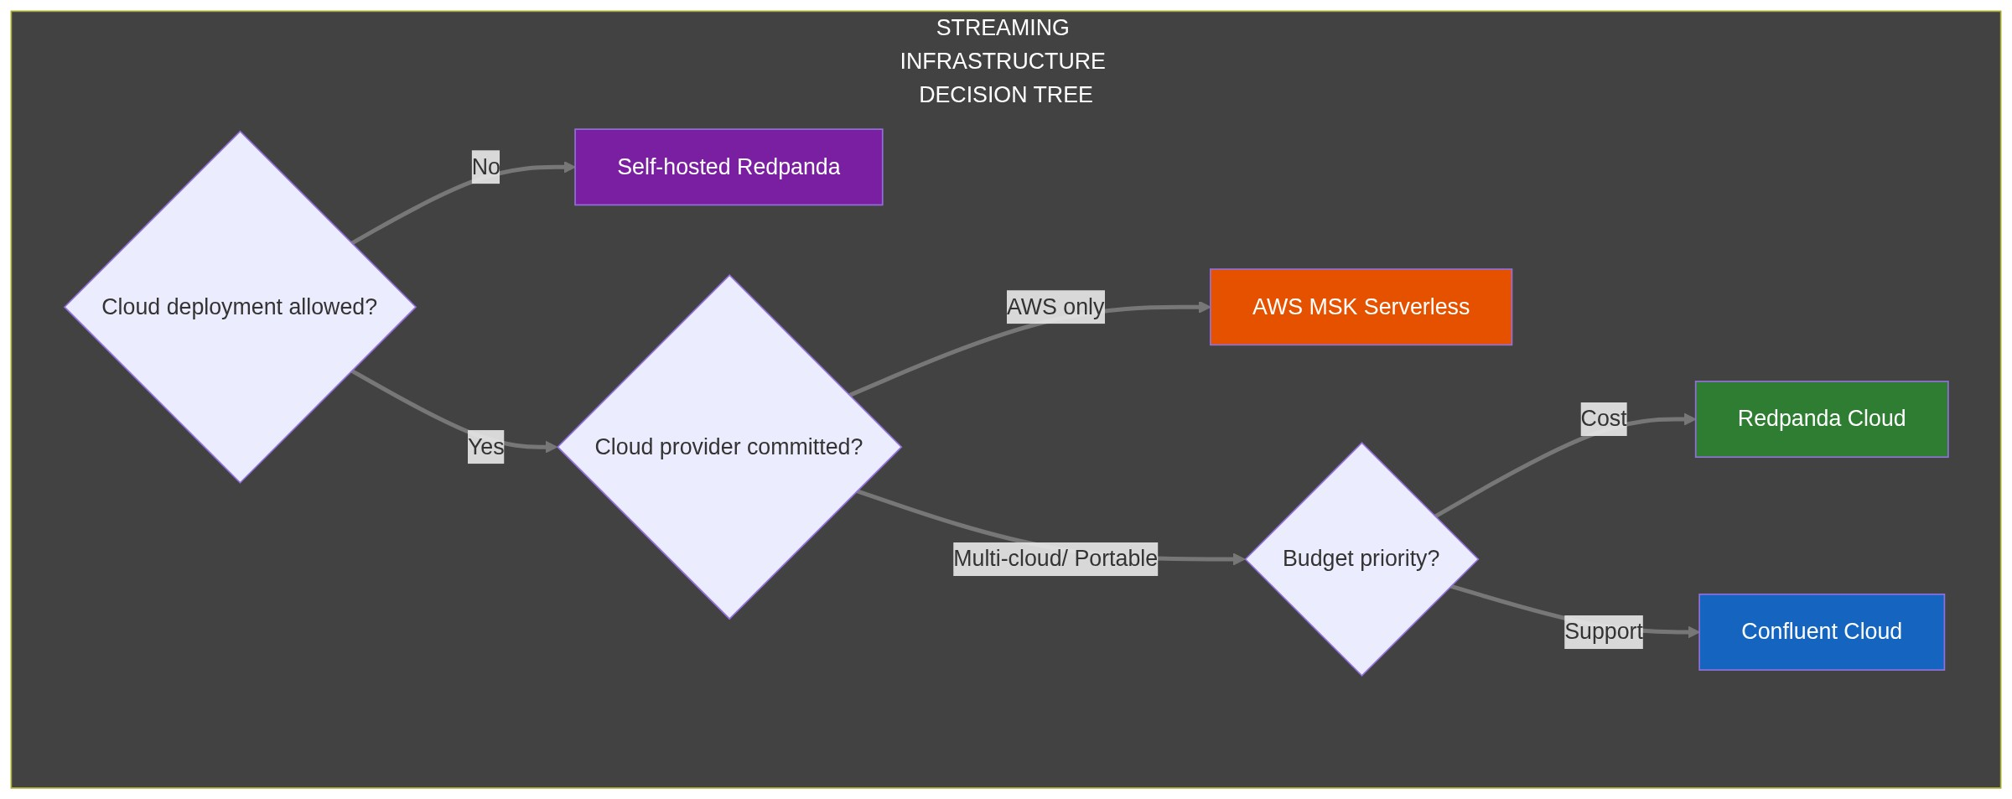

Decision
Build for streaming; use batch as fallback.
Specifically:
- Day 1 implementation uses event streaming (Kafka/Redpanda) as the primary data flow
- All state changes publish to event streams before writing to the lakehouse
- UI components assume live data; show "⚠️ Stale" only when streaming is degraded
- Batch processing handles historical aggregations, reports, and fallback during outages
- APIs are WebSocket/SSE-first; REST endpoints for compatibility and initial data load

Consequences

Positive
Benefit | Description
Commercial-scale ready | Same architecture handles research reactor or 50-unit fleet
Better UX | Users see changes instantly; no refresh buttons, no wondering if data is current
Safety-critical readiness | Console sync, 30-min timers, concurrent editing work natively
Simpler mental model | "Data is live" is easier than "data might be 5 minutes old"
Fleet operations | Correlate anomalies, propagate limits, coordinate load-following across units

Negative
Risk | Mitigation
Higher initial infrastructure cost | Use managed streaming (see Technology Evaluation); ~$200-400/mo at our scale
Streaming complexity | Abstract behind event SDK; developers don't touch Kafka directly
Network dependency | Batch fallback automatically kicks in; local caching for offline resilience
Debugging distributed systems | Comprehensive event tracing; dead letter queues; replay capability

Trade-offs Accepted
- Higher monthly infrastructure cost (~$200-500/mo vs. ~$50/mo for batch-only)
- Team needs to learn event-driven patterns (investment in skills)
- More moving parts in production (mitigated by managed services)

Technical Implementation

Event-Driven Core
All state changes flow through the event bus:
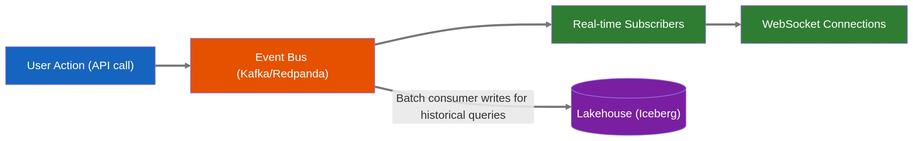

UI Pattern: "Live" as Default
Every data display assumes live data:
┌─────────────────────────────────────────────────┐
│ Reactor Power: 950 kW │
│ ───────────────────────────────────────────── │
│ 🟢 Live │
└─────────────────────────────────────────────────┘
When streaming is degraded:
┌─────────────────────────────────────────────────┐
│ Reactor Power: 950 kW │
│ ───────────────────────────────────────────── │
│ ⚠️ Data may be stale (last update: 5 min ago) │
│ [Retry Connection] │
└─────────────────────────────────────────────────┘

Latency Targets
Feature | Target Latency | Implementation
Ops Log console sync | < 500ms | WebSocket + Kafka
30-minute check timer | < 100ms | Shared state via WebSocket
Facility entrance display | < 2s | Server-Sent Events
Sample status updates | < 1s | WebSocket subscription
Dashboard refresh | < 5s | Streaming aggregations
Historical queries | < 3s | Batch-processed Gold tables

Batch Fallback Strategy
Batch processing serves three purposes:
- Historical aggregations: Hourly/daily/monthly rollups for dashboards
- Disaster recovery: If streaming fails, batch catches up from event log
- Cost optimization: Some analytics (burnup calculations) don't need real-time
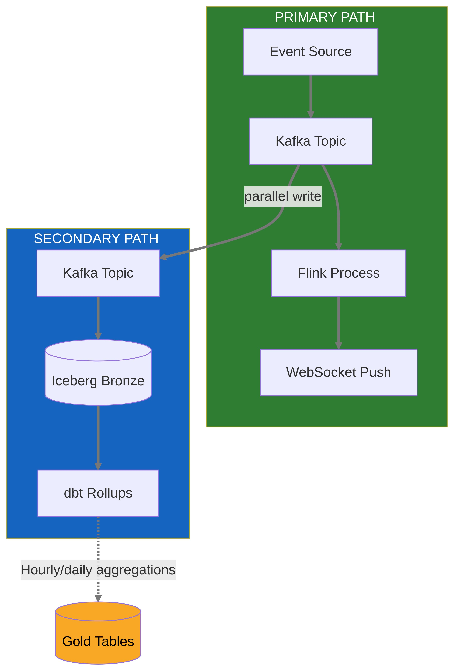

Module-Specific Streaming Implementation
Module | Streaming Approach | Batch Fallback
Ops Log Console Sync | WebSocket pub/sub, CRDT for conflicts | 30s polling if WS fails
30-Minute Check Timer | Shared countdown via WebSocket | Local timer + sync on reconnect
Facility Entrance Display | Server-Sent Events | 60s polling fallback
Sample Status | WebSocket subscription per sample | REST polling on demand
Production Orders | WebSocket for status, SSE for tracking | Email notifications as backup
Burnup Dashboard | Batch (no streaming needed) | N/A - batch is primary
Historical Analytics | Batch (by definition) | N/A - batch is primary

API Design Patterns

WebSocket-First (Primary)
// Client connects and subscribes
const ws = new NeutronOSClient('wss://api.neutron-os.io/v1/stream');
// Subscribe to reactor status
ws.subscribe('reactor.status', { facility: 'netl-triga' }, (event) => {
updateDisplay(event.data);
});
// Subscribe to ops log entries
ws.subscribe('opslog.entries', { facility: 'netl-triga' }, (event) => {
appendEntry(event.data);
});

REST for Initial Load & Fallback
GET /api/v1/reactor/status?facility=netl-triga
Response:
{
"power_kw": 950,
"status": "critical",
"timestamp": "2026-01-21T14:32:00.123Z",
"streaming_available": true,
"ws_endpoint": "wss://api.neutron-os.io/v1/stream"
}

Server-Sent Events for Simple Displays
// For entrance displays that just need one-way updates
const events = new EventSource('/api/v1/facility/netl-triga/display');
events.onmessage = (e) => updateEntranceDisplay(JSON.parse(e.data));

Infrastructure

Managed Services (Recommended)
Component | Primary Choice | Alternative | Monthly Cost (Est.)
Event streaming | Redpanda Cloud | Confluent Cloud, AWS MSK | $150-300
Stream processing | Redpanda Transforms (in-broker) | Apache Flink, Kafka Streams | $0-200
WebSocket gateway | Fastify + uWebSockets.js | AWS API Gateway WebSocket | $50-100
Total streaming infra |  |  | ~$200-600/mo

Self-Hosted Alternative (Air-Gapped / Cost-Sensitive)
For deployments where cloud services aren't permitted or cost exceeds ~$800/mo:
Component | Recommendation | Notes
Event streaming | Redpanda (single-node) | No ZooKeeper; runs on 4GB RAM
Stream processing | Embedded (in Redpanda) | Or Flink if complex CEP needed
WebSocket gateway | FastAPI + Redis pub/sub | Or Socket.io for simpler setup
Deployment | Helm chart on K3s | Same chart as cloud; different values

Migration Path
For facilities starting with limited infrastructure:
Phase | Capability | Infrastructure
Phase 0 | REST + polling (5 min) | Existing setup
Phase 1 | WebSocket for critical features | Add WS gateway
Phase 2 | Full streaming | Add Kafka/Redpanda
Phase 3 | Edge streaming | Add local event bus

Facilities can enter at any phase based on their needs and budget.

Affected Components
- All UI components: Assume live data; implement connection status indicator
- API layer: WebSocket/SSE primary; REST for compatibility
- Data pipelines: Event-first; Dagster for batch aggregations only
- Database schema: Include event_id, event_timestamp, version for event sourcing

References
- Martin Fowler: Event Sourcing
- Redpanda: Real-time streaming for modern applications
- Confluent: Event-Driven Architecture
- Tech Spec §4.8: Event-Driven Architecture

