Mermaid Diagram Styling Guidelines

CRITICAL REQUIREMENTS
All mermaid diagrams MUST have:
- Node text that contrasts with node background color
- Arrow colors that contrast with the diagram's background
- NO ASCII art boxes - use proper mermaid diagrams instead

Node Text Color (CRITICAL)
Every styled node MUST specify both fill and color:
style NodeName fill:#e3f2fd,color:#000000 ← Light background + dark text
style NodeName fill:#1565c0,color:#ffffff ← Dark background + white text
Never rely on default text colors. Always be explicit.

Arrow Color Contrast
STANDARD: Use neutral grey arrows that work on both light and dark backgrounds.
linkStyle default stroke:#777777,stroke-width:3px
This grey color (#777777) is visible on:
- Light backgrounds (white diagram background)
- Dark backgrounds (dark editor backgrounds in VS Code)
- Nested diagrams with mixed colors
DO NOT use color-specific arrows (like #ffffff on dark or #333333 on light) - they cause visibility problems when the diagram is used in different contexts.

For Mixed/Complex Diagrams (if needed)
Only use separate linkStyle when diagram has both very light AND very dark backgrounds:
linkStyle 0,2,4 stroke:#777777,stroke-width:3px ← Light sections
linkStyle 1,3,5 stroke:#777777,stroke-width:3px ← Dark sections
(Both use the same neutral grey for consistency)

Complete Diagram Template
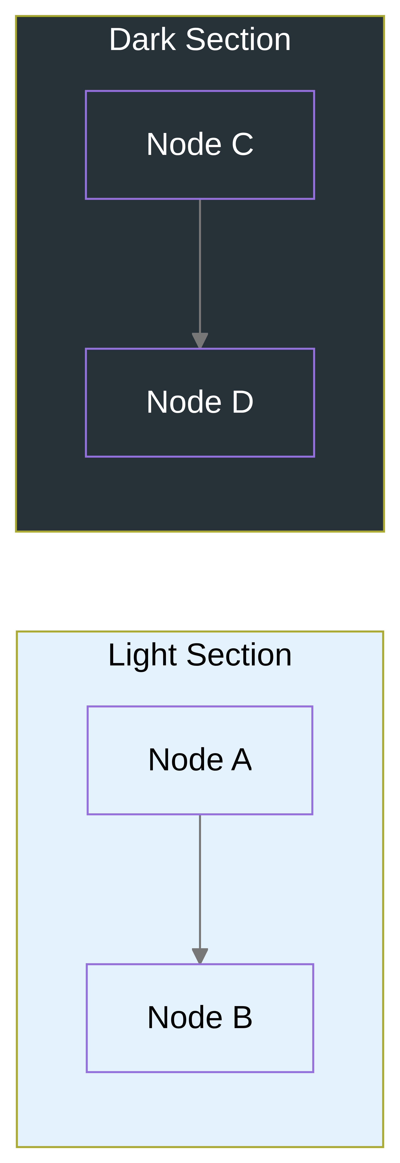

Subgraph Titles (Container Labels)
CRITICAL: Keep subgraph titles SHORT to avoid text wrapping that gets obscured by nested content.
Problem: Long titles wrap to multiple lines, and bottom lines get hidden under child boxes.
❌ WRONG:
subgraph Storage["Lakehouse (Iceberg + DuckDB)"] ← Title wraps, text obscured
bronze["Bronze (Raw)"] ← Child box hides title text
end
Solution: Use shorter, single-line titles. Move detail to separate nodes or descriptions.
✓ RIGHT:
subgraph Storage["Lakehouse Layer"] ← Single line, always visible
bronze["Bronze (Raw)"]
silver["Silver (Cleaned)"]
gold["Gold (Analytics)"]
end
Guidelines:
- Max 30-35 characters per subgraph title
- Remove parenthetical details from titles
- If you need to explain what's in the subgraph, add a comment node instead
- Never use <br/> in subgraph titles (mermaid will ignore it, causing misalignment)

ASCII Art Removal
Do NOT use ASCII art boxes like:
┌─────────────────────┐
│ ASCII ART BOX │
└─────────────────────┘
Instead:
- Create proper mermaid diagrams
- Use code blocks with syntax highlighting
- Use markdown tables if showing structured data

Testing Checklist
- [ ] All nodes have explicit color property when filled
- [ ] All diagrams have linkStyle default stroke: statement
- [ ] Arrow color matches background (dark arrows on light, white on dark)
- [ ] Subgraph titles are short (< 35 chars) and single-line
- [ ] No <br/> tags in subgraph labels
- [ ] Preview in VS Code and verify readability
- [ ] Check in both light and dark VS Code themes
- [ ] No ASCII art boxes in diagram sections

