Table of Contents
Product Requirements Document: Analytics Dashboards
Executive Summary
User Journey Map
Dashboard User Journeys by Role
Data Flow to Dashboards
Dashboard Hierarchy
Stakeholder Insights
Key Feedback from Nick Luciano
Key Feedback from Jim (TJ)
Dashboard Inventory
Priority 1: Operations Dashboards
Priority 2: Analysis Dashboards
Priority 3: Experiment Dashboards
Priority 4: Digital Twin Dashboards
Dashboard Specifications
1. Reactor Operations Overview
2. Operations Log Compliance
3. Fuel Burnup Heatmap
4. Xenon Inventory (Inferred)
5. Shift Summary / Handover Report
Security Requirements
Access Tiers
Implementation
Data Refresh Patterns
Export Requirements
Supported Formats
Integration Points
From Reactor Ops Log
From Experiment Manager
From Time-Series (Iceberg)
From Models
MVP Scope (Phase 1)
In Scope
Out of Scope (Future)
Open Questions
Success Metrics
Appendix: Stakeholder Quotes Reference

Product Requirements Document: Analytics Dashboards
Module: Superset Analytics Dashboards Status: Draft Last Updated: January 21, 2026 Stakeholder Input: Jim (TJ), Nick Luciano (Jan 2026) Parent: Executive PRD

Executive Summary
Analytics Dashboards provide visual insights into reactor operations, experiment tracking, fuel performance, and system health. Built on Apache Superset, dashboards enable both real-time monitoring (for operations staff) and historical analysis (for researchers and management). The goal is to transform raw reactor data into actionable information.

User Journey Map

Dashboard User Journeys by Role

Data Flow to Dashboards
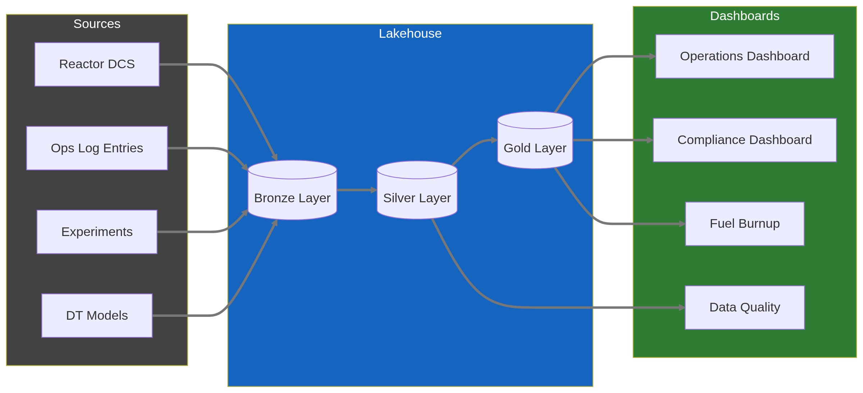

Dashboard Hierarchy
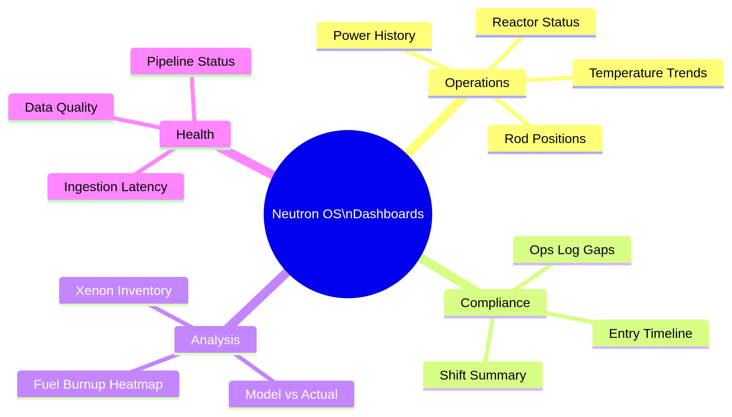

Stakeholder Insights

Key Feedback from Nick Luciano

On Live Streaming
"We'd ideally get live streaming, but currently we just upload the data after-hours due to cost."
Design Implication: Dashboard architecture is streaming-first with batch fallbacks. Real-time is the default; batch processing handles historical aggregations and disaster recovery. See .ADR 007

On Security Concerns
"The public should generally not know when the reactor is at power. More specifically, we don't want live updates on the reactor status available online. A Superset login that is well protected is sufficient."
Design Implication: Dashboards require authentication. No public-facing real-time power status. Day-after data is acceptable for broader access.

On Calendar vs. Reality
"The calendar is used to schedule time. It is not a reflection of what actually happened."
Design Implication: Dashboard should show actual reactor data, not scheduled data. Calendar integration is low priority.

On Xenon Tracking
"This [xenon] cannot be measured directly, but can be correlated with critical rod heights."
Design Implication: Xenon dashboard should use inferred/calculated values, not direct measurement. Show correlation methodology.

On Fuel Burnup
"This [fuel burnup heatmap] would be great. Ultimately, a product of the code would be burnup values for individual fuel elements. I could see a time series of burnup being displayed."
Design Implication: Fuel burnup heatmap is high-value. Requires model integration for per-element calculations.

Key Feedback from Jim (TJ)

On Operational Insights
"We can ascertain a baseline fuel 'burn up' amount when starting up from a long period of shut down. During operation, fuel 'burn up' amounts can be tracked as well."
Design Implication: Burnup tracking should show both baseline (post-shutdown) and operational (during run) values.

On Log Entry Counts
"I am not sure what insight could be achieved by counting the number of log entries. We could however add a 'watch type' to all entries and then gather what operations we normally perform at what hour."
Design Implication: Simple entry counts are not useful. But tagging entries by type (watch type, category) enables meaningful analysis—e.g., "What operations happen at 2 AM vs 2 PM?"

On Compliance Gaps
"A gap would mean that this :30 minute check was not performed when operating."
Design Implication: Gaps in mandatory checks should be visually prominent—this is a compliance indicator.

On Export Requirements
"Export to PDF would work, but a simple text file for archive and future proof would also work."
Design Implication: Support multiple export formats. Plain text for archival longevity.

Dashboard Inventory
Based on stakeholder feedback, prioritized:

Priority 1: Operations Dashboards
Dashboard | Primary Users | Key Insight | Stakeholder Quote
Reactor Operations Overview | Operators, RM | Real-time (or near-real-time) reactor status | Nick: "We'd ideally get live streaming"
Operations Log Compliance | RM, NRC | Gaps in mandatory checks | Jim: "A gap would mean... check was not performed"
Shift Summary | SRO, RM | Entries by watch/shift, handover report | Jim: "add a 'watch type' to all entries"

Priority 2: Analysis Dashboards
Dashboard | Primary Users | Key Insight | Stakeholder Quote
Fuel Burnup Heatmap | RM, Analysts | Per-element burnup visualization | Nick: "This would be great"
Xenon Inventory (Inferred) | Operators, Analysts | Xe-135 tracking via rod height correlation | Nick: "cannot be measured directly, but can be correlated"
Power History | Researchers | Historical power levels, trends | Standard operational need

Priority 3: Experiment Dashboards
Dashboard | Primary Users | Key Insight | Stakeholder Quote
Experiment Tracking | Researchers, PIs | Sample status, beam time usage | Khiloni: correlate with reactor conditions
Facility Usage | RM, PIs | Which facilities are most used | Operational planning

Priority 4: Digital Twin Dashboards
Dashboard | Primary Users | Key Insight | Stakeholder Quote
Model vs. Measurement | Analysts | Validation of DT predictions | Foundational DT metric
Model Performance | Developers | Execution times, convergence | Technical health

Dashboard Specifications

1. Reactor Operations Overview
Purpose: Real-time (or near-real-time) view of reactor status for console monitoring.
Security Note: Requires authentication. Not public-facing per Nick's security concern.
Panels:
- Current Power Level (big number with trend sparkline)
- Control Rod Positions (bar chart or rod diagram)
- Pool Temperature (gauge with alarm thresholds)
- Coolant Flow Rate (if measured)
- Status Indicator (Shutdown / Startup / Operating / Scram)
- Time Since Last Ops Log Entry (compliance indicator)
Data Refresh & Freshness:
Design Decision: Streaming-first with batch fallbacks. See ADR 007
Data Type | Target Latency | Implementation
Ops Log entries | <500ms | WebSocket push
30-min rule timer | <100ms | Real-time sync
Reactor status | <2s | Event-driven update
Historical aggregations | Minutes | Batch job (Dagster)

Freshness Indicator: Live is the default — users assume data is current. Warnings appear only when streaming is degraded:
- 🟢 Live — default state, no indicator needed
- ⚠️ Degraded — streaming delayed, showing last known values
- 🔴 Stale — connection lost or >5 min behind
Mockup:
┌────────────────────────────────────────────────────────────────┐
│ REACTOR OPERATIONS OVERVIEW │
│ 🟡 Last Updated: 5 min ago [⟳ Refresh] [Settings]│
├────────────────────────────────────────────────────────────────┤
│ │
│ ┌──────────────┐ ┌──────────────┐ ┌──────────────┐ │
│ │ POWER │ │ STATUS │ │ POOL TEMP │ │
│ │ 950 kW │ │ OPERATING │ │ 85°F │ │
│ │ ▲ +50kW │ │ ● ● ● ● │ │ ─────── │ │
│ └──────────────┘ └──────────────┘ └──────────────┘ │
│ │
│ ┌────────────────────────────────────────────────────────┐ │
│ │ CONTROL RODS │ │
│ │ ████████░░ A: 72% ████████░░ B: 68% ████░░░░░ C: 41%│ │
│ └────────────────────────────────────────────────────────┘ │
│ │
│ ┌────────────────────────────────────────────────────────┐ │
│ │ POWER HISTORY (Last 24h) │ │
│ │ 1000 ─┬───────────────────────────────────────────── │ │
│ │ │ ████████████████████████ │ │
│ │ 500 ─┼───────────█████████ │ │
│ │ │ ███████ │ │
│ │ 0 ─┴───────────────────────────────────────────── │ │
│ │ 00:00 06:00 12:00 18:00 │ │
│ └────────────────────────────────────────────────────────┘ │
│ │
└────────────────────────────────────────────────────────────────┘

2. Operations Log Compliance
Purpose: Ensure mandatory 30-minute checks are being performed; surface gaps for RM review.
Panels:
- Gap Indicator (big red/green: "X gaps this shift")
- Timeline of Entries (dots on timeline, gaps highlighted)
- Entries by Type (pie chart)
- Entries by Operator (bar chart)
- Entries by Watch Type (per Jim's suggestion)
Key Metric:
- Gap = Operating period > 30 min without CONSOLE_CHECK entry
Mockup:
┌────────────────────────────────────────────────────────────────┐
│ OPS LOG COMPLIANCE DASHBOARD [Shift: Day] │
├────────────────────────────────────────────────────────────────┤
│ │
│ ┌──────────────┐ ┌──────────────────────────────────────┐ │
│ │ GAPS │ │ ENTRY TIMELINE (Today) │ │
│ │ │ │ │ │
│ │ 0 ✓ │ │ ●───●───●───●───●───●───●───●───● │ │
│ │ │ │ 08 09 10 11 12 13 14 15 16 │ │
│ │ This Shift │ │ │ │
│ └──────────────┘ └──────────────────────────────────────┘ │
│ │
│ ┌──────────────────────┐ ┌─────────────────────────────┐ │
│ │ ENTRIES BY TYPE │ │ ENTRIES BY OPERATOR │ │
│ │ │ │ │ │
│ │ Console Check: 12 │ │ J. Smith: 8 │ │
│ │ Experiment: 3 │ │ M. Jones: 4 │ │
│ │ General Note: 2 │ │ K. Lee: 5 │ │
│ │ Maintenance: 1 │ │ │ │
│ └──────────────────────┘ └─────────────────────────────┘ │
│ │
│ ┌────────────────────────────────────────────────────────┐ │
│ │ ⚠️ GAPS IN LAST 30 DAYS │ │
│ │ │ │
│ │ 2026-01-15 14:30-15:15 (45 min gap) - Shift: Night │ │
│ │ 2026-01-08 02:00-02:45 (45 min gap) - Shift: Night │ │
│ └────────────────────────────────────────────────────────┘ │
│ │
└────────────────────────────────────────────────────────────────┘

3. Fuel Burnup Heatmap
Purpose: Visualize per-element fuel burnup for operational planning and regulatory reporting.
Data Source: Model output (not direct measurement). Per Nick: "a product of the code would be burnup values for individual fuel elements."
Panels:
- Core Map Heatmap (top-down view, colored by burnup)
- Burnup by Element (sortable table)
- Burnup Trend (time series for selected element)
- Baseline vs Current (per Jim: "baseline fuel 'burn up' amount when starting up from a long period of shut down")
Mockup:
┌────────────────────────────────────────────────────────────────┐
│ FUEL BURNUP VISUALIZATION [As of: 2026-01]│
├────────────────────────────────────────────────────────────────┤
│ │
│ ┌──────────────────────────────┐ ┌────────────────────────┐ │
│ │ CORE MAP (Top-Down) │ │ BURNUP SCALE │ │
│ │ │ │ │ │
│ │ ░░░███░░░ │ │ ████ High (>50 MWd) │ │
│ │ ░░████████░░ │ │ ▓▓▓▓ Med (25-50) │ │
│ │ ░███▓▓▓▓▓▓███░ │ │ ░░░░ Low (<25 MWd) │ │
│ │ ░██▓▓▓▓▓▓▓▓██░ │ │ │ │
│ │ ░███▓▓▓▓▓▓███░ │ │ Click element for │ │
│ │ ░░████████░░ │ │ detail view │ │
│ │ ░░░███░░░ │ │ │ │
│ │ │ │ │ │
│ └──────────────────────────────┘ └────────────────────────┘ │
│ │
│ ┌────────────────────────────────────────────────────────┐ │
│ │ BURNUP HISTORY (Selected: Element B-4) │ │
│ │ │ │
│ │ 60 MWd ─┬─────────────────────────────────────█████ │ │
│ │ │ ███████ │ │
│ │ 30 MWd ─┼────────────────███████████████ │ │
│ │ │ ██████████████ │ │
│ │ 0 MWd ─┴───────────────────────────────────────── │ │
│ │ 2022 2023 2024 2025 │ │
│ └────────────────────────────────────────────────────────┘ │
│ │
└────────────────────────────────────────────────────────────────┘

4. Xenon Inventory (Inferred)
Purpose: Track Xe-135 buildup/decay for operational planning (startup timing, power maneuvers).
Data Source: Inferred from critical rod heights, per Nick: "cannot be measured directly, but can be correlated with critical rod heights."
Panels:
- Estimated Xe-135 Inventory (time series)
- Critical Rod Height Correlation (scatter plot showing relationship)
- Methodology Note (explain inference approach)
Important Caveat: Display prominently that this is inferred data, not direct measurement.

5. Shift Summary / Handover Report
Purpose: Generate end-of-shift summary for handover to incoming crew.
Content:
- Power level changes during shift
- All Ops Log entries (with supplements)
- Experiments conducted
- Equipment issues noted
- Pending items for next shift
Export: PDF and plain text per Jim's requirement.

Security Requirements
From Nick:
"The public should generally not know when the reactor is at power."

Access Tiers
Tier | Access Level | Example Users
Public | None (no public dashboards) | N/A
Delayed | Data from >24 hours ago | External researchers (future)
Real-time | Current data | Operators, RM, HP
Admin | Full access + configuration | System administrators

Implementation
- All dashboards behind Superset authentication
- No embedding of live dashboards in public websites
- Day-after exports acceptable for external sharing

Data Refresh Patterns
Pattern | Latency | Use Case
Nightly Batch | ~12 hours | Current implementation; sufficient for historical analysis
Near-Real-Time | ~5 min | Future; needed for operations dashboard
Real-Time | <1 min | Future; needed for console monitoring

Nick's note: "We'd ideally get live streaming, but currently we just upload the data after-hours due to cost."
Design Decision: Streaming-first architecture. Real-time is the default; batch for historical aggregations and fallback. See .ADR 007

Export Requirements
Per Jim: "Export to PDF would work, but a simple text file for archive and future proof would also work."

Supported Formats
Format | Notes
PDF | Charts rendered as images; professional formatting
PNG/SVG | Individual chart export
CSV | Underlying data for any chart
Plain Text | For compliance reports and archival

Integration Points

From Reactor Ops Log
- Entry counts by type/time
- Gap detection alerts
- Watch-type tagging

From Experiment Manager
- Sample status aggregations
- Facility utilization

From Time-Series (Iceberg)
- Power levels, temperatures, rod positions
- Historical queries for trends

From Models
- Burnup calculations
- Xenon inferred values
- Model vs measurement comparisons

MVP Scope (Phase 1)

In Scope
- Reactor Operations Overview (with nightly batch data)
- Operations Log Compliance (gap detection)
- Power History (simple time-series charts)
- Basic authentication

Out of Scope (Future)
- Real-time streaming
- Fuel Burnup Heatmap (requires model integration)
- Xenon Inference (requires model)
- External/delayed access tier

Open Questions
- Real-time priority: How important is real-time vs cost savings of nightly batch?
- Historical depth: How far back should dashboards query? (2 years per NRC, or full history?)
- Alert routing: Should compliance gaps trigger email/SMS to RM?
- Model integration: What's the timeline for burnup model output integration?
- Watch types: What are the standard watch types to tag entries with?

Success Metrics
Metric | Target | Measurement
Dashboard adoption | 80% of operators check daily | Login analytics
Gap detection accuracy | 100% of gaps surfaced | Audit comparison to paper logs
Export usage | NRC inspection prep uses exports | Staff survey
Insight generation | RM identifies 1+ operational improvement per quarter | Qualitative feedback

Appendix: Stakeholder Quotes Reference
Nick Luciano:
- "We'd ideally get live streaming, but currently we just upload the data after-hours due to cost."
- "The public should generally not know when the reactor is at power."
- "The calendar is used to schedule time. It is not a reflection of what actually happened."
- "[Xenon] cannot be measured directly, but can be correlated with critical rod heights."
- "[Fuel burnup heatmap] would be great."
Jim (TJ):
- "We can ascertain a baseline fuel 'burn up' amount when starting up from a long period of shut down."
- "I am not sure what insight could be achieved by counting the number of log entries."
- "Add a 'watch type' to all entries and then gather what operations we normally perform at what hour."
- "A gap would mean that this :30 minute check was not performed when operating."
- "Export to PDF would work, but a simple text file for archive and future proof would also work."
Document Status: Ready for technical review and Superset implementation planning

