Table of Contents
Product Requirements Document: Compliance Tracking System
Executive Summary
Regulatory Framework
Compliance Monitoring Architecture
Key Compliance Requirements
30-Minute Console Checks (Jim's Priority)
Training Currency Tracking
Experiment Authorization Tracking
Compliance Dashboards
Real-Time Compliance Monitor
NRC Inspection Package Generator
User Stories
Compliance Officers
Operations Staff
Training Coordinators
Management
Compliance Rules Engine
Rule Categories
Rule Definition Language
Integration Points
Data Sources
Compliance Outputs
Success Metrics
Implementation Considerations
Data Retention
Access Control
Fail-Safe Design
Implementation Phases
Phase 1: Core Compliance (Month 1)
Phase 2: Expanded Tracking (Month 2)
Phase 3: NRC Package Generation (Month 3)
Phase 4: Advanced Analytics (Months 4-6)

Product Requirements Document: Compliance Tracking System
Module: Cross-Cutting Compliance Infrastructure Status: Draft Last Updated: January 22, 2026 Stakeholder Input: Jim (TJ) - NRC requirements, 30-min checks, 2-year inspection scope Related Modules: , , Parent: Reactor Ops LogExperiment ManagerTrainingExecutive PRD

Executive Summary
The Compliance Tracking System is a cross-cutting concern that ensures regulatory compliance across all Neutron OS modules. It monitors operational requirements (30-minute console checks, training currency, authorization validity), generates evidence packages for inspections, and provides real-time compliance dashboards. Rather than each module implementing its own compliance logic, this centralized system provides consistent tracking, alerting, and reporting.
Key Principle: Compliance is about monitoring, evidence, and reporting, not about the operational activities themselves. The Reactor Ops Log records operations, Training tracks certifications, but the Compliance System ensures nothing falls through the cracks.

Regulatory Framework
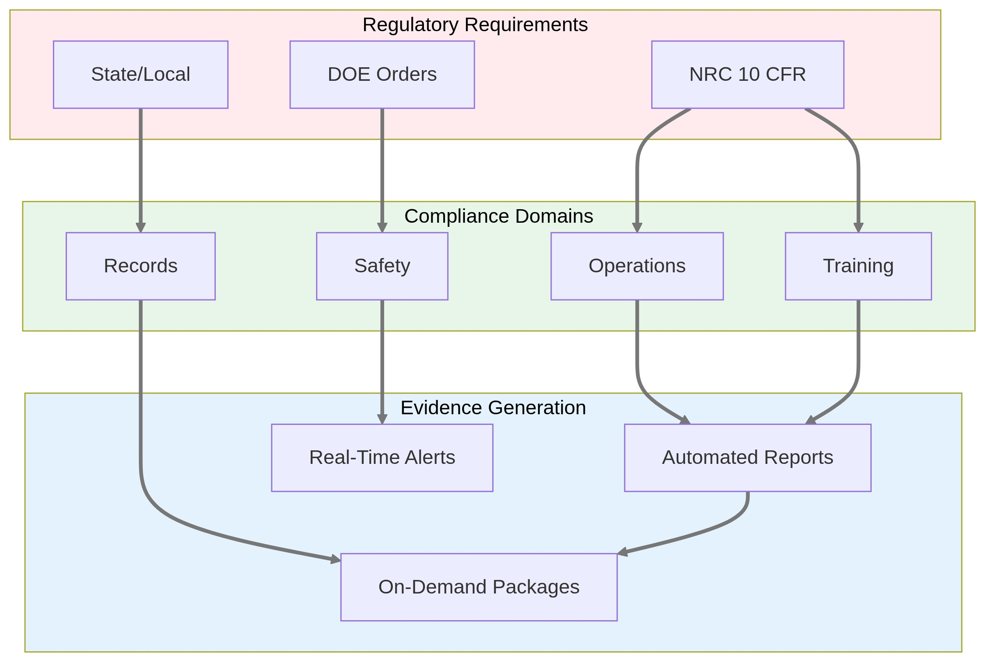

Compliance Monitoring Architecture
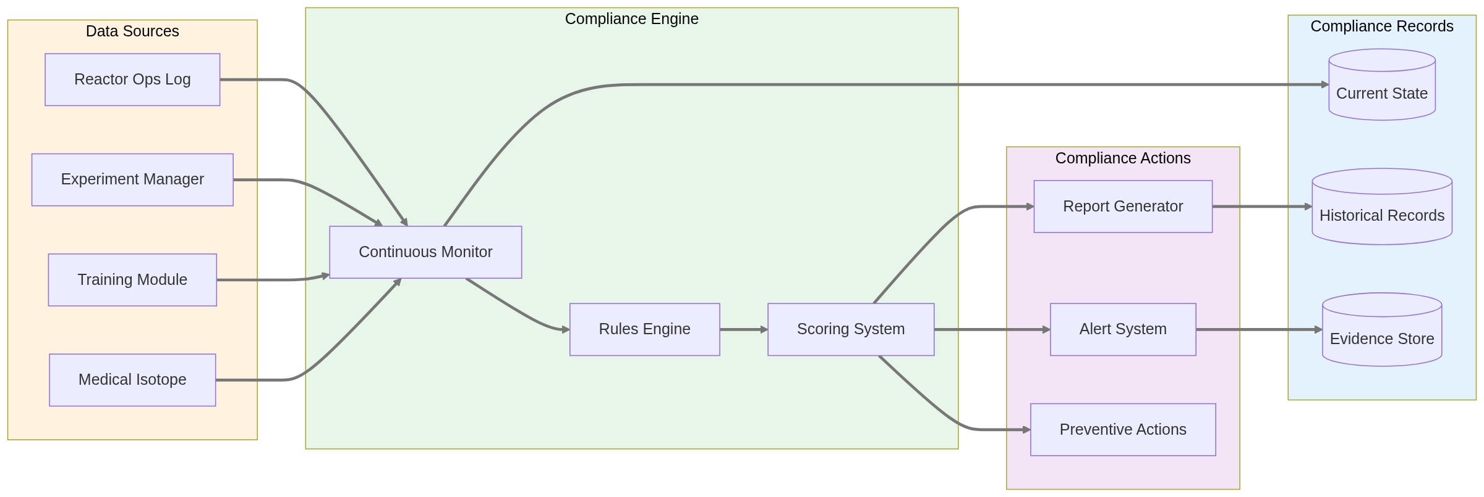

Key Compliance Requirements

30-Minute Console Checks (Jim's Priority)
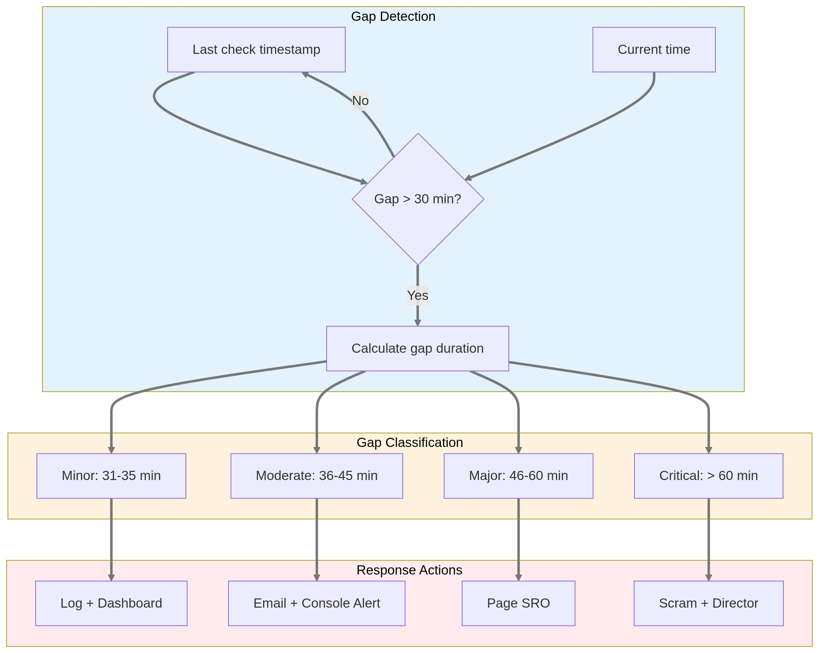

Training Currency Tracking
Requirement | Frequency | Track | Alert | Action
Initial Qualification | Once | Completion date, exam score | N/A | Enable operator privileges
Requalification | 4 hrs/quarter | Hours completed, topics covered | 30 days before due | Block console access if expired
Medical Exam | Annual | Exam date, clearance status | 60 days before due | Remove from shift schedule
Emergency Drill | Quarterly | Participation, role, performance | 2 weeks before quarter end | Schedule makeup session
Regulatory Changes | As needed | Training date, acknowledgment | Upon publication | Require read & sign

Experiment Authorization Tracking
⚠️ Diagram rendering failed

Compliance Dashboards

Real-Time Compliance Monitor
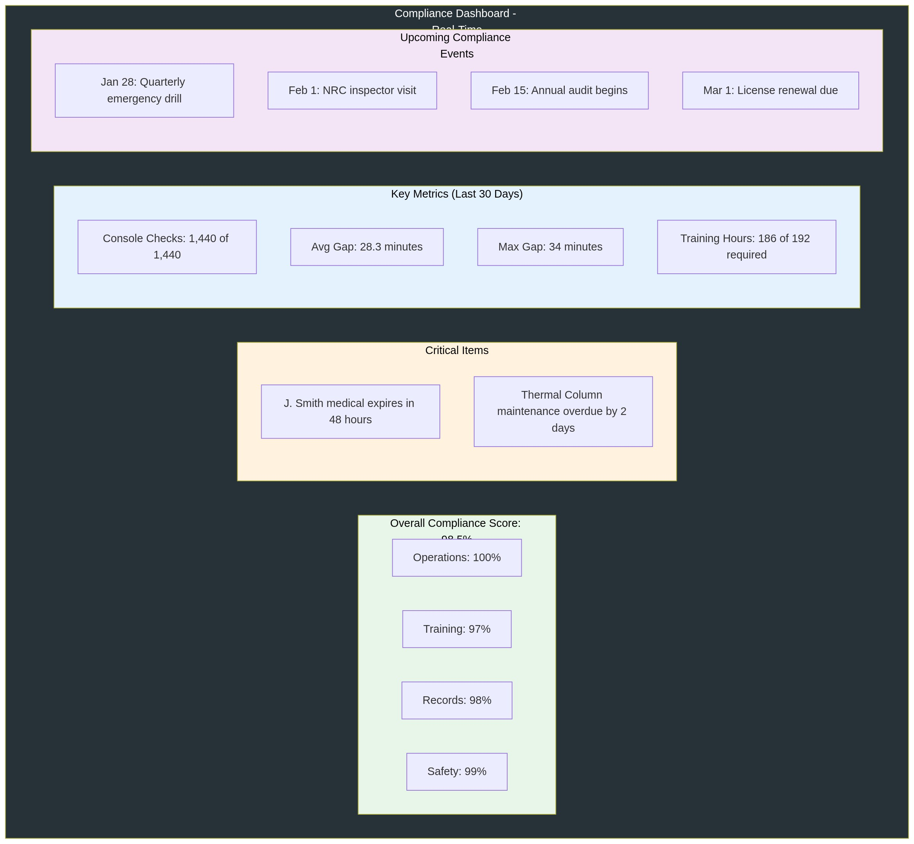

NRC Inspection Package Generator
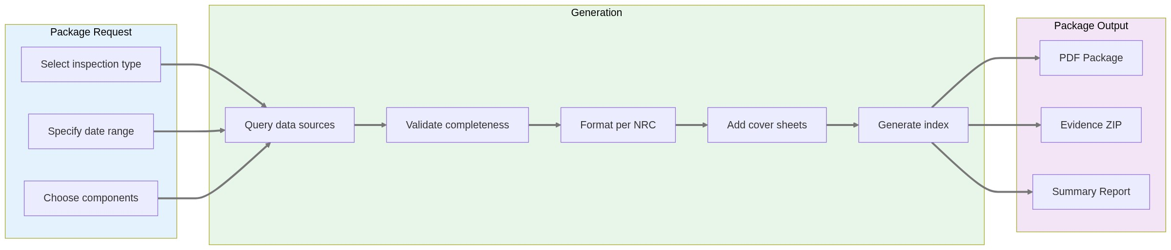

User Stories

Compliance Officers
- As a compliance officer, I want a real-time dashboard showing all compliance metrics so I can identify issues before they become violations.
- As a compliance officer, I want to generate NRC inspection packages covering any 2-year period with one click.
- As a compliance officer, I want automatic alerts when any compliance metric drops below threshold so I can take corrective action.
- As a compliance officer, I want trend analysis showing compliance patterns over time to identify systemic issues.

Operations Staff
- As a reactor operator, I want visual/audio reminder for 30-minute checks so I never miss one.
- As a shift supervisor, I want to see compliance status for my shift including any gaps from previous shifts.
- As a reactor manager, I want weekly compliance reports showing performance by shift and operator.

Training Coordinators
- As a training coordinator, I want to see who needs requalification in the next 30/60/90 days.
- As a training coordinator, I want automatic scheduling of required training before expiration.
- As a training coordinator, I want proof of completion records that satisfy NRC requirements.

Management
- As a facility director, I want monthly compliance trending to present at management reviews.
- As a facility director, I want predictive alerts about future compliance risks based on current trends.

Compliance Rules Engine

Rule Categories
Category | Examples | Enforcement | Escalation
Hard Requirements | 30-min checks, licensed operator on console | System interlock - cannot proceed | Immediate to SRO/RM
Procedural | Two-person rule, independent verification | Warning with override option | Log override with reason
Best Practice | ALARA reviews, pre-job briefs | Suggestion only | Track for trending
Facility-Specific | Local procedures, additional requirements | Configurable enforcement | Per facility policy

Rule Definition Language
# Example: 30-Minute Console Check Rule
rule:
id: NRC-10CFR50-CONSOLE-CHECK
name: "30-Minute Console Check"
category: hard_requirement
regulation: "10 CFR 50.54(i)"
description: "Licensed operator must check console indicators every 30 minutes during operation"
trigger:
source: reactor_ops_log
event: console_check_logged
condition:
time_since_last:
max_minutes: 30
violation_response:
minor: # 31-35 minutes
- log_gap
- update_dashboard
moderate: # 36-45 minutes
- log_gap
- email_supervisor
- console_alert
major: # 46-60 minutes
- log_gap
- page_sro
- email_reactor_manager
critical: # >60 minutes
- log_gap
- automatic_scram
- notify_director
- file_event_report

Integration Points

Data Sources
System | Provides | Update Frequency | Used For
Reactor Ops Log | Console checks, power levels, maintenance | Real-time | 30-min compliance, tech specs
Experiment Manager | ROC approvals, sample records | On change | Authorization validity
Training Module | Certifications, hours, expiry | Daily sync | Currency tracking
Medical Isotope | QA records, shipping docs | On completion | Quality compliance
Personnel | Medical clearance, background checks | Weekly sync | Operator eligibility
Scheduling | Planned activities, staff assignments | Real-time | Coverage verification

Compliance Outputs
Output | Format | Recipients | Frequency
Real-time Dashboard | Web/Mobile | All staff | Continuous
Daily Summary | Email | Supervisors, RM | 6 AM daily
Weekly Report | PDF | Management | Monday AM
Monthly Metrics | PDF + Excel | Director, ROC | 1st of month
NRC Package | PDF + ZIP | Inspectors | On demand
Audit Trail | Immutable log | Compliance, IT | Continuous

Success Metrics
Metric | Target | Current Baseline | Measurement
30-Min Check Compliance | 100% | 98.5% (paper logs) | Zero gaps >30 min
Training Currency | 100% | 95% (spreadsheet) | All ops qualified
Inspection Prep Time | <4 hours | 2-3 days | Package generation time
Evidence Completeness | 100% | ~90% (searching) | All required docs present
Alert Response Time | <5 min | Unknown | Time to acknowledge
Audit Findings | Zero repeat | 2-3 per year | NRC inspection results

Implementation Considerations

Data Retention
- Operational data: 2 years minimum per NRC
- Training records: 5 years for initial qual, 3 years for requal
- Audit trails: 7 years for compliance actions
- Inspection packages: Permanent archive

Access Control
- View dashboards: All badged personnel
- Acknowledge alerts: Authorized operators
- Override warnings: SRO or above
- Modify rules: Compliance officer + RM approval
- Generate packages: Compliance, management, NRC

Fail-Safe Design
⚠️ Diagram rendering failed

Implementation Phases

Phase 1: Core Compliance (Month 1)
- 30-minute check tracking
- Basic compliance dashboard
- Manual gap reporting
- Simple alerting

Phase 2: Expanded Tracking (Month 2)
- Training currency
- Experiment authorizations
- Automated alerts
- Weekly reports

Phase 3: NRC Package Generation (Month 3)
- Evidence compilation
- Package formatting
- Search and retrieval
- Archive system

Phase 4: Advanced Analytics (Months 4-6)
- Predictive analytics
- Trend identification
- Risk scoring
- Process optimization
This PRD defines the Compliance Tracking System as a cross-cutting concern that monitors regulatory requirements across all Neutron OS modules while maintaining separation of concerns.

