Table of Contents
Data Platform PRD
Overview
User Journey Map
Data Engineer: Pipeline Development
Data Flow Architecture
Query Access Patterns
User Personas
Problem Statement
Current State
Future State
Requirements
Epic: Data Lake Foundation
Epic: Lakehouse (Iceberg + DuckDB)
Epic: Transformations (dbt)
Epic: Orchestration (Dagster)
Epic: Analytics (Superset)
Epic: Audit & Compliance
Test-Driven Approach
Success Metrics
Data Sources
Technical Dependencies
Open Questions

Data Platform PRD
Product: Neutron OS Data Platform Status: Draft Last Updated: 2026-01-21 Parent: Executive PRD

Overview
The Neutron OS Data Platform provides a unified data foundation for nuclear research and operations, replacing fragmented CSV/JSON files with a modern lakehouse architecture.

User Journey Map

Data Engineer: Pipeline Development
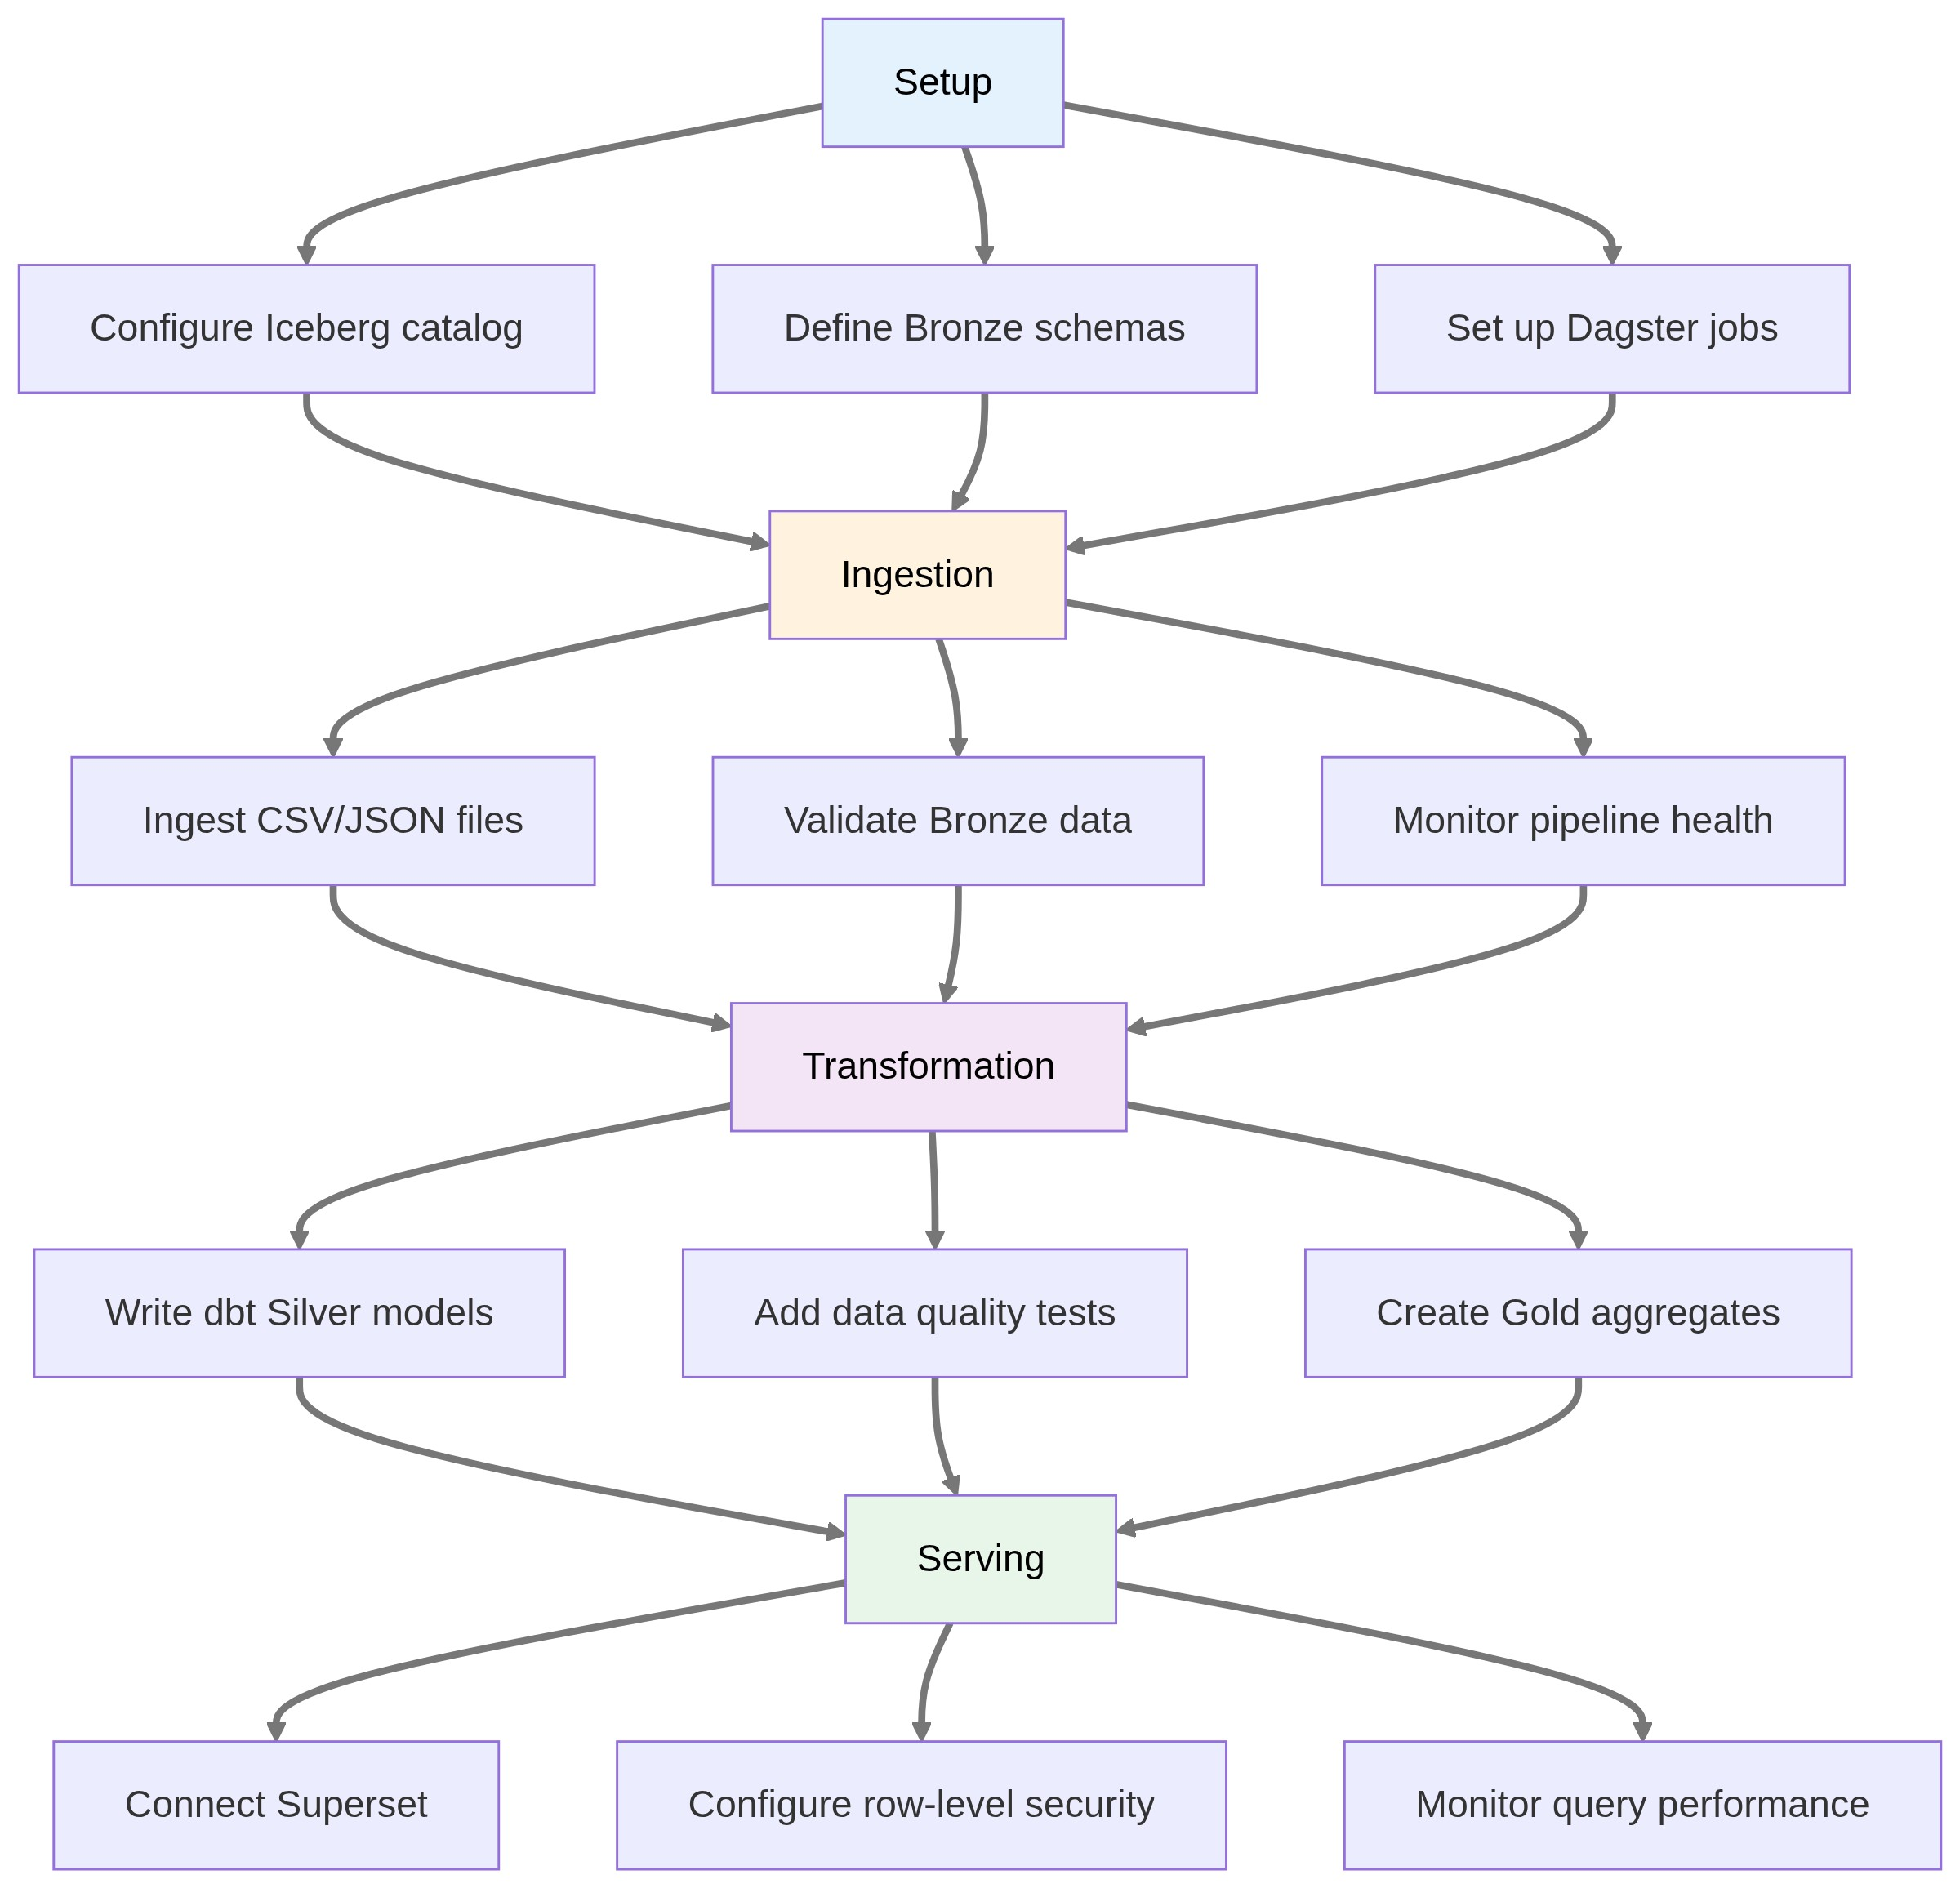

Data Flow Architecture
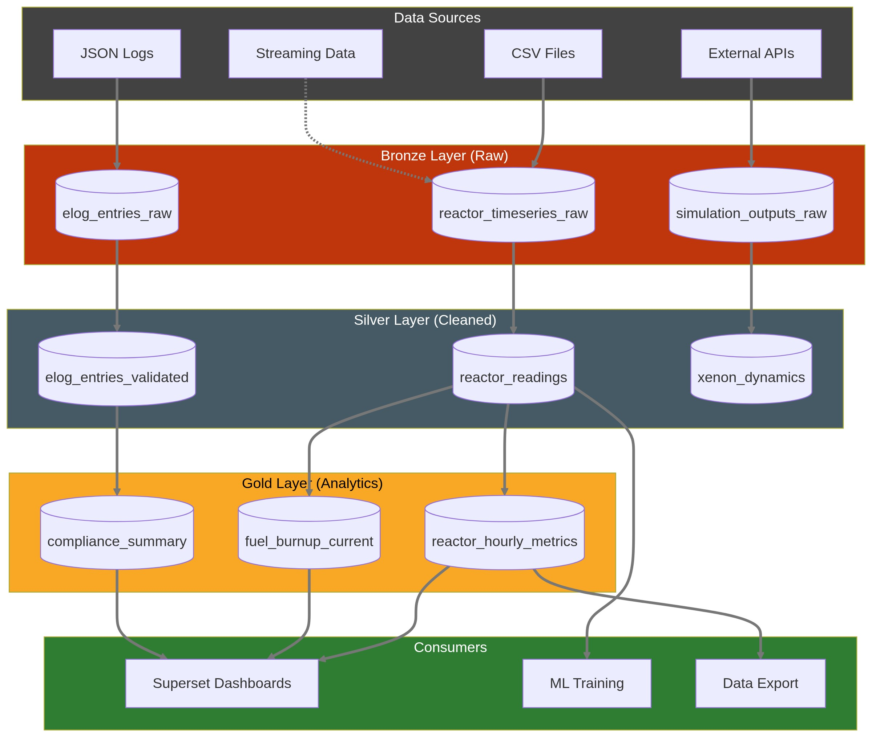

Query Access Patterns
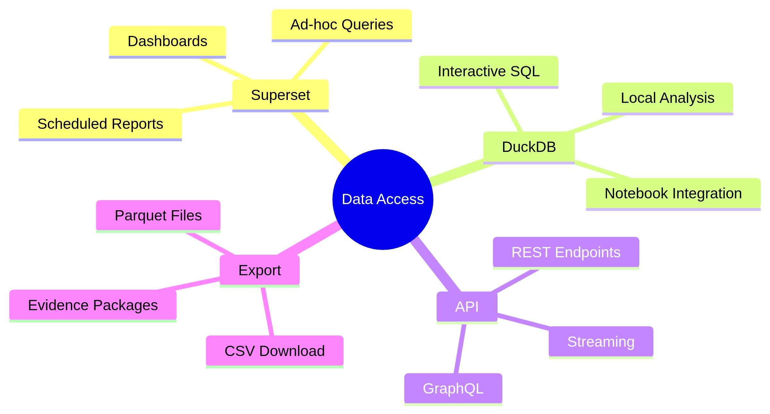

User Personas
Persona | Description | Primary Needs
Reactor Operator | Monitors reactor state | Real-time dashboards, historical lookback
Researcher | Analyzes experimental data | Self-service queries, data export
Data Engineer | Builds pipelines | Reliable ingestion, transformation tools
Regulatory Inspector | Reviews records | Immutable history, time-travel queries
Facility Manager | Oversees operations | KPI dashboards, anomaly alerts

Problem Statement

Current State
- CSV files in various directories
- JSON for logs and metadata
- PostgreSQL/TimescaleDB for some time-series
- No unified query layer
- No data versioning
- Manual data preparation for analysis

Future State
- Bronze/Silver/Gold data tiers (Iceberg)
- Time-travel queries for any historical state
- Self-service analytics (Superset)
- Automated pipelines (Dagster + dbt)
- Immutable audit trail for all data changes

Requirements

Epic: Data Lake Foundation
ID | Requirement | Priority
DL-001 | Ingest reactor time-series to Bronze tier | P0
DL-002 | S3-compatible object storage | P0
DL-003 | 7-year retention policy | P1
DL-004 | Automated daily ingestion from Box | P0
DL-005 | Manual upload capability for legacy data | P1

Epic: Lakehouse (Iceberg + DuckDB)
ID | Requirement | Priority
LH-001 | Iceberg tables for Silver/Gold tiers | P0
LH-002 | Time-travel queries | P0
LH-003 | Schema evolution without downtime | P1
LH-004 | DuckDB for embedded analytics | P0
LH-005 | Trino for distributed queries | P2

Epic: Transformations (dbt)
ID | Requirement | Priority
TR-001 | Bronze → Silver cleaning transforms | P0
TR-002 | Silver → Gold aggregation transforms | P0
TR-003 | dbt tests for data quality | P0
TR-004 | Incremental model updates | P1
TR-005 | Data lineage documentation | P1

Epic: Orchestration (Dagster)
ID | Requirement | Priority
OR-001 | Scheduled daily ingestion | P0
OR-002 | Sensor-triggered pipelines | P1
OR-003 | Pipeline monitoring and alerting | P1
OR-004 | Backfill capability | P1
OR-005 | Dagster UI for pipeline visibility | P0

Epic: Analytics (Superset)
ID | Requirement | Priority
AN-001 | Reactor Operations Dashboard | P0
AN-002 | Self-service SQL queries | P0
AN-003 | Dashboard export (PDF, PNG) | P1
AN-004 | Dashboard version control (JSON in Git) | P0
AN-005 | Role-based dashboard access | P1

Epic: Audit & Compliance
ID | Requirement | Priority
AU-001 | All data mutations logged to audit trail | P0
AU-002 | Merkle proof verification API | P0
AU-003 | Evidence package generation | P1
AU-004 | Data access logging | P1

Test-Driven Approach
Superset scenarios drive data model design:
- Define Superset dashboard requirements
- Derive Gold table schemas
- Write dbt tests (must pass)
- Implement Bronze → Silver → Gold pipeline
- Build dashboard, export JSON to Git
- Stakeholder review and approval
See: Superset Scenarios

Success Metrics
Metric | Target
Dashboard load time (7-day view) | < 3 seconds
Dashboard load time (30-day view) | < 10 seconds
Ingestion latency (new data available) | < 1 hour
dbt test pass rate | 100%
Time-travel query support | Any point in 7-year window

Data Sources
Source | Location | Format | Refresh
Reactor time-series | serial_data/*.csv | CSV | Daily
Core configurations | static/core/*.csv | CSV | Event-driven
Xenon dynamics | Xe_burnup_2025.csv | CSV | Simulation
Rod calibration | CRH_*.csv, rho_vs_T.csv | CSV | Event-driven
Elog entries | Elog service | JSON/API | Real-time

Technical Dependencies
- Apache Iceberg (table format)
- DuckDB (embedded query)
- Apache Superset (BI)
- dbt-core (transforms)
- Dagster (orchestration)
- PostgreSQL + pgvector (metadata, vectors)
- Object storage (pending hosting decision)

Open Questions
- Where will the data lake be hosted? (TACC, cloud, hybrid)
- What time resolution for Gold tables? (hourly, daily)
- How much historical data to backfill?
- Should MPACT shadow predictions be included in dashboards?

