Table of Contents
Product Requirements Document: Medical Isotope Production
Executive Summary
User Journey Map
Hospital Customer: Order to Delivery
Production Manager: Weekly Batch
Order State Machine
System Integration
Current State (to be validated)
User Stories
Primary Users
User Stories: Ordering
User Stories: Production
User Stories: Quality & Compliance
User Stories: Fulfillment & Delivery
User Stories: Analytics
Isotope Catalog (Configurable)
Workflow Stages
Stage Transitions
Order Schema
Production Batch Schema
QC Record Schema
UI Mockup Concepts
Customer Order Portal
Production Manager Dashboard
QA/QC Entry Form
Integration Points
Shared with Experiment Manager
Medical Isotope-Specific
Regulatory Considerations
NRC Requirements
FDA Requirements (if applicable)
DOT Requirements
Configurability
Success Metrics
Open Questions
Relationship to Experiment Manager

Product Requirements Document: Medical Isotope Production
Module: Medical Isotope Production & Fulfillment Status: Draft Last Updated: January 21, 2026 Module Type: Optional (configurable on/off per facility mission) Related Module: (shared backend, different workflow) Parent: Experiment ManagerExecutive PRD

Executive Summary
The Medical Isotope Production module manages the end-to-end workflow for producing and delivering medical radioisotopes to healthcare providers. It replaces the current manual process (phone calls, spreadsheets, weekly production schedules) with a digital system that handles ordering, production scheduling, quality assurance, fulfillment, and delivery tracking.
Key Distinction from Experiment Manager:
- Experiment Manager: Researcher-initiated, variable samples, research outcomes
- Medical Isotope Production: Customer-initiated orders, standardized products, patient care outcomes
Both share technical backend (scheduling, tracking, reactor integration) but serve fundamentally different workflows and stakeholders.

User Journey Map

Hospital Customer: Order to Delivery
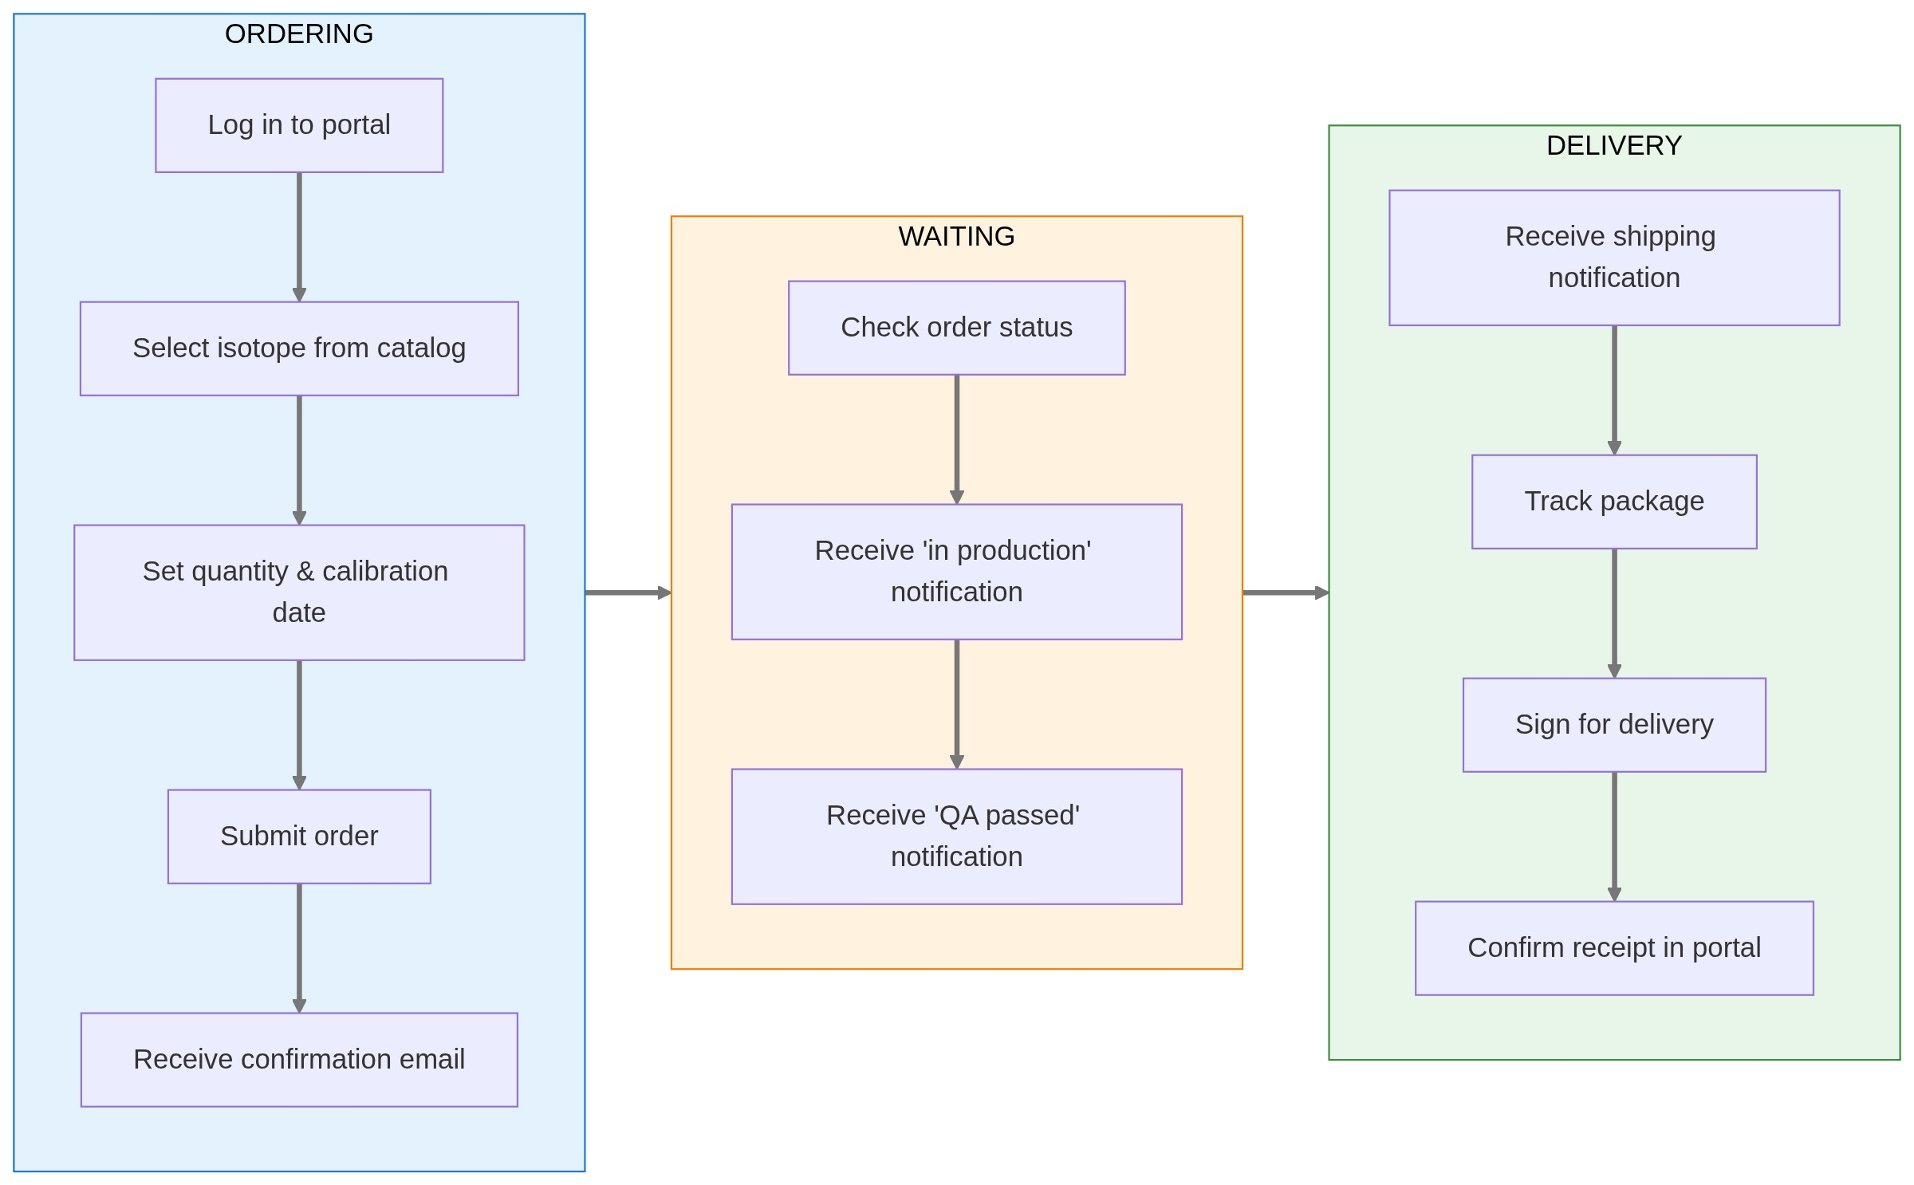

Production Manager: Weekly Batch
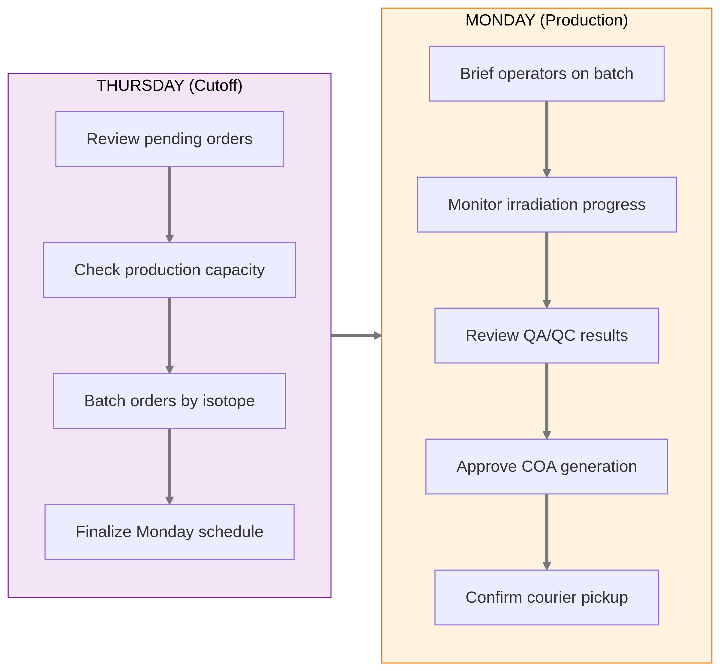

Order State Machine
⚠️ Diagram rendering failed

System Integration
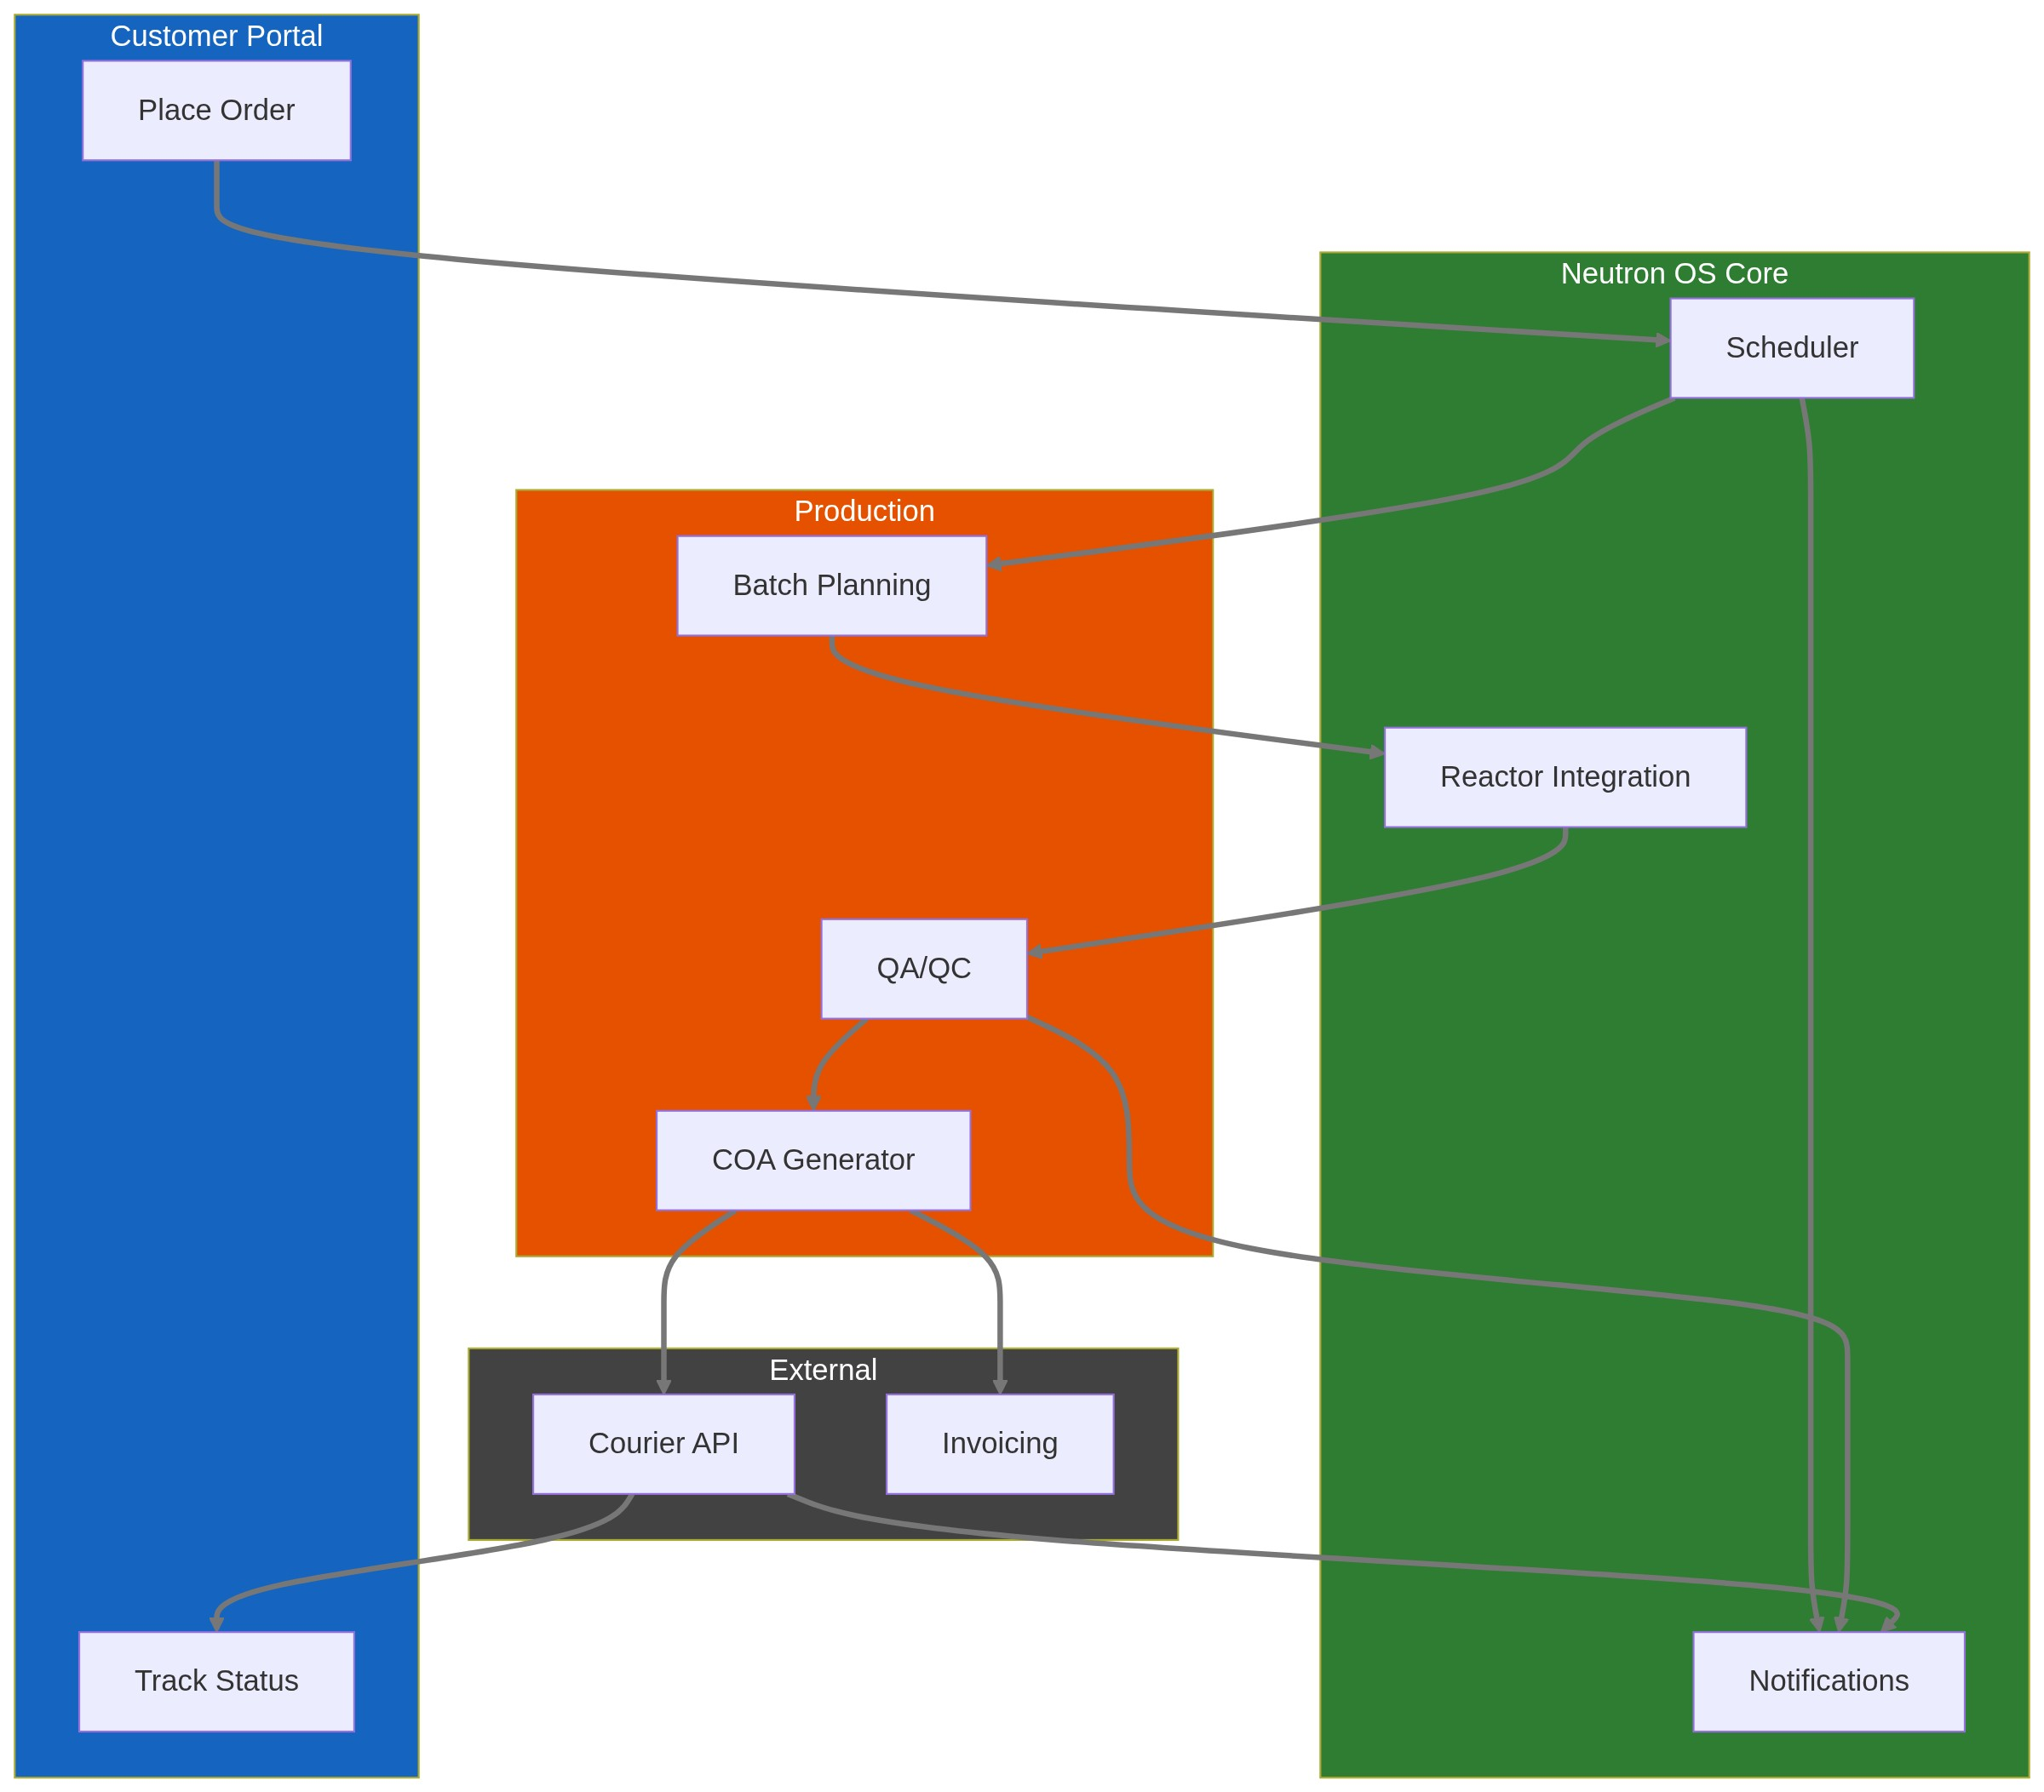

Current State (to be validated)
Based on typical research reactor medical isotope programs:
Production cadence: Weekly, typically Mondays
Ordering process: Phone calls and emails to reactor staff
Tracking: Spreadsheets, paper records
Delivery: Courier pickup on production day
Customers: Hospital nuclear medicine departments, radiopharmacies, research institutions
Pain points (hypothesized):
- No self-service ordering for repeat customers
- Manual coordination between customer requests and production schedule
- Limited visibility into order status
- Paper-based QA/QC records
- Reactive (not proactive) communication about delays

User Stories

Primary Users
User | Need
Hospital/Radiopharmacy Staff | Order isotopes reliably, know when they'll arrive
Reactor Production Manager | See all orders, plan production batch, track fulfillment
QA/QC Officer | Document quality checks, certify shipments
Courier/Logistics | Know pickup times, receive shipping documentation
Billing/Admin | Generate invoices, track payments
Facility Director | See production metrics, revenue, capacity utilization

User Stories: Ordering
- As a hospital nuclear medicine tech, I want to place a standing order for I-131 (same quantity, same day each week) so that I don't have to call every week.
- As a hospital buyer, I want to see available isotopes and current lead times so that I can plan patient treatments.
- As a new customer, I want to request an account and see pricing before committing.
- As an existing customer, I want to view my order history and reorder with one click.
- As a customer, I want to receive automatic confirmation when my order is accepted and updates when it ships.

User Stories: Production
- As a production manager, I want to see all orders for the upcoming production cycle so that I can batch similar isotopes efficiently.
- As a production manager, I want to flag when demand exceeds capacity so that I can prioritize or reschedule orders.
- As an operator, I want a production checklist that guides me through irradiation steps for each isotope type.
- As a production manager, I want to record actual production quantities (may differ from target due to yield variations).

User Stories: Quality & Compliance
- As a QA officer, I want to record quality measurements (activity, purity, sterility) against acceptance criteria.
- As a QA officer, I want to generate a Certificate of Analysis (COA) for each shipment.
- As a compliance officer, I want immutable records of all production and QA activities for FDA/NRC inspection.
- As a QA officer, I want to reject a batch if it doesn't meet specifications and notify the customer.

User Stories: Fulfillment & Delivery
- As a shipping coordinator, I want to generate shipping labels and DOT-compliant documentation.
- As a courier, I want to know exactly when packages are ready for pickup.
- As a customer, I want real-time tracking of my shipment.
- As a customer, I want proof of delivery with timestamp and signature.

User Stories: Analytics
- As a facility director, I want to see monthly production volume, revenue, and on-time delivery rate.
- As a production manager, I want to see yield trends over time (are we getting better or worse at production?).

Isotope Catalog (Configurable)
Example products for a TRIGA facility (actual catalog varies):
Isotope | Half-Life | Common Use | Typical Order Unit | Production Method
I-131 | 8.0 days | Thyroid treatment | mCi | Fission product extraction
Mo-99/Tc-99m | 66h / 6h | Diagnostic imaging | Generator | Fission product or (n,γ)
Lu-177 | 6.7 days | Cancer therapy | mCi | (n,γ) on Lu-176
Ir-192 | 74 days | Brachytherapy | Seeds | (n,γ) on Ir-191
Co-60 | 5.3 years | Radiation therapy | Sources | (n,γ) on Co-59
P-32 | 14.3 days | Research/therapy | mCi | (n,γ) on S-32

Configurable per facility:
- Which isotopes are offered
- Pricing per unit
- Minimum/maximum order quantities
- Lead time requirements
- Available production days

Workflow Stages
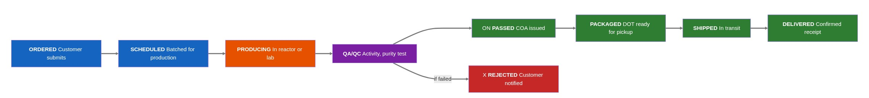

Stage Transitions
From | To | Trigger | Data Captured
Ordered | Scheduled | Manager assigns to production batch | Production date, batch ID
Scheduled | Producing | Irradiation begins | Start time, reactor conditions
Producing | QA/QC | Irradiation complete, sample ready | End time, actual activity
QA/QC | Passed | All QC checks pass | QC measurements, COA
QA/QC | Rejected | Any QC check fails | Failure reason
Passed | Packaged | Package prepared | Package ID, DOT class
Packaged | Shipped | Courier picks up | Tracking number, pickup time
Shipped | Delivered | Customer confirms receipt | Delivery time, signature

Order Schema
Field | Type | Description | Example
order_id | UUID | System-assigned | 550e8400-...
order_number | string | Human-readable | MIP-2026-0042
customer_id | UUID | Link to customer record
isotope_code | enum | From catalog | I-131
quantity_ordered | decimal | Requested amount | 50.0
quantity_unit | enum | mCi, µCi, MBq, etc. | mCi
calibration_datetime | timestamp | When activity should be calibrated to | 2026-01-27T12:00:00Z
requested_delivery_date | date | Customer's requested date | 2026-01-27
actual_delivery_date | date | When actually delivered
order_status | enum | Current stage | producing
production_batch_id | UUID | Link to production batch
total_price | decimal | Calculated from catalog | 1250.00
special_instructions | text | Customer notes | "Need by 10 AM for patient treatment"
created_at | timestamp | Order submission time
updated_at | timestamp | Last status change

Production Batch Schema
Field | Type | Description | Example
batch_id | UUID | System-assigned
batch_number | string | Human-readable | BATCH-2026-W04
production_date | date | Scheduled production | 2026-01-27
isotope_code | enum | Isotope being produced | I-131
target_quantity | decimal | Sum of orders | 500.0
actual_quantity | decimal | What was actually produced | 485.0
yield_percentage | decimal | Actual/target | 97.0
reactor_power_kw | decimal | Power during irradiation | 950.0
irradiation_start | timestamp | Start time
irradiation_end | timestamp | End time
irradiation_facility | enum | Which facility | TPNT
batch_status | enum | Current status | qa_pending
orders | array[UUID] | Orders in this batch

QC Record Schema
Field | Type | Description | Example
qc_id | UUID | System-assigned
batch_id | UUID | Link to batch
order_id | UUID | Link to specific order (if split batch)
measured_activity | decimal | Measured activity | 52.3
activity_unit | enum | Unit | mCi
calibration_datetime | timestamp | When measured
radionuclidic_purity | decimal | % purity | 99.8
radiochemical_purity | decimal | % purity | 99.5
sterility_test | enum | pass/fail/na | pass
endotoxin_test | enum | pass/fail/na | pass
overall_result | enum | pass/fail | pass
qc_officer_id | string | Who performed QC
notes | text | Additional observations
coa_generated | boolean | COA issued | true
coa_file_uri | string | Link to PDF

UI Mockup Concepts

Customer Order Portal
┌─────────────────────────────────────────────────────────────────────┐
│ NETL MEDICAL ISOTOPES [My Orders] [Account] │
├─────────────────────────────────────────────────────────────────────┤
│ │
│ PLACE NEW ORDER │
│ ───────────────────────────────────────────────────────────────── │
│ │
│ Isotope: [I-131 (Sodium Iodide) ▼] │
│ │
│ Quantity: [____] mCi Calibrated to: [Jan 27, 2026 12:00 PM] │
│ │
│ 💡 Based on your history, typical order is 50 mCi. [Use 50 mCi] │
│ │
│ Delivery Date: [Monday, Jan 27, 2026 ▼] │
│ │
│ ⚠️ Note: Orders must be placed by Thursday 5 PM for Monday │
│ delivery. │
│ │
│ Special Instructions: [_______________________________________] │
│ │
│ ───────────────────────────────────────────────────────────────── │
│ Estimated Price: $1,250.00 │
│ [Add to Cart] [Submit] │
│ │
│ ═══════════════════════════════════════════════════════════════ │
│ STANDING ORDERS │
│ ═══════════════════════════════════════════════════════════════ │
│ │
│ ┌─────────────────────────────────────────────────────────────┐ │
│ │ I-131 │ 50 mCi │ Every Monday │ Active │ [Edit] [Pause] │ │
│ │ Mo-99 │ 100 mCi│ Every Monday │ Active │ [Edit] [Pause] │ │
│ └─────────────────────────────────────────────────────────────┘ │
│ │
└─────────────────────────────────────────────────────────────────────┘

Production Manager Dashboard
┌─────────────────────────────────────────────────────────────────────┐
│ PRODUCTION PLANNING [This Week] [Next Week ▶] │
│ Week of January 27, 2026 │
├─────────────────────────────────────────────────────────────────────┤
│ │
│ MONDAY PRODUCTION BATCH (BATCH-2026-W05) │
│ ═══════════════════════════════════════════════════════════════ │
│ │
│ ┌────────────────────────────────────────────────────────────┐ │
│ │ Isotope │ Total Ordered │ Orders │ Facility │ Status │ │
│ ├────────────────────────────────────────────────────────────┤ │
│ │ I-131 │ 350 mCi │ 7 │ TPNT │ Scheduled │ │
│ │ Mo-99 │ 500 mCi │ 4 │ CT │ Scheduled │ │
│ │ Lu-177 │ 25 mCi │ 2 │ RSR │ Scheduled │ │
│ └────────────────────────────────────────────────────────────┘ │
│ │
│ ORDERS PENDING SCHEDULING (3) │
│ ┌────────────────────────────────────────────────────────────┐ │
│ │ Customer │ Isotope │ Qty │ Req. Date │ Action │ │
│ ├────────────────────────────────────────────────────────────┤ │
│ │ Memorial Hosp │ I-131 │ 75 mCi │ Feb 3 │ [Schedule]│ │
│ │ UT Health │ P-32 │ 10 mCi │ Feb 3 │ [Schedule]│ │
│ │ Research Lab │ Co-60 │ 5 mCi │ Feb 10 │ [Schedule]│ │
│ └────────────────────────────────────────────────────────────┘ │
│ │
│ ⚠️ CAPACITY ALERT: I-131 demand (350 mCi) is 87% of weekly │
│ capacity (400 mCi). Consider second production run. │
│ │
└─────────────────────────────────────────────────────────────────────┘

QA/QC Entry Form
┌─────────────────────────────────────────────────────────────────────┐
│ QC RECORD — BATCH-2026-W05 — I-131 │
├─────────────────────────────────────────────────────────────────────┤
│ │
│ Batch Info: 350 mCi ordered across 7 orders │
│ Irradiation: Jan 27 06:00 - 10:00 (TPNT, 950 kW) │
│ │
│ ═══════════════════════════════════════════════════════════════ │
│ MEASUREMENTS │
│ ═══════════════════════════════════════════════════════════════ │
│ │
│ Total Activity Measured: [____] mCi │
│ Calibration Time: [Jan 27, 2026 12:00 PM] │
│ │
│ Radionuclidic Purity: [____] % (Spec: ≥99.0%) [Pass/Fail] │
│ Radiochemical Purity: [____] % (Spec: ≥95.0%) [Pass/Fail] │
│ │
│ Sterility Test: [Pass ▼] │
│ Endotoxin Test: [Pass ▼] │
│ │
│ Notes: [_____________________________________________________] │
│ │
│ ───────────────────────────────────────────────────────────────── │
│ QC Officer: J. Martinez │
│ │
│ [Reject Batch] [Approve & Generate COA]│
└─────────────────────────────────────────────────────────────────────┘

Integration Points

Shared with Experiment Manager
Component | Shared? | Notes
Reactor scheduling | Yes | Both need to book reactor time
Reactor time-series | Yes | Both correlate with reactor conditions
Facility definitions | Yes | Same irradiation positions
Reactor Ops Log integration | Yes | Production activities logged
User authentication | Yes | Same identity system
Notification engine | Yes | Both send emails/SMS

Medical Isotope-Specific
Component | Description
Customer database | Hospitals, radiopharmacies with billing info
Pricing engine | Catalog prices, volume discounts
COA generator | PDF certificates with regulatory formatting
Shipping integration | DOT compliance, tracking APIs (FedEx, UPS)
Billing/invoicing | Connect to accounting system

Regulatory Considerations

NRC Requirements
- 10 CFR Part 30: Specific licenses for byproduct material
- 10 CFR Part 35: Medical use of byproduct material
- Package labeling and shipping documentation

FDA Requirements (if applicable)
- Drug Master Files (DMF) for certain radiopharmaceuticals
- cGMP compliance for radiopharmaceutical production

DOT Requirements
- 49 CFR 173: Packaging requirements
- Proper shipping names, UN numbers
- Activity limits per package
System Support:
- Templates for required documentation
- Validation that activity limits aren't exceeded
- Audit trail for all production and QC activities

Configurability
Aspect | Configurable | Notes
Isotope catalog | Yes | Each facility offers different isotopes
Pricing | Yes | Facility-specific pricing
Production days | Yes | Some facilities produce multiple days/week
QC parameters | Yes | Acceptance criteria may vary by product
Customer tiers | Yes | Academic vs. commercial pricing
Lead time rules | Yes | Order cutoff times
Shipping carriers | Yes | Which couriers are used
Documentation templates | Yes | Facility branding, format preferences

Module On/Off:
- Facility director can enable/disable entire module
- Facilities without medical isotope programs don't see this module at all
- When enabled, appears as separate section in Neutron OS navigation

Success Metrics
Metric | Target | Measurement
Order-to-delivery time | <24 hours from production | Timestamp tracking
On-time delivery rate | >98% | Delivered by requested date
QC pass rate | >99% | Batches passing all QC
Customer self-service | >80% of orders via portal | vs. phone/email
Repeat order rate | Track | Customer loyalty indicator
Revenue per production day | Track | Operational efficiency

Open Questions
- Existing customer list: Who are current medical isotope customers? What's order volume?
- Pricing structure: How is pricing determined? Volume discounts?
- Production capacity: What's max weekly production per isotope?
- Shipping logistics: Which carriers? Who schedules pickups?
- Billing integration: What accounting system is used?
- Standing order patterns: What % of orders are recurring vs. one-time?
- Regulatory documentation: What COA format is currently used?

Relationship to Experiment Manager
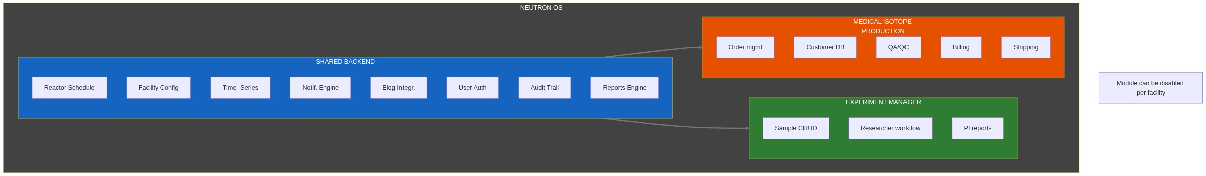
Shared code estimate: ~60% of backend logic is reusable between modules.
Document Status: Draft - Needs validation with NETL medical isotope program staff

