Table of Contents
Neutron OS — Executive Product Requirements
What is Neutron OS?
Who is it for?
Product Modules
Core Infrastructure
Application Modules
Future Modules
Module Architecture
Module Status Legend
Key Value Propositions
For Operations Staff
For Researchers
For Facility Management
Key Design Decisions
Streaming-First Philosophy
Deployment Architecture
Phased Rollout
Data Flow & Integration
Compliance & Safety Framework
Success Metrics (Platform-Wide)
Constituent PRDs
Core Infrastructure
Application Modules
Optional Modules
Module Feature Comparison
Module Interdependencies
Technical Foundation
Feedback & Stakeholder Input

Neutron OS — Executive Product Requirements
Nuclear Energy Unified Technology for Research, Operations & Networks
Property | Value
Version | 1.0
Last Updated | 2026-01-21
Status | Active
Product Owner | Ben Booth

What is Neutron OS?
Neutron OS is a modular digital platform for nuclear facilities that unifies data management, operations tracking, experiment scheduling, and analytics into a single system. It replaces fragmented workflows (paper logs, spreadsheets, phone calls, email calendars) with integrated digital tools.

Who is it for?
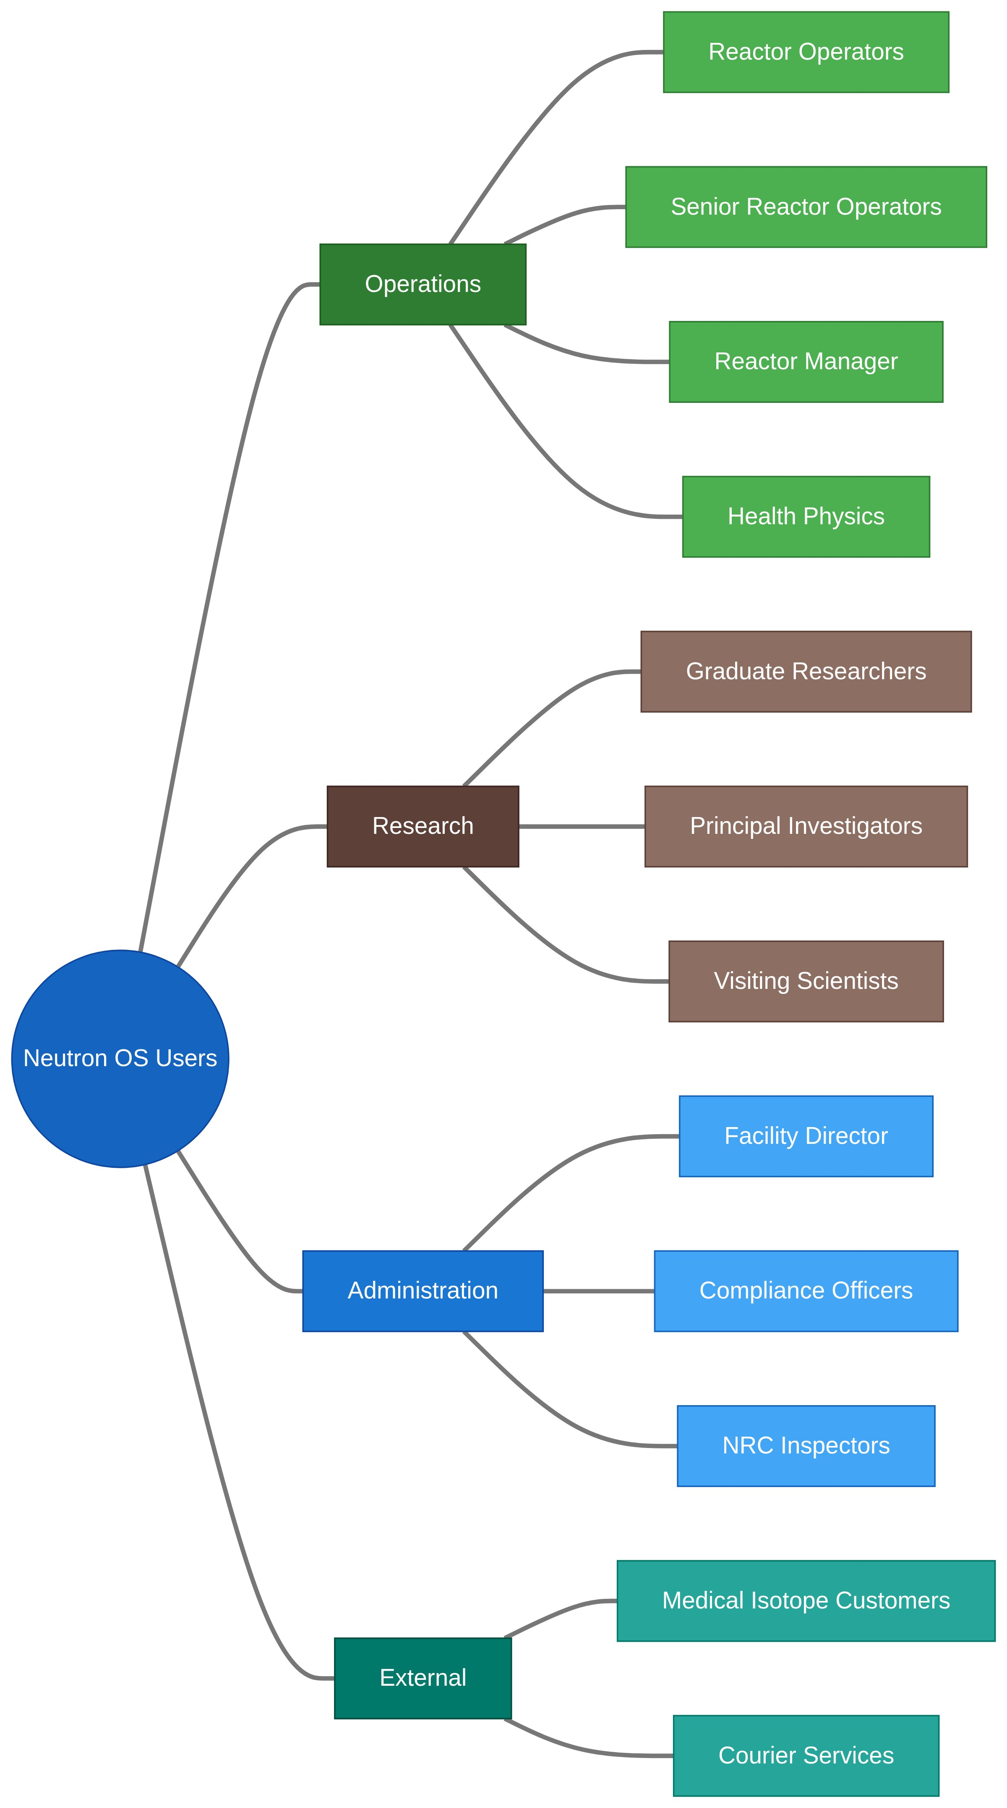

Product Modules
Neutron OS is modular. Facilities enable only what they need.

Core Infrastructure
Module | Purpose | PRD | Default
Core Platform | Data lakehouse, authentication, dashboards | Data Platform PRD | Required
Scheduling System | Cross-cutting time management, resource allocation | Scheduling System PRD | Required
Compliance Tracking | Cross-cutting regulatory monitoring, evidence generation | Compliance Tracking PRD | Required

Application Modules
Module | Purpose | PRD | Default
Reactor Ops Log | Operations logging, console checks, shift handoffs | Reactor Ops Log PRD | On
Experiment Manager | Sample lifecycle, metadata, results correlation | Experiment Manager PRD | On
Analytics Dashboards | Superset visualizations, KPIs, trending | Analytics PRD | On
Medical Isotope Production | Customer orders, QA/QC, shipping | Medical Isotope PRD | Off

Future Modules
Module | Purpose | PRD | Default
Training | Qualification tracking, requal scheduling, records | (future PRD) | Off
Personnel | Staff directory, certifications, contact info | (future PRD) | Off
Search / AI | RAG, workflow agents, tuned LLMs | (future PRD) | Off
Connections | External system integrations | (future PRD) | Off

This swimlane diagram shows how different users interact with Neutron OS throughout a typical week:
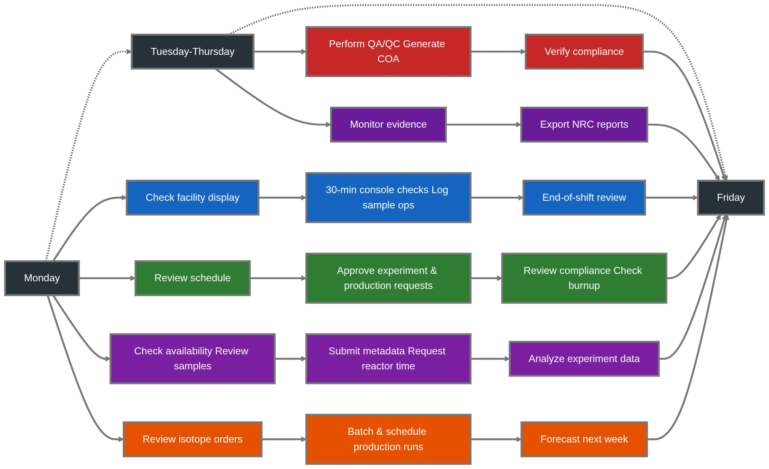

Module Architecture
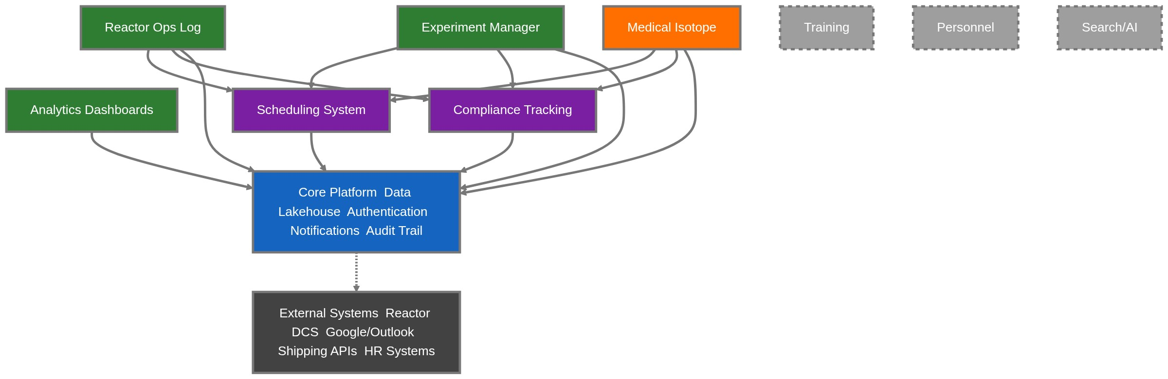

Module Status Legend
Symbol | Status | Description
🟢 Green | Priority | First release modules, enabled by default
🟠 Orange | Optional | First release modules, off by default
⬜ Grey Dashed | Future | Planned for later releases
🟣 Purple | Cross-cutting | Shared services used by multiple modules
🔵 Blue | Core | Required platform infrastructure
⬛ Dark Grey | External | Third-party integrations

Key Value Propositions

For Operations Staff
Pain Point | Neutron OS Solution
Paper logbooks are hard to search | Full-text search across all entries
30-minute checks sometimes missed | Timer alerts, gap detection dashboard
Shift handoffs lose context | Digital shift summary, persistent state
NRC inspection prep takes days | One-click evidence export

For Researchers
Pain Point | Neutron OS Solution
Scheduling via email is slow | Self-service time slot booking
Sample tracking in personal spreadsheets | Unified sample lifecycle management
"What were reactor conditions during my experiment?" | Automatic correlation with time-series data
Repeating experiment setup is tedious | Templates, smart defaults, AI assistance

For Facility Management
Pain Point | Neutron OS Solution
No visibility into facility utilization | Usage dashboards, capacity planning
Compliance gaps discovered during audits | Real-time compliance monitoring
Medical isotope orders via phone calls | Customer self-service portal
Revenue tracking in spreadsheets | Integrated billing and reporting

Key Design Decisions
Neutron OS architecture embodies several foundational decisions documented in our :Architecture Decision Records
Decision | Implication | ADR
Streaming-first architecture | Real-time is the default; batch processing for aggregations and fallback | ADR 007
Open lakehouse (Iceberg + DuckDB) | No vendor lock-in; on-premise deployment possible | ADR 003
Multi-facility via configuration | Same codebase serves NETL, NRAD, etc. with facility-specific settings | Tech Spec §1.5
Module-based architecture | Facilities enable only what they need; Medical Isotope off by default | This PRD

Streaming-First Philosophy
Designed for commercial reactor scale from day one.
As nuclear commercialization accelerates, fleet operators will manage dozens of units generating petabytes of telemetry. Streaming-first architecture enables:
- Fleet-wide anomaly detection — correlate signals across multiple units in real-time
- Instant operating limit propagation — safety parameter changes flow immediately to all systems
- Coordinated load-following — respond to grid demands across a fleet, not just one unit
- Graceful scaling — same architecture handles one research reactor or fifty commercial units
With streaming-first:
- 🟢 Live is the default — users assume data is current
- ⚠️ Stale warnings only appear when streaming is degraded
- Batch processing handles historical aggregations and disaster recovery

Deployment Architecture
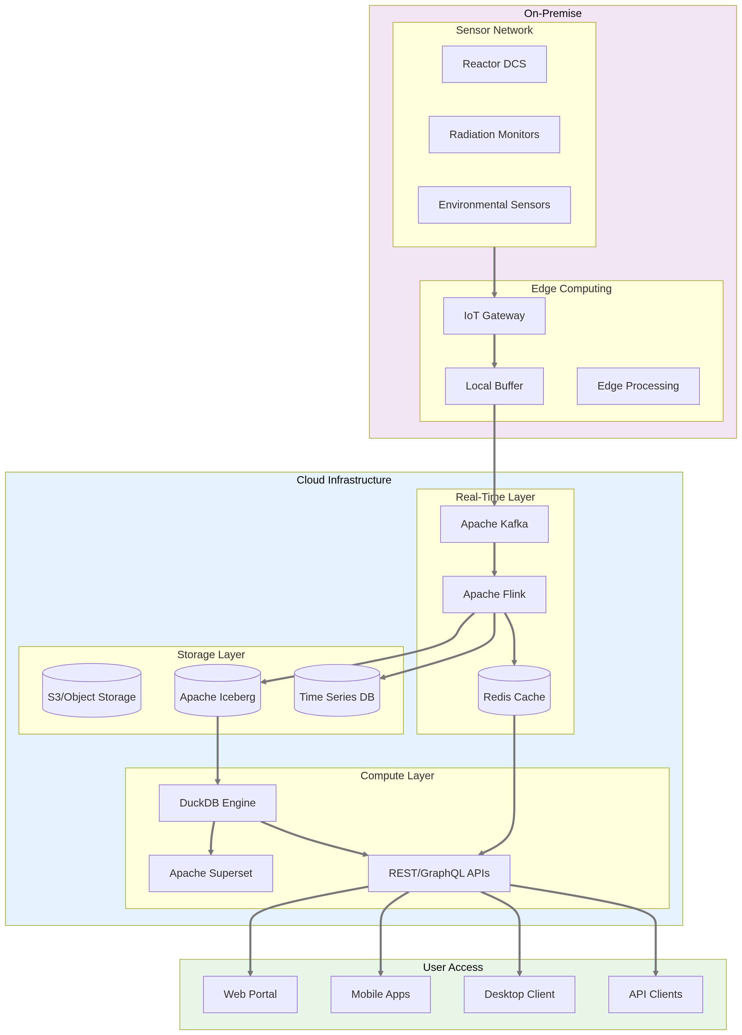

Phased Rollout
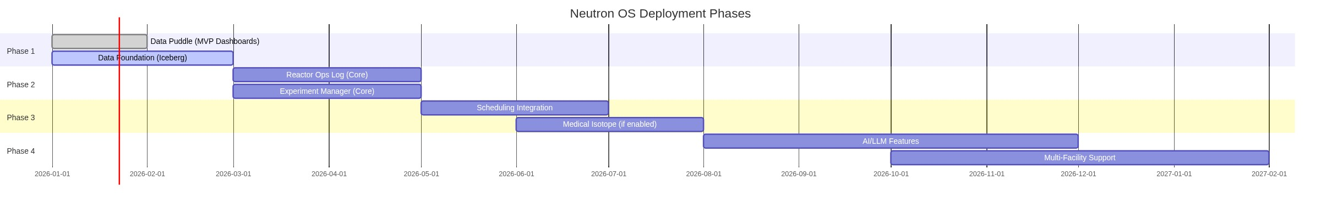

Data Flow & Integration
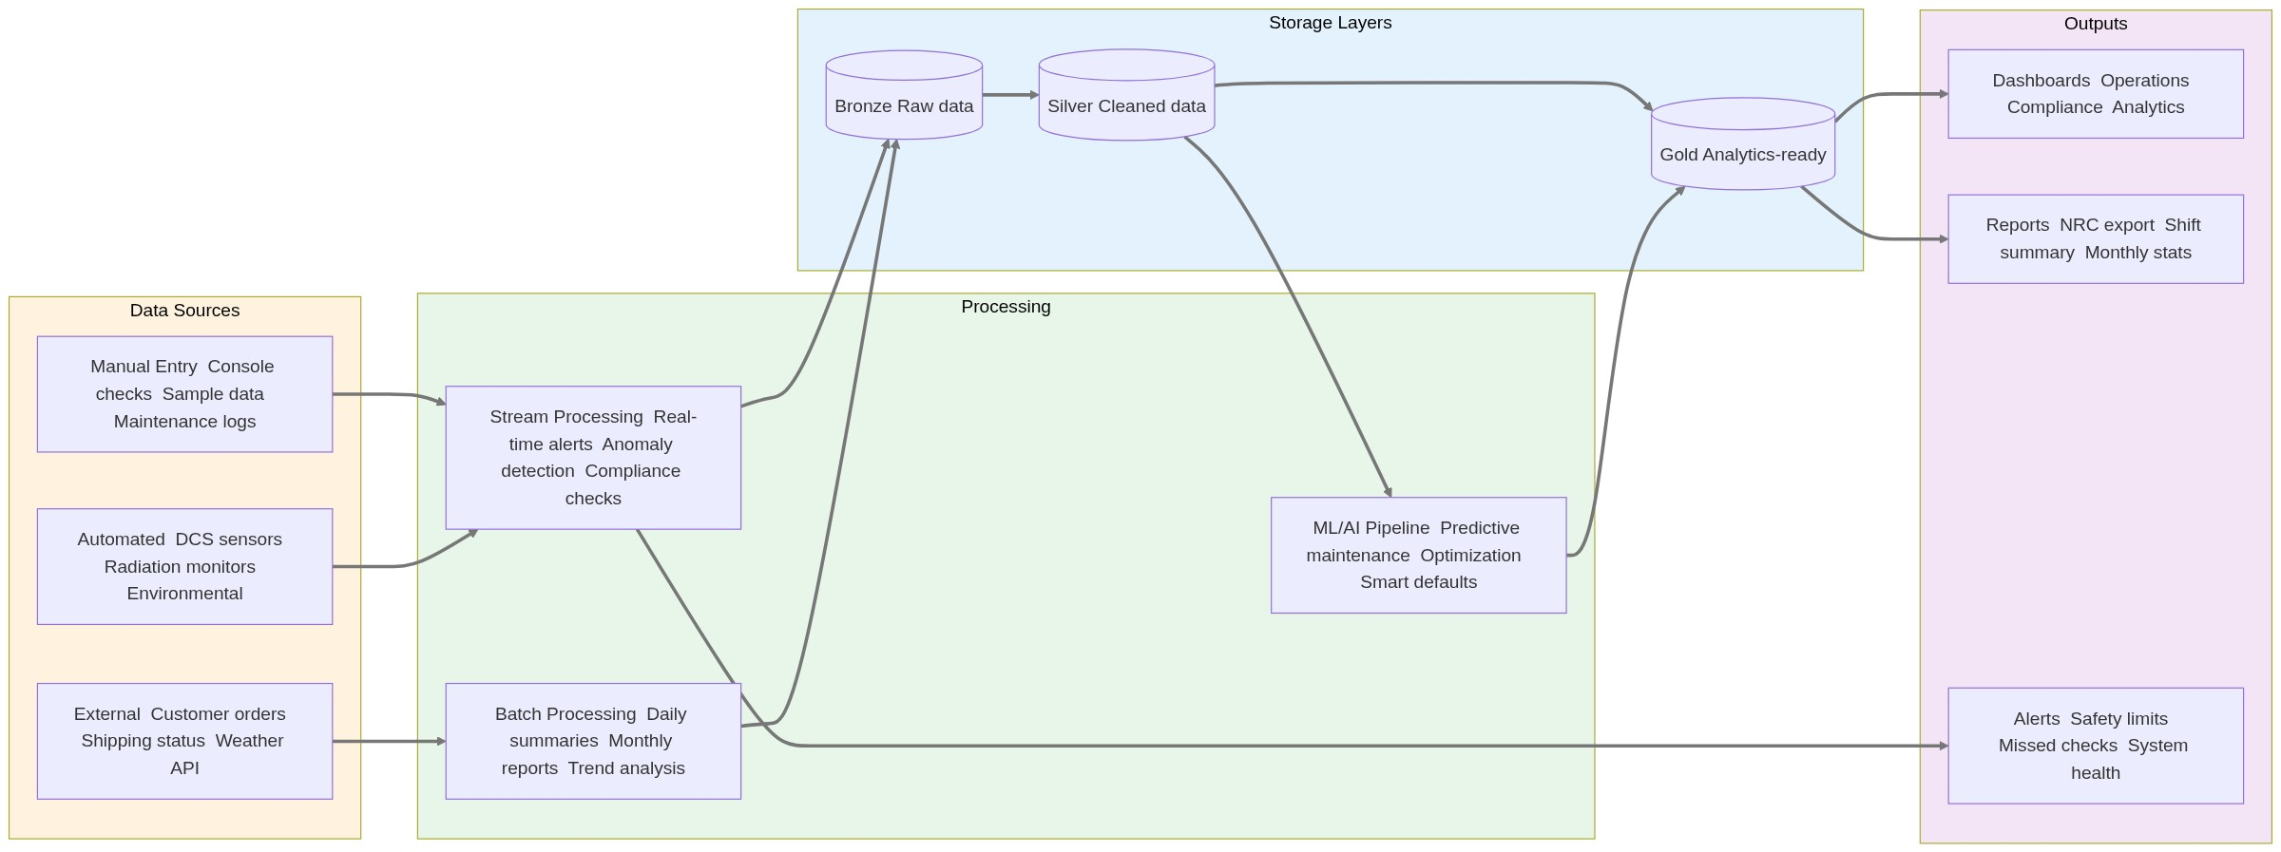

Compliance & Safety Framework
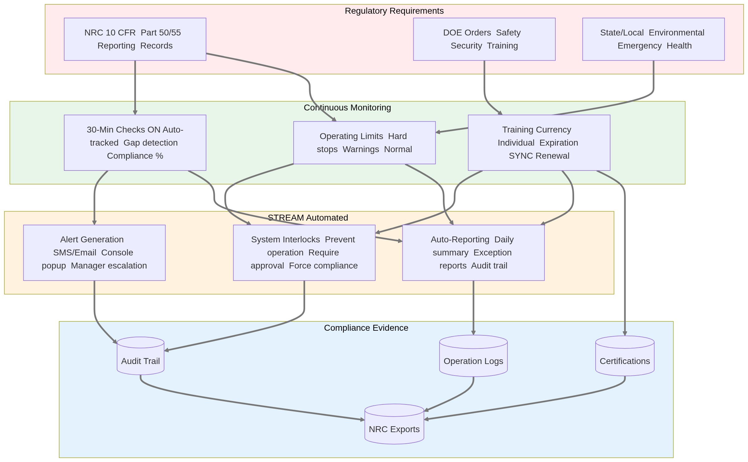

Success Metrics (Platform-Wide)
Metric | Target | Timeline
Adoption | 90% of daily operations use Neutron OS | 6 months post-launch
Data Entry Time | 50% reduction vs. current workflows | 6 months
Compliance Gaps | Zero missed 30-minute checks | 3 months
Self-Service Rate | 80% of scheduling via portal (not email) | 6 months
NRC Prep Time | 75% reduction in inspection prep | 12 months

Constituent PRDs
Each module has a detailed PRD with user stories, schemas, and mockups:

Core Infrastructure
- [Data Platform PRD](data-platform-prd.md)
○ Lakehouse architecture (Bronze/Silver/Gold)
○ Time-series ingestion
○ Query layer (DuckDB, Superset)
○ Streaming and batch processing
- [Scheduling System PRD](scheduling-system-prd.md) (Cross-Cutting)
○ Unified time slot management
○ Resource allocation and conflicts
○ Multi-module integration
○ Calendar synchronization
- [Compliance Tracking PRD](compliance-tracking-prd.md) (Cross-Cutting)
○ Regulatory monitoring (NRC, DOE)
○ 30-minute check enforcement
○ Evidence package generation
○ Real-time compliance dashboards

Application Modules
- [Reactor Ops Log PRD](reactor-ops-log-prd.md)
○ Console check logging
○ Shift handoffs and summaries
○ Maintenance tracking
○ Tamper-proof audit trail
- [Experiment Manager PRD](experiment-manager-prd.md)
○ Sample lifecycle tracking
○ Metadata and chain of custody
○ Results correlation
○ ROC authorization tracking
- [Analytics Dashboards PRD](analytics-dashboards-prd.md)
○ Reactor Operations dashboard
○ Utilization metrics
○ Fuel burnup visualization
○ Data quality monitoring

Optional Modules
- [Medical Isotope Production PRD](medical-isotope-prd.md)
○ Customer order portal
○ Production batching
○ QA/QC workflow
○ Shipping and delivery tracking

Module Feature Comparison
Module | Complexity | Business Value | Priority
Reactor Ops Log | Medium | Critical | First release
Experiment Manager | Medium | High | First release
Analytics Dashboards | Low | High | First release
Medical Isotope Production | High | Medium | Optional
Scheduling System | Low | Critical | Core infrastructure
Compliance Tracking | Low | Critical | Core infrastructure
Training Module | Medium | Medium | Future
AI/Search | Very High | High | Future
Personnel | Low | Low | Future

Module Interdependencies
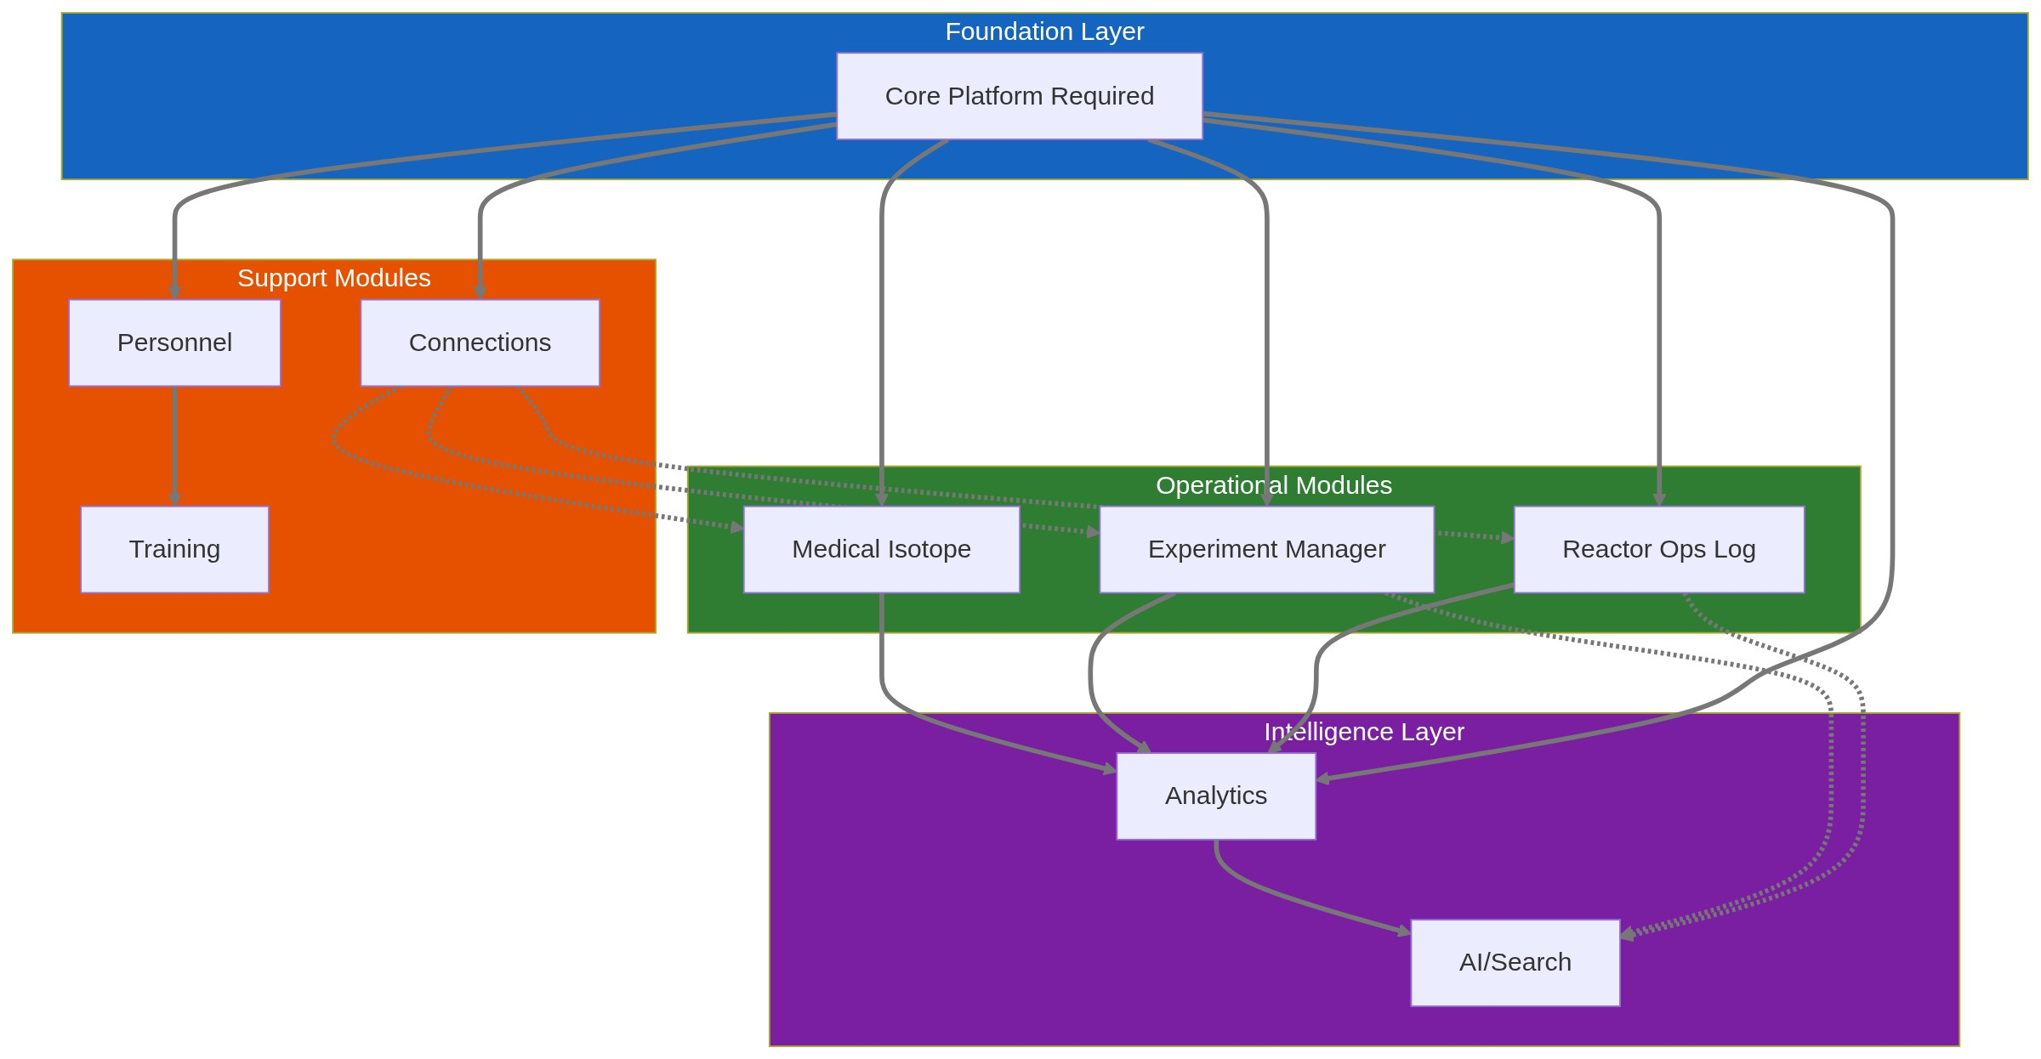

Technical Foundation
For technical architecture, schemas, and implementation details, see:
- [Neutron OS Master Tech Spec](../specs/neutron-os-master-tech-spec.md) — Full technical specification
- [Executive Technical Summary](../specs/neutron-os-executive-summary.md) — 2-page technical overview

Feedback & Stakeholder Input
This PRD incorporates feedback from:
Stakeholder | Role | Input Incorporated
Khiloni Shah | Post-Doctoral Nuclear Engineering Researcher | Experiment workflow, facility names, sample metadata
Jim (TJ) | NETL TRIGA Manager | Reactor Ops Log requirements, 30-min checks, compliance
Nick Luciano | Post-Doctoral Nuclear Engineering Researcher | Time-series data, security, dashboards

Document Status: Active — Updated with stakeholder feedback January 2026

