Table of Contents
Product Requirements Document: Reactor Ops Log
Executive Summary
Ops Log vs. Experiment Log: A Unified System
Background
Our Approach: Unified System, Separate Views
Why Combine?
User Stories (Unified System)
Entry Type Examples
User Journey Map
Reactor Operator: Daily Shift
Entry Lifecycle
Compliance Flow
Stakeholder Insights
Current State and Challenges (from Jim)
Mandatory Checks Gap
Regulatory Context
Tamper-Proof Requirements
Experiment Categories
User Stories
Primary Users
User Stories
Entry Types and Categories
Mandatory Entry Types
Optional Entry Types
Experiment Authorization Categories
Entry Tags (User-Assignable)
Data Schema
Entry Schema
Supplement Schema
Tamper-Evidence Implementation
Design Principles
Example: Correcting an Error
Mandatory Check Timer
Requirements
Gap Detection
Export Requirements
Export Formats
Export Filters
UI Mockup Concepts
Console View (Primary Interface During Operations)
Quick Console Check Entry
Entry Detail View (with Supplement)
Technical Requirements
Data Freshness & Real-Time Architecture
Performance
Reliability
Security
MVP Scope (Phase 1)
In Scope
Out of Scope (Future)
Implementation Recommendation
Open Questions
Success Metrics
Appendix: 10 CFR 50.9 Compliance Notes

Product Requirements Document: Reactor Ops Log
Module: Reactor Ops Log Status: Draft Last Updated: January 22, 2026 Stakeholder Input: Jim (TJ), Nick Luciano (Jan 2026) Parent: Historical Reference: Previously referred to as "elog" in some contextsExecutive PRD

Executive Summary
The Reactor Ops Log captures reactor operations events, mandatory safety checks, and operational notes in a tamper-evident format that satisfies NRC regulatory requirements. It replaces the current paper-based console logbook with a digital system that maintains 10 CFR 50.9 compliance while enabling searchability, correlation with time-series data, and export for inspection.

Ops Log vs. Experiment Log: A Unified System

Background
Historically at NETL, Jim maintains two separate physical logbooks:
- Reactor Ops Log — Console operations, 30-minute checks, startups/shutdowns, anomalies
- Reactor Experiment Log — Experiment activities, sample insertions/removals, research notes
This separation exists due to physical logistics (different binders at different locations), not regulatory mandate. NRC cares about completeness and tamper-evidence, not which binder an entry lives in.

Our Approach: Unified System, Separate Views
Neutron OS combines both logs into a single system with:
- Entry type classification: Each entry is tagged as OPS or EXPERIMENT (or both)
- Filtered views: Users can view Ops-only, Experiment-only, or combined chronological
- Seamless navigation: One-click toggle between views; cross-references visible in both
- Single search: Find any entry regardless of type
- Unified audit trail: All entries share the same tamper-evident infrastructure

Why Combine?
Benefit | Description
Correlation | Ops events and experiment activities are often related—see both in context
Single source of truth | No confusion about which log to check
Simpler compliance | One export for NRC, filterable as needed
Reduced duplication | Operators don't log the same event in two places
Training efficiency | One system to learn, one interface

User Stories (Unified System)
- As a reactor operator, I want to quickly toggle between Ops view and All Entries view so I can focus on console operations but still see experiment context when needed.
- As a researcher, I want to filter to Experiment entries for my samples while still seeing relevant Ops entries (startups, power changes) that affected my irradiation.
- As an NRC inspector, I want to export all entries for a date range and filter by type as needed during review.

Entry Type Examples
Entry | Type | Notes
30-minute console check | OPS | Mandatory operational
Reactor startup | OPS | Operational milestone
Sample insertion (NAA-042) | EXPERIMENT | Researcher activity
Sample removal with dose rate | OPS + EXPERIMENT | Both (ops performed, experiment record)
Power change for experiment | OPS | Operational, but linked to experiment
Anomaly during irradiation | OPS + EXPERIMENT | Safety-relevant to both

User Journey Map

Reactor Operator: Daily Shift
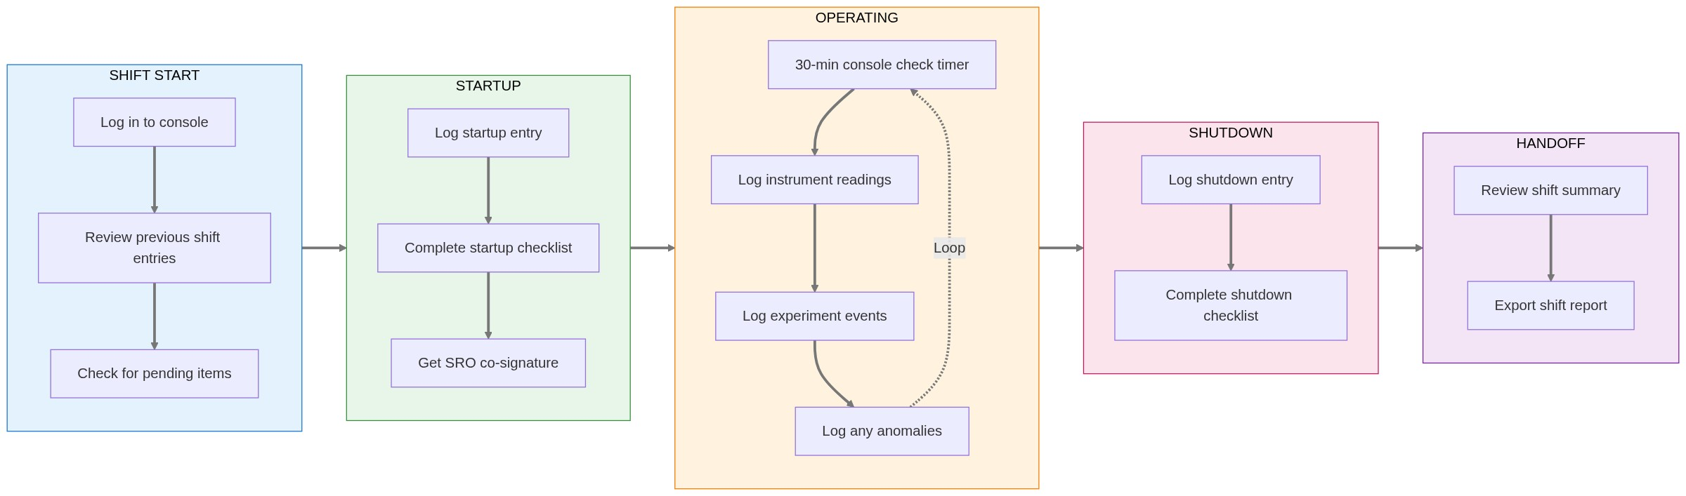

Entry Lifecycle
⚠️ Diagram rendering failed

Compliance Flow
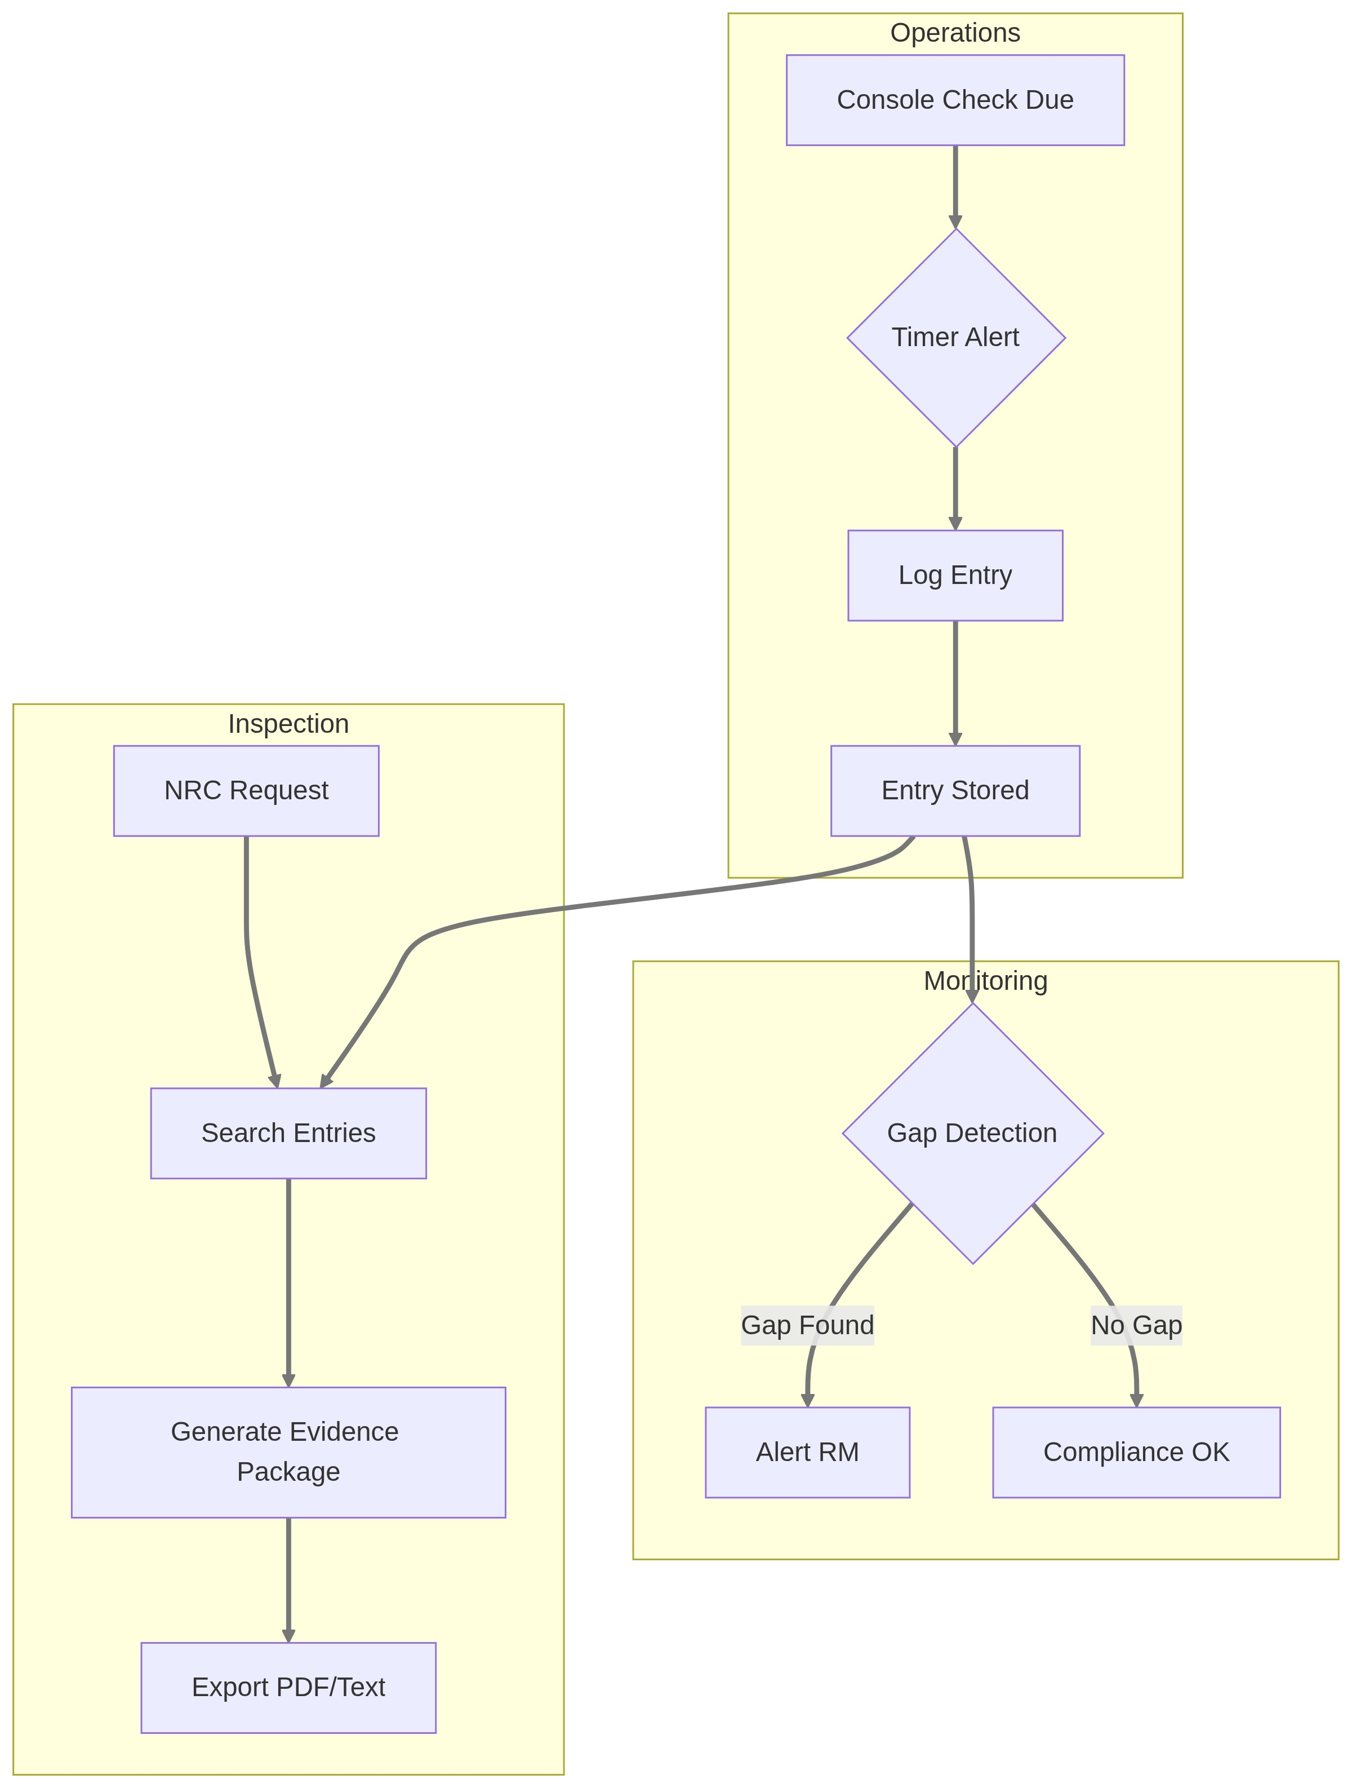

Stakeholder Insights

Current State and Challenges (from Jim)
"We have attempted to use the elog software as a training exercise to familiarize ourselves with digital/electronic elog software. We found that it is a steep learning curve for the 'older' ops staff. I believe it would be useful to have a modeler/designer come to the NETL and investigate and review our current system. Perhaps we could have a designer come to the NETL while operating and then design/massage the elog software according to our users' needs."
Note: "elog" here refers to third-party electronic logbook software Jim evaluated, not Neutron OS.

Mandatory Checks Gap
"A gap would mean that the :30 minute check was not performed when operating. When operating at the NETL, we are required to perform a console 'walkdown' every 30 minutes. During this check, we take readings from various instruments and log them in the elog."
Note: "elog" here refers to the reactor operations logbook, now the Reactor Ops Log in Neutron OS.

Regulatory Context
"NRC inspects documents yearly... they normally only look at half of the records, and we don't have to go back past the 2 years of operation in many cases. They prefer electronic documents."
Key Compliance Numbers (from Jim):
- Inspection periodicity: NRC inspects half of records each year (effectively 2-year coverage)
- Evidence package scope: 2 years of operational records
- Preferred format: Electronic (PDF + plain text archive)
- Operator requalification: 4 hours/quarter minimum console time required

Tamper-Proof Requirements
"Supplemental comments. The only way to 'edit' an entry should be a supplement. No deleting an entry—you should simply be able to add a supplement which identifies and corrects the mistake."

Experiment Categories
"We have a schedule of Authorized Experiments. These experiments are authorized by the ROC (Reactor Oversight Committee) after review through NETL Staff (Reactor Manager/HP/Director - Then ROC chair). Routine Experiments are performed as they are covered under an Authorized Experiment."

User Stories

Primary Users
User | Need
Reactor Operator (RO) | Log events quickly without disrupting console attention
Senior Reactor Operator (SRO) | Review and co-sign entries, see shift summary
Reactor Manager (RM) | Review logs, authorize routine experiments, generate reports
NRC Inspector | Search and export records for compliance verification
Health Physics (HP) | Access radiation survey entries, correlate with dosimetry

User Stories
- As a reactor operator, I want to log the 30-minute console check with minimal clicks so that I can return attention to the console quickly.
- As a reactor operator, I want a timer/reminder for mandatory checks so that I don't miss the 30-minute window.
- As a SRO, I want to see all entries from my shift in chronological order so that I can review before sign-off.
- As a RM, I want to be alerted if mandatory checks are missed so that I can follow up.
- As an NRC inspector, I want to search entries by date range, category, and operator so that I can efficiently review records.
- As any user, I want to add supplemental comments to correct errors without modifying the original entry so that the audit trail is preserved.
- As a reactor manager, I want to track each operator's console hours per quarter so that I can ensure they meet the 4-hour/quarter minimum for requalification.
- As a reactor manager, I want to generate NRC evidence packages covering the most recent 2 years of records so that I can efficiently prepare for inspections.

Entry Types and Categories
Based on stakeholder feedback:

Mandatory Entry Types
Type | Trigger | Required Fields | Interval
CONSOLE_CHECK | Timer / Manual / Auto-sense (TBD) | Instrument readings, operator initials | Every 30 min while operating
STARTUP | Manual | Startup checklist items, authorization | Per startup
SHUTDOWN | Manual | Shutdown reason, checklist | Per shutdown
SCRAM | Manual (or auto-triggered) | Cause, rod positions, recovery actions | Per event
RADIATION_SURVEY | Manual | Location, reading, instrument | Per survey

Optional Entry Types
Type | Use Case
EXPERIMENT_LOG | Experiment start/stop, sample insertion/removal
MAINTENANCE | Equipment issues, repairs, calibrations
VISITOR | Visitor log entries
GENERAL_NOTE | Anything not fitting other categories
SUPPLEMENT | Correction/addition to existing entry
EXCESS_REACTIVITY | Burnup measurement via excess reactivity after long shutdown
DOSE_RATE | Radiation survey results, dose rate measurements

Experiment Authorization Categories
From Jim:
Category | Approval Level | Description
Authorized Experiment | ROC (Reactor Oversight Committee) | Full safety review through RM/HP/Director chain
Routine Experiment | RM or SSRO | Covered under existing Authorized Experiment

Entry Tags (User-Assignable)
From Jim: Categories help with searchability and NRC inspection preparation.
Tag | Use Case | Example
pnt-sample | Pneumatic transfer operations | Sample insertion/removal via TPNT/EPNT
excess-reactivity | Core performance tracking | Post-shutdown reactivity measurement (~-49 cents)
dose-rate | Radiation protection | Frisker readings, survey results
startup | Reactor mode change | Criticality approach, power ascension
shutdown | Reactor mode change | Planned or unplanned shutdown
maintenance | Equipment-related | Calibrations, repairs, replacements
visitor | Personnel tracking | Tours, inspections, vendor visits

Data Schema

Entry Schema
entry:
id: uuid (system-generated)
entry_number: integer (sequential within year, e.g., 2026-001)
timestamp: datetime (system clock, immutable)
entry_type: enum (see types above)
author_id: uuid (logged-in operator)
author_name: string (display name)
co_signer_id: uuid (optional, for dual-sign entries)
# Content
title: string (brief summary)
body: text (detailed entry)
# Structured data (type-dependent)
instrument_readings: json (for CONSOLE_CHECK)
checklist_items: json (for STARTUP/SHUTDOWN)
# Metadata
reactor_mode: enum (shutdown, startup, steady-state, power-change)
reactor_power_kw: decimal (auto-populated from time-series)
# Supplements
supplements: array of supplement objects
# Audit
created_at: datetime
ip_address: string (for audit trail)
signature_hash: string (cryptographic verification)

Supplement Schema
supplement:
id: uuid
parent_entry_id: uuid
timestamp: datetime
author_id: uuid
author_name: string
reason: enum (correction, clarification, addition)
body: text
signature_hash: string

Tamper-Evidence Implementation
Per Jim's requirement ("No deleting an entry—you should simply be able to add a supplement"):

Design Principles
- Append-only storage: Entries are INSERT-only. No UPDATE or DELETE operations on entry content.
- Cryptographic signatures: Each entry is hashed with the previous entry's hash (blockchain-style chain), making retroactive modification detectable.
- Supplements for corrections: Any modification is captured as a linked supplement with its own timestamp and author.
- Audit log: All access (read/write) is logged with user ID, timestamp, and IP address.

Example: Correcting an Error
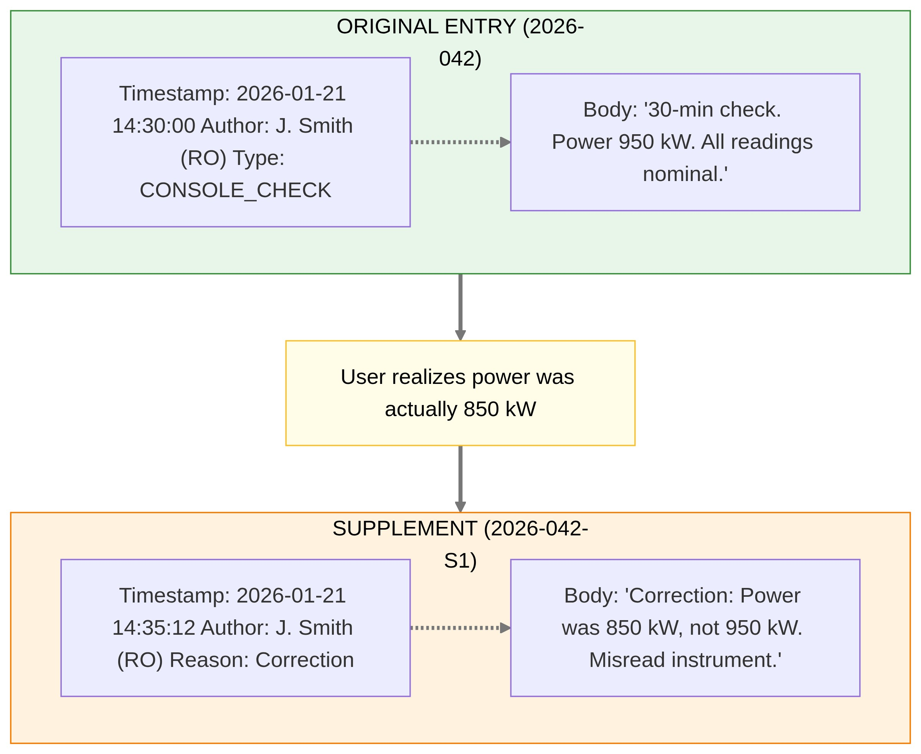

Mandatory Check Timer

Requirements
- Visual countdown timer showing time until next mandatory check
- Audible alert at 25 minutes (5-minute warning) and 30 minutes (deadline)
- Entry form pre-populated when timer triggers
- Dashboard indicator showing "missed checks" count per shift

Gap Detection
From Jim: "A gap would mean that the :30 minute check was not performed when operating."
Detection logic:
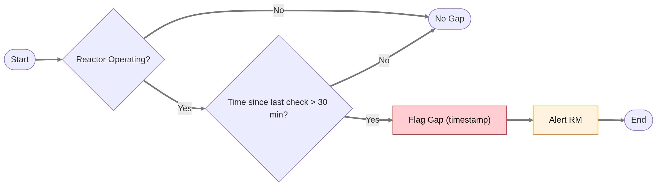
Dashboard alert:
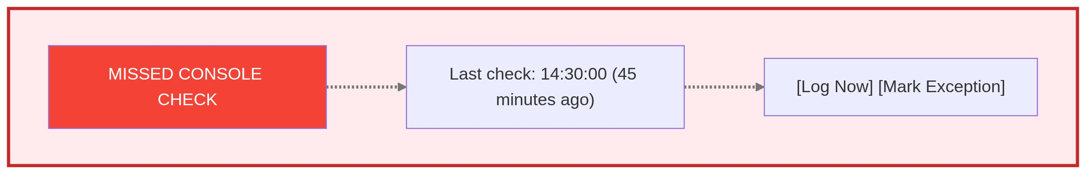

Export Requirements
From Jim: "Export to PDF would work, but a simple text file for archive and future proof would also work."

Export Formats
Format | Use Case | Contents
PDF | NRC inspection, official records | Formatted, includes signatures, page numbers
Plain Text | Archive, future-proofing | Human-readable, no proprietary format dependencies
CSV | Analysis, data mining | Structured, importable to spreadsheets
JSON | API integration, backups | Machine-readable, includes all metadata

Archive Integrity (from Jim):
"Concerned about software failure/migration. Text archives could be modified."
Design Response:
- PDF exports include cryptographic signatures (verifiable)
- Plain text archives include SHA-256 checksums
- Both formats exported together for redundancy
- Checksums stored in tamper-evident audit trail (Hyperledger)
- Regular automated export to long-term storage (prevents software dependency)

Export Filters
- Date range
- Entry type(s)
- Author(s)
- Keyword search
- Include/exclude supplements

UI Mockup Concepts

Console View (Primary Interface During Operations)
┌─────────────────────────────────────────────────────────────────────┐
│ NETL OPERATIONS LOG [2026-01-21] [Shift: Day] │
│ Operator: J. Smith (RO) ┌────────────────────────────────┐ │
│ Power: 950 kW │ NEXT CHECK IN: 12:45 │ │
│ Status: OPERATING │ ████████████░░░░░░░░░ [Log] │ │
│ └────────────────────────────────┘ │
├─────────────────────────────────────────────────────────────────────┤
│ │
│ [+ New Entry ▼] [Console Check] [Experiment] [General Note] │
│ │
│ ═══════════════════════════════════════════════════════════════ │
│ RECENT ENTRIES │
│ ═══════════════════════════════════════════════════════════════ │
│ │
│ 14:30 │ CONSOLE_CHECK │ 30-min check. All readings nominal. │
│ │ J. Smith │ [Detail] │
│ ───────────────────────────────────────────────────────────────── │
│ 14:15 │ EXPERIMENT │ Sample Au-foil-042 inserted in TPNT. │
│ │ J. Smith │ Ops Request 4521. [Detail] │
│ ───────────────────────────────────────────────────────────────── │
│ 14:00 │ CONSOLE_CHECK │ 30-min check. Power raised to 950 kW. │
│ │ J. Smith │ [Detail] │
│ ───────────────────────────────────────────────────────────────── │
│ 13:30 │ STARTUP │ Startup complete. Reaching 500 kW. │
│ │ J. Smith │ Co-signed: M. Jones (SRO) [Detail] │
│ │
└─────────────────────────────────────────────────────────────────────┘

Quick Console Check Entry
┌─────────────────────────────────────────────────────────────────────┐
│ 30-MINUTE CONSOLE CHECK [Cancel] [X]│
├─────────────────────────────────────────────────────────────────────┤
│ │
│ Time: 15:00:00 (auto) Power: 950 kW (auto from DCS) │
│ │
│ ┌─────────────────────────────────────────────────────────────┐ │
│ │ INSTRUMENT READINGS (auto-populated where available) │ │
│ ├─────────────────────────────────────────────────────────────┤ │
│ │ Channel A: [___] % Channel B: [___] % │ │
│ │ Pool Temp: [___] °F Coolant Temp: [___] °F │ │
│ │ Rod A: [___] % Rod B: [___] % │ │
│ └─────────────────────────────────────────────────────────────┘ │
│ │
│ Notes: [All readings nominal____________________________] │
│ │
│ ☑ I have performed a physical console walkdown │
│ │
│ [Submit] │
└─────────────────────────────────────────────────────────────────────┘

Entry Detail View (with Supplement)
┌─────────────────────────────────────────────────────────────────────┐
│ ENTRY 2026-042 [Back] [PDF]│
├─────────────────────────────────────────────────────────────────────┤
│ │
│ Type: CONSOLE_CHECK │
│ Timestamp: 2026-01-21 14:30:00 │
│ Author: J. Smith (RO) │
│ Reactor Power: 950 kW │
│ │
│ ─────────────────────────────────────────────────────────────── │
│ CONTENT │
│ ─────────────────────────────────────────────────────────────── │
│ 30-minute console check. Power 950 kW. All readings nominal. │
│ Channel A: 48%, Channel B: 47% │
│ │
│ ─────────────────────────────────────────────────────────────── │
│ ⚠️ SUPPLEMENT (2026-01-21 14:35:12) │
│ ─────────────────────────────────────────────────────────────── │
│ Author: J. Smith (RO) │
│ Reason: Correction │
│ │
│ Correction: Power was 850 kW, not 950 kW. Misread instrument. │
│ │
│ ─────────────────────────────────────────────────────────────── │
│ [Add Supplement] │
│ │
│ Signature Hash: a3f8c2...d91e (verified ✓) │
└─────────────────────────────────────────────────────────────────────┘

Technical Requirements

Data Freshness & Real-Time Architecture
Design Decision: Streaming-first architecture. Real-time is the default; batch for aggregations and fallback.
See ADR 007
Reactor Ops Log Latency Targets:
Feature | Target Latency | Implementation | Priority
Entry sync across consoles | <500ms | WebSocket push | 🔴 High
30-minute check timer | <100ms | Real-time shared countdown | 🔴 High
Concurrent editing awareness | <200ms | Live "Nick is typing..." via WebSocket | 🔴 High
Search results | <2s | Near-real-time indexed | 🟡 Medium
Compliance gap alerts | <30s | Streaming alert push | 🟡 Medium
Historical aggregations | Minutes | Batch job (Dagster) | 🟢 Low

UI Pattern: Live is the default. Warnings appear only when streaming is degraded:
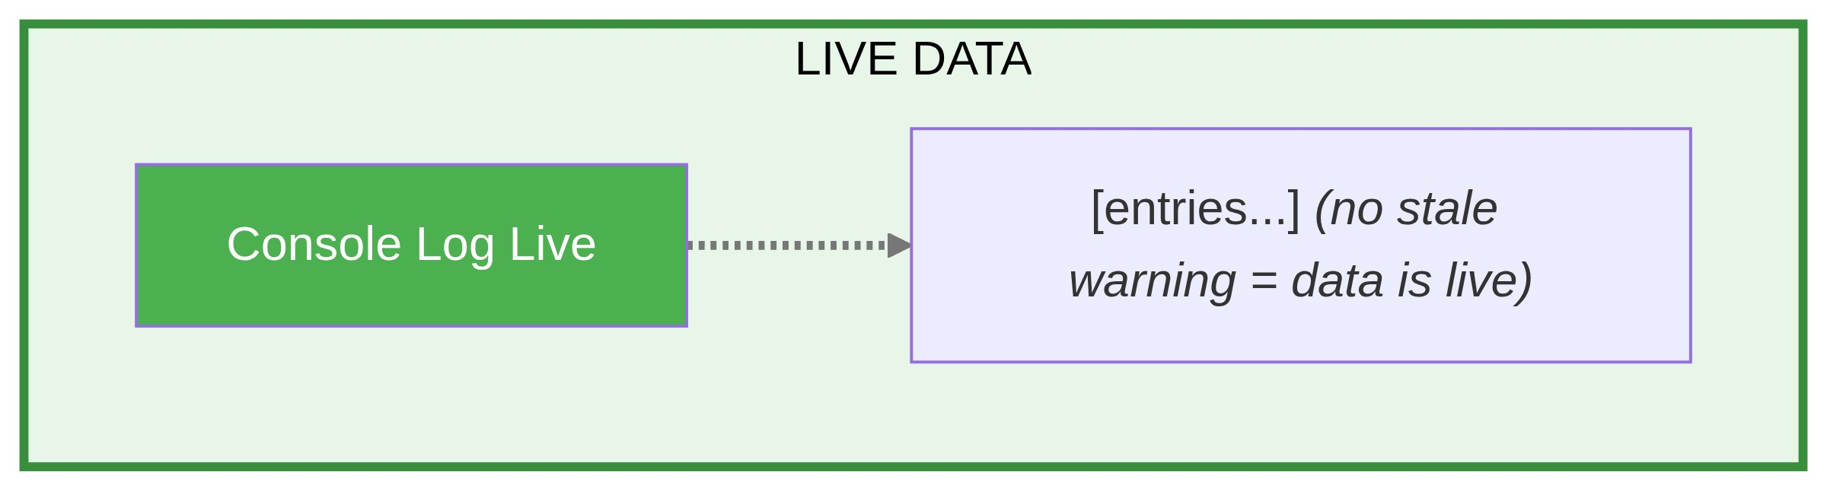

Performance
- Entry submission < 1 second (operators cannot wait during operations)
- Search results < 3 seconds for 2-year date range
- Export PDF < 10 seconds for 1-month range

Reliability
- Offline-capable: Must function if network is temporarily unavailable
- Local cache syncs when connectivity restored
- No data loss scenario acceptable

Security
- Authentication required (linked to facility badge/credentials)
- Role-based access: RO can create entries; RM can view all and generate reports
- All access logged for audit

MVP Scope (Phase 1)

In Scope
- Basic entry creation (CONSOLE_CHECK, STARTUP, SHUTDOWN, GENERAL_NOTE)
- Supplement addition (no edit/delete of originals)
- 30-minute timer with alerts
- Export to PDF and plain text
- Search by date, type, author

Out of Scope (Future)
- Auto-population from DCS instruments
- Offline mode with sync
- Digital signature (cryptographic)
- Integration with experiment manager
- Mobile interface

Implementation Recommendation
From Jim:
"Perhaps we could have a designer come to the NETL while operating and then design/massage the elog software according to our users' needs."
Proposed approach:
- Deploy minimal prototype (console check only)
- Designer/developer spends 2-3 operating days at NETL console
- Iterate based on real-world usage
- Expand to other entry types after validation

Open Questions
- Instrument readings: Which specific instruments are read during console checks? Can any be auto-populated from DCS?
- Dual signatures: Which entry types require SRO co-signature?
- Existing records: Should historical paper logs be digitized, or start fresh?
- Badge integration: Can we authenticate via existing facility badge system?
- Offline behavior: How long can the console be offline before operations must pause?
- Automatic console check sensing (TBD - Design exploration needed):
○ The legacy 1990s console view in the operations room is driven by data we can access
○ Question: Can we automatically sense when console checks occur (via data tap) and auto-populate the Ops Log instead of requiring manual entry?
○ Rationale: Eliminates dual-entry requirement (console data + ops log entry)
○ Scope: Determine feasibility with console software status, data interface availability, and validation requirements
○ Next step: Explore UI/UX workflows for auto-sensed vs. manual vs. hybrid entry modes
○ Design Document: See for 4 proposed workflow alternatives and recommendationsConsole Check UI/UX Mockups

Success Metrics
Metric | Target | Measurement
Missed check alerts | 0 gaps per month | System gap detection
Entry time | < 30 seconds for console check | Timing analytics
NRC inspection prep time | Reduced by 75% | Staff survey
Adoption | 100% of operating shifts using digital log within 3 months | Usage tracking

Appendix: 10 CFR 50.9 Compliance Notes
The Operations Log must satisfy NRC requirements for:
- Completeness: All required operating data recorded
- Accuracy: Information is correct; corrections are traceable
- Availability: Records accessible for inspection (2+ year retention)
- Authenticity: Can verify entries were made by authorized personnel at stated times
The supplement-based correction model and cryptographic chaining specifically address the "no modification without trace" requirement.
Document Status: Ready for on-site validation and technical review

