Table of Contents
Product Requirements Document: Scheduling System
Executive Summary
System Architecture
User Journey: Multi-Module Scheduling
Resource Types & Constraints
Schedulable Resources
Scheduling Rules Engine
Integration Points
Module Interfaces
External Integrations
User Stories
Schedule Requesters
Schedule Managers
Schedule Consumers
Display Requirements
Facility Entrance Display
Console 4-Hour View
Success Metrics
Technical Requirements
Performance
Reliability
Security
Implementation Phases
Phase 1: Core Scheduling (Months 1-2)
Phase 2: Module Integration (Months 2-3)
Phase 3: Advanced Features (Months 3-4)
Phase 4: Intelligence (Months 4-6)

Product Requirements Document: Scheduling System
Module: Cross-Cutting Scheduling Infrastructure Status: Draft Last Updated: January 22, 2026 Stakeholder Input: Jim (TJ), Khiloni Shah, Nick Luciano Related Modules: , , Parent: Experiment ManagerReactor Ops LogMedical IsotopeExecutive PRD

Executive Summary
The Scheduling System is a cross-cutting concern that provides unified time management across all Neutron OS modules. It handles reactor time allocation, facility bookings, staff assignments, maintenance windows, and regulatory inspection scheduling. Rather than each module implementing its own scheduling logic, this centralized system ensures consistency, prevents conflicts, and provides holistic visibility.
Key Principle: Scheduling is about time slot allocation and conflict resolution, not about the specifics of what happens in those slots. The Experiment Manager, Reactor Ops Log, and other modules consume scheduling services but don't own them.

System Architecture
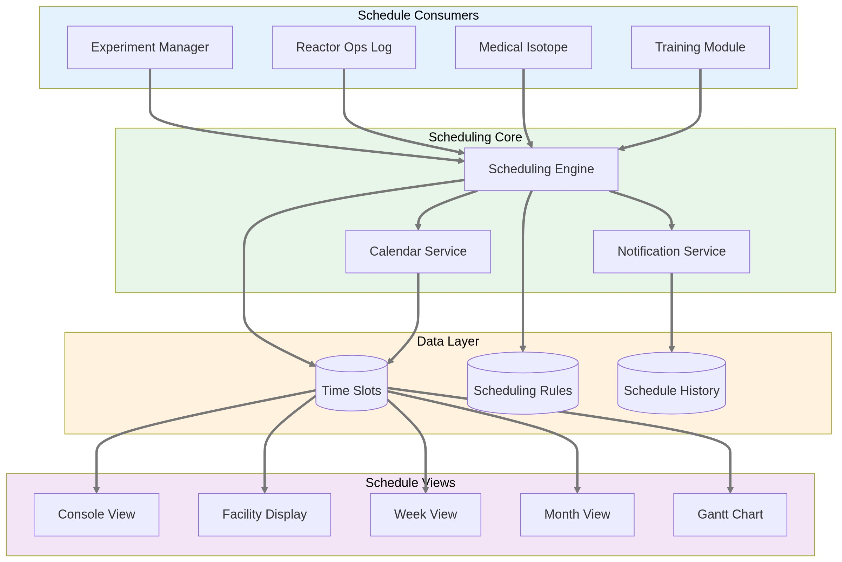

User Journey: Multi-Module Scheduling
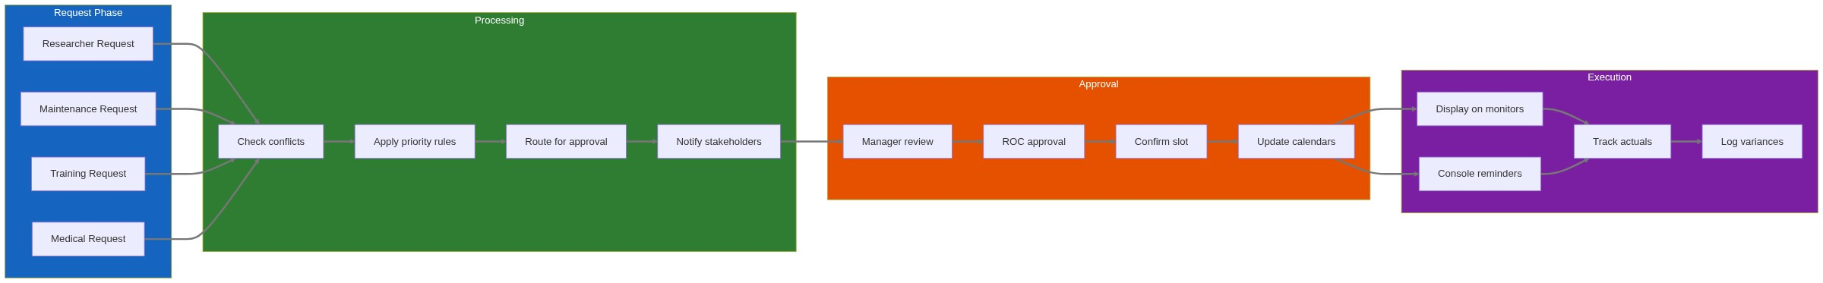

Resource Types & Constraints

Schedulable Resources
Resource Type | Examples | Constraints | Priority
Reactor Time | Core operations, power levels | Safety limits, maintenance windows | Critical
Facilities | Beam ports, pneumatic rabbit, thermal column | One experiment at a time | High
Staff | SRO on console, HP coverage | Certification requirements, shift limits | Critical
Equipment | Detectors, hot cells, glove boxes | Calibration status, availability | Medium
Spaces | Labs, conference rooms, training areas | Capacity limits, safety requirements | Low

Scheduling Rules Engine
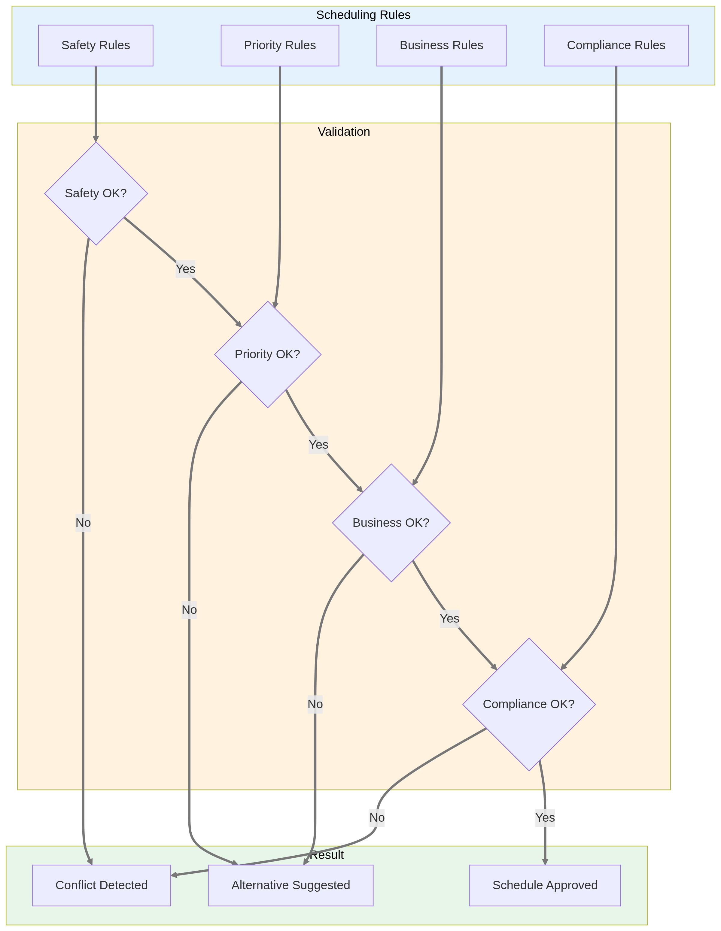

Integration Points

Module Interfaces
Each module interacts with the Scheduling System through defined interfaces:
Module | Provides to Scheduler | Receives from Scheduler
Experiment Manager | Sample metadata, duration estimates, facility needs | Approved time slots, conflict notifications
Reactor Ops Log | Maintenance windows, shift schedules | Upcoming events, staff assignments
Medical Isotope | Production requirements, shipping deadlines | Batch scheduling, resource allocation
Training | Requalification needs, course schedules | Available slots, compliance tracking
Personnel | Staff availability, certification status | Shift assignments, coverage gaps

External Integrations
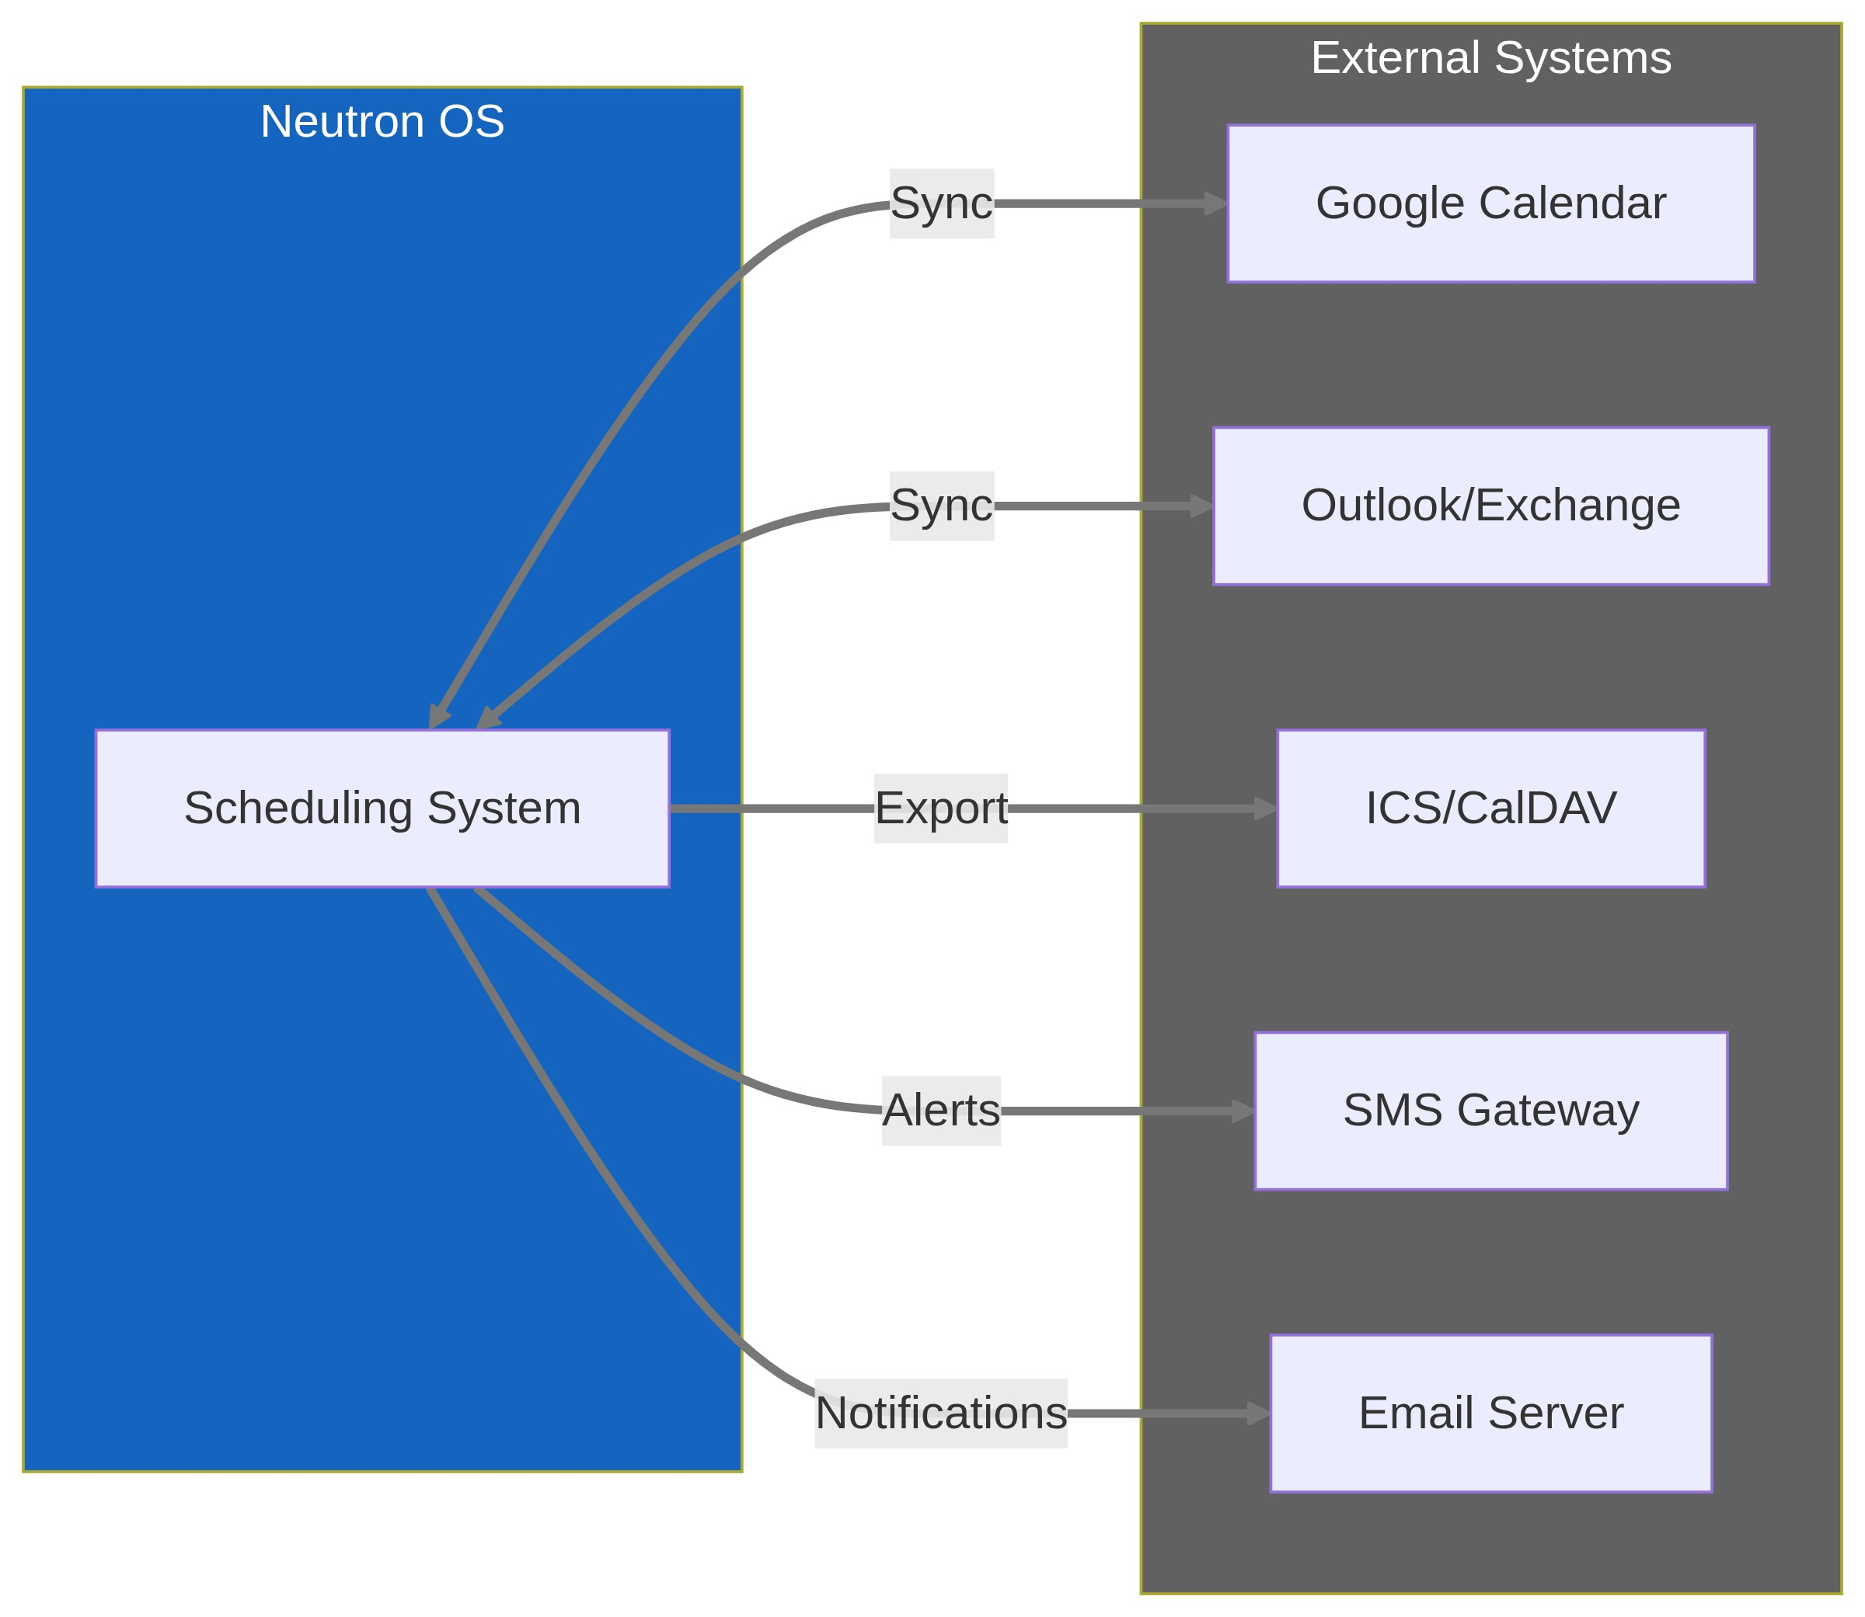

User Stories

Schedule Requesters
- As a researcher, I want to see all available reactor time slots for next week so I can plan my experiment.
- As a maintenance engineer, I want to block out 4 hours for pump replacement with automatic notifications to affected users.
- As a training coordinator, I want to ensure each operator gets their 4 hours/quarter requalification scheduled before deadlines.
- As a medical isotope customer, I want to see available production slots that meet my delivery requirements.

Schedule Managers
- As a reactor manager, I want to review all pending schedule requests in one place with conflict indicators.
- As a reactor manager, I want to set recurring maintenance windows (e.g., "Every Tuesday 6-8 AM") that automatically block scheduling.
- As a shift supervisor, I want to see staffing levels for next week to identify coverage gaps.
- As a facility director, I want monthly utilization reports showing scheduled vs. actual usage by category.

Schedule Consumers
- As a reactor operator, I want to see the next 4 hours of scheduled activities on my console display.
- As any staff member, I want to see today's facility schedule on the entrance display when I arrive.
- As a researcher, I want automatic email/SMS reminders 24 hours before my scheduled reactor time.
- As a compliance officer, I want to verify that all required training was completed within regulatory timeframes.

Display Requirements

Facility Entrance Display
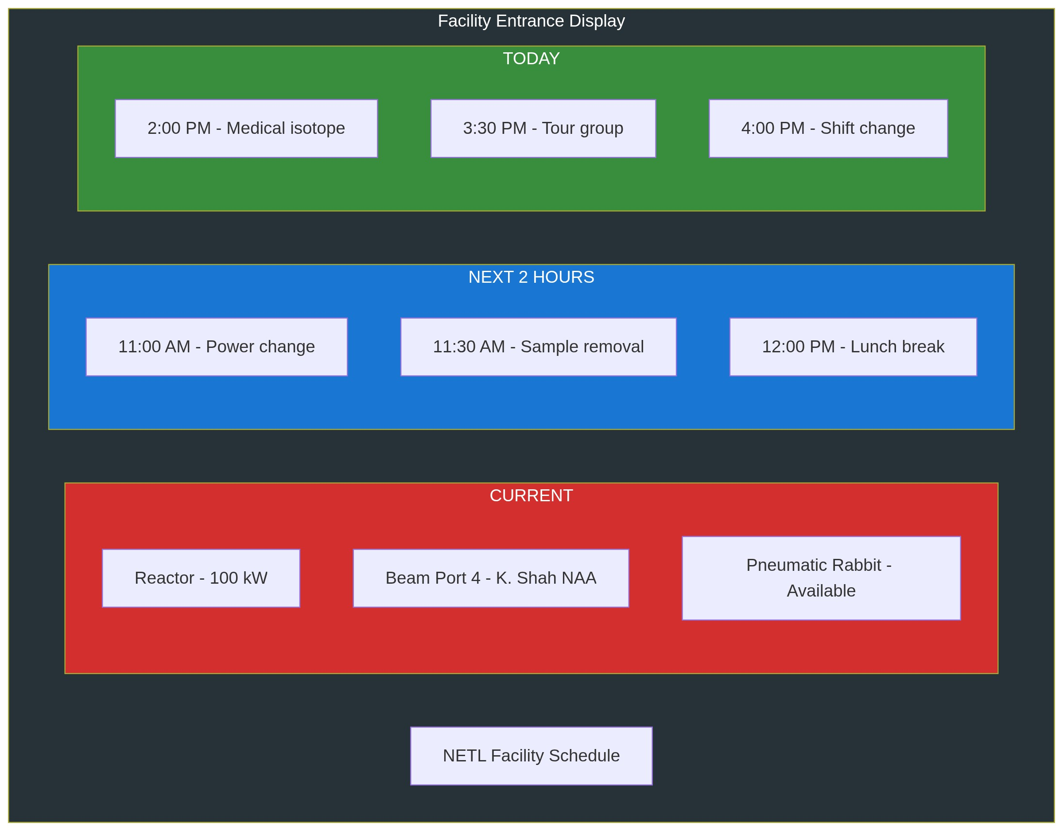

Console 4-Hour View
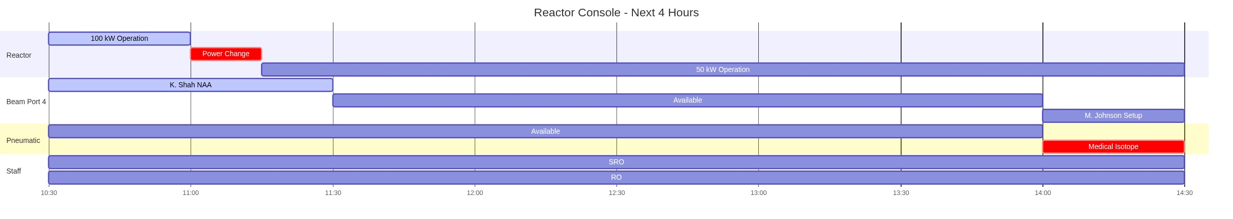

Success Metrics
Metric | Target | Measurement Method
Schedule Accuracy | 90% of scheduled activities start within 15 min | Compare scheduled vs. actual from ops log
Conflict Rate | <5% of requests have conflicts | Track rejection reasons
Self-Service Adoption | 80% of requests via portal (not email/phone) | Source tracking on requests
Notification Delivery | 100% of approved requests get confirmation within 5 min | Notification system logs
Utilization Visibility | Real-time dashboard always within 1 hour of actual | Compare schedule to ops log
Compliance Coverage | 100% of required training scheduled before expiry | Training deadline reports

Technical Requirements

Performance
- Schedule queries return in <200ms for week view
- Support 1000+ schedule items per month
- Handle 50+ concurrent schedule viewers
- Real-time updates to all displays within 5 seconds

Reliability
- 99.9% uptime for viewing schedules
- Graceful degradation if external calendars unavailable
- Offline mode for read-only schedule access
- Audit trail of all schedule changes

Security
- Role-based access to approval functions
- Immutable audit log of approvals
- Encryption of external calendar credentials
- Rate limiting on public schedule views

Implementation Phases

Phase 1: Core Scheduling (Months 1-2)
- Basic time slot management
- Conflict detection
- Manual approval workflow
- Console and facility displays

Phase 2: Module Integration (Months 2-3)
- Experiment Manager integration
- Reactor Ops Log integration
- Notification system
- Basic reporting

Phase 3: Advanced Features (Months 3-4)
- External calendar sync
- Recurring schedules
- Priority/optimization engine
- Mobile access

Phase 4: Intelligence (Months 4-6)
- Utilization analytics
- Predictive scheduling
- Resource optimization
- Compliance forecasting
This PRD defines the Scheduling System as a cross-cutting concern that serves all Neutron OS modules while maintaining separation of concerns.

