The Nuclear Data Infrastructure Challenge

Why DeepLynx + Neutron OS Together Can Do What Neither Can Alone
Vision Document | January 2026

The Industry Problem We're Solving Together
Nuclear energy is at an inflection point. The U.S. has 94 operating reactors. Over the next 20 years, industry forecasts suggest 200-500+ new units (SMRs, microreactors, advanced designs) may be constructed and operated. This represents a data infrastructure challenge the industry has never faced:
Challenge | Current State | Commercial Scale (2035+)
Plant configurations | Manually tracked | 500+ unique designs, continuous updates
Operational time-series | GB/day per plant | Petabytes/day across fleet
Digital twins | R&D projects | Production safety systems
Regulatory compliance | Per-plant reporting | Fleet-wide automation
AI/ML integration | Experiments | Operational requirements

The question isn't whether we need data infrastructure. It's whether we build one coherent architecture or 500 incompatible silos.

Why "Just Use DeepLynx" Isn't the Answer (And Neither Is "Just Use Neutron OS")
Both systems are excellent—at different things. Trying to make one system do everything leads to architectural compromises that hurt both use cases.

DeepLynx: The Digital Engineering Backbone
DeepLynx excels at structural data—the things that define what a reactor is:
Strength | Why It Matters
Ontology management | Defines components, relationships, safety classifications
Relationship graphs | "Control rod A connects to drive mechanism B with parameters C"
Configuration tracking | Design evolution, as-built vs. as-designed
GraphQL for structure | Query: "What are all safety-related components in Reactor X?"
Multi-project coordination | Proven on MARVEL, NRIC, complex construction projects

DeepLynx knows what things are and how they relate.

Neutron OS: The Operational Intelligence Layer
Neutron OS excels at temporal data—the things that define what a reactor does:
Strength | Why It Matters
Streaming-first architecture | Sub-second latency for real-time operations
Time-series lakehouse | Petabyte-scale sensor history with time-travel queries
ML/surrogate pipelines | Train, validate, deploy physics-informed models
Uncertainty quantification | Know how much to trust predictions
Agentic AI integration | MCP servers for AI assistants to query operational context

Neutron OS knows what's happening and what will happen next.

The Gap Neither Fills Alone
Capability | DeepLynx Alone | Neutron OS Alone | Together
"What components exist?" | ✅ Excellent | ❌ Not its job | ✅
"What are sensor readings now?" | ⚠️ Possible but not optimized | ✅ Excellent | ✅
"Predict power in 10ms" | ❌ Not its job | ✅ Excellent | ✅
"Which safety components are degrading?" | ⚠️ Knows components | ⚠️ Knows trends | ✅ Combined insight
"AI: explain this anomaly in context" | ⚠️ Structure only | ⚠️ Time-series only | ✅ Full picture

The Integrated Architecture Vision
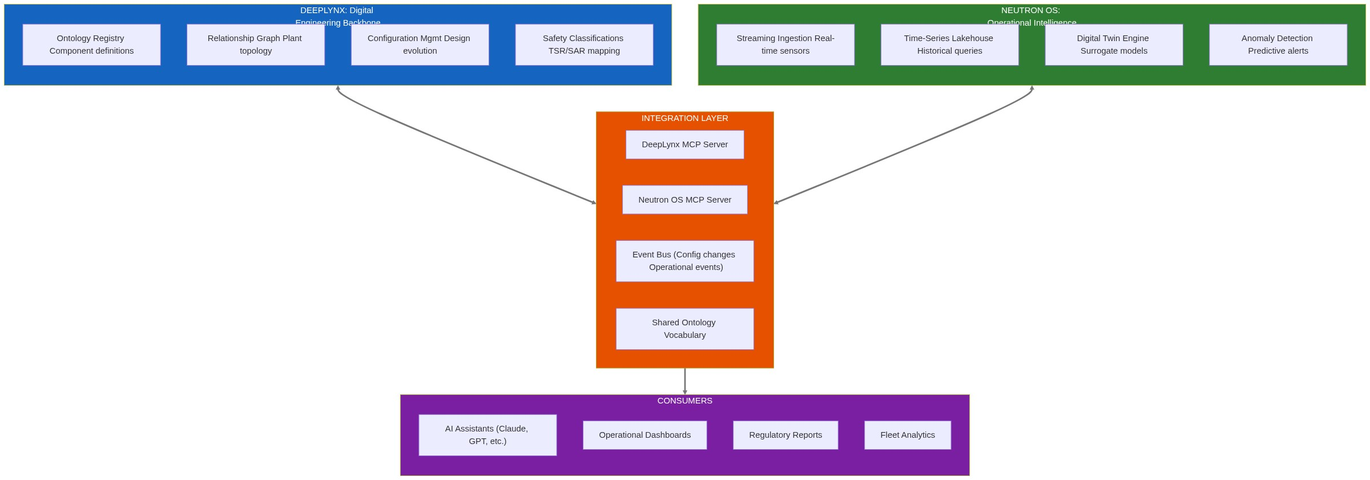

Integration Mechanisms
Mechanism | Purpose | Example
Shared Ontology Vocabulary | Same names for same things | Both systems call it NETL_RX_POWER_KW, not "power" vs "reactor_power"
MCP Servers (Both Sides) | AI agents query either system | "Claude, what's the safety classification of the component showing anomalous readings?"
Event Bus | Real-time sync | DeepLynx publishes config changes → Neutron OS updates ML model context
Data Contracts | Schema guarantees | Time-series data includes component_id that references DeepLynx ontology

What This Enables at Commercial Scale

Scenario: Fleet-Wide Anomaly Detection (2035)
An operator manages 47 SMRs across 12 sites. A subtle pump vibration pattern appears at Site 3.
Step | System | Action
1 | Neutron OS | Streaming anomaly detection flags deviation from baseline
2 | Neutron OS | Queries historical data: "Has this pattern appeared elsewhere?"
3 | Neutron OS → DeepLynx | "What component is this sensor monitoring?"
4 | DeepLynx | Returns: Primary coolant pump, Model X, installed 2031, safety-related
5 | DeepLynx | "What other sites have Model X pumps?" → Sites 3, 7, 12, 29
6 | Neutron OS | Queries time-series from Sites 7, 12, 29: "Similar patterns?"
7 | AI Assistant | Synthesizes: "Emerging wear pattern in Model X pumps after 4 years. Recommend inspection at all sites."
8 | Regulatory | Automatic Part 21 notification drafted with supporting data

Neither system could do this alone. DeepLynx knows the fleet topology. Neutron OS knows the operational patterns. Together: predictive fleet maintenance.

Scenario: AI-Assisted Regulatory Query
NRC asks: "For all TRIGAs operating above 900 kW in Q3 2034, show xenon poisoning events correlated with fuel age."
Query Component | System | Response
"All TRIGAs" | DeepLynx | 23 facilities in registry
"Operating above 900 kW in Q3 2034" | Neutron OS | Time-series filter → 18 facilities
"Xenon poisoning events" | Neutron OS | Pattern detection in power history
"Correlated with fuel age" | DeepLynx | Fuel element installation dates
Synthesis | AI Agent (MCP to both) | "Xenon events 3.2x more frequent in fuel >15 years. Trend significant at p<0.01."

The Path Forward: Collaboration, Not Competition

Phase 1: Ontology Alignment (Now - Q2 2026)
Deliverable | Owner | Benefit
Shared TRIGA vocabulary | Joint | Same component names across systems
Cross-reference schema | Joint | Neutron OS data links to DeepLynx entities
Documentation | Joint | Published standard others can adopt

Phase 2: MCP Integration (Q3-Q4 2026)
Deliverable | Owner | Benefit
DeepLynx MCP Server | INL | AI agents query plant structure
Neutron OS MCP Server | UT | AI agents query operational data
Cross-system agent demo | Joint | "First nuclear AI assistant with full context"

Phase 3: Event Integration (2027)
Deliverable | Owner | Benefit
Config change events | INL → UT | Neutron OS models stay current
Operational event feed | UT → INL | DeepLynx knows what's actually happening
Shared data lake access | Joint | Cross-query without data duplication

Phase 4: Fleet Deployment (2028+)
Deliverable | Owner | Benefit
Reference architecture | Joint | "How to deploy DT infrastructure for new reactors"
NEUP/ARPA-E proposals | Joint | Funding for advanced capabilities
Commercial partnerships | Joint | Vendor adoption of the integrated stack

Why This Matters for INL
Strategic Interest | How This Collaboration Advances It
DeepLynx adoption | Neutron OS becomes a pathway, not a competitor—"use DeepLynx for structure, add Neutron OS for operations"
NRIC mission | Reference architecture for digital infrastructure at new reactor demos
NE-5 leadership | DOE's nuclear data strategy includes both structural and operational data
Industry influence | Integrated stack becomes the standard, not a fragmented landscape

Why This Matters for UT
Strategic Interest | How This Collaboration Advances It
Research credibility | Partnership with INL's production system validates approach
Student placement | Graduates know both systems = more employable
Funding | Joint proposals stronger than solo
Impact | Technology reaches production, not just publications

The Ask
We're not asking INL to adopt Neutron OS, and we're not asking to replace DeepLynx. We're proposing that both systems become more valuable by working together.
Immediate next steps:
- Technical deep-dive: Map DeepLynx and Neutron OS data models for integration points
- MCP exploration: Could DeepLynx expose an MCP server for AI agent queries?
- Pilot scope: Define a small cross-system demo (e.g., TRIGA component + time-series query)
The opportunity: Define the data architecture for nuclear's commercial future—together.

Contact
Ben Booth UT Austin Computational Nuclear Engineering ben.booth@utexas.edu
Kevin Clarno UT Austin, Cockrell Chair kevin.clarno@utexas.edu
Vision document for INL collaboration discussion. January 2026.

