Table of Contents
Neutron OS Diagrams - Mermaid Format
1. Current System (As-Built)
2. MVP Target Architecture
3. Data Flow: Measured vs Modeled
4. Development Phases
5. Component Dependencies
6. Multi-Tenant Architecture
7. Prediction Uncertainty Over Time
Usage Notes
Rendering
Editing
Converting to Images for Word

Neutron OS Diagrams - Mermaid Format
These diagrams render in GitHub, GitLab, and VS Code (with Mermaid extension).

1. Current System (As-Built)
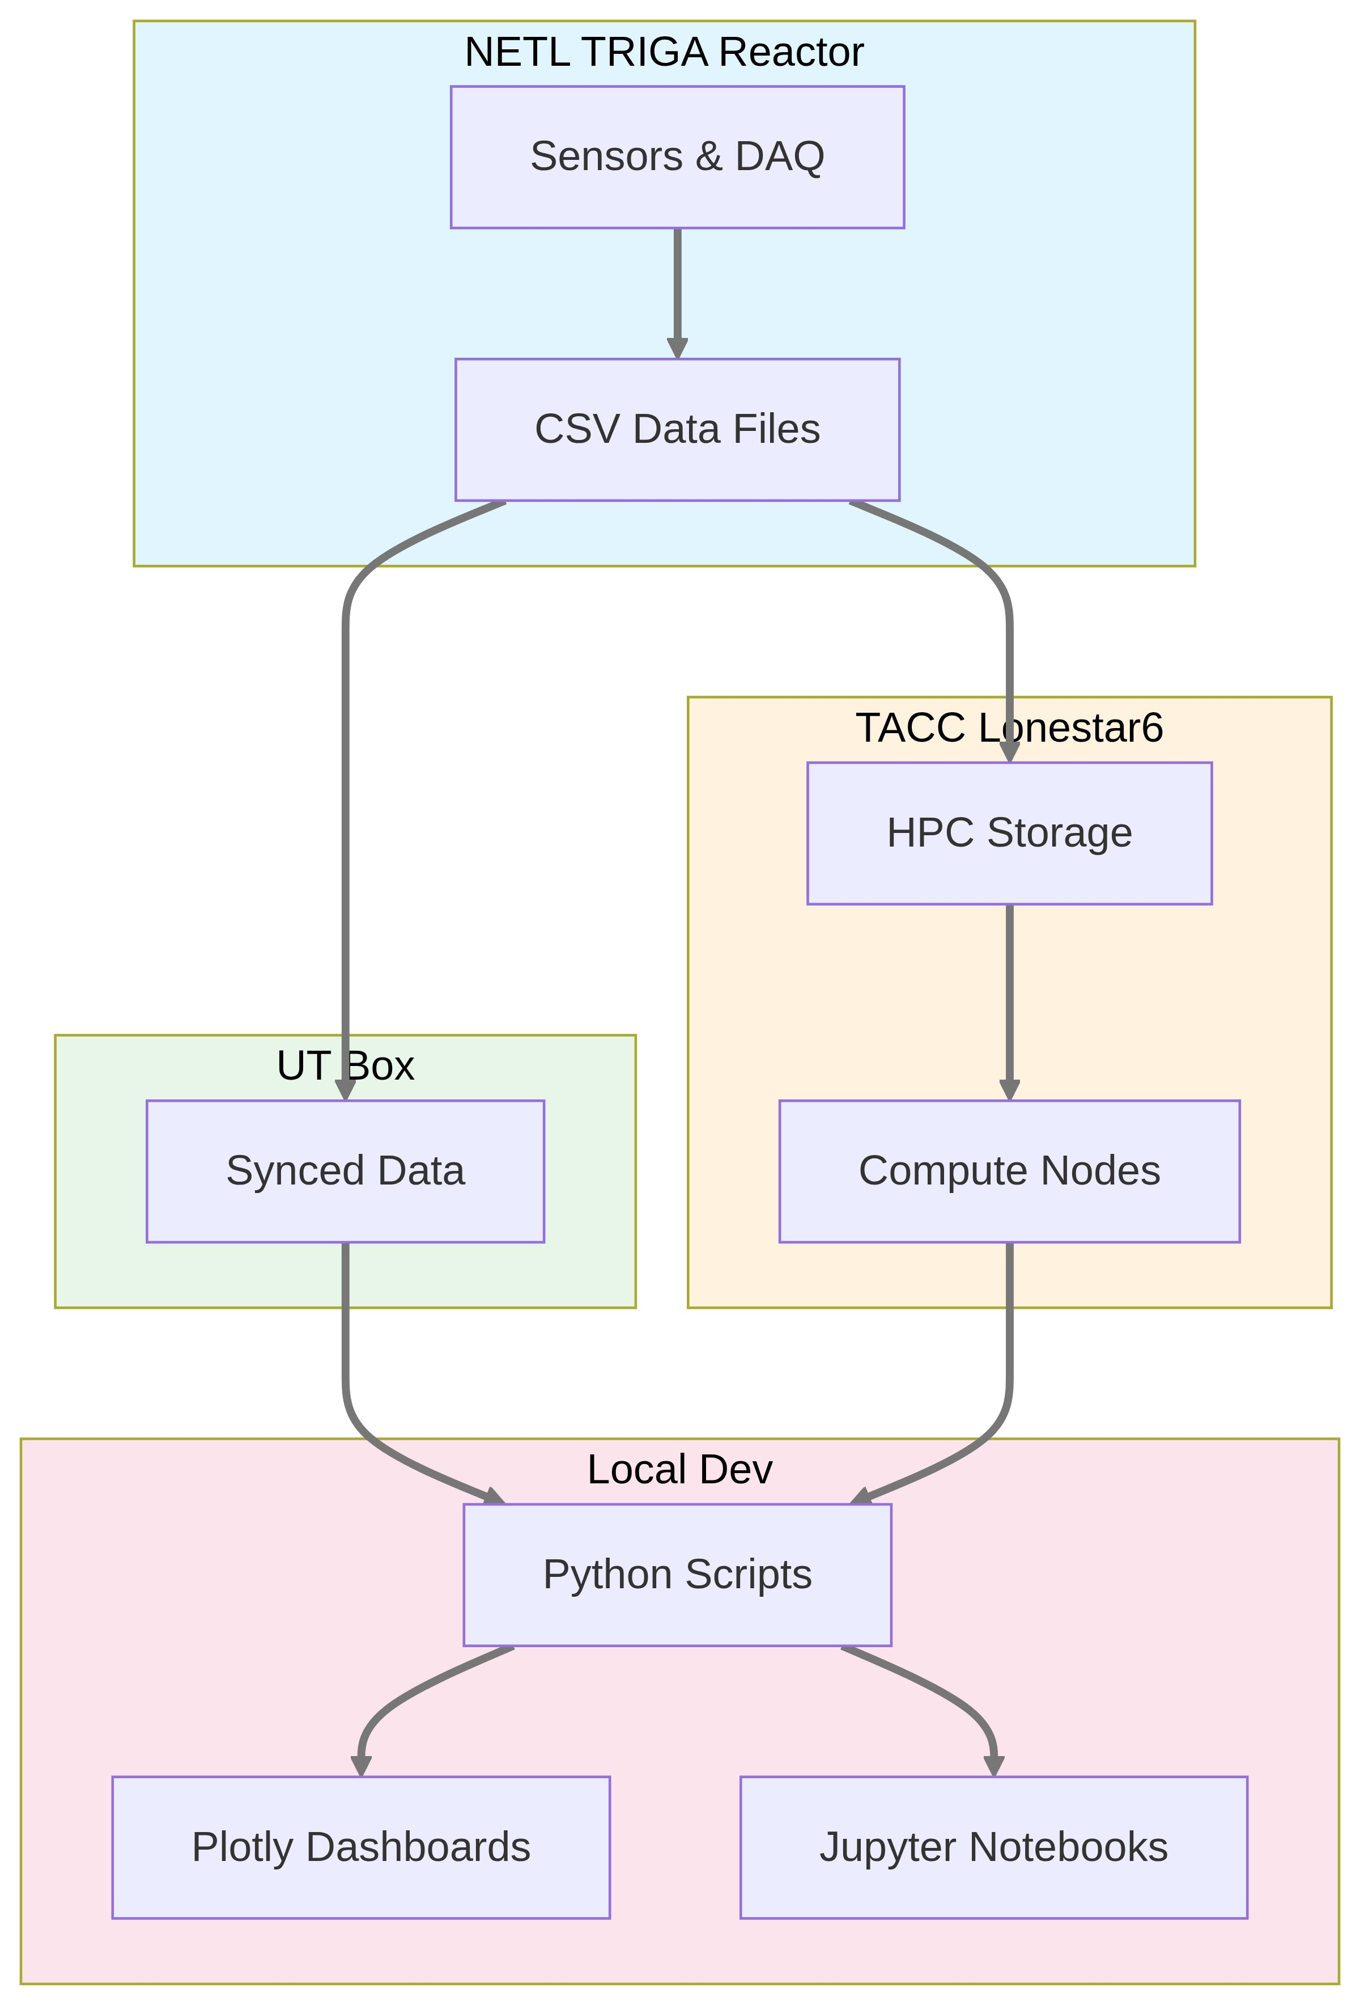

2. MVP Target Architecture
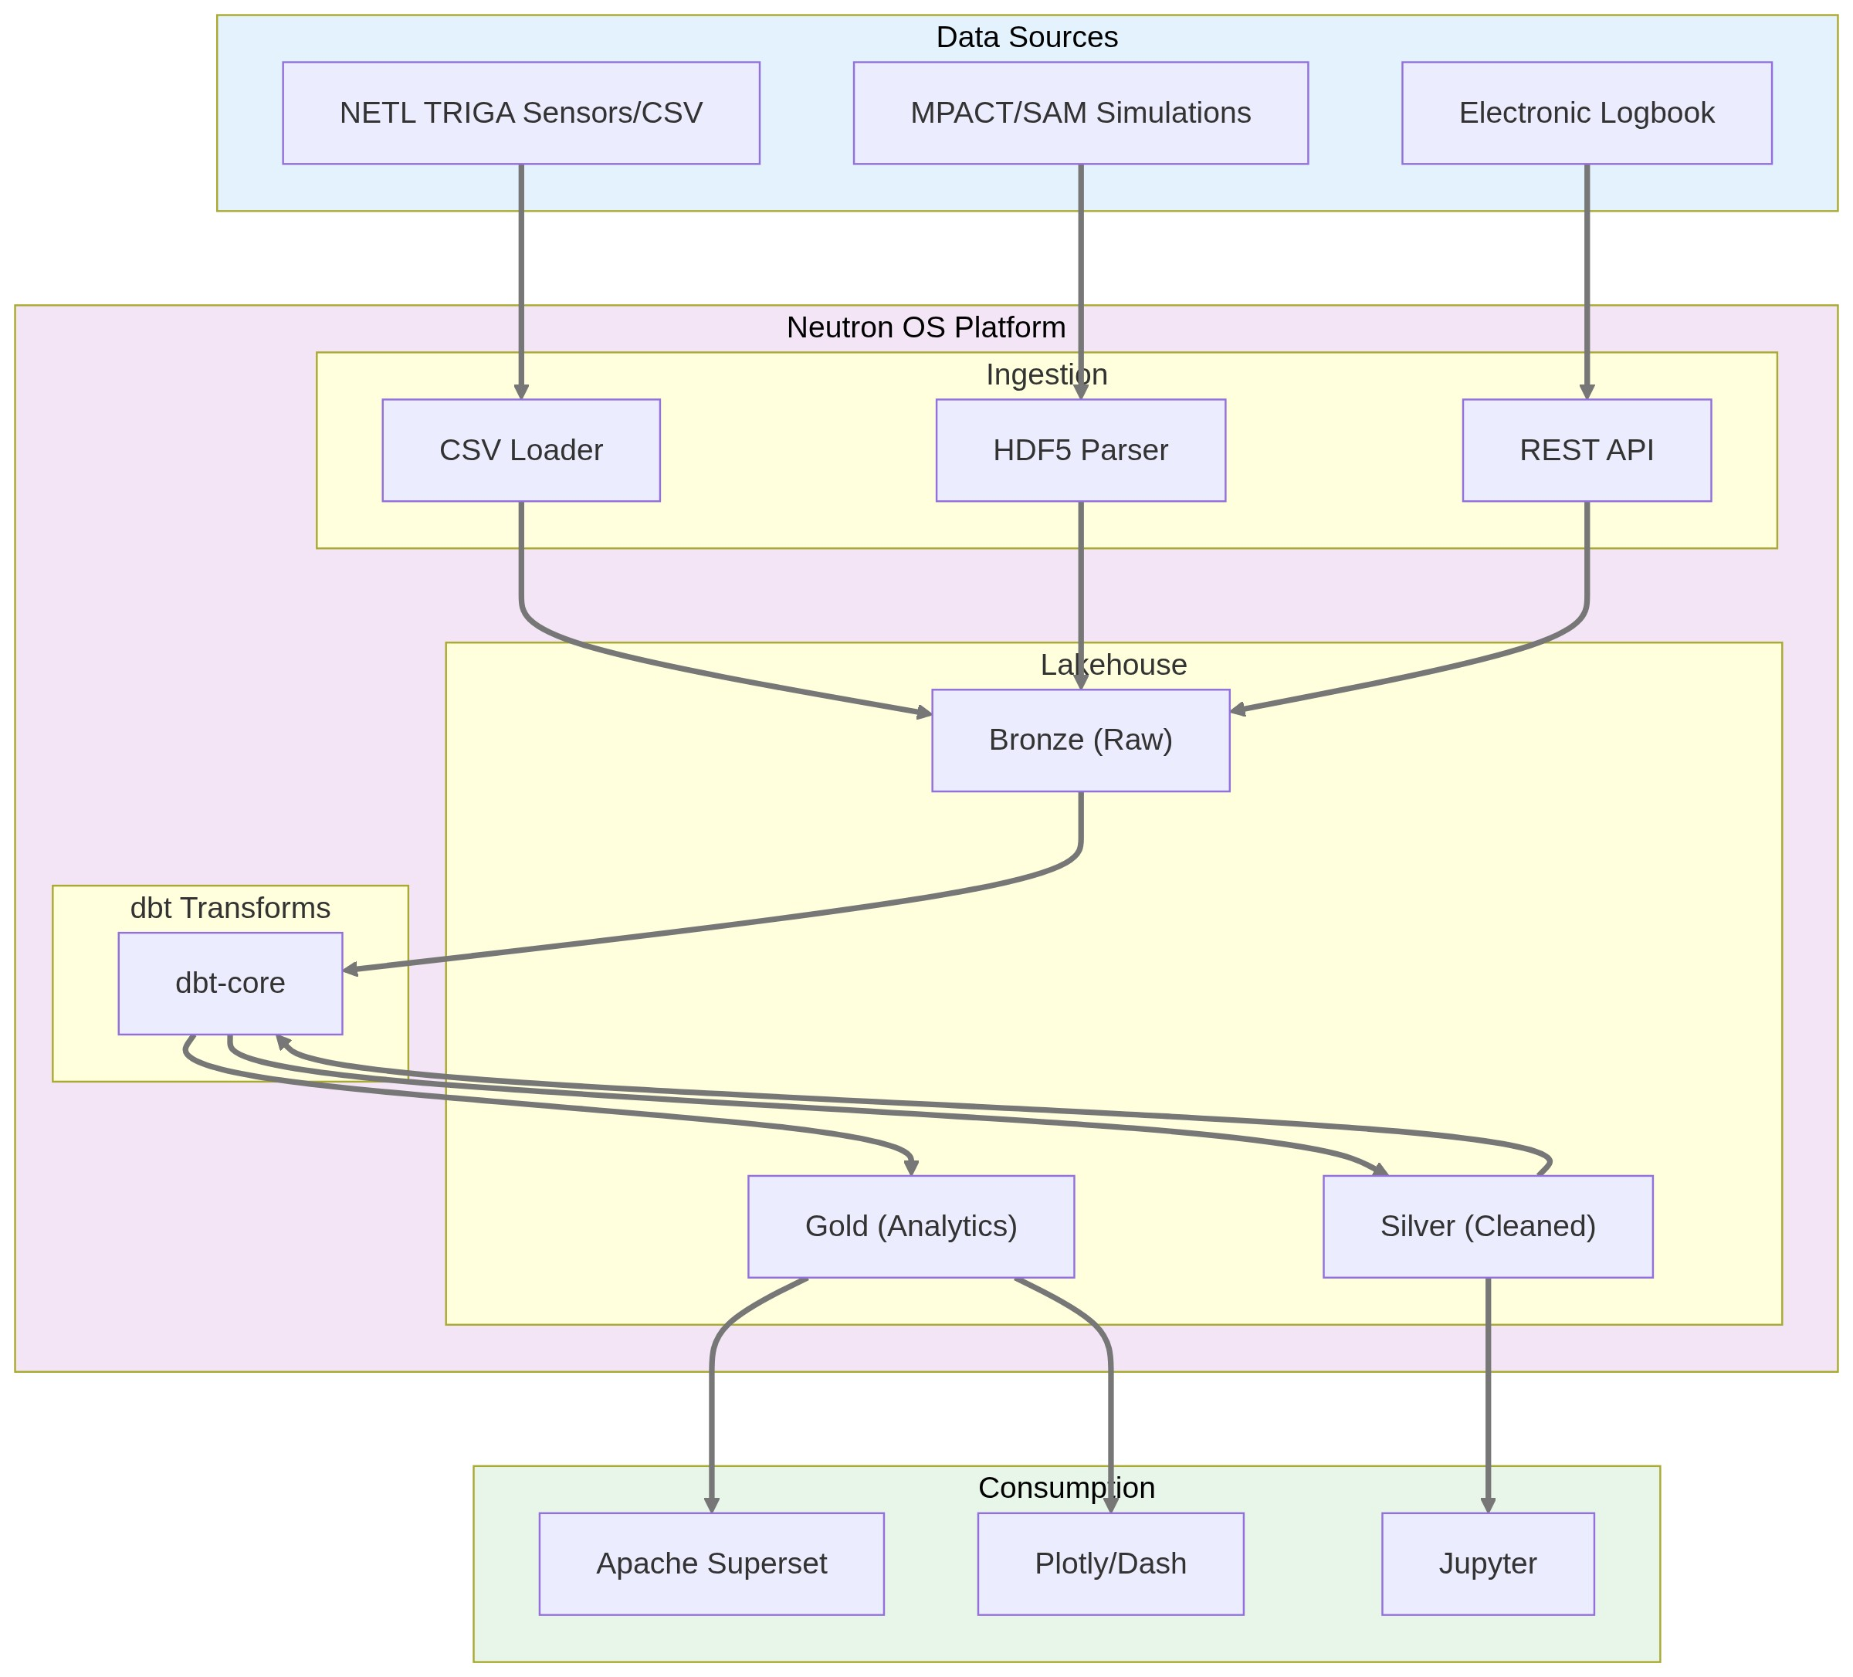

3. Data Flow: Measured vs Modeled
⚠️ Diagram rendering failed

4. Development Phases
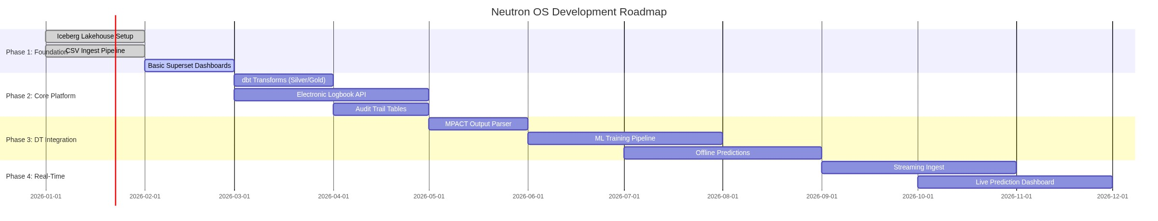

5. Component Dependencies
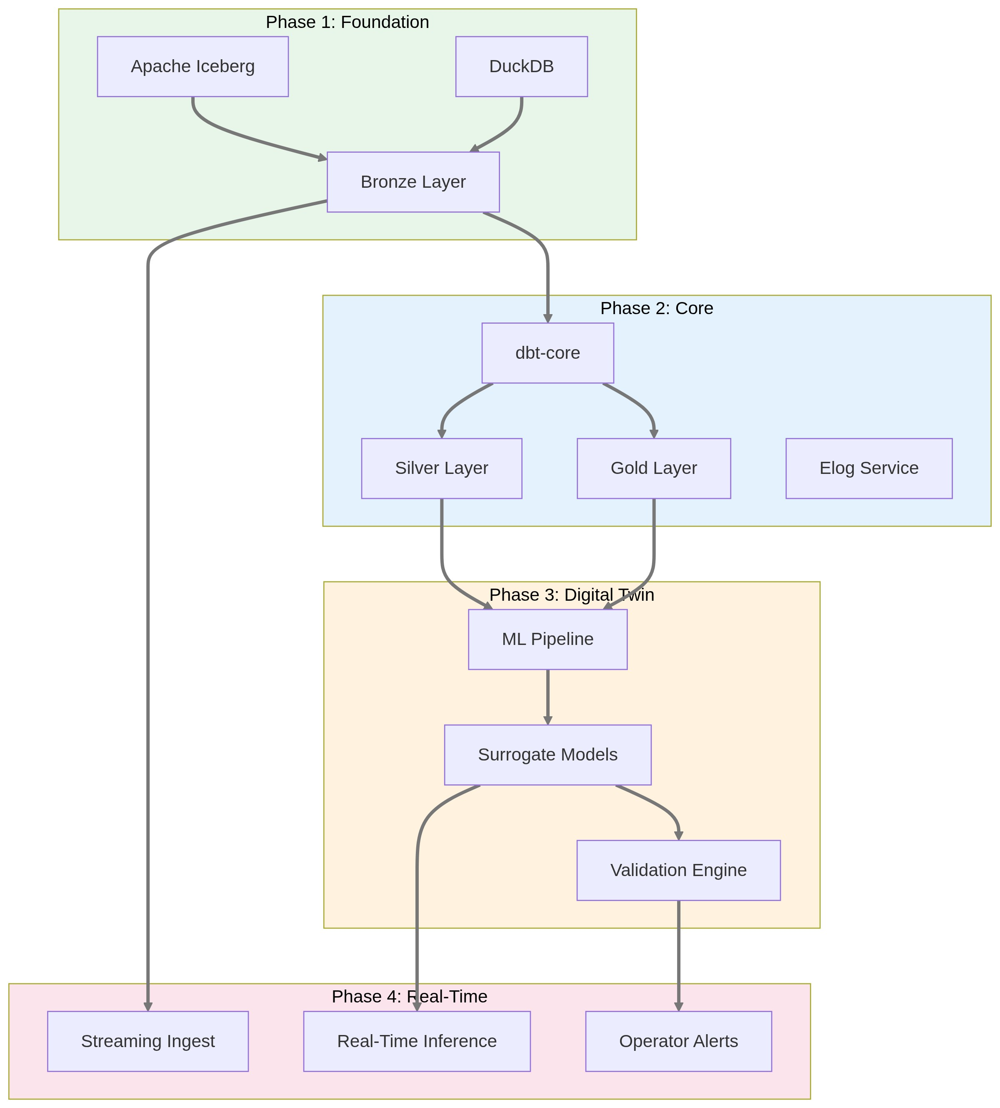

6. Multi-Tenant Architecture
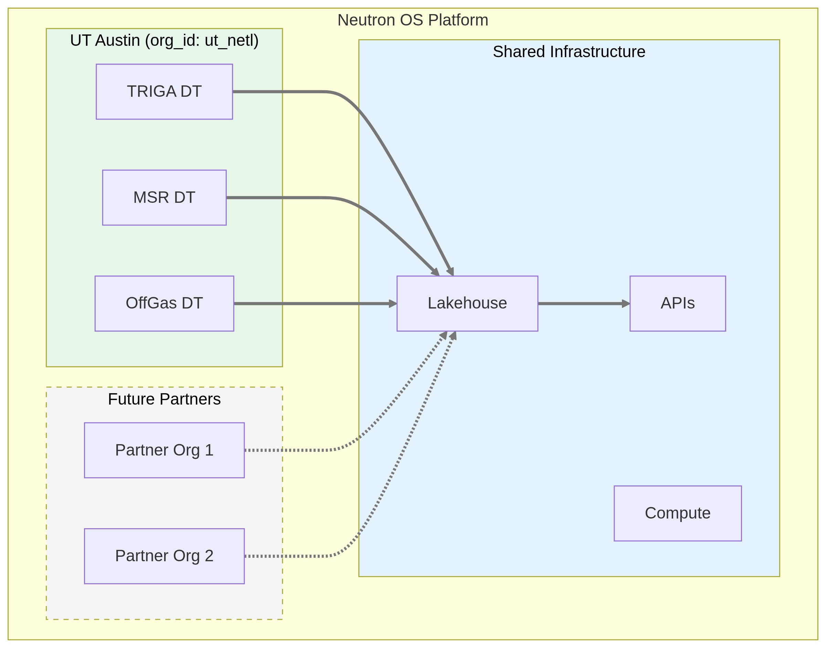

7. Prediction Uncertainty Over Time
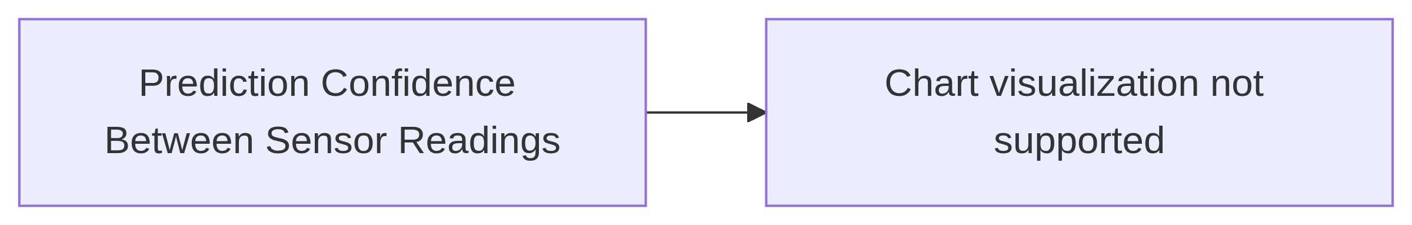

Usage Notes

Rendering
- GitHub/GitLab: Renders automatically in markdown preview
- VS Code: Install "Markdown Preview Mermaid Support" extension
- Export to PNG/SVG: Use mermaid CLI (mmdc) or online editor at mermaid.live

Editing
- Live editor: https://mermaid.live
- Syntax docs: https://mermaid.js.org/syntax/flowchart.html

Converting to Images for Word
# Install mermaid CLI
npm install -g @mermaid-js/mermaid-cli
# Convert to PNG
mmdc -i diagram.mmd -o diagram.png -b transparent
# Convert to SVG (better for scaling)
mmdc -i diagram.mmd -o diagram.svg

