Table of Contents
DeepLynx + Neutron OS: Integrated Architecture Assessment
1. Executive Summary
The Core Insight
1.1 What Each System Does Best
1.2 The Integration Opportunity
1.3 Technical Property Comparison
1.4 What We're Adopting From DeepLynx
1.5 Why Two Systems Instead of One?
2. DeepLynx Technical Deep Dive
2.1 Architecture Overview
2.2 Core Technical Components
2.3 Data Model Philosophy
2.4 Key Features
2.5 Ledger Table Pattern (ADR-001)
2.6 MCP (Model Context Protocol) Integration
3. Architecture Comparison
3.1 Side-by-Side Comparison
3.2 Feature Matrix
4. What's Valuable for Neutron OS
4.1 Highly Valuable: Ledger Table Pattern
4.2 Valuable: Ontology Concepts
4.3 Valuable: MCP Server Pattern
4.4 Moderately Valuable: Event System
5. Query Interface Integration
5.1 GraphQL + SQL: Best of Both Worlds
5.2 Schema Management Approaches
5.3 Different Integration Ecosystems
5.4 Complementary Data Models
5.5 Technology Stack Alignment
6. Integrated Architecture Vision
6.1 The Complete Picture
6.2 Integration Mechanisms
6.3 Integration Patterns
6.4 What We've Adopted from DeepLynx
7. Collaboration Roadmap
7.1 Phase 1: Ontology Alignment (Now - Q2 2026)
7.2 Phase 2: MCP Integration (Q3-Q4 2026)
7.3 Phase 3: Event Integration (2027)
7.4 Phase 4: Fleet Deployment (2028+)
7.3 Architectural Principles
8. Appendix: Technical Details
8.1 DeepLynx Repository Structure
8.2 Key Technical Specifications
8.3 Useful Links
Document History
9 Collaboration Scenarios
9.1 Scenario: Active INL Partnership
9.2 NRAD Ontology Analysis (January 15, 2026 - Evening)
9.2.3 Sensors in NRAD vs NETL TRIGA
9.2.4 What's Missing (Opportunities for Neutron OS)
9.2.5 Revised Architecture: Complementary Systems
9.3 Summary: The Integrated Vision
9.4 What This Enables
Addendum: Supporting References
Data Lakehouse Architecture Patterns
Hyperscale Data Platform Case Studies
DeepLynx Documentation
Modern Data Stack Components

DeepLynx + Neutron OS: Integrated Architecture Assessment
Technical Analysis of Complementary Capabilities
Document Status: Technical Reference
Date: January 21, 2026 (Updated)
Lead Author: Ben Booth, UT Computational NE
Classification: Internal Planning Document

Table of Contents
- Executive Summary
- DeepLynx Technical Deep Dive
- Architecture Comparison
- Integrated Architecture Vision
- Collaboration Roadmap
- Technical Appendix

1. Executive Summary

The Core Insight
DeepLynx and Neutron OS are complementary systems optimized for different data patterns. Together, they provide capabilities neither can achieve alone. This is not competition—it's specialization.

1.1 What Each System Does Best
Capability | DeepLynx | Neutron OS
Ontology management | ✅ Excellent | ❌ Not its job
Relationship graphs | ✅ Excellent | ❌ Not its job
Configuration tracking | ✅ Excellent | ⚠️ Basic
Streaming time-series | ⚠️ Batch-oriented | ✅ Sub-second
Historical analytics | ⚠️ File-based queries | ✅ Iceberg lakehouse
ML/surrogate training | ⚠️ Not optimized | ✅ Native workflows
Uncertainty quantification | ❌ Not its job | ✅ Core capability
Agentic AI integration | ✅ MCP Server | ✅ MCP Server

1.2 The Integration Opportunity
Scenario: An operator asks: "Which safety-related components are showing anomalous trends?"
Step | System | Action
1 | Neutron OS | Streaming anomaly detection flags 3 sensors
2 | Neutron OS → DeepLynx | "What components are these sensors monitoring?"
3 | DeepLynx | Returns: Pump A (safety-related), Valve B (not safety), Detector C (safety-related)
4 | DeepLynx | "What are the safety limits for Pump A and Detector C?"
5 | Neutron OS | Queries time-series: "How close to limits?"
6 | AI Assistant | Synthesizes full picture for operator

Neither system could answer this alone. DeepLynx knows structure and safety classification. Neutron OS knows trends and predictions.

1.3 Technical Property Comparison
Property | DeepLynx Nexus (v2) | Neutron OS
Primary Focus | Digital engineering backbone | Operational intelligence layer
Data Model | Graph (ontology-driven) | Lakehouse (Iceberg tables)
Tech Stack | C# + React + PostgreSQL | Python + dbt + Kafka
Query Language | GraphQL + DataFusion SQL | SQL (DuckDB/Trino)
Time-Series | File-based, batch queries | Streaming-first, interactive
AI Integration | MCP Server (C#) | MCP Server (Python)
License | MIT | MIT (proposed)

1.4 What We're Adopting From DeepLynx
Pattern | Implementation | Status
Ledger table pattern | Denormalized historical snapshots for audit | Adopted
Ontology vocabulary | DIAMOND class names, properties, relationships | Aligned
MCP architecture | AI agents query both systems via MCP | In progress
Limits schema | Safety importance, voting logic, TSR references | Adopted

1.5 Why Two Systems Instead of One?
The question: "Why not just use DeepLynx for everything?"
The answer: Different data patterns need different architectures.
Pattern | DeepLynx Optimized | Neutron OS Optimized
"What components exist in Reactor X?" | ✅ Graph traversal | ❌ Would need to JOIN many tables
"Show power readings for last 6 months" | ❌ File scan, batch job | ✅ Partition pruning, milliseconds
"Train ML model on sensor history" | ❌ Export to files first | ✅ Native DataFrame access
"What's the safety classification?" | ✅ Single GraphQL query | ❌ Would need DeepLynx anyway
"Predict state at t+10ms" | ❌ Not its job | ✅ Surrogate model inference

Trying to make one system do both leads to architectural compromise. The integrated approach lets each system excel at what it's designed for.

2. DeepLynx Technical Deep Dive

2.1 Architecture Overview
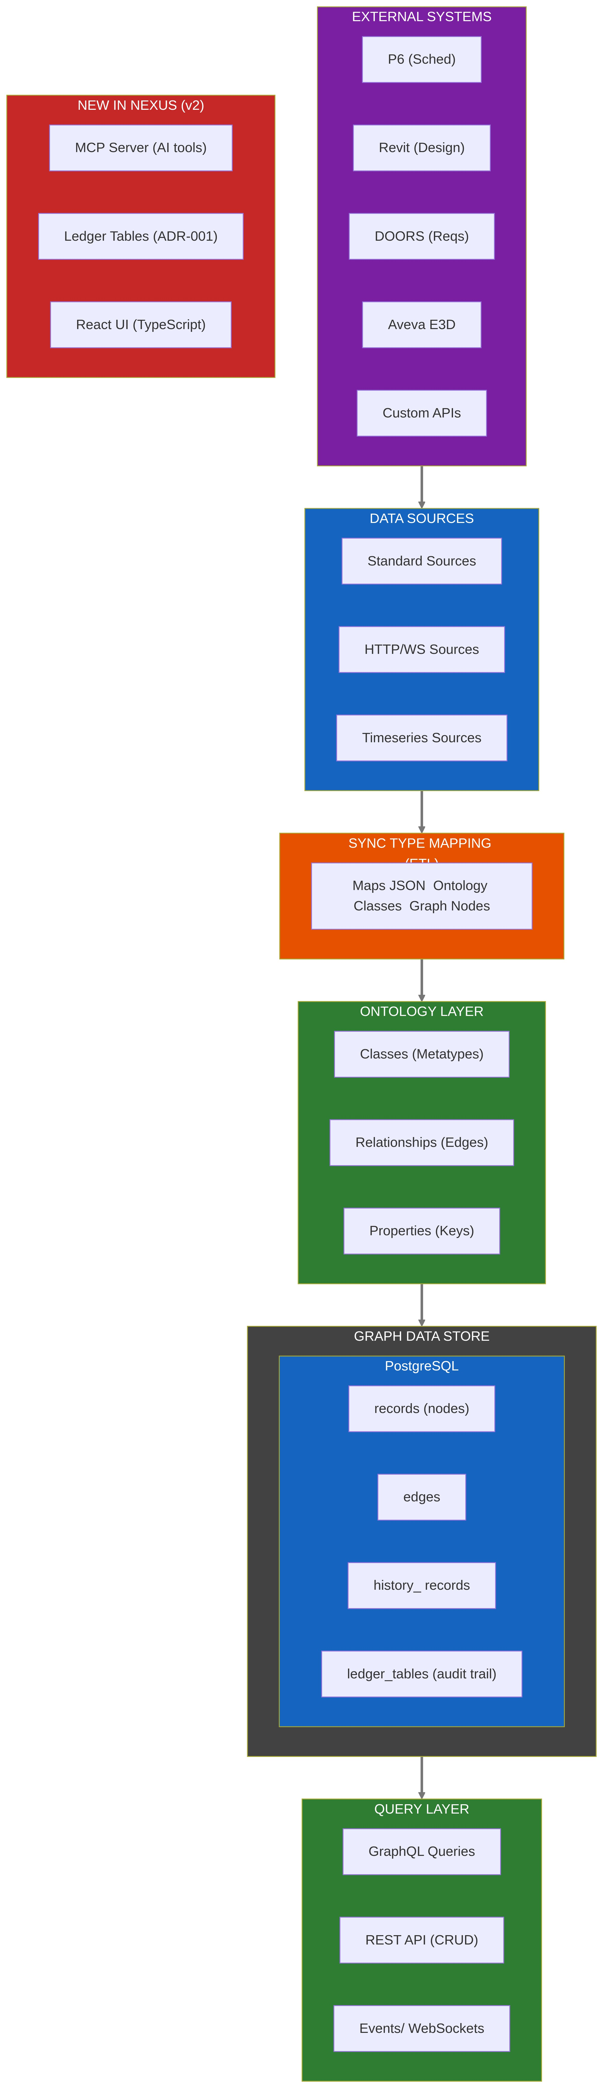

2.2 Core Technical Components
Component | Technology | Purpose
Backend | C# (.NET 10) | API server, business logic
Frontend | React + TypeScript | Admin UI, data exploration
Database | PostgreSQL | Graph storage (records/edges)
ORM | Entity Framework | Database migrations, CRUD
API | REST + GraphQL | Data access
Docs | Next.js (MDX) | Documentation site
Auth | OAuth2 + API Keys | Multi-tenant access
Deploy | Kubernetes + Docker | Container orchestration
AI | MCP Server (C#) | LLM tool integration

2.3 Data Model Philosophy
DeepLynx uses an ontology-driven graph model:
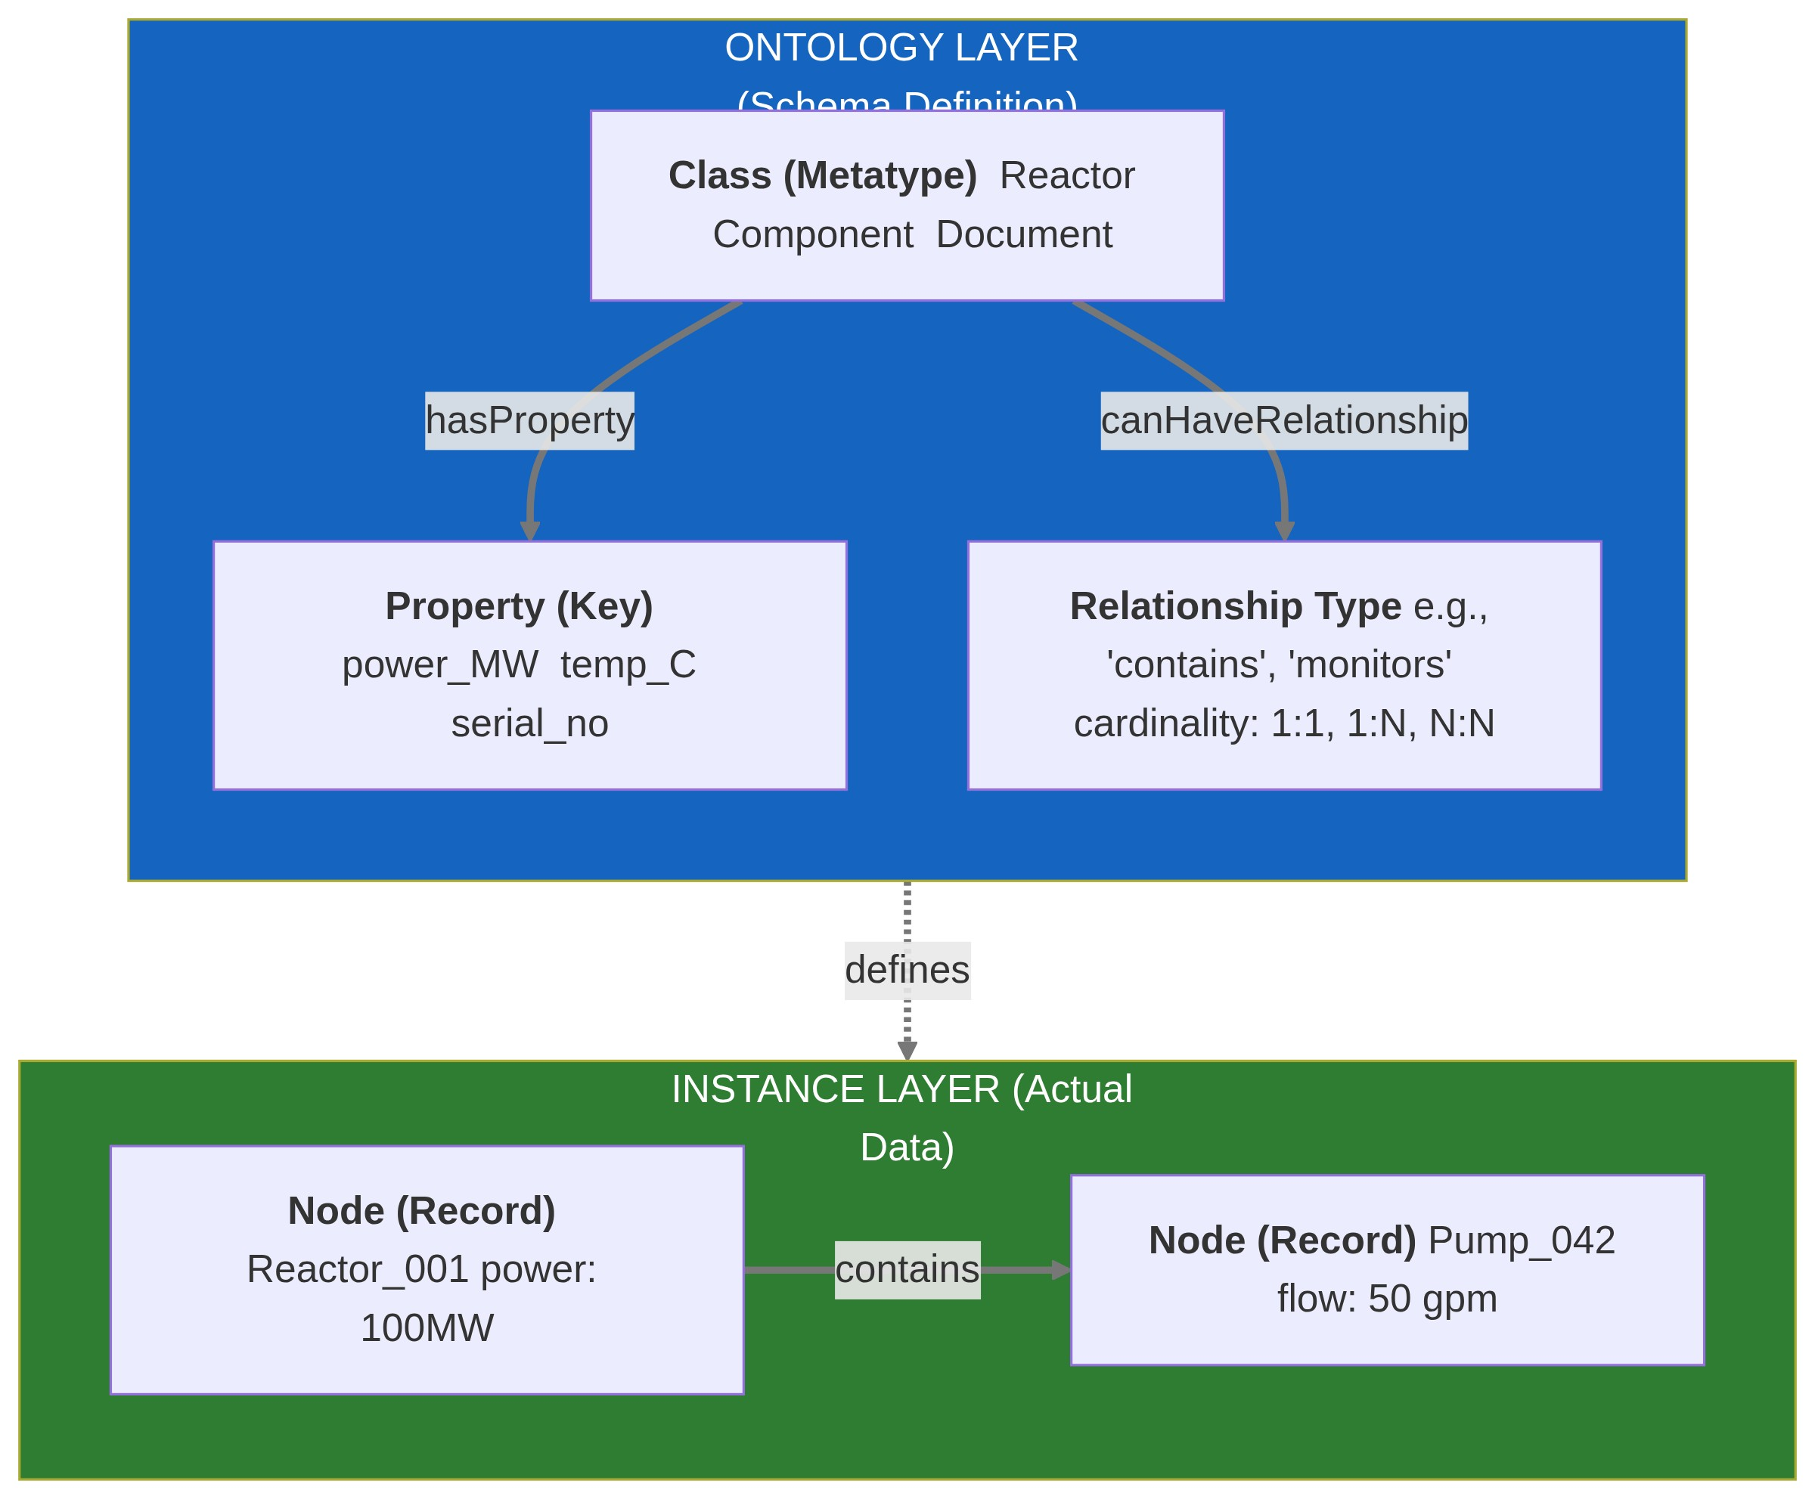

2.4 Key Features
Feature | Description | Maturity
Ontology Import | Import .owl files (DIAMOND ontology) | Mature
Ontology Versioning | Track schema changes over time | Mature
Ontology Inheritance | Classes can inherit properties | Mature
Type Mapping | Map JSON→Classes automatically | Mature
GraphQL Queries | Client-defined queries | Mature
Event System | Pub/sub for data changes | Mature
Data Targets | Export to external systems | Mature
Timeseries Data | Tabular data alongside graph | Mature
Ledger Tables | ADR-001: Historical snapshots | New (v2)
MCP Server | AI tool integration | New (v2)

2.5 Ledger Table Pattern (ADR-001)
This is highly relevant to Neutron OS's audit requirements:
┌─────────────────────────────────────────────────────────────────┐
│ DEEPLYNX LEDGER TABLE PATTERN (ADR-001) │
├─────────────────────────────────────────────────────────────────┤
│ │
│ CURRENT STATE (Normalized) │
│ ┌─────────────────────────────────────────────────────────┐ │
│ │ records │ │
│ │ ┌────────┬─────────┬──────────┬─────────┬──────────┐ │ │
│ │ │ id │ class_id│ data │created_at│modified_at│ │
│ │ ├────────┼─────────┼──────────┼─────────┼──────────┤ │ │
│ │ │ 1 │ 5 │ {json} │ ts_1 │ ts_3 │ │ │
│ │ │ 2 │ 3 │ {json} │ ts_2 │ ts_2 │ │ │
│ │ └────────┴─────────┴──────────┴─────────┴──────────┘ │ │
│ └─────────────────────────────────────────────────────────┘ │
│ │ │
│ │ On any UPDATE/DELETE │
│ ▼ │
│ HISTORICAL STATE (Denormalized Snapshot) │
│ ┌─────────────────────────────────────────────────────────┐ │
│ │ historical_records │ │
│ │ ┌───┬──────────┬────────────┬────────┬──────────────┐ │ │
│ │ │id │record_id │ class_name │ tags │ snapshot_at │ │ │
│ │ ├───┼──────────┼────────────┼────────┼──────────────┤ │ │
│ │ │ 1 │ 1 │ "Reactor" │[a,b] │ ts_1 │ │ │
│ │ │ 2 │ 1 │ "Reactor" │[a,b,c] │ ts_2 │ │ │
│ │ │ 3 │ 1 │ "Reactor" │[a,b,c] │ ts_3 │ │ │
│ │ └───┴──────────┴────────────┴────────┴──────────────┘ │ │
│ │ │ │
│ │ Key insight: Snapshot includes denormalized names │ │
│ │ (class_name, tags) so history is self-contained │ │
│ └─────────────────────────────────────────────────────────┘ │
│ │
│ WHY THIS MATTERS: │
│ • If class is renamed/deleted, history still accurate │
│ • No JOINs needed for historical queries │
│ • Audit trail is independent of current schema │
│ │
└─────────────────────────────────────────────────────────────────┘

2.6 MCP (Model Context Protocol) Integration
DeepLynx has an early MCP server implementation:
deeplynx.mcp/
├── tools/
│ ├── ProjectTools.cs # List/search projects
│ └── RecordTools.cs # Query/create records
├── helpers/
│ └── ...
├── Program.cs # MCP server entry point
└── .env_sample
This allows AI agents to:
- Query project data
- Search records
- Create/update data programmatically

3. Architecture Comparison

3.1 Side-by-Side Comparison
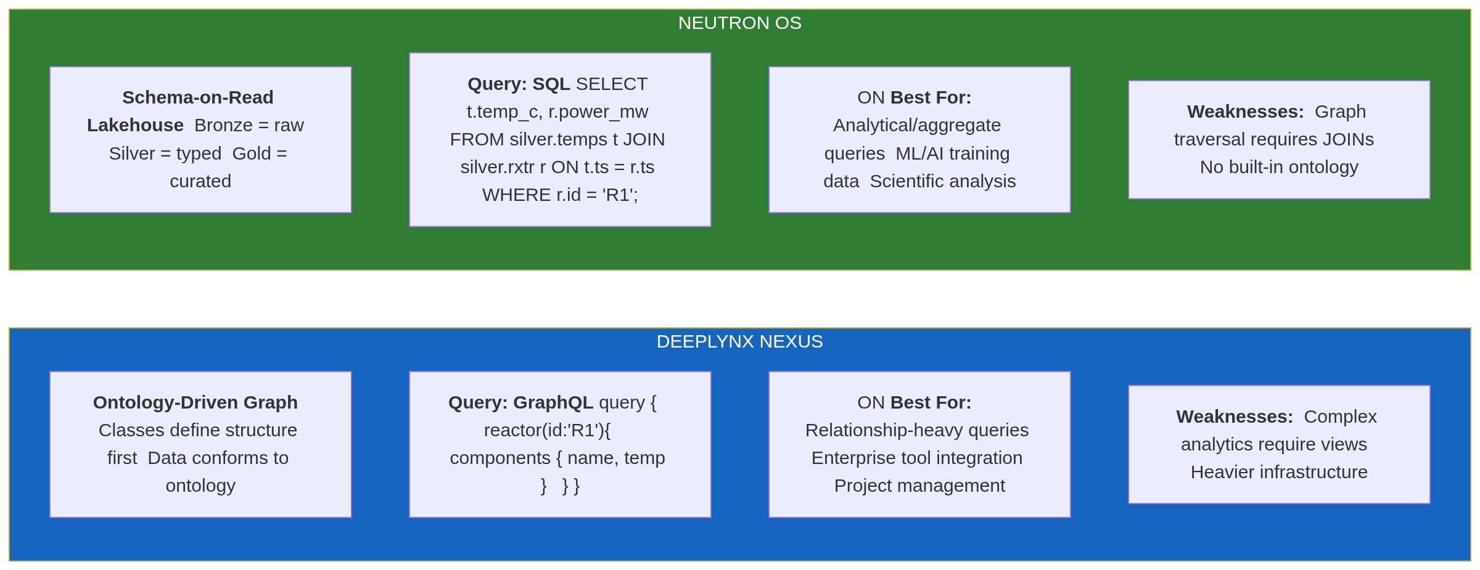

3.2 Feature Matrix
Feature | DeepLynx | Neutron OS | Notes
Data Storage
Time-travel queries | ⚠️ Via ledger | ✅ Native Iceberg | Iceberg is purpose-built
Schema versioning | ✅ Ontology versions | ✅ Schema evolution | Both good
ACID transactions | ✅ PostgreSQL | ✅ Iceberg | Both good
Columnar storage | ❌ Row-based | ✅ Parquet | Neutron faster for analytics
Query Capabilities
SQL analytics | ⚠️ Requires views | ✅ Native | Neutron wins
Graph traversal | ✅ Native | ⚠️ Via JOINs | DeepLynx wins
GraphQL | ✅ Built-in | ❌ Not planned | Different philosophy
Integrations
Enterprise tools | ✅ Many | ❌ Not focus | DeepLynx wins
ML/AI workflows | ⚠️ Basic MCP | ✅ Designed for | Neutron wins
BI dashboards | ⚠️ Custom needed | ✅ Superset native | Neutron wins
Operations
Local development | ✅ Docker Compose | ✅ K3D + Docker | Both good
Kubernetes ready | ✅ Helm charts | ✅ Terraform + Helm | Both good
Multi-tenant | ✅ Containers | ⚠️ Planned | DeepLynx ahead
Audit/Compliance
Immutable audit log | ✅ Ledger tables | ✅ Hyperledger | Different approaches
Change tracking | ✅ Per-record | ✅ Per-table | DeepLynx more granular
Regulatory compliance | ✅ Designed for | ⚠️ In progress | DeepLynx more mature

4. What's Valuable for Neutron OS

4.1 Highly Valuable: Ledger Table Pattern
Adopt this pattern for elog entries, reactor data, and simulation outputs.
# Proposed implementation for Neutron OS
# dbt model: models/audit/elog_entries_historical.sql
{{
config(
materialized='incremental',
unique_key='snapshot_id'
)
}}
WITH snapshots AS (
SELECT
{{ dbt_utils.generate_surrogate_key(['elog_id', 'snapshot_ts']) }} AS snapshot_id,
elog_id,
-- Denormalized fields (self-contained history)
author_name, -- Not author_id (avoids JOIN)
facility_name, -- Not facility_id
tag_names, -- Array of strings, not IDs
-- Full content at snapshot time
entry_content,
attachments,
-- Metadata
snapshot_ts,
change_type -- 'created', 'updated', 'archived'
FROM {{ ref('elog_entries_bronze') }}
)
SELECT * FROM snapshots
{% if is_incremental() %}
WHERE snapshot_ts > (SELECT MAX(snapshot_ts) FROM {{ this }})
{% endif %}

4.2 Valuable: Ontology Concepts
Consider adopting lightweight ontology support without the full graph overhead:
# neutron_os/schemas/ontology/reactor.yaml
classes:
Reactor:
description: "Nuclear reactor system"
properties:
- name: thermal_power_mw
type: float
unit: MW
required: true
- name: coolant_type
type: enum
values: [water, sodium, helium, salt]
relationships:
- type: contains
target: ReactorComponent
cardinality: one_to_many
ReactorComponent:
description: "Component within a reactor"
parent: PhysicalAsset # Inheritance
properties:
- name: serial_number
type: string
required: true
- name: install_date
type: date
This YAML-based ontology can:
- Generate Pydantic validators
- Generate dbt schema tests
- Provide LLM context for semantic queries
- Document the domain model

4.3 Valuable: MCP Server Pattern
DeepLynx's MCP implementation shows the path for Neutron OS:
# Proposed: neutron_os/mcp/tools/reactor_tools.py
from mcp.server import Server
from mcp.types import Tool, TextContent
server = Server("neutron-os")
async def query_reactor_timeseries(
reactor_id: str,
metric: str,
start_time: str,
end_time: str
) -> list[TextContent]:
"""Query reactor time-series data via DuckDB"""
sql = f"""
SELECT timestamp, {metric}
FROM gold.reactor_metrics
WHERE reactor_id = '{reactor_id}'
AND timestamp BETWEEN '{start_time}' AND '{end_time}'
"""
result = duckdb_conn.execute(sql).fetchdf()
return [TextContent(type="text", text=result.to_markdown())]
async def search_elog_entries(
query: str,
facility: str | None = None,
limit: int = 10
) -> list[TextContent]:
"""Semantic search over elog entries using pgvector"""
# ... vector search implementation

4.4 Moderately Valuable: Event System
DeepLynx's event system for real-time data propagation could inform Dagster sensors:
# Instead of WebSockets (DeepLynx), use Dagster sensors
def reactor_data_sensor(context):
"""Trigger pipeline when new data arrives"""
new_files = list_new_iceberg_files(
table="bronze.reactor_timeseries",
since=context.last_tick_time
)
if new_files:
yield RunRequest(run_key=new_files[0].snapshot_id)

5. Query Interface Integration

5.1 GraphQL + SQL: Best of Both Worlds
DeepLynx's GraphQL Strength: According to their documentation, DeepLynx "dynamically generates a schema each time you interact with the GraphQL endpoint for a given container... the generated schema's types map 1:1 to a Class in the container you are querying." This auto-reflection from ontology to API is genuinely elegant—when you add a new Class (e.g., "Detector"), a corresponding GraphQL type becomes immediately available without code changes.
Neutron OS's SQL Strength: Time-series analytics and ML workflows are SQL-native. LLMs are highly capable at generating SQL from natural language.
Integration Strategy: Use both query interfaces with intelligent routing
┌─────────────────────────────────────────────────────────────────┐
│ QUERY EVOLUTION │
├─────────────────────────────────────────────────────────────────┤
│ │
│ 2015-2020: GraphQL Era │
│ ───────────────────────────── │
│ User: "I want reactor data with components" │
│ Developer: *writes GraphQL query* │
│ │
│ query { │
│ reactor(id: "R1") { │
│ thermalPower │
│ components { name, serialNumber } │
│ } │
│ } │
│ │
│ 2024+: Natural Language Era │
│ ──────────────────────────── │
│ User: "Show me reactor R1's power and all its components" │
│ LLM: *generates SQL directly* │
│ │
│ SELECT r.thermal_power, c.name, c.serial_number │
│ FROM gold.reactors r │
│ JOIN gold.components c ON r.id = c.reactor_id │
│ WHERE r.id = 'R1'; │
│ │
│ ADVANTAGE: No schema memorization required │
│ │
└─────────────────────────────────────────────────────────────────┘

5.2 Schema Management Approaches
DeepLynx Approach: Manual JSON→Ontology mapping rules provide explicit control over data modeling.
Neutron OS Approach: LLM-assisted schema inference for rapid iteration
# Old way (DeepLynx type mapping)
# Manually configure: JSON field "T_inlet" → Class "Sensor" → Property "temperature"
# New way (LLM-assisted)
async def infer_schema(sample_data: dict) -> OntologyMapping:
"""Use Claude to infer schema from sample data"""
prompt = f"""
Analyze this reactor data sample and suggest ontology mappings:
{json.dumps(sample_data, indent=2)}
Map to our domain classes: Reactor, Sensor, Component, Measurement
"""
response = await claude.complete(prompt)
return OntologyMapping.parse(response)

5.3 Different Integration Ecosystems
DeepLynx's Ecosystem: Enterprise engineering tools (P6, Revit, DOORS, AssetSuite)—critical for large construction projects like MARVEL and NRIC.
Neutron OS's Ecosystem: Scientific computing tools (Python/Jupyter, Git, HPC workflows)—critical for research and ML development.
Integration Opportunity: Projects may need both ecosystems. The integrated architecture allows data to flow between them.

5.4 Complementary Data Models
Graph-First (DeepLynx): Optimized for structural queries—"What components does Reactor X contain? What safety limits apply to Detector Y?"
SQL-First (Neutron OS): Optimized for analytical queries—"What was the average power last month? Train a model on this sensor history."
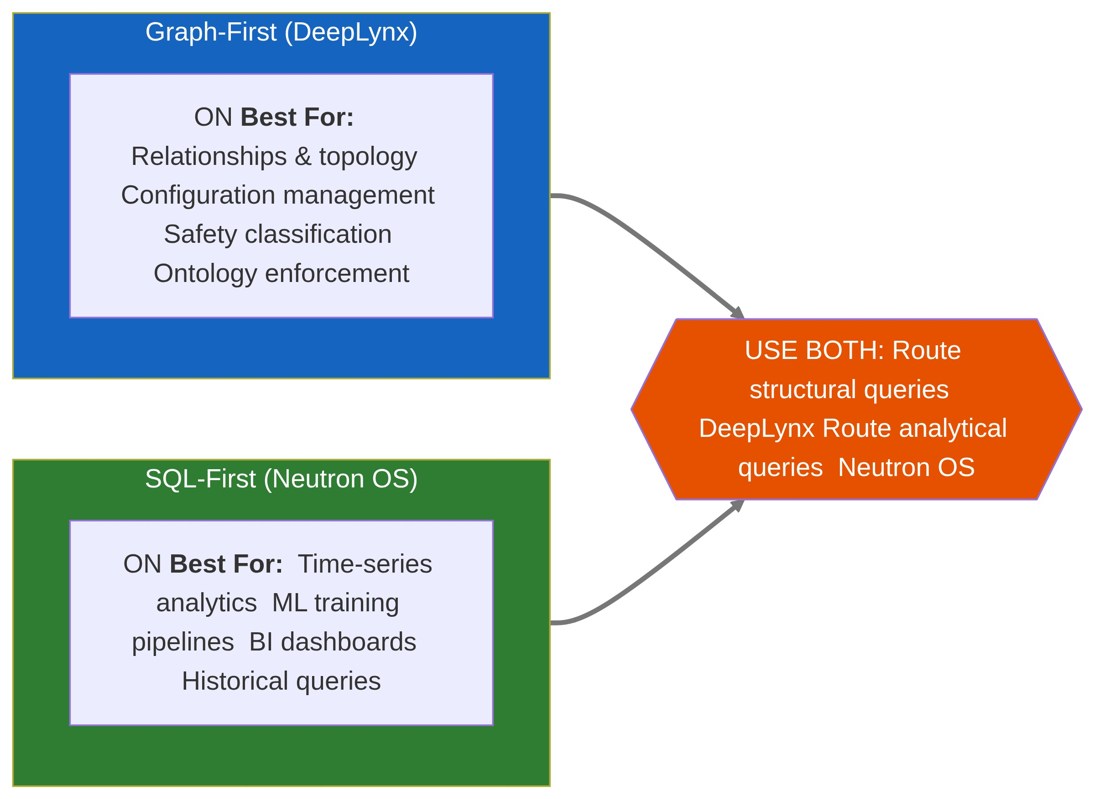

5.5 Technology Stack Alignment
DeepLynx Stack: C#/.NET + React—aligned with enterprise engineering teams and INL's broader infrastructure.
Neutron OS Stack: Python-first (dbt, Dagster, FastAPI)—aligned with research teams and ML workflows.
No need to unify stacks. MCP servers provide a common interface for AI agents to access both systems regardless of underlying technology.

6. Integrated Architecture Vision

6.1 The Complete Picture
DeepLynx and Neutron OS together provide a complete digital twin infrastructure:
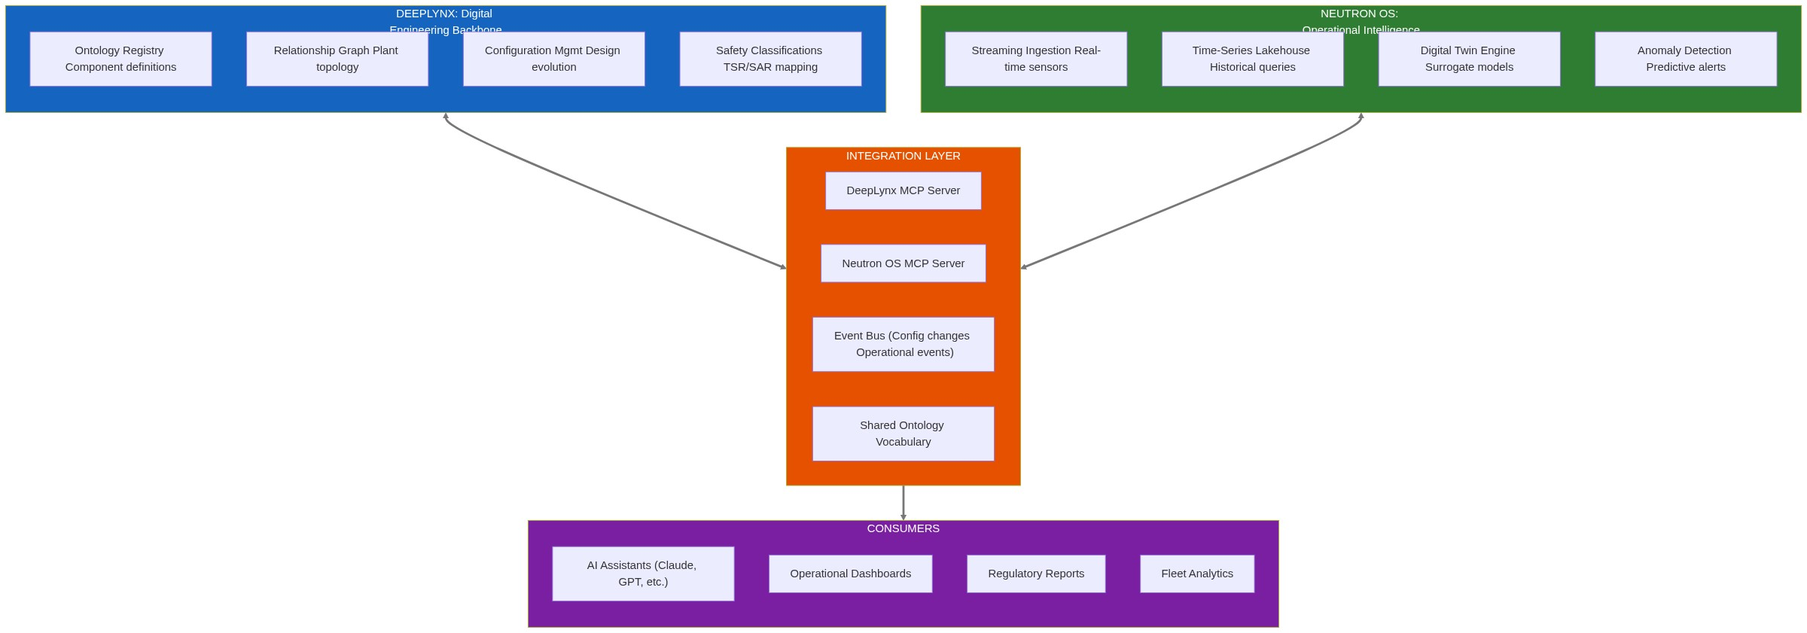

6.2 Integration Mechanisms
Mechanism | Purpose | Status
Shared Ontology Vocabulary | Same names for same things across systems | Aligned with DIAMOND
MCP Servers (Both Systems) | AI agents query either system seamlessly | DeepLynx: C#, Neutron OS: Python
Event Bus | Real-time sync between systems | Planned
Data Contracts | Schema guarantees for cross-system references | In progress

6.3 Integration Patterns
Pattern 1: Component ID Cross-Reference
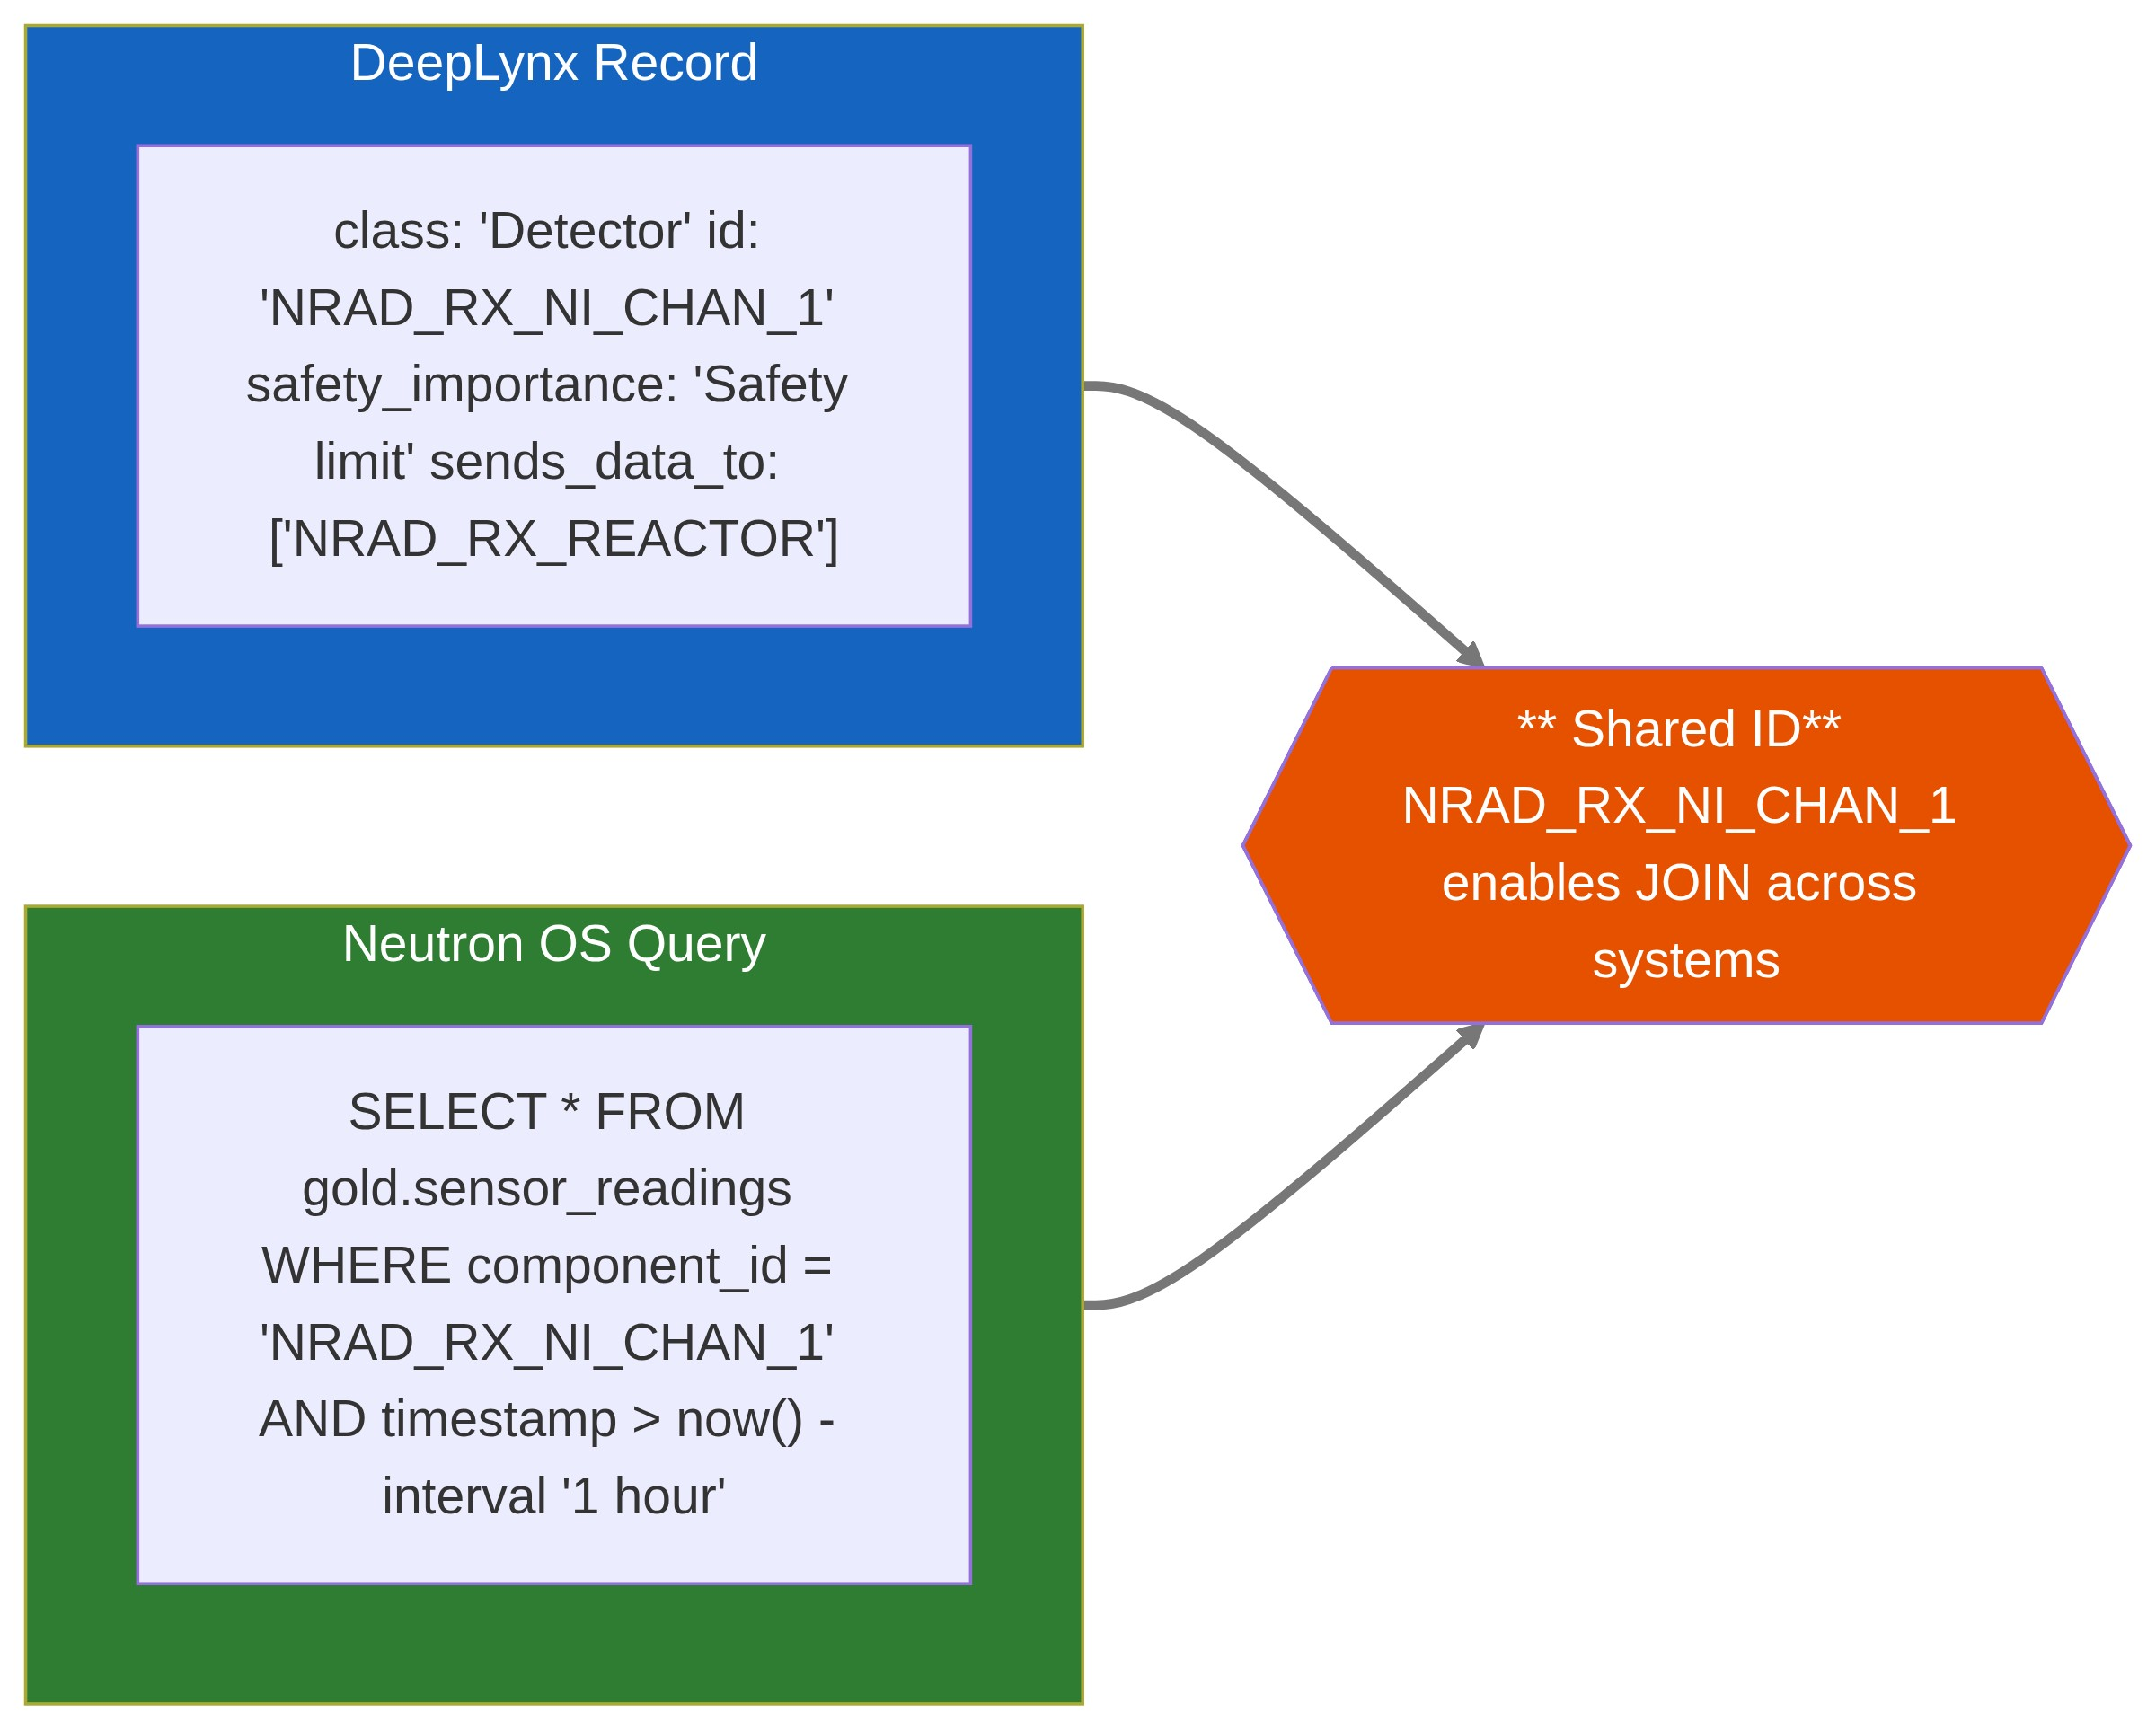
Pattern 2: Event-Driven Sync
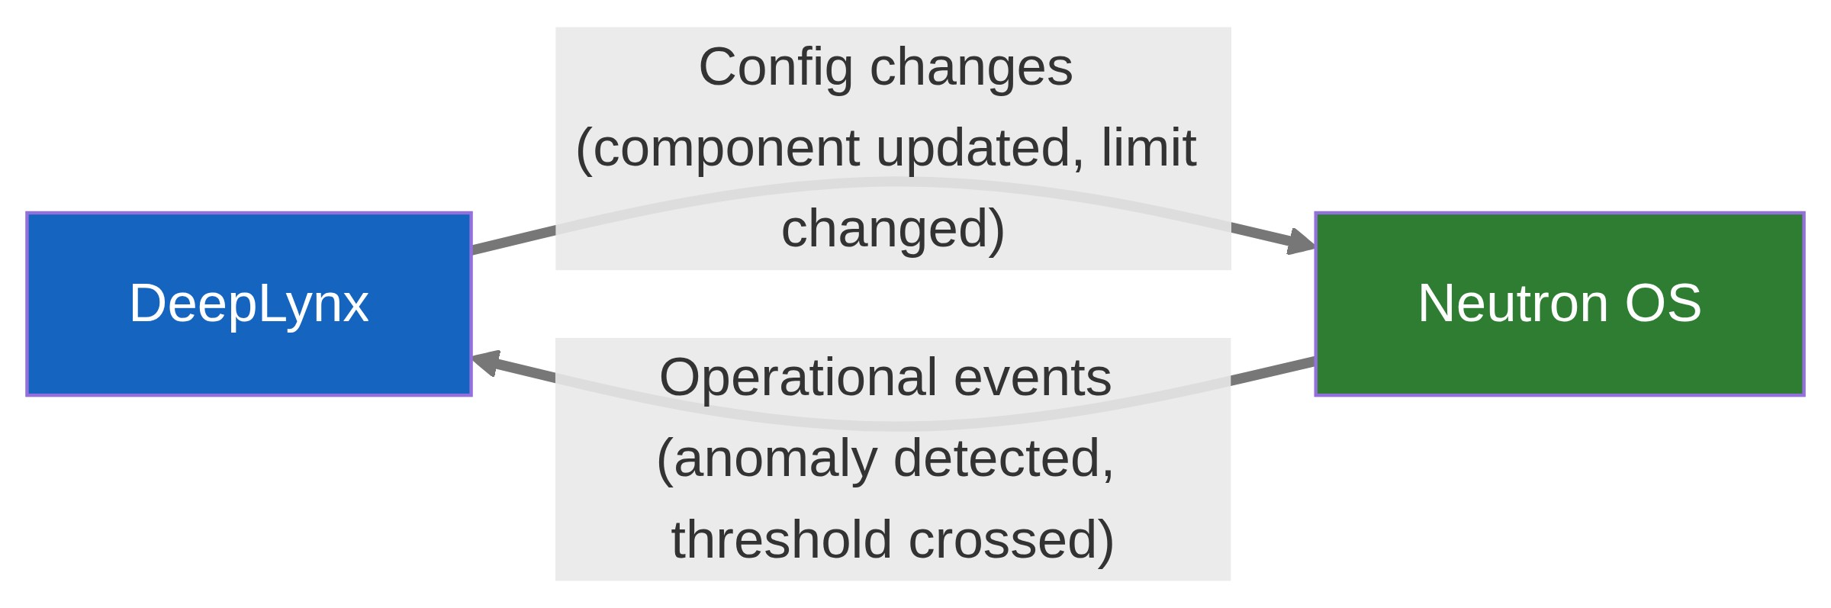
Pattern 3: Unified AI Agent Access
⚠️ Diagram rendering failed

6.4 What We've Adopted from DeepLynx
Pattern | Implementation in Neutron OS | Status
Ledger tables | dbt incremental model for audit snapshots | ✅ Adopted
NRAD ontology vocabulary | Class names, tag naming, limits schema | ✅ Aligned
MCP server architecture | Python MCP SDK with SQL + GraphQL tools | 🔄 In progress
Safety importance schema | safety_importance, required_logic, reference fields | ✅ Adopted
Tag naming convention | NETL_RX_* pattern (matches NRAD_RX_*) | ✅ Adopted
GraphQL for relationships | Strawberry Python dynamic schema | 📋 Planned

7. Collaboration Roadmap

7.1 Phase 1: Ontology Alignment (Now - Q2 2026)
Objective: Ensure DeepLynx and Neutron OS speak the same language.
Deliverable | Owner | Status
Adopt NRAD class names (Detector, Control Element, Limits) | UT | ✅ Complete
Align tag naming (NETL_RX_* ↔ NRAD_RX_*) | UT | ✅ Complete
Adopt limits schema (safety_importance, required_logic) | UT | ✅ Complete
Document vocabulary alignment | Joint | 📋 In progress

7.2 Phase 2: MCP Integration (Q3-Q4 2026)
Objective: AI agents can query both systems seamlessly.
Deliverable | Owner | Status
DeepLynx MCP Server (C#) | INL | ✅ Exists
Neutron OS MCP Server (Python) | UT | 🔄 In progress
Cross-system query demo | Joint | 📋 Planned
Shared tool interface specification | Joint | 📋 Planned

7.3 Phase 3: Event Integration (2027)
Objective: Real-time sync between systems.
Deliverable | Owner | Status
Config change event feed (DeepLynx → Neutron OS) | INL | 📋 Planned
Operational event feed (Neutron OS → DeepLynx) | UT | 📋 Planned
Shared data lake access protocol | Joint | 📋 Planned

7.4 Phase 4: Fleet Deployment (2028+)
Objective: Reference architecture for new reactor projects.
Deliverable | Owner | Status
Integrated deployment guide | Joint | 📋 Future
NEUP/ARPA-E proposal for advanced capabilities | Joint | 📋 Future
Commercial vendor engagement | Joint | 📋 Future

7.3 Architectural Principles
Principle | Rationale
Use each system for what it's best at | DeepLynx for structure, Neutron OS for time-series
Integrate via MCP and shared vocabulary | Loose coupling, independent evolution
Don't duplicate functionality | If DeepLynx has an ontology, reference it—don't copy it
Start with integration points, not merge | Prove value before deeper coupling

8. Appendix: Technical Details

8.1 DeepLynx Repository Structure
idaholab/DeepLynx/
├── deeplynx.api/ # C# REST API
├── deeplynx.UI/ # React frontend
├── deeplynx.business/ # Business logic
├── deeplynx.datalayer/ # Entity Framework + PostgreSQL
├── deeplynx.models/ # Domain models
├── deeplynx.interfaces/ # Abstractions
├── deeplynx.helpers/ # Utilities
├── deeplynx.tests/ # Test suite
├── deeplynx.mcp/ # MCP server (AI tools) ← INTERESTING
├── deeplynx.docs/ # Next.js documentation
├── documentation/adr/ # Architecture decisions
├── kubernetes/ # K8s manifests
└── Dockerfiles/ # Container builds

8.2 Key Technical Specifications
Spec | Value
Runtime | .NET 10
Database | PostgreSQL 14+
Container | Docker + Kubernetes
Auth | OAuth2 + API Keys
API | REST + GraphQL
Frontend | React + TypeScript
Docs | Next.js + MDX
MCP SDK | C# (custom impl)

8.3 Useful Links
Resource | URL
GitHub Repo | https://github.com/idaholab/DeepLynx
Product Page | https://inlsoftware.inl.gov/product/deep-lynx
Documentation | https://deeplynx.inl.gov/docs
Wiki (v1, deprecated) | https://github.com/idaholab/DeepLynx/wiki
DIAMOND Ontology | https://github.com/idaholab/DIAMOND
Contact | GRP-deeplynx-team@inl.gov

Document History
Version | Date | Author | Changes
0.1 | 2026-01-15 | UT Team | Initial assessment
0.2 | 2026-01-15 | UT Team | Major revision: Added timeseries capabilities, INL TRIGA context

9 Collaboration Scenarios

9.1 Scenario: Active INL Partnership
┌─────────────────────────────────────────────────────────────────────────────────────┐
│ SCENARIO: ACTIVE PARTNERSHIP │
├─────────────────────────────────────────────────────────────────────────────────────┤
│ │
│ IMMEDIATE OPPORTUNITIES │
│ │
│ ┌─────────────────────────────────────────────────────────────────────────────┐ │
│ │ 1. TRIGA DT ONTOLOGY ALIGNMENT │ │
│ │ │ │
│ │ • Ryan already sent Cole and Nick their TRIGA DT ontology. │ │
│ │ • Compare with our NETL TRIGA schema │ │
│ │ • Propose unified ontology for reactor DTs │ │
│ │ │ │
│ │ Effort: 2-4 weeks | Value: Very High │ │
│ └─────────────────────────────────────────────────────────────────────────────┘ │
│ │
│ ┌─────────────────────────────────────────────────────────────────────────────┐ │
│ │ 2. DATA EXCHANGE PROTOCOL │ │
│ │ │ │
│ │ DeepLynx GraphQL Neutron OS SQL │ │
│ │ ┌───────────────┐ ┌───────────────┐ │ │
│ │ │ Timeseries │◄────────────────►│ Iceberg │ │ │
│ │ │ Data Source │ Shared │ Tables │ │ │
│ │ └───────────────┘ Schema └───────────────┘ │ │
│ │ │ │
│ │ • Define common CSV/Parquet interchange format │ │
│ │ • Enable data sharing between INL/UT TRIGA deployments │ │
│ │ │ │
│ │ Effort: 1-2 months | Value: High │ │
│ └─────────────────────────────────────────────────────────────────────────────┘ │
│ │
│ ┌─────────────────────────────────────────────────────────────────────────────┐ │
│ │ 3. MCP SERVER INTEROPERABILITY │ │
│ │ │ │
│ │ INL DeepLynx MCP (C#) UT Neutron OS MCP (Python) │ │
│ │ ┌───────────────┐ ┌───────────────┐ │ │
│ │ │ ProjectTools │ │ ReactorTools │ │ │
│ │ │ RecordTools │──── Shared ───── │ SensorTools │ │ │
│ │ │ QueryTools │ Tool Spec │ SimTools │ │ │
│ │ └───────────────┘ └───────────────┘ │ │
│ │ │ │
│ │ • AI agents can work with both systems │ │
│ │ • Shared tool interface specification │ │
│ │ │ │
│ │ Effort: 2-3 months | Value: High │ │
│ └─────────────────────────────────────────────────────────────────────────────┘ │
│ │
│ FUNDING OPPORTUNITY │
│ │
│ ┌─────────────────────────────────────────────────────────────────────────────┐ │
│ │ NEUP IRP (Integrated Research Project) │ │
│ │ │ │
│ │ Concept: "Multi-Lab Reactor Digital Twin Infrastructure" │ │
│ │ │ │
│ │ Partners: │ │
│ │ • UT Austin (Lead): Neutron OS data platform │ │
│ │ • INL: DeepLynx integration, TRIGA deployment │ │
│ │ • [Additional labs/facilities with reactors] │ │
│ │ │ │
│ │ Funding: $2-5M over 3 years │ │
│ │ Deadline: Full proposal June 9, 2026 │ │
│ │ │ │
│ │ Key advantage: INL already has working TRIGA DT deployment │ │
│ └─────────────────────────────────────────────────────────────────────────────┘ │
│ │
│ REVISED RECOMMENDATION: ✅ **ACTIVELY PURSUE** │
│ │
└─────────────────────────────────────────────────────────────────────────────────────┘

9.2 NRAD Ontology Analysis (January 15, 2026 - Evening)
Source: nrad_dt_generic_ontology_v4.txt shared by Ryan via Nick

9.2.1 Ontology Structure
┌─────────────────────────────────────────────────────────────────────────────────────┐
│ NRAD DIGITAL TWIN ONTOLOGY │
├─────────────────────────────────────────────────────────────────────────────────────┤
│ │
│ CLASSES (10) RELATIONSHIPS (4) │
│ ├── Digital Twin ├── consists_of │
│ ├── Control Element ├── sends_data_to │
│ ├── Detector ├── has_setting_limits │
│ ├── Limits └── allows │
│ ├── Data Acquisition System │
│ ├── Data File │
│ ├── Analysis │
│ ├── Visualization │
│ ├── Modes of Operation │
│ └── Remote Monitoring │
│ │
│ DATA FLOW (via sends_data_to edges) │
│ │
│ ┌──────────────┐ ┌──────────────┐ ┌──────────────┐ ┌──────────────┐ │
│ │ Detectors │───▶│ TINA DAQ │───▶│ Data File │───▶│ Analysis │ │
│ │ (25+ nodes) │ │ System │ │ (CSV) │ │ (ML/SM) │ │
│ └──────────────┘ └──────────────┘ └──────────────┘ └──────┬───────┘ │
│ │ │
│ ▼ │
│ ┌──────────────┐ │
│ │ User │ │
│ │ Interface │ │
│ └──────────────┘ │
│ │
└─────────────────────────────────────────────────────────────────────────────────────┘

9.2.2 What's Excellent About This Ontology
Feature | Implementation | Why It Matters
Limits as first-class | Separate Limits class with structured arrays | LCO/TSR compliance built-in
Safety importance | "safety importance": "LCO"/"Safety limit"/"Scram function" | Regulatory traceability
ML integration | Analysis nodes for LSTM, Gaussian process | Model-aware digital twin
Explicit data flow | sends_data_to relationship chain | Clear data lineage
Reference citations | "reference": "SAR-406 pg 3-16" | Audit trail to safety docs

9.2.3 Sensors in NRAD vs NETL TRIGA
Category | NRAD Sensors | NETL TRIGA Equivalent
Control | Shim Rod 1, 2 + Regulating Rod | Safety, Shim, Reg rods
Power | Multi-Range Linear Ch 1-3, Wide-Range Log | NI channels (similar)
Fuel Temp | Fuel Temperature Detector | IFE thermocouples
Cooling | HX inlet/outlet, Primary/Secondary flow | Pool temp, flow sensors
Tank | Water level, Tank temp | Pool level, temp
Radiation | Room RAM, CAM, gaseous monitors | ARM, CAM

Key Finding: ~80% sensor overlap between NRAD and NETL TRIGA. Ontology is highly transferable.

9.2.4 What's Missing (Opportunities for Neutron OS)
Gap in NRAD Ontology | Neutron OS Could Add
No time-series aggregation classes | Trend analysis, anomaly detection
No historical state | Iceberg time-travel queries
No experiment/sample tracking | sample_tracking schema (per Nick's feedback)
No elog integration | Unified log system
tag name fields empty | Tag mapping infrastructure
No dashboard/BI concept | Superset integration

9.2.5 Revised Architecture: Complementary Systems
┌─────────────────────────────────────────────────────────────────────────────────────┐
│ HYBRID ARCHITECTURE: DEEPLYNX + NEUTRON OS │
├─────────────────────────────────────────────────────────────────────────────────────┤
│ │
│ DEEPLYNX (Operations Layer) NEUTRON OS (Analytics Layer) │
│ ───────────────────────────── ──────────────────────────── │
│ │
│ ┌─────────────────────────────┐ ┌─────────────────────────────┐ │
│ │ Asset Ontology │ │ Time-Series Lakehouse │ │
│ │ • Detector definitions │ │ • Iceberg tables │ │
│ │ • Control elements │◀────▶│ • Historical data │ │
│ │ • Relationship graph │ sync │ • dbt transformations │ │
│ └─────────────────────────────┘ └─────────────────────────────┘ │
│ │
│ ┌─────────────────────────────┐ ┌─────────────────────────────┐ │
│ │ Limits & Compliance │ │ Analytics & ML │ │
│ │ • LCO tracking │ │ • Trend analysis │ │
│ │ • Safety limits │─────▶│ • Anomaly detection │ │
│ │ • Scram logic (2/3, etc.) │alerts│ • Predictive models │ │
│ └─────────────────────────────┘ └─────────────────────────────┘ │
│ │
│ ┌─────────────────────────────┐ ┌─────────────────────────────┐ │
│ │ Real-time State │ │ Historical Analysis │ │
│ │ • Current sensor values │ │ • "What happened?" │ │
│ │ • Operational mode │─────▶│ • Root cause analysis │ │
│ │ • WebSocket streaming │ │ • SQL/BI dashboards │ │
│ └─────────────────────────────┘ └─────────────────────────────┘ │
│ │
│ BEST FOR: BEST FOR: │
│ • "Is this sensor in limits?" • "Show me last month's trends" │
│ • "What's connected to what?" • "Train a model on this data" │
│ • "What's the current state?" • "Build a Superset dashboard" │
│ │
└─────────────────────────────────────────────────────────────────────────────────────┘

9.3 Summary: The Integrated Vision
Core Insight: DeepLynx and Neutron OS are complementary, not competing:
System | Excels At
DeepLynx | Asset relationships, limits/compliance, configuration tracking, safety classification
Neutron OS | Time-series analytics, ML workflows, BI dashboards, historical queries, streaming

The integrated architecture lets each system do what it's best at while sharing data through MCP servers, event buses, and aligned vocabularies.

9.4 What This Enables
Capability | Neither System Alone | Integrated Systems
"Which safety components have anomalies?" | Partial answer | ✅ Full answer
"Train model with component context" | Structure OR history | ✅ Both
"AI assistant with full reactor context" | Limited | ✅ Complete
"Fleet-wide pattern detection" | Topology OR trends | ✅ Correlated
"Regulatory query across systems" | Manual JOIN | ✅ Unified

Addendum: Supporting References

Data Lakehouse Architecture Patterns
Topic | Reference | Relevance
Medallion Architecture | Databricks: What is a Medallion Architecture? | Bronze/Silver/Gold pattern we adopt
Apache Iceberg | Iceberg: An Open Table Format | Time-travel, schema evolution, open format
Apache Hudi | Hudi: Upserts on Data Lakes | Iceberg predecessor; similar problem space
dbt | dbt: Transform Data in Your Warehouse | SQL-first transformation layer

Hyperscale Data Platform Case Studies
Topic | Reference | Key Insight
Raw → Modeled Tiering | Uber's Big Data Platform: 100+ PB | EL not ETL; separation of ingestion from transformation
Incremental Processing | Uber: Hoodie (now Hudi) | Upserts on immutable storage; incremental reads
Schema Enforcement | Uber: Marmaray Ingestion | Generic ingestion platform; schema validation
Query Federation | Presto: SQL on Everything | Interactive queries across heterogeneous sources

DeepLynx Documentation
Topic | Reference | Notes
DeepLynx Nexus Docs | deeplynx.inl.gov/docs | Official v2 documentation
DeepLynx GitHub | github.com/idaholab/DeepLynx | Source code and wiki
Timeseries 2 Feature | DeepLynx Wiki: Querying Tabular Data | DataFusion-based SQL queries
DIAMOND Ontology | INL internal | TRIGA digital twin ontology (shared via collaboration)

Modern Data Stack Components
Component | Reference | Our Usage
DuckDB | duckdb.org | Embedded analytics (Phase 1-3)
Trino | trino.io | Distributed queries (Phase 4+)
Dagster | dagster.io | Pipeline orchestration
Apache Superset | superset.apache.org | Self-service dashboards
LangGraph | langchain-ai.github.io/langgraph | LLM workflow orchestration

End of Document

