Table of Contents
Neutron OS: Executive Summary
What Is Neutron OS?
The Problem We're Solving
What Neutron OS Delivers
For Researchers
For Operators
For Project Managers
For Regulators
Architecture at a Glance
Development Phases
Why Open Lakehouse (Not Databricks/Snowflake)?
Relationship to INL DeepLynx
Why Not Just Use DeepLynx and Extend It?
Future Directions: What This Architecture Enables
Current Status
Resource Requirements
Documentation Structure
Next Steps

Neutron OS: Executive Summary
Version: 1.0 DRAFT Date: January 2026 Authors: UT Computational Nuclear Engineering Group
Document Scope: This specification focuses on data architecture—the foundation that everything else builds on. Detailed specifications for user interfaces (dashboards, portals) and Hyperledger blockchain integration (audit trails, multi-facility consensus) are reserved for subsequent documents.
Dual-Track Approach: We're not waiting for perfect architecture to deliver value. The plan is to sandwich MVP analytics immediately (a "data puddle" with Superset dashboards connected to the DMSRI-web PostgreSQL database) while building the full lakehouse foundation in parallel. Jay can stand up queryable dashboards now; we evolve the underlying infrastructure without blocking visibility. Early wins fund patience for solid architecture.
Current state: DMSRI-web PostgreSQL does minimal aggregation and scrubbing of raw data for display in Plotly today. This doesn't scale, but connecting Superset to it delivers immediate value.

What Is Neutron OS?
Neutron OS is an agentic data ecosystem for nuclear digital twins—a streaming-first platform that connects reactor sensors, physics simulations, and operational decisions in real time.
Core capabilities:
- Streaming-first architecture with real-time data flow and intelligent batch fallback
- Digital twin simulation that predicts reactor state between sensor readings (~10ms predictions vs ~100ms sensors)
- Agentic data access via MCP, enabling AI assistants to query reactor data, documentation, and operational context
- Multi-facility design built for fleet operations, from research reactors to commercial deployments
Think of it as the "operating system" for nuclear data: sensors stream to it, digital twins query it, AI assistants reason over it, and regulators audit it.
Why build this? Nuclear digital twins require infrastructure that doesn't exist today—real-time pipelines with sub-second latency, physics-informed ML training loops, and blockchain-grade audit trails. As nuclear energy commercializes at scale (50+ units/year), the industry needs common data infrastructure. Neutron OS provides that foundation, starting with UT Austin's research portfolio.

The Problem We're Solving
Nuclear research generates enormous volumes of data across disconnected systems:
Current State | Pain Point
Sensor data in CSV files on Box | No queryable history; manual analysis
Simulation outputs scattered across HPC | Results disconnected from measurements
Meeting notes in Slack, Teams, Word docs, voice transcripts | Requirements lost; action items forgotten
Each project builds custom tooling | Duplicated effort; inconsistent quality

The core tension: Digital twin capabilities are advancing rapidly, but the data infrastructure to support them—reliable ingestion, versioned storage, reproducible transforms, validated predictions—lags behind. We're building sophisticated ML models on fragile data foundations.

What Neutron OS Delivers

For Researchers
- Query any historical reactor state with SQL
- Compare simulation predictions to actual measurements
- Reproduce any analysis from any point in time

For Operators
- Real-time dashboards showing reactor status
- Predictions that fill gaps between sensor readings
- Alerts when predictions diverge from measurements

For Project Managers
- Automated extraction of action items from meetings
- Traceability from requirements to implementation
- Cross-project visibility into data quality

For Regulators
- Immutable audit trail of all data and predictions
- Blockchain-backed proof of prediction accuracy
- Multi-facility consensus on model validity

Architecture at a Glance
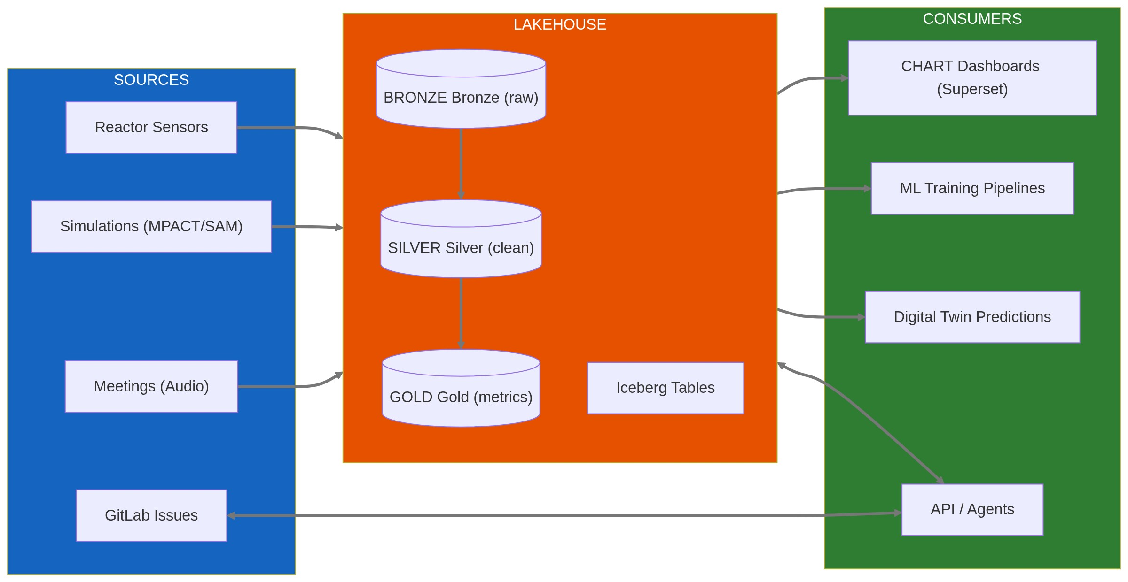
Key technology choices:
- Apache Iceberg for versioned, time-travel-capable storage
- DuckDB for fast embedded analytics (scales to Trino for multi-facility)
- dbt for reproducible data transformations
- Dagster for observable pipeline orchestration
- Superset for self-service dashboards

Development Phases
Phase | Deliverable | Timeline | Status
1a. Data Puddle (MVP) | Superset dashboards on DMSRI-web PostgreSQL; immediate visibility | Now | 🟢 Jay can start
1b. Foundation | Iceberg lakehouse, dbt models, proper data contracts | Q1 2026 | 🟡 In Progress
2. Core Analytics | Full medallion architecture, Dagster orchestration; migrate puddle → lakehouse | Q2 2026 | ⚪ Planned
3. Batch Digital Twin | Offline model training, historical validation | Q3 2026 | ⚪ Planned
4. Real-Time Streaming | Live sensor ingest, <1s predictions | Q4 2026 | ⚪ Planned
5. Agentic Workflows | Meeting extraction, automated issue creation | Q1 2027 | ⚪ Planned
6. Closed-Loop Control | Predictions inform control systems | TBD | ⚪ Research

Phase 1 is dual-track: 1a delivers dashboards stakeholders can see now; 1b ensures we don't have to rebuild when scale or complexity increases. The "puddle" migrates onto proper infrastructure in Phase 2.

Why Open Lakehouse (Not Databricks/Snowflake)?
Some stakeholders ask: "Why not just pay Databricks to maintain this?"
Factor | Databricks/Snowflake | Open Lakehouse
Data sovereignty | Vendor control plane has access; proprietary format | You choose where data lives; open Iceberg format is portable
Nuclear compliance | Export control complexity | Full control over data residency
Cost trajectory | DBU pricing scales with usage | Fixed TACC allocation; marginal cost ~$0
Customization | Limited to platform APIs | Full access for DT integration
Skills transfer | Vendor-specific knowledge | Industry-standard patterns
Lock-in risk | High switching costs | Portable Iceberg format

Our position: For nuclear research with sensitive data, regulatory requirements, and deep customization needs, building capability beats buying a platform. The open lakehouse stack (Iceberg + DuckDB + dbt) has reached maturity where it's the right choice for our context.
See for detailed analysis.Platform Comparison: Databricks

Relationship to INL DeepLynx
INL's DeepLynx is a graph-based digital thread platform focused on engineering data management and ontology modeling. Neutron OS is a time-series lakehouse focused on sensor data, simulations, and ML pipelines.
Aspect | DeepLynx | Neutron OS
Data model | Graph + separate time-series files | Unified columnar tables
Primary use case | Engineering data management | Reactor operations + DT simulation
Query interface | GraphQL (graph), batch SQL (time-series) | Interactive SQL
Deployment | INL infrastructure | TACC / local Kubernetes

Why Not Just Use DeepLynx and Extend It?
This is a fair question. The short answer: different data patterns require different architectures.
- DeepLynx optimizes for relationship traversal ("what components are affected by this requirement?")
- Neutron OS optimizes for time-series analytics ("average power over 24 hours with 10ms granularity")
DeepLynx does have time-series capabilities ("Timeseries 2" via DataFusion), but uses a batch workflow (submit query → poll → download CSV). For interactive dashboards and ML inference, we need millisecond response times. Extending DeepLynx to serve our use case would require adding columnar storage, interactive queries, time-travel, and medallion architecture—effectively building Neutron OS inside DeepLynx.
They're complementary, not competing. The right architecture uses DeepLynx for engineering ontology (component relationships, requirements traceability) and Neutron OS for operational data (sensor readings, predictions, ML training). Integration happens via shared identifiers and APIs.
See for detailed analysis, including Section 1.3 "Why Not Just Use DeepLynx and Extend It?"DeepLynx Assessment

Future Directions: What This Architecture Enables
The data platform is designed to grow. The same data contracts that power digital twin predictions can support additional capabilities as needs evolve:
Future Capability | How Data Platform Enables It
Compliance & Audit | Append-only tables + blockchain anchoring → regulatory evidence packages
AI Assistants | Structured data + embeddings → LLM + RAG for natural language queries
Multi-Facility Collaboration | Tenant isolation + federated queries → cross-site benchmarking
Operations Modules | Gold-layer APIs → experiment planning, fuel management dashboards
Sensor Integration | Streaming ingest patterns → real-time DAQ connectors

These are not current deliverables—they're architectural options. The platform doesn't lock us out of future directions, and pursuing them becomes straightforward once the data foundation is solid.

Current Status
What exists today:
- TRIGA sensor data flowing: NETL → Box → TACC → Plotly dashboards
- Historical data archive: 18 months of reactor operations
- Prototype Iceberg tables with basic dbt models
- Meeting transcription pipeline (Whisper + LLM extraction)
What's in development:
- Full medallion architecture (Bronze → Silver → Gold)
- Dagster orchestration for automated pipelines
- Superset dashboards replacing custom Plotly code
What's planned:
- Real-time streaming ingest
- Digital twin surrogate model training
- Multi-facility tenant isolation

Resource Requirements
Category | Year 1 | Year 2 | Year 3
Personnel | 1.5 FTE (grad students + PI time) | 2 FTE | 2 FTE
Compute | TACC Lonestar6 allocation | TACC + local K8s | Multi-facility
Software | Open source (no license cost) | Same | Same
Estimated Budget | $300K | $400K | $400K

Total 3-year estimate: $800,000 - $1,200,000 (pending CINR NOFO confirmation)

Documentation Structure
This executive summary is part of a modular documentation set:
Document | Audience | Content
Executive Summary (this doc) | Leadership, PIs, reviewers | High-level overview
Master Tech Spec | Technical leads | Binding architecture decisions
Databricks Comparison | Stakeholders | Platform strategy rationale
DeepLynx Assessment | INL collaborators | Integration opportunities
Component Specs | Engineers | Deep implementation details
Design Prompts | Developers | Actionable build specifications

Next Steps
- Complete Phase 1 (Q1 2026): Full Iceberg lakehouse with dbt models
- Submit CINR PreApp (Jan 28, 2026): Funding request for 3-year development
- Stakeholder review: Circulate this summary for feedback
- Begin component builds: Use design prompts to drive implementation
For technical details, see the [Master Technical Specification](neutron-os-master-tech-spec.md).

