物導2014年Ch1-6重點整理
Chapter 1 Getting Started
- method: objects interact with one another by means of actions
- two types of Java program
  - Applications: start with main method
  - Applet: run from Web browser
- System.out.println
  - System.out: object
  - println: method
- l-value:位置. r-value:內容

  - byte-code
    - machine language for a fictitious computer (Java Virtual Machine)
    - can be used on any computer
- Class Loader(linker): a program that connects the byte-code of the classes
- javac: compile command
  - e.g javac FirstProgram.java
- Identifier: name of a variable
  - identifiers have no maximum length
- keywords(reserved words): predefined meaning in Java
  - e.g public, class, void, static
- predefined identifiers: defined in libraries
  - e.g. System, String, println
- <重要！>Primitive Types 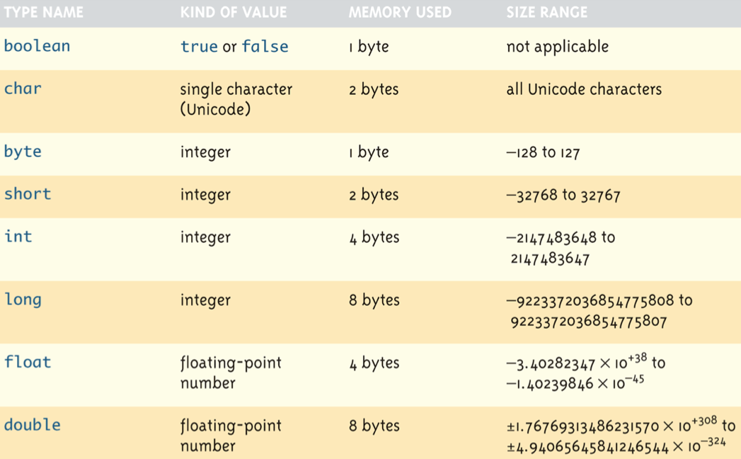

- Assignment
  - temperature = 98.6; //98.6預設為double
  - a=2; //2預設為int
  - int intVal = 2.99; //Illegal

byte a = 1; //1應該為int，不是應該塞不進byte嗎？但是compiler自動把他轉為byte大小
short b = 1;
int c = 1;
long d = 1;
float e = 1.0; //error, 因為1.0為預設double，塞不進float
double f = 1.0;

a = 100000; //error, 因為byte塞不下這麼大的數字
b = 100000; //error, 因為short塞不下這麼大的數字
c = 100000;
d = 100000;
d = 100000000L; //OK
e = 1.0f //OK

- Constants (literal)
  - 例如光速常數：
<java>
public static final double c =3.0E8; //常數不要寫在main函式裡面
<C>
const double c=3.0E8;
- 兩種變數類型做四則運算後會變大者, e.g
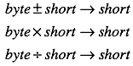
- Precedence Rules
  - First: the unary operators: +, -, ++, —, and ! (right-to-left)
  - Second: the binary arithmetic operators: *, /, and % (left-to-right)
  - Third: the binary arithmetic operators: + and - (left-to-right)
- 非class的基本資料形態若要使用則必須先給他一個明確的初始值
class裡面的data member如果沒有明確的給他初始值，則boolean給false，剩下全部補0
- garbage collection
  - 若沒有變數指向某物件，該物件則由java的garbage collection負責刪除並把記憶體還給系統
  - <C> malloc來配置，free來釋放
  - <C++> new來配置，delete來釋放
<java> new來配置，可將指標變數設為null，最後自動由garbage collection處理掉
Chapter 2: Console Input and Output
- legacy code: code that is “old fashioned” but too expensive to replace
  - e.g printf
- Importing Packages and Classes
  - java.lang package is automatically imported
  - e.g java.text.NumberFormat
    - java.text: package
    - NumberFormat: class name
- Scanner Class: keyboard input
  - need to import java.util.Scanner
  - e.g. Scanner keyboard = new Scanner(System.in);
  - e.g. int numberOfPods = keyboard.nextInt();
  - e.g. String word = keyboard.next();
  - e.g. String line = keyboard.nextLine();

Chapter 3: Flow of Control
- switch: 只能用於char, int, short, byte, String
- conditional operator
if (n1 > n2) max = n1;
else max = n2;
max = (n1 > n2) ? n1 : n2; //same as the two lines above

if (a>b)
if(c>d) max = c;
else max = d;
else
if(e>f) max = e;
else max = f;

max = (a>b) ?
(c>d) ? c:d
:
(e>f) ? e:f;
- == with Strings: to see if they are stored in the same memory location
- logical operators
  - short-circuit (lazy evaluation): &&, ||
      - &&：檢查第一個不成立，就不檢查第二個
      - ||：檢查第一個成立，就不檢查第二個
public static void main(String[] args) {
int a=1;
int x=20;

if(a>10 && x>a++){ //前者做完不成立，後者不用做

}
System.out.println(a); //print出1
}

  - boolean operator: not(!), and(&), or(|), xor(^)
public static void main(String[] args) {
int a=1;
int x=20;

if(a>10 & x>a++){ //前者做完不成立，後者還是要做

}
System.out.println(a); //print出2
}
      - &兩側為boolean expression，&則扮演logical operator
      - &兩側為int，&則扮演bitwise logical operator

- shift operators
  - signed right-shift operator >>
      - e.g. 128 >> 1 returns 128/2¹ = 64, -256 >> 4 returns 256/2⁴ = -16
  - unsigned right-shift operator >>>
  - signed left-shift operator <<
  - unsigned left-shift operator <<<
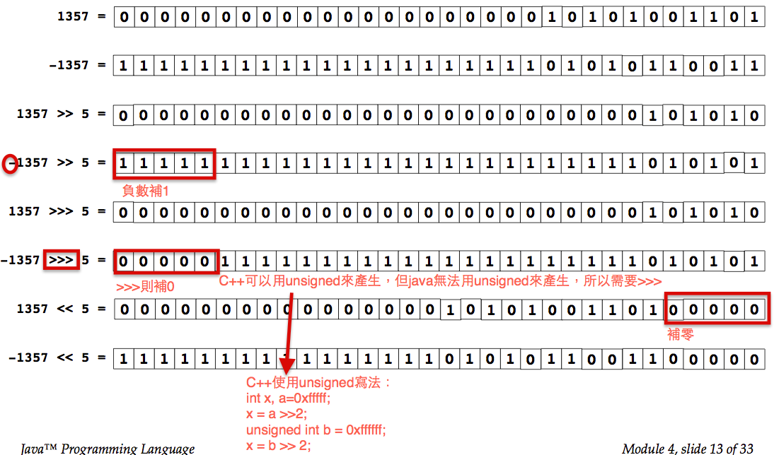

- Precedence
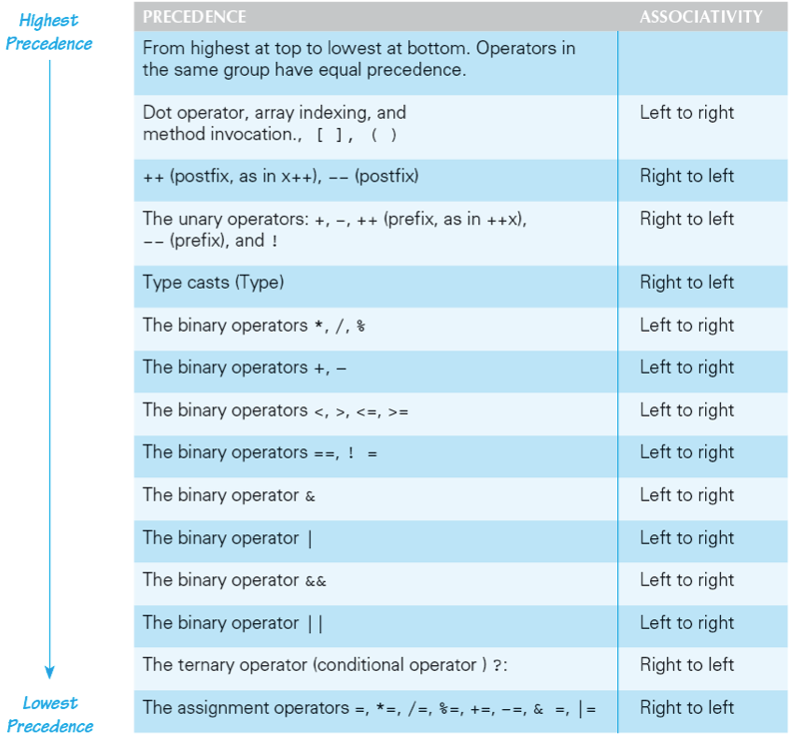

- side effects: an expression changes something, such as value of a variable. 某指令狀態前與後，若變數值有改變就是side effect
  - e.g. assignment, increment, decrement
  - pass by value沒有side effect，因為不會改變到原本傳進去變數的值
  - pass by reference有side effect，因為會改變到原本船進去變數的值，不過java沒有pass by reference這種東西
  - example 1:
main(){
int x=10;
f(x);
print(x); //10
//no side effect
}

f(int a){
a++;
}
  - example 2:
public static void main(String[] args) {
String x = "abc"; //x points to another memory block stored "abc"
f(x);
System.out.print(x); //abc
}

public static void f(String a){
a="def"; //a points to another memory block stored “def"
//因為String immutable，所以a指向別的物件去了
}

- stack memory during pass by value
public static void main(String[] args){
int a;
int b=5;
}

public static void f(int c){

}
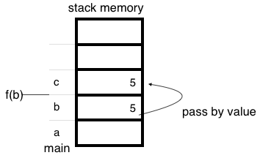
- exit: end the program immediately
- assertion checks: asserts something about the state of a program
  - if evaluates to false, program ends, and outputs an assertion failed error message
- random numbers
import java.util.Random;
Random rnd = new Random();
int i = rnd.nextInt(10); //Random number from 0 to 9
double d = rnd.nextDouble(); // 0 <= d < 1

//亦可使用Math class的random() //random()輸出值>=0, <1
Math.random()*100 //若要產生0~100的亂數
Math.random()*50+50 //若要產生50~100的亂數
int x = (int)(Math.random()*6)+1; //模擬dice的運作
char y = (char)(Math.random()*26+'a'); //a到z間任取一個字母

- special loop flow control
  - break [label];
outer:
do{
statement;
do {
statement;
if (boolean expression){
break outer; //跳出外面的do while回圈
}
statement;
} while (boolean expression)
} while (boolean expression)

  - continue [label];
do{
statement;
if (boolean expression){
continue; //回到do的地方執行
}
statement;
} while (boolean expression)

  - label: statement; //where statement should be a loop

Chapter 4: Defining Classes I
- programmer-defined types: typedef, enum, struct, class(blueprint for objects)
- members = data items + methods
- fields = instance variables = data items = attributes
- variables
  - local/automatic/temporary/stack variables
        - declared within a method
        - no default value
  - no global variable
  - parameters of primitive type
        - 呼叫函式傳入的變數叫做formal parameters/parameters(參數)
        - 被呼叫函式接收的變數叫做actual parameters/argument(引述)
void main(String[] argv{
int a;
f(a); //a為parameter
}

f(int b){ //b為argument
b++
}
        - 若int傳入double類型，會發生automatically type cast
        - this
      - Explicit name for the calling object.指標變數(reference)指向自身物件.
      - must be used if same name is used in the method
      - static method do not contain this
  - member and class variables are automatically initialized
public class HelloJava {
static int x;
public static void main(String[] args) {
int a;
System.out.println(a); //error, because not initialized
System.out.println(x); //no error, because x is a member
}
}
- bottom-up testing: first test all the methods invoked by that method, and then test the method itself. 被呼叫的函式全部先測試好，才能使用該函式
- information hiding
  - the practice of separating how to use a class from the details of its implementation
  - ADT (abstract data type): data type using information hiding
- encapsulation
  - data and methods of a class are combined into a single unit
  - API (application programming interface): description of how to use a class
- accessor methods: obtain value of an object’s instance variable
- mutator methods: change the value of an object’s instance variable
- overloading: two or more methods with same name in the same class
  - need different signatures: types of parameters
- construct
  - need new operator to construct
  - if no constructor, Java automatically create a default/no-argument constructor
  - if include constructor, Java will not provide default constructor
      - therefore, user need to provide no-argument constructor
  - default constructor
      - boolean: false
      - primitive types: zero
class types: null
Chapter 5: Defining Classes II
- static method: without calling object (所以static methods沒有this)
  - 不屬於任何一個class的method
  - e.g public static double pow(double base, double exponent)
  - static method can’t access private data member and member functions
- static variable: variable with only one copy for a class
  - static method can access static variable
  - static variable不透過constructor而建構，所以若要對static variable做初始化動作，可以寫個static block，來對所有static variable處理，如下：
static{

}
  - should always be defined private, unless it is also a defined constant
    - e.g Math.PI is a public static final double
- Wrapper Class
  - boxing: primitive type to object of its wrapper class
      - e.g. Integer integerObject = new Integer(42);
      - automatic boxing: Integer integerObject = 42;
  - unboxing: object of a wrapper class to primitive type
      - e.g. int i = integerObject.intValue();
      - automatic unboxing: int i = integerObject;
  - conversions:
      - convert string to number. e.g. Integer.parseInt(“123”);
      - convert number to string. e.g. Double.toString(123.99);
- <重要！>reference assignment operator =
e.g. MyDate date = new MyDate(22, 7, 1964);
  - new會在heap記憶體區段配置MyDate大小的空間
  - MyDate constructor初始化data member
  - 回傳自己在heap記憶體區段的位置，並指定給在stack記憶體區段的reference變數date
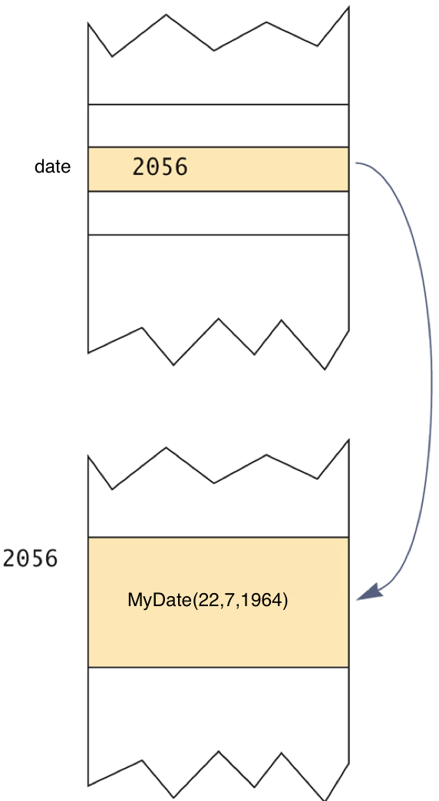
- class parameters: any change made to the object named by the parameter will be made to the object named by the argument
- anonymous object: an object whose reference is not assigned to a variable
- null (constant)
  - not an object
  - placeholder for a reference that does not name any memory location
- copy constructor: a constructor with a single argument of the same type as the class
  - primitive type: copy directly
  - class type: must creates a new one (prevent privacy leak)
  - deep copy: a copy of an object which has no references in common, except for immutable objects 所有物件都不share，除了無法修改內容的物件例外可以share
  - shallow copy: not a deep copy
- packages: a group of classes
  - to make a package
      - group all classes into a single folder
      - add package package_name to the beginning of each class file
  - java.lang is automatically imported. It includes
      - Math
      - String
      - wrapper classes
  - package directories
e.g. assume I have a file under the directory (\libraries\newlibraries)
      - a package class in the directory (\libraries\newlibraries\utitlities\numericstuff) needed to be imported
      - type import utilities.numericstuff.*
      - utilities.numericstuff is a CLASSPATH
  - packages prevent name clashes (a situation in which two classes have the same name)

Chapter 6: Arrays
- Declaration: BaseType[] ArrayName = new BaseType[size]
e.g. double[] score = new double[5];
e.g. double[] score = {56,88,55,99,33};
- array is an object
- length instance variable
  - return numbers of elements in the array
  - e.g. score.length
- character array to String
char[] a = {‘A’, ‘B’, ‘C’};
String s = a; // illegal! Only C++ can do this

// OK! makes a new string by String constructor, s1 is “ABC”
String s1 = new String(a);

String s2 = new String(a, 0, 2) // OK! s2 is “AB”

System.out.println(a); // prints out ABC

int[] ar = {1,2,3,4,5};
System.out.print(ar); // prints out the address of ar, not 12345

- arrays with class base type
  - e.g. Date[] holidayList = new Date[20]; //doesn’t create 20 Date objects, null for all indexes
    - 所以總共要new 20次(20個Date) + 1次(Date array) = 21次
- array parameters
  - e.g. public static void doubleElements (double[] a);
  - e.g. public static void main (String[] args)
    - when using terminal, java SomeProgram Hi ! there
    - args[0] is “Hi”
    - args[1] is “!”
    - args[2] is “there”
- return array
  - e.g. public static int[] {returns anArray;} //returns reference of the array, but has privacy leak
//deep copy for accessor to prevent privacy leak
public int[] getArray(){
double[] temp = new double[count];
for (int i = 0; i < count; i++)
temp[i] = anArray[i];
return temp;
}

- for each loop
  - for (ArrayBaseType VariableName : ArrayName)
Statement
  - for ( double element : arr) //access all elements in arr, and print them
println(element);
  - VariableName is a copy from the element in ArrayName, assignment to VariableName doesn’t change the element in ArrayName
- ellipsis
  - Type… ArrayName
  - e.g. public static Type methodName(Type… ArrayName)
    - methodName can take variable number of parameters
  - for example:
private static void m1(int[] a){
for(int i=0; i< a.length; i++){
System.out.println(a[i]);
}
}

/* m2 can’t overload m1 because they have same type of parameter(which is array) */
private static void m2(int... a){ //a is an array
//no need to pass by array from main to m2
for(int i=0; i<a.length; i++){
System.out.println(a[i]);
}
}

public static void main(String[] args) {
m1(1); //error, need to pass by array
m1(1,2); //error, need to pass by array

int[] b = {1};
m1(b); //ok!

m2(1); //ok, 當1傳入m2時，同時也被打包成array，成為陣列a的元素
m2(1,2); //ok, 當1,2傳入m2時，同時也被打包成array，成為陣列a的元素
m2(1,2,3); //ok
m2(1,2,3,4); //ok
m2(b); //ok
}

- enum: 直接列舉所有此種自訂類型的值
  - enum TypeName {VALUE_1, VALUE_2, …, VALUE_N}
enum WorkDay{MONDAY, TUESDAY, WEDNESDAY, THURSDAY, FRIDAY};
WorkDay meetingDay, availableDay;
meetingDay = WorkDay.THURSDAY;
availableDay = null;
System.out.println(meetingDay); //outputs is THURSDAY, not String value

  - == or equals method to compare two variables or constants
    - values method: returns entire enum as an array
    - e.g. WorkDay[] day = WorkDay.values(); //day[0] is MONDAY, day[1] is TUESDAY…
  - can be used with switch statement
  - enum with data members and methods
public enum Planet {
MERCURY (3.303e+23, 2.4397e6), //每一項都是constant object
VENUS (4.869e+24, 6.0518e6), //後面括號的數字相當於直接去呼叫了
EARTH (5.976e+24, 6.37814e6), //constructor
MARS (6.421e+23, 3.3972e6),
JUPITER (1.9e+27, 7.1492e7),
SATURN (5.688e+26, 6.0268e7),
URANUS (8.686e+25, 2.5559e7),
NEPTUNE (1.024e+26, 2.4746e7),
PLUTO (1.27e+22, 1.137e6);

private final double mass; // in kilograms (data member)
private final double radius; // in meters (data member)
Planet(double mass, double radius) { //constructor
this.mass = mass;
this.radius = radius;
}
public double mass() { return mass; } //enum methods
public double radius() { return radius; }

// universal gravitational constant (m³ kg⁻¹ s⁻²)
public static final double G = 6.67300E-11;

public double surfaceGravity() {
return G * mass / (radius * radius);
}
public double surfaceWeight(double otherMass) {
return otherMass * surfaceGravity();
}
}

- Multidimensional Arrays
  - e.g. char [][] a = a[5][12]; //宣告了一個空間為5的陣列，每項元素指向一個空間為12的char陣列，可以想成是row為5，column為12的陣列
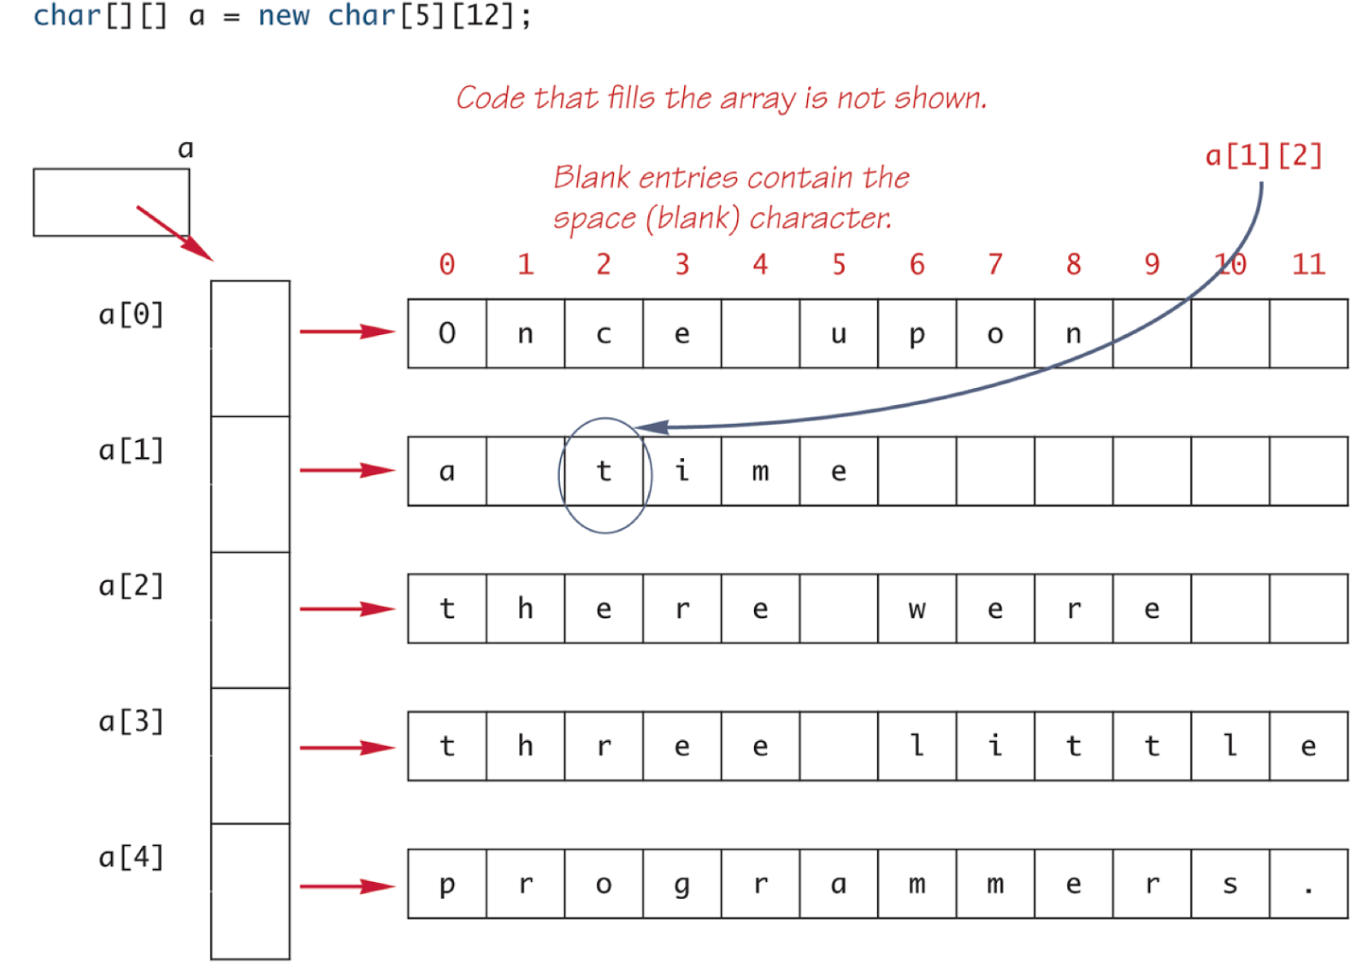
  - e.g. int[][] b = new int[4][]; //宣告了一個空間為4個陣列，每項元素指向一個int的陣列（每個陣列的大小可能不一，稱之為ragged array）
int[][] b = new int[4][];
b[0] = new int[3];
b[1] = new int[5];

  - 若想要將多維陣列都確實有物件，總共需要產生多少物件？
    - e.g. new int[4][5]; //共 1 + 4 = 5個物件（因為是int，所以只需要配置array物件）
    - e.g. new A[3][5]; //共 1 + 3 + 3*5 = 19個物件
 | 說明
1 | A[0]~A[2]的一個陣列
3 | A[0][0]~A[0][4], A[1][0]~A[1][4], A[2][0]~A[2][4] 三個陣列
3*5 | 二維陣列內所有元素需要配置之物件A的數量

    - e.g. new A[3][5][7]; //共 1 + 3 + 3*5 + 3*5*7 = 124個物件
    - e.g. new A[3][5][7][9]; //共 1 + 3 + 3*5 + 3*5*7 + 3*5*7*9 = 1069個物件

- copying array: System.arraycopy() method
  - System.arraycopy(sourceArr, sourceArr starting index, destinationArr, destinationArr starting index, element numbers);
int sourceArr[] = {1,2,3,4,5};
int destinationArr[] = {6,7,8,9,10,11,12};
System.arraycopy(sourceArr, 0, destinationArr, 0, sourceArr.length);

- static import:
  - <SE5.0 doc> allows unqualified access to static members without inheriting from the type containing the static members
  - <wiki> allows members (fields and methods) defined in a class as public static to be used in Java code without specifying the class in which the field is defined.
static import java.lang.Math.PI;
public static void main(String[] args){
System.out.println(Math.PI); //if no static import
System.out.println(PI); //with static import, no need to
//specify class name
}

