
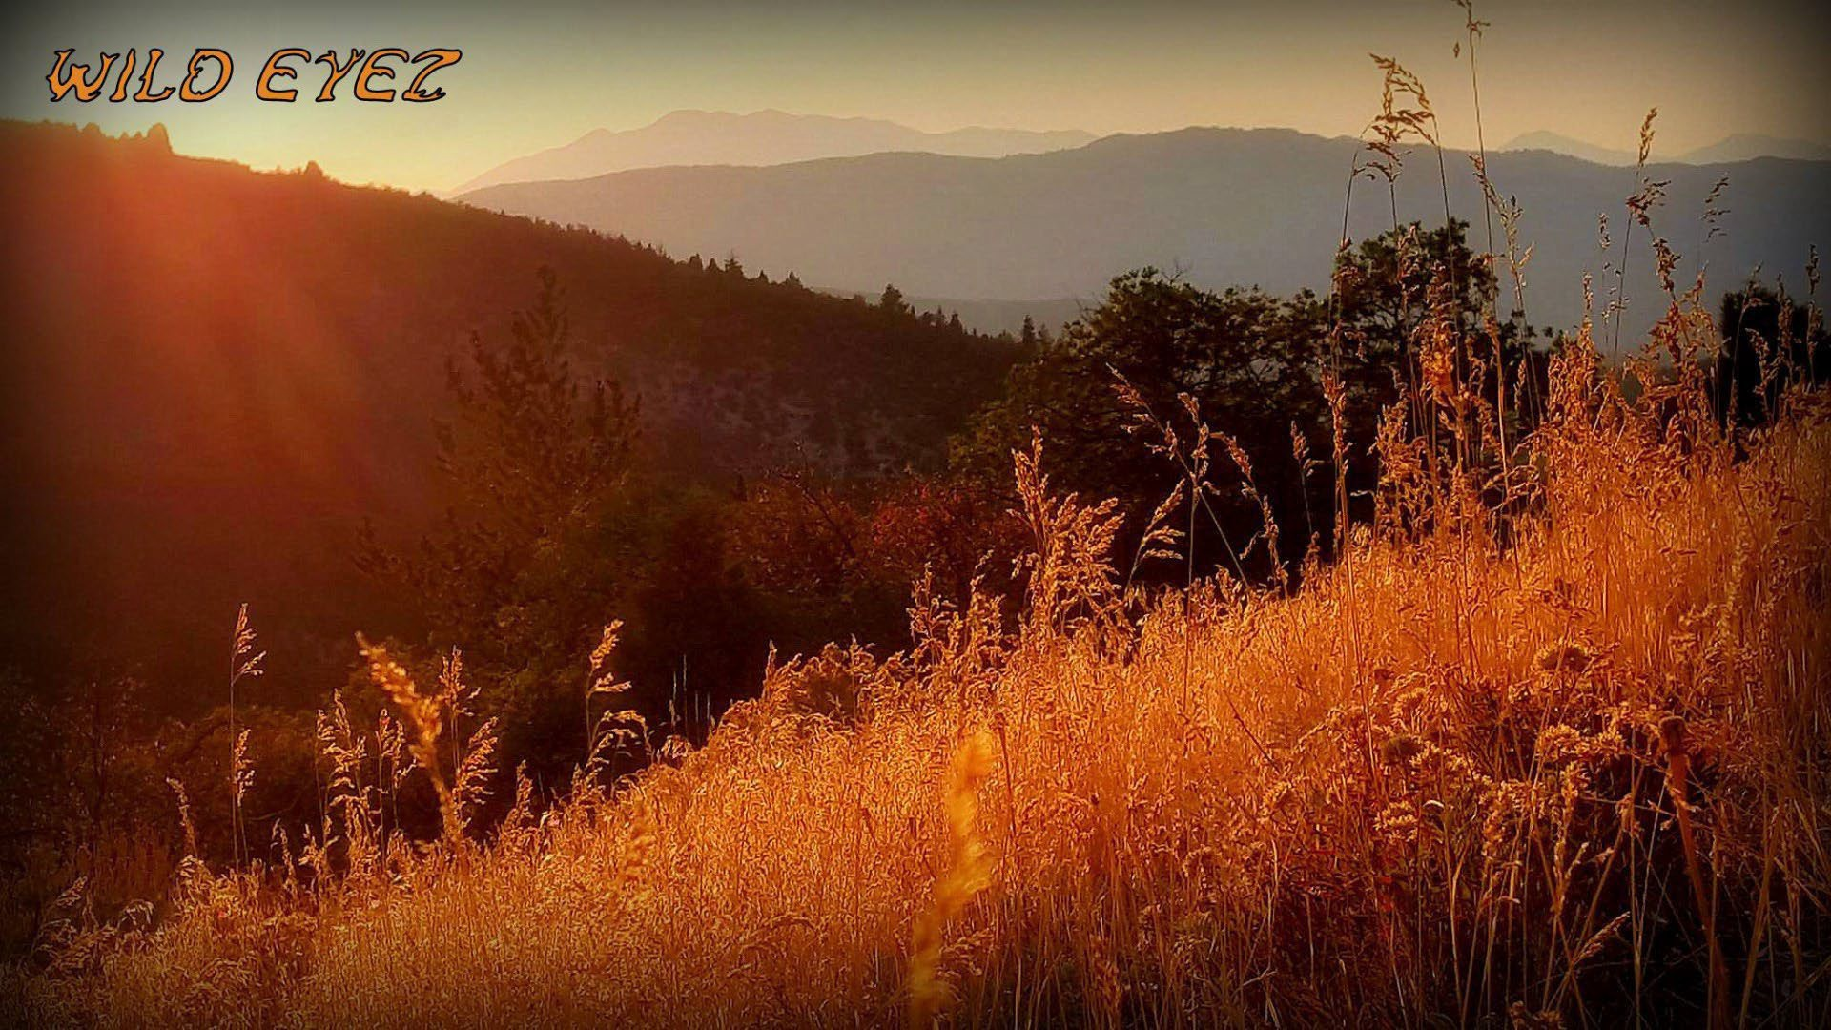


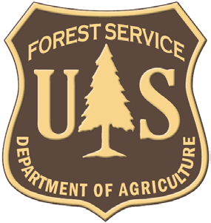
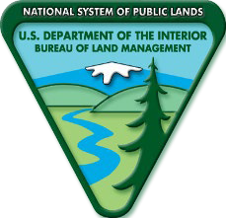
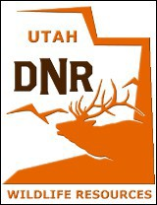
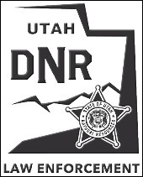
WILD EYEZ OUTFITTERS
PREP FOR HUNTING SUCCESS
WILD EYEZ OUTFITTER’S CLIENT WESTERM HUNTING PREP MANUAL

PREPARATION KNOWLEDGE EXPERIENCE SAFETY + ETHICS = SUCCESS

“Preparation, Knowledge and Experience are the foundation of every Safe, Ethical, and successful hunt.”


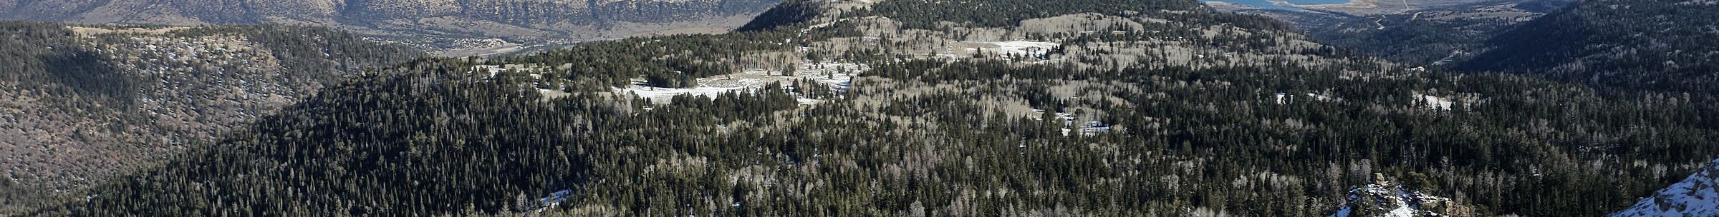


WELCOME

AUDIO =>
I'm Tyler Miller with Wild Eyes Outfitters. This Client Hunt Prep Manual provides a general packing list, preparation guide, and outline of what to expect during a big game hunt in Utah. It includes important safety information, equipment recommendations, clothing suggestions, and practical guidance for preparing for your hunt. If you received this manual, you may be considering a hunt with us, or you may have already contracted your hunt. Either way, I want to thank you for considering Wild Eyes Outfitters and congratulate you on your upcoming hunting adventure.
The items in this manual are not brand specific. I may occasionally recommend a particular brand or explain whether an item is essential or optional. However, the final selection of clothing and equipment remains at your discretion.
Utah's weather, terrain, elevation, and big game habitat vary greatly. The information in this manual is based on knowledge of the local area, seasonal migration patterns, previous client hunts, and more than forty years of personal hunting and field experience.
HOW TO USE THIS GUIDE
Read the explanations first so you understand how the hunt operates and why each category matters. Then use the checklists twice: once while gathering and testing your equipment, and again immediately before departure. The goal is not to own every possible item. The goal is to arrive with a complete system that you have already worn, carried, and practiced with.

SAFETY FIRST

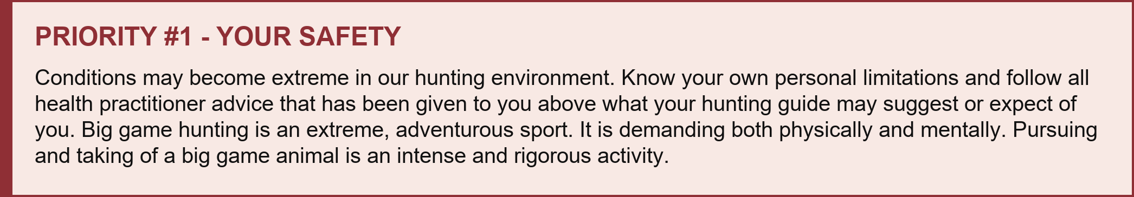
.

Hunting is LETHAL by nature; something will likely die. We want that to be the game animal that is on your permit and not yourself or any other unintended life.


WILD EYEZ OUTFITTERS | PREP FOR SUCCESS



WHATTOEXPECT

Expect travel methods to vary with weather, terrain, and access conditions. We may use a heated 4x4, snowmobiles, ATVs or side-by-sides, equine travel, or hiking, but our primary way of reaching hunting ground is usually on foot. If you are uncomfortable with any method of travel, please let me know before your hunt so I can plan accordingly.
TRANSPORTATION
- A heated 4x4 off-road hunting automobile, if conditions permit and it is the best choice for access

- Snowmobiles when snow and weather require them
- ATV's (4-wheelers) and side by side OHV where terrain and conditions allow

- Equine animal when that is the most practical travel method for the area
- Hiking, which is still the primary way we get where we need to go

A typical day will start around 5:00 a.m. We will develop a plan based on current big game animal location, weather conditions, hunting conditions, and past experience. A typical pursuit may include traveling to the intended hunting location, spotting and glassing for the game animal, and then executing a stalk. This stalk may involve hiking, sitting, kneeling, spotting, and moving again while carrying your weapon, gear, and pack.
PROFESSIONAL POINTER
When conditions allow, plan to sleep or fully rest during the middle of the day. If midday hunting is productive, we may remain active, continue glassing, reposition, or continue the pursuit. When downtime is available, use it to reset your mind. The goal is to remain mentally sharp when the evening opportunity arrives.

WEATHER & TERRAIN
We may hunt piñon and juniper country at roughly 5,000 to 7,000 feet, or quaking aspen and blue spruce terrain from roughly 7,000 to 11,000 feet. Cover may range from semi-open to dense. Distance to your game can vary from 50 to 800 yards or more. You should be comfortable lying down, sitting, kneeling, and standing while establishing a secure rest. The prone position is usually the most stable.
One suggestion is to carry a waterproof mat or similar pad which can be very quickly deployed to lay upon rather than directly in the dirt, mud or snow. However, it is not always possible to deploy this equipment before taking your shot and you should consider it an exception to the general rule. Plan on and prepare for weather conditions from hot afternoons on rocky, dry dirt terrain down to extremes of snow conditions and freezing temperatures. A hunt may move from 70- or 80-degree dry terrain to a foot of snow and freezing conditions. Weather can remain consistent or change dramatically in less than one hour. That variability is manageable when you prepare for it.
CLIENT FIELD MANUAL • 3

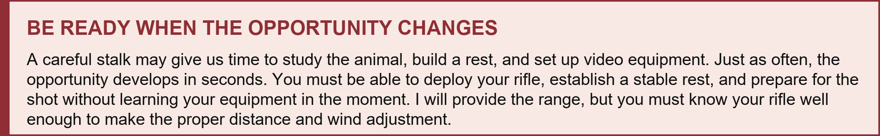
WILD EYEZ OUTFITTERS | PREP FOR SUCCESS


BE READY WHEN THE OPPORTUNITY CHANGES
A careful stalk may give us time to study the animal, build a rest, and set up video equipment. Just as often, the opportunity develops in seconds. You must be able to deploy your rifle, establish a stable rest, and prepare for the shot without learning your equipment in the moment. I will provide the range, but you must know your rifle well enough to make the proper distance and wind adjustment.
CLOTHING & FOOTWEAR

Do not skimp on clothing. You may have only seconds to sit or lie in snow, gain your sight picture, and take the shot. Your outer layer should be waterproof or highly water resistant. Build a quiet, flexible layering system that allows you to add, remove, or vent clothing as conditions change. Avoid cotton, which holds moisture, and test every garment by rubbing the fabric together. If it whistles, crackles, or rubs loudly, it can compromise a stalk. Overdress rather than underdress; you can remove a layer, but you cannot put on clothing you left at home.

UPPER BODY LOWER BODY

Base layer: undershirt and thermal layer. These should be comfortable, quiet, and easy to move in.
☐
Middle layer: light and mid-weight shirt, light-
- weight vest, and a light jacket or hoodie to give you flexibility as temperatures change.
- Base layer: long underwear or thermal layer.

- Middle layer: joggers or light to mid-weight pants.

Top / outer layer: mid-weight jacket and heavy-weight coat with a hood.
☐
Additional waterproof or highly water-resistant outerwear for wet-weather conditions.
☐
Top / outer layer: mid-heavy weight pants with enough room to move comfortably.
Gaiters to keep dirt and snow out of your boots and off your lower legs.
☐
☐
Two pairs of socks, one light weight and one

  - merino wool, or one good heavy-weight merino wool pair if your boots are high quality.
☐
Waterproof boots with aggressive soles, already broken in before opening day.

PRO TIP - PROTECT YOUR FEET
Protect your feet before the hunt starts. Break in your boots before opening day, test your sock system on real walks or hikes, and address hot spots immediately. A small blister on day one can become the reason you cannot hunt hard on day three. Your feet are part of your weapon system because they determine whether you can still get into position when the opportunity comes.

CLIENT FIELD MANUAL • 4


WILD EYEZ OUTFITTERS | PREP FOR SUCCESS


FIELD GEAR

Every item in your pack should solve a real field problem: navigation, water, warmth, communication, meat care, repair, or sustained energy. Pack deliberately and know exactly where essential items are located. Practice retrieving them while wearing your hunting clothing. That may sound elementary, but when adrenaline hits, familiar movements matter. For hydration, I commonly use water mixed with an electrolyte drink, supported by high-carbohydrate foods the body can access quickly.
FIELD GEAR - ESSENTIALS
- Hunting license, permit, identification, and any required hunter-safety documentation.

- Offline map, GPS or mapping app, and a backup compass or paper map.
- Satellite communicator, emergency locator, or other reliable backup communication option when cell service is limited.

- Headlamp plus extra batteries or a backup light. You may leave before daylight and return after dark.
- Compact first-aid and foot-care kit, including blister care, tape, pain reliever, and personal medications.

- Water bottle or bladder plus water treatment tablets, filter, or other backup water-purification method.
- Wind direction indicator, such as a wind puffer or lightweight indicator material.

- Binoculars, rangefinder, lens cloth, and any optics support you intend to use.
- Two sharp knives with a sharpening stone or similar sharpening device.

- Game bags. Preferably heavy canvas and not the netting type game bags. Potato or burlap sacks are cheap and perfect.
- Four pairs of nitrile or latex gloves. They are optional, but handy to have for cleanup after quartering your game.

- Backpack or daypack with a bladder. Do not go cheap on a backpack.
- Baby wipes.

- Waterproof mat or similar quick-deploy pad.
- Lighter and matches. Vaseline-saturated cotton balls work well for starting a fire in difficult situations.

- Small repair kit: duct tape or gear tape, extra boot laces, zip ties, and a compact multi-tool.
- Walking sticks or shooting sticks if desired, wrapped or silenced on the ends so they do not alert game when contacting rock or brush.

- High-carbohydrate food and fluids like candy bars, canned fruit, pudding, or sandwiches.

CLIENT FIELD MANUAL • 5



WILD EYEZ OUTFITTERS | PREP FOR SUCCESS

FIREARMS&AMMUNITION
Bring the rifle you know best and are most comfortable operating under pressure. Arrive with enough ammunition for the hunt and for meaningful practice before arrival. Your scope should be checked, your rifle should be zeroed before the hunt, and your system should include any bipod, independent shooting sticks, cleaning kit, and hearing protection you intend to use.
Familiarity matters more than novelty. Opening morning is not the time to learn a new safety, turret, bipod, sling, or magazine system. Practice moving into position, establishing a solid rest, ranging, settling the rifle, and staying on the rifle after the shot. If hearing protection is important to you, use electronic protection that reduces the rifle report while still allowing you to hear your guide. I cannot effectively spot a follow-up shot if you cannot hear my instructions.
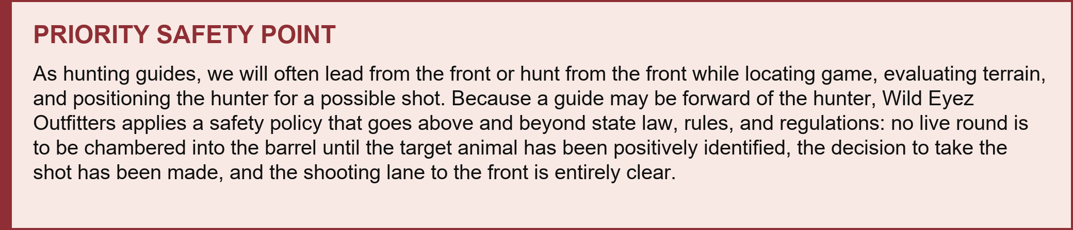

AMMUNITION STANDARD
Lead ammunition is preferred. Copper ammunition is not preferred. I highly suggest .30 caliber or equivalent and a rifle system that you know well. It is your responsibility to understand your rifle's capabilities and ballistics. I will coach you through the actual shot, provide ranges, and operate as your spotter for follow-up shots.
THREE CONDITIONS BEFORE CHAMBERING A LIVE ROUND
01 | 02 | 03
TARGET IDENTIFIED | DECISION MADE | LANE CLEAR
The target animal has been positively identified. | The decision to take the shot has been made. | The shooting lane to the front is entirely clear.

This policy protects everyone involved. It is never compromised.


WILD EYEZ OUTFITTERS | PREP FOR SUCCESS


PRESEASON PREPARATION

Your hunt begins before you travel to Utah. Wear your full clothing system, carry your loaded daypack, and practice realistic shooting positions. Pretend an animal has appeared and you have only seconds to move into an awkward uphill or downhill position. Get on the ground and look through your scope. These dry runs expose problems while there is time to correct them and create muscle memory for the moment when adrenaline makes clear thinking difficult.
PREPARATION CHECKLIST
- Confirm your rifle is zeroed before arrival and verify the ammunition you plan to hunt with.

- Try your clothing and gear on at home, wear it around, and assume all potential firing positions.

- Wear your hunting clothing, orange outer-layer vest and headgear if required, daypack, accessory equipment, and rifle on walks or hikes before your hunt.

- Develop scenarios such as spotting a game animal, conducting a short stalk, and deploying your weapon system quickly from an abnormal or inconvenient field position.
- Practice shooting uphill and downhill. Nothing is level in the mountains.

A wounded animal can occur, but it is an ugly thing. It is not taken lightly by our guides, and it weighs heavily on one's mind. We will go to extremes, short of risking safety, to recover an animal that is wounded at your hands. Please do your best to minimize that outcome. Be prepared.

FINAL REMINDERS
PRIORITY ITEMS
- Bring your hunting license, permit, and required identification.

- Carry emergency contact information and any required prescription medications.

- Text Wild Eyez Outfitters first, when possible, since mountain service can be limited and I am often out of coverage locating your big game animal.
- Arrive physically prepared, mentally sharp, and with your clothing, gear, rifle, and pack working together.

- Use the checklists above before packing and again before departure.

CLIENT FIELD MANUAL • 7


WILD EYEZ OUTFITTERS | PREP FOR SUCCESS

WILD EYEZ OUTFITTERS

ARE YOU READY FOR THE MOUNTAIN???

Thank you very much and again, congratulations on your upcoming hunt. Prepare yourself as best as possible and your likelihood of success will be high. We have prepared diligently for your hunt, are ready for your arrival, and look forward to making tracks with you on the mountain. This opportunity is a gift and an experience worth remembering for the rest of your life. We share our experience because hunting is our passion and because helping a client realize a personal goal is deeply rewarding. You may arrive as a stranger, but our hope is that you leave as a friend.

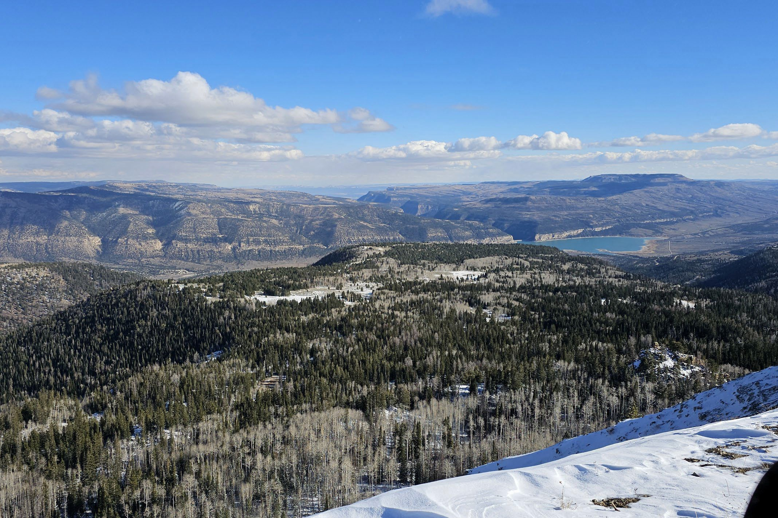

YOUR OUTFITTER TYLER MILLER

PREPARE HUNT SAFELY
HUNT ETHICALLY
Wild Eyez Outfitters Manti, Utah 435-851-6480
tyler@wildeyez.net

Preparation. Knowledge. Safety. Ethics. Success.

~SEE THE WILD!!!
CLIENT FIELD MANUAL • 8

