Students Management

Student: Danila Vlad-Mihai

**Group: 30432**

Table of Contents

1. Requirements Analysis 3

1.1 Assignment Specification 3

1.2 Functional Requirements 3

1.3 Non-functional Requirements 3

2. Use-Case Model 3

3. System Architectural Design 4

4. UML Sequence Diagrams 5

5. Class Design 6

6. Data Model 7

7. System Testing 7

8. Bibliography 7

1. Requirements Analysis

# Assignment Specification

This application aims to develop a management system for TUCN CS Department students using Layers architectural pattern.

# Functional Requirements

* System shall block users from access to use the application if they are not logged in
* Add/Update/View client information
* Create/Read/Update/Delete student profile
* Process class enrolment
* Generate reports
* Validate input before saving it in the database

# Non-functional Requirements

* The system shall be organized using Layers architectural pattern
* Data Access Layer shall be created using SQL statements
* Data will be stored in a relational database

2. Use-Case Model

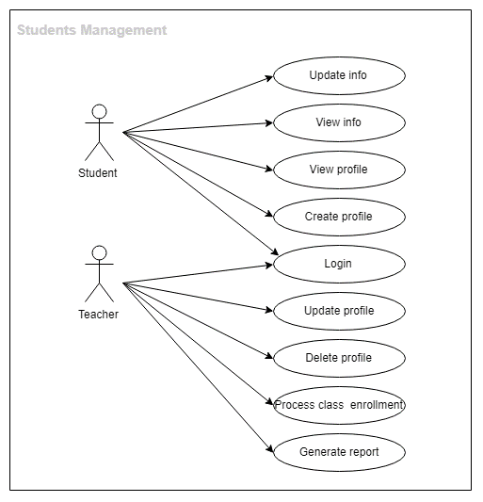

**Use case**: Student login using username and password

**Level**: User-goal level

**Primary** **actor**: Student

**Main** **success** **scenario**:

1. Student opens the application
2. Student enters the username and password
3. Student receives a message confirming the authentication
4. Student login successfully completed

**Extensions:**

1. Student opens the application
2. Student enters the username and password
3. Student receives an error message
4. Student enters the username and password again
5. Student receives a message confirming the authentication
6. Student login successfully completed

3. System Architectural Design

**3.1 Architectural Pattern Description**

The system will be built using Layers architectural pattern. Logically similar functionalities will be grouped from the technical point of view by dividing the entire program logic into three layers: Presentation Layer, Business Layer and Database Layer. Our goal is to minimize the amount of overlapping functionalities across the entire application.

**3.2 Diagrams**

System’s conceptual architecture

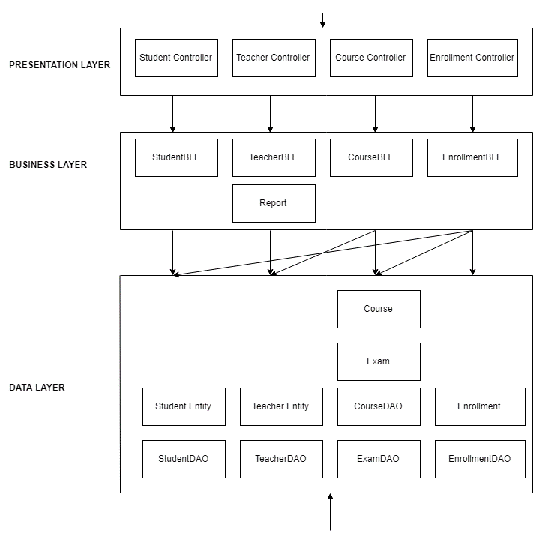

Package diagram

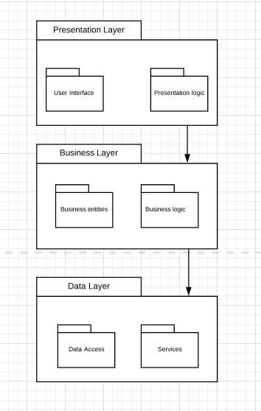

1. UML Sequence Diagrams

Scenario: Student enrollment

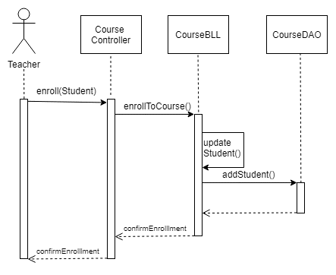

Deployment diagram

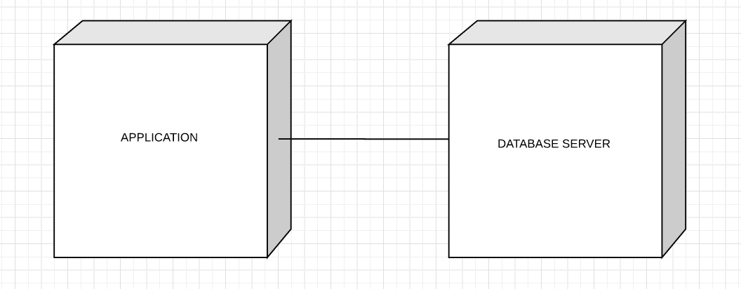

5. Class Design

* 1. **Design Patterns Description**

Singleton design pattern – one single database connection

* 1. 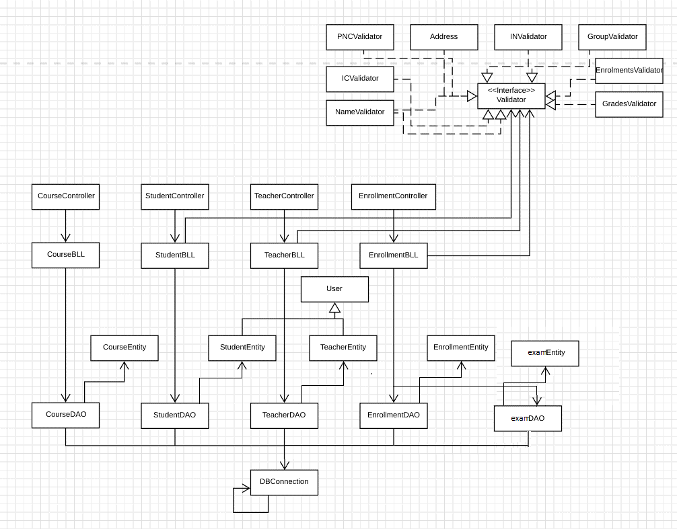**UML Class Diagram**

6. Data Model

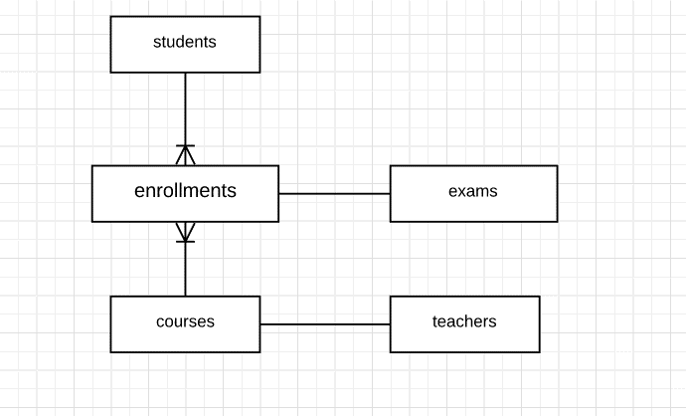

7. System Testing

* Unit Testing – write test to verify that a relatively small piece of code is doing what it is intended to do.

Junit will be used for testing at method or class level, by checking that the actual output matches the expected output.

8. Bibliography

[stackoverflow.com](https://stackoverflow.com)

[lucidchart.com](https://www.lucidchart.com)

<http://users.utcluj.ro/~dinso/PS2018/>