Assignment A1

Student: Raul-Mihai Acu

**Group: 30432**

Table of Contents

1. Requirements Analysis 3

1.1 Assignment Specification 3

1.2 Functional Requirements 3

1.3 Non-functional Requirements 3

2. Use-Case Model 3

3. System Architectural Design

3.1 Architectural Pattern Description 3

3.2 Diagrams 3

4. UML Sequence Diagrams 3

5. Class Design 3

5.1 Design Pattern Description 3

5.2 UML Class Diagram 3

6. Data Model 3

7. System Testing 3

8. Bibliography 3

1. Requirements Analysis

# Assignment Specification

Design and implementation of an application for the management of students in the Computer Science department of the Technical University of Cluj-Napoca. It will provide access to students, classes and teachers information and will be able to generate reports for a particular student`s activities performed over a given period of time.

# Functional Requirements

• The data will be stored in a relational database.

• The application should have a Layered architecture.

• All the inputs of the application have to be validated before submission.

# Non-functional Requirements

• Accessibility and Usability – the application will have as targets all kinds of users.

• Readability – the code needs to be easily understood by other programmers, have a good naming convention.

• Security and Privacy – only the users will have access to the data.

2. Use-Case Model

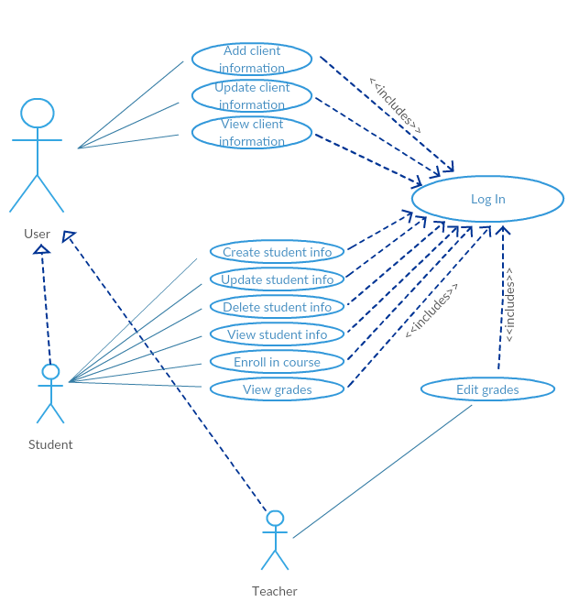

• Use case: View Student Profile

• Level: User-goal level

• Primary actor: Student

• Main success scenario: The student logs in and chooses to view his profile. The info is displayed on the screen.

• Extensions: The student tries to log in, but provides wrong password and no access is granted. The student tries to log in, but does not have an account.

3. System Architectural Design

**3.1 Architectural Pattern Description**

Components within the layered architecture pattern are organized into horizontal layers, each layer performing a specific role within the application. Although the layered architecture pattern does not specify the number and types of layers that must exist in the pattern, most layered architectures consist of four standard layers: presentation, business, persistence, and database

**3.2 Diagrams**

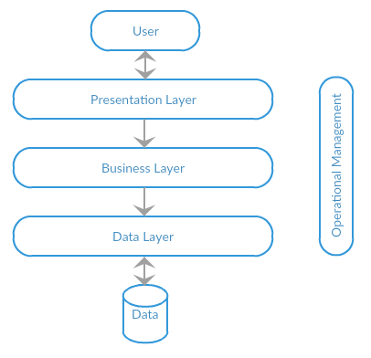

**• Package Diagram:**

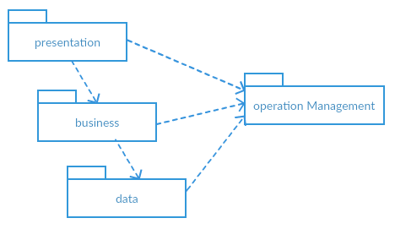

4. UML Sequence Diagrams

*[Create a sequence diagram for a relevant scenario.]*

5. Class Design

**5.1 Design Patterns Description**

*[Describe briefly the used design patterns.]*

**5.2 UML Class Diagram**

*[Create the UML Class Diagram and highlight and motivate how the design patterns are used.]*

6. Data Model

*[Present the data models used in the system’s implementation.]*

7. System Testing

• **Unit testing** is a software testing method by which individual units of source code, sets of one or more computer program modules together with associated control data, usage procedures, and operating procedures, are tested to determine whether they are fit for use.

• **Graphical user interface testing** is the process of testing a product's graphical user interface to ensure it meets its specifications. This is normally done through the use of a variety of test cases. To generate a set of test cases, test designers attempt to cover all the functionality of the system and fully exercise the GUI itself.

**• Usability testing** is a technique used in user-centered interaction design to evaluate a product by testing it on users. Setting up a usability test involves carefully creating a scenario, or realistic situation, wherein the person performs a list of tasks using the product being tested while observers watch and take notes (dynamic verification).

8. Bibliography

<https://msdn.microsoft.com/en-us/library/ee658109.aspx>

<https://www.oreilly.com/ideas/software-architecture-patterns/page/2/layered-architecture>

<https://en.wikipedia.org/wiki/System_testing>