Student Management System

Student: Andreea Ionutas

**Group: 30432**

Table of Contents

1. Requirements Analysis 3

1.1 Assignment Specification 3

1.2 Functional Requirements 3

1.3 Non-functional Requirements 3

2. Use-Case Model 3

3. System Architectural Design 3

4. UML Sequence Diagrams 3

5. Class Design 3

6. Data Model 3

7. System Testing 3

8. Bibliography 3

1. Requirements Analysis

# Assignment Specification

The application will serve as a management tool for the CS Department at UTCN. It can be used by both students and teacher/administrator. Having a user-friendly graphical interface and being connected to a database, the application can perform specific actions according to each type of user.

# Functional Requirements

There are two types of users: student or teacher/administrator.

Operations that can be performed by a regular user:

* Add/update/view client information (name, identity card number, personal numerical code, address, etc.)
* Create/Update/Delete/View student profile (account information)
* Process class enrolment

Operations that can be performed by the administrator user:

* CRUD on students information
* Generate reports for a particular period containing the activities performed by a student.

# Non-functional Requirements

* Adaptability: the system should be able to adapt itself fast and efficiently to any type of changes.
* Stability: most of the objects will be stable over time and will not need changes
* Reusability: the system can be used in various platforms/contexts.

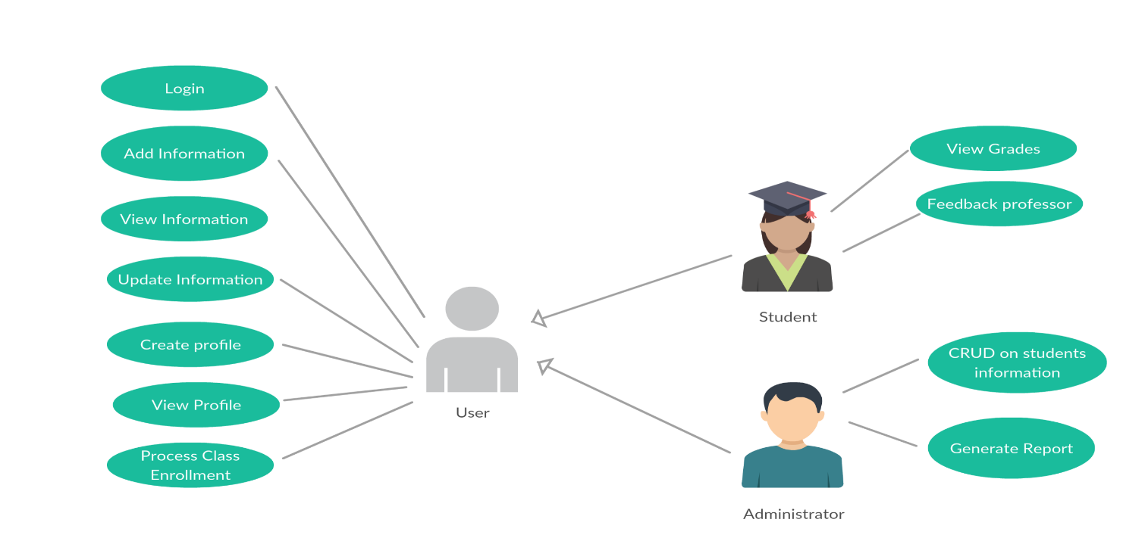2. Use-Case Model

***Use case:*** Generate report

*Level:* User Goal Level

*Primary actor:* Administrator

*Main success scenario:*

* Log in into application
* Select a student
* Click on generate report
* Visualize a report containing the student’s performances

*Extensions:* Fail to log in into application (the login id or password were introduced incorrectly)

3. System Architectural Design

* 1. **Architectural Pattern Description**

The architectural pattern used is Layers. The most widespread use of multitier architecture is the three-tier architecture.

N-tier application architecture provides a model by which developers can create flexible and reusable applications. By segregating an application into tiers, developers acquire the option of modifying or adding a specific layer, instead of reworking the entire application. A three-tier architecture is typically composed of a presentation tier, a business logic tier, and a data storage tier.

#### ***Presentation layer***

Presentation of the web pages, UI forms and end user interracting API’s

#### ***Business layer***

The logic behind the accessibility, security and authentication happens in this layer.

#### ***Persistent layer***

This is the presentation layer for the Data. This includes the DAO (Data Access Object) presentation, ORM (Object Relational Mappings) and Other modes of presenting persistent data in the application level.

**3.2 Diagrams**

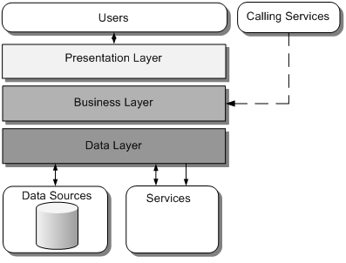

*Layered Architecture*

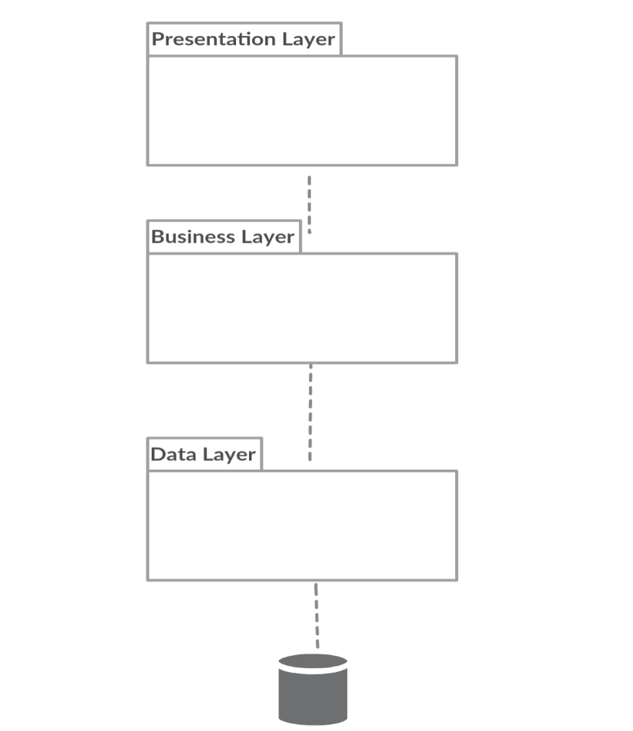

*Package Diagram*

4. UML Sequence Diagrams

5. Class Design

**5.1 Design Patterns Description**

*[Describe briefly the used design patterns.]*

**5.2 UML Class Diagram**

*[Create the UML Class Diagram and highlight and motivate how the design patterns are used.]*

6. Data Model

*[Present the data models used in the system’s implementation.]*

7. System Testing

*[Present the used testing strategies (unit testing, integration testing, validation testing) and testing methods (data-flow, partitioning, boundary analysis, etc.).]*

8. Bibliography