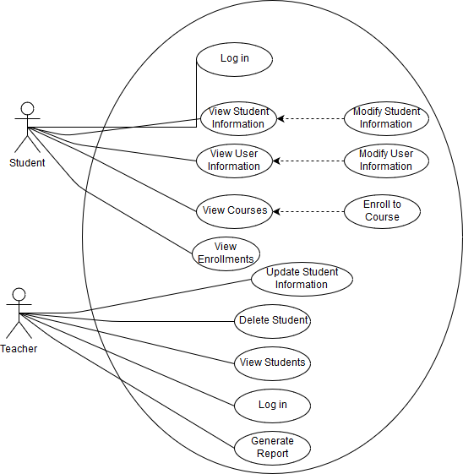
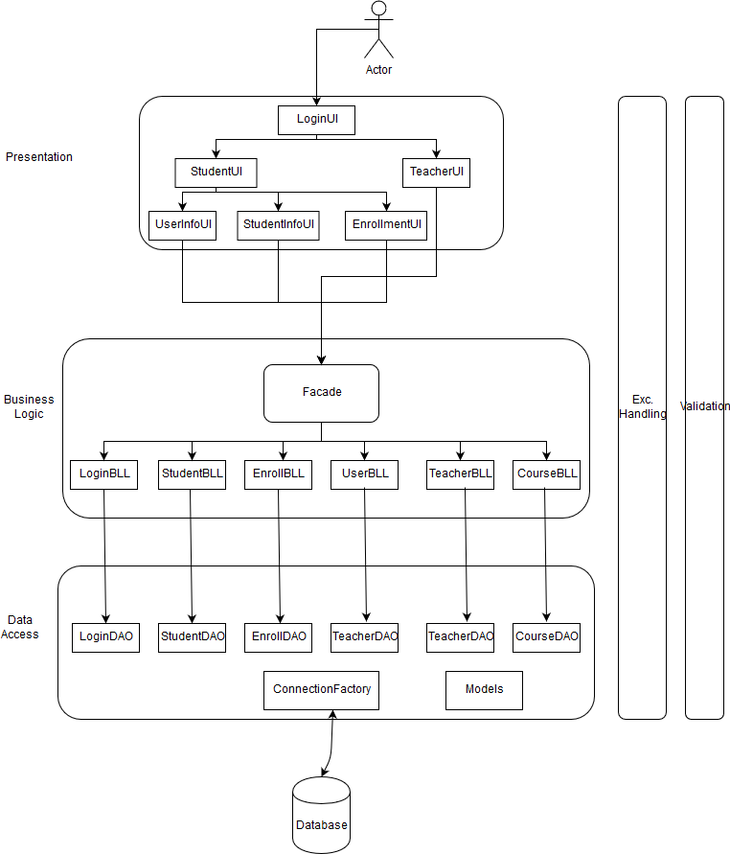
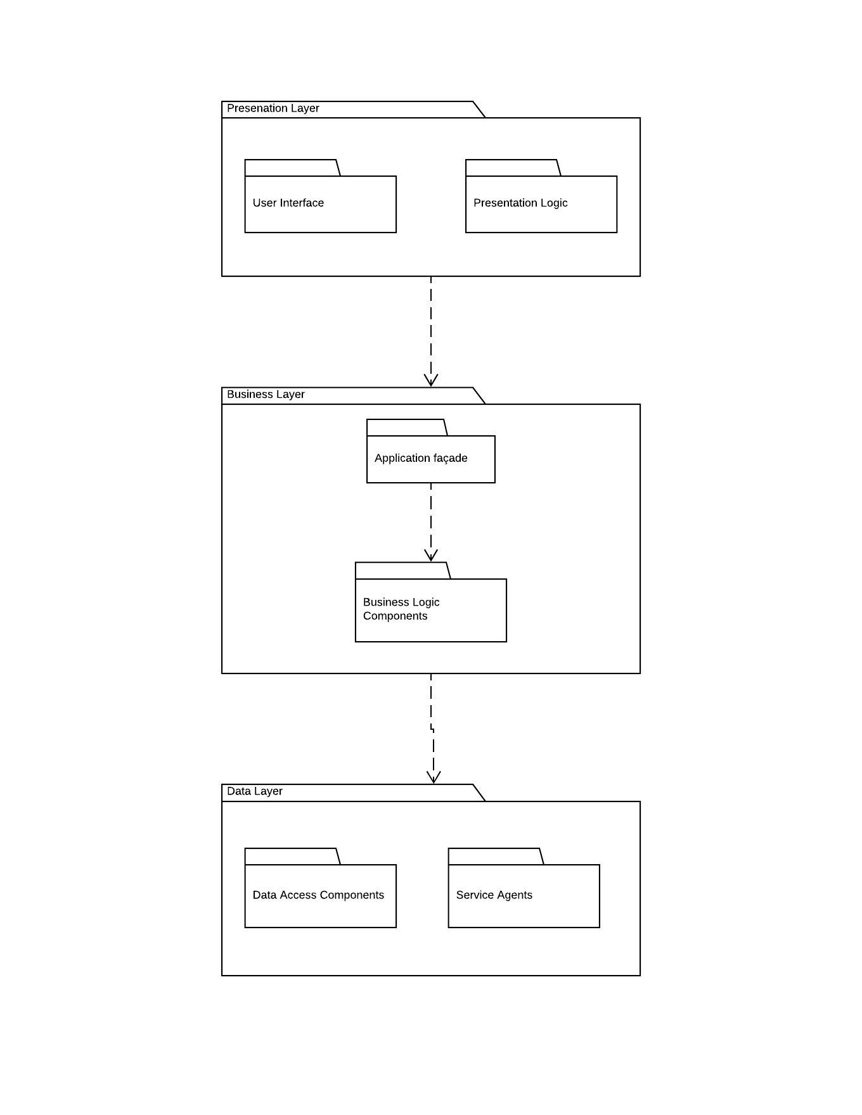
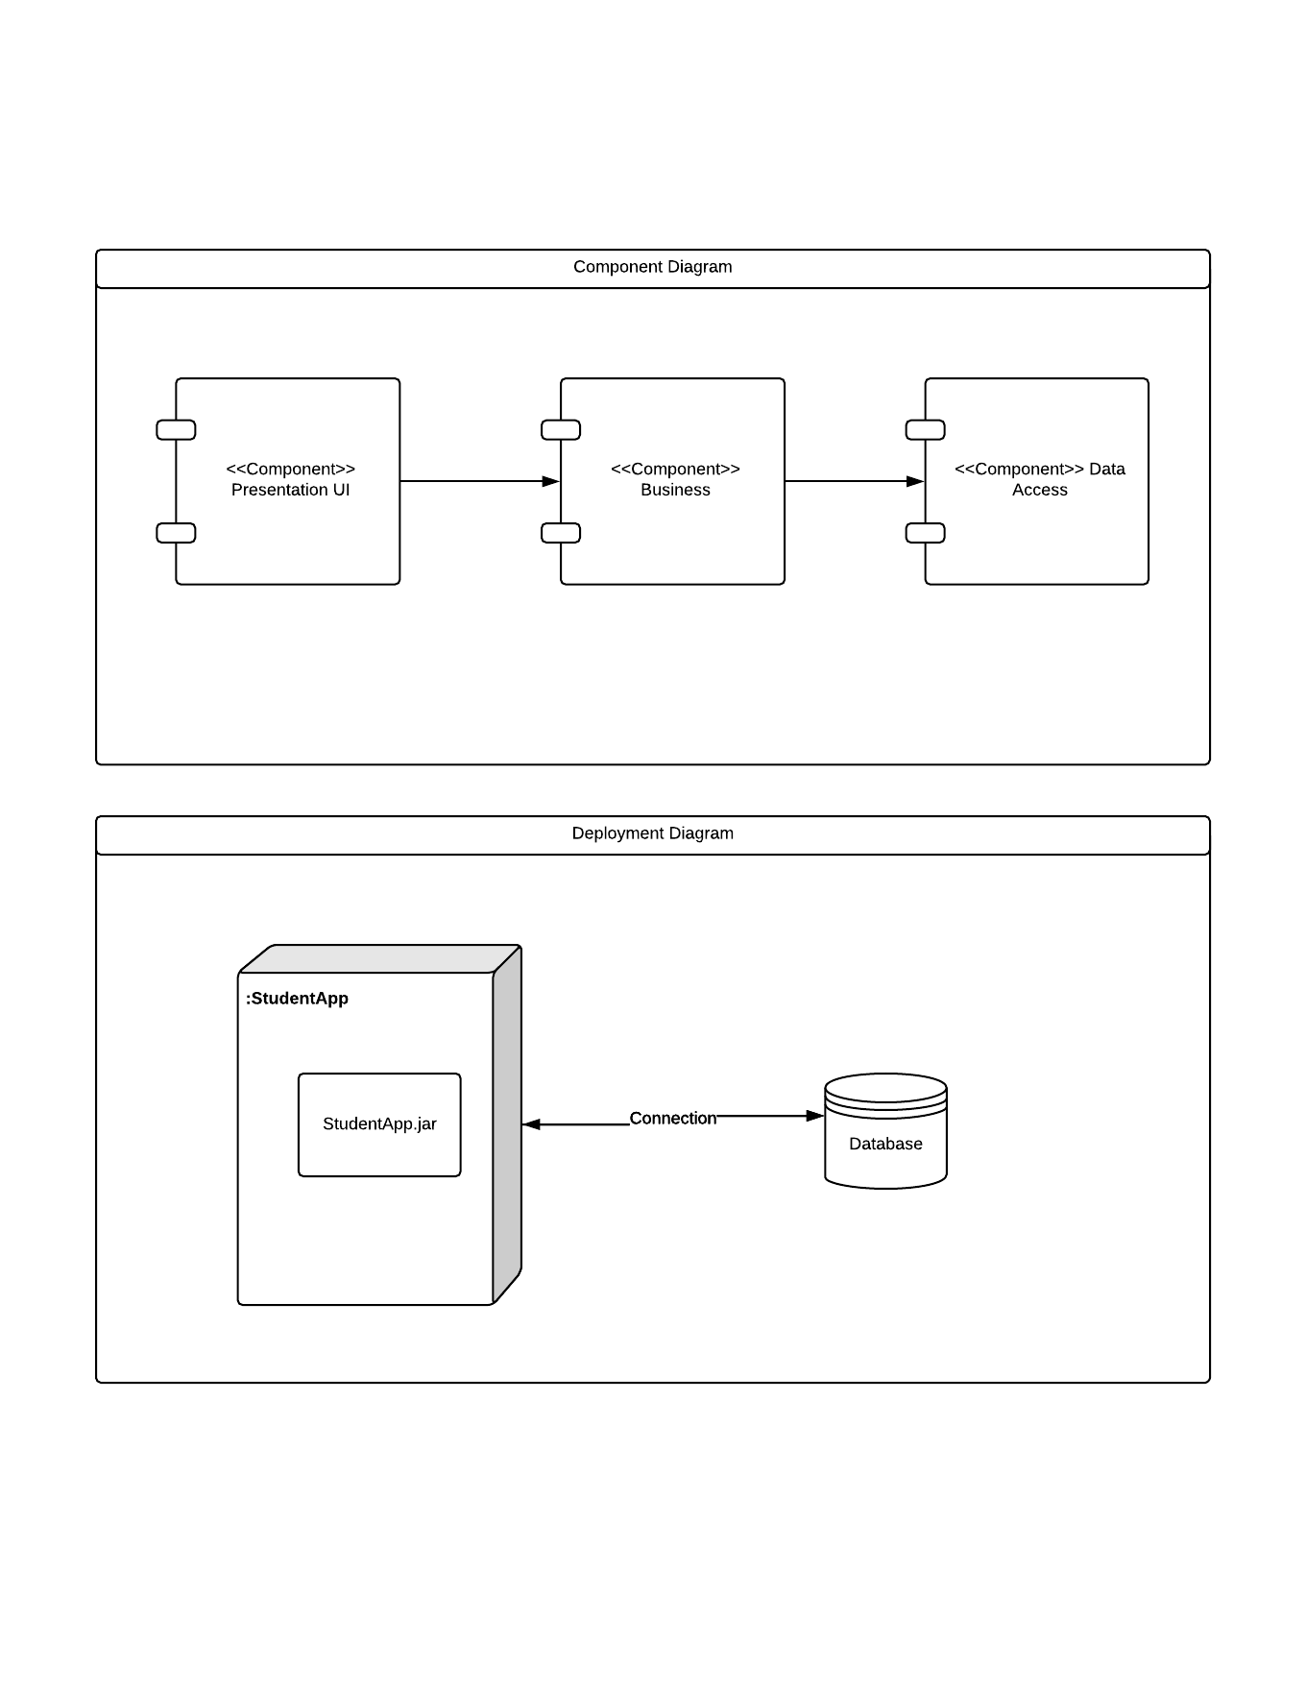
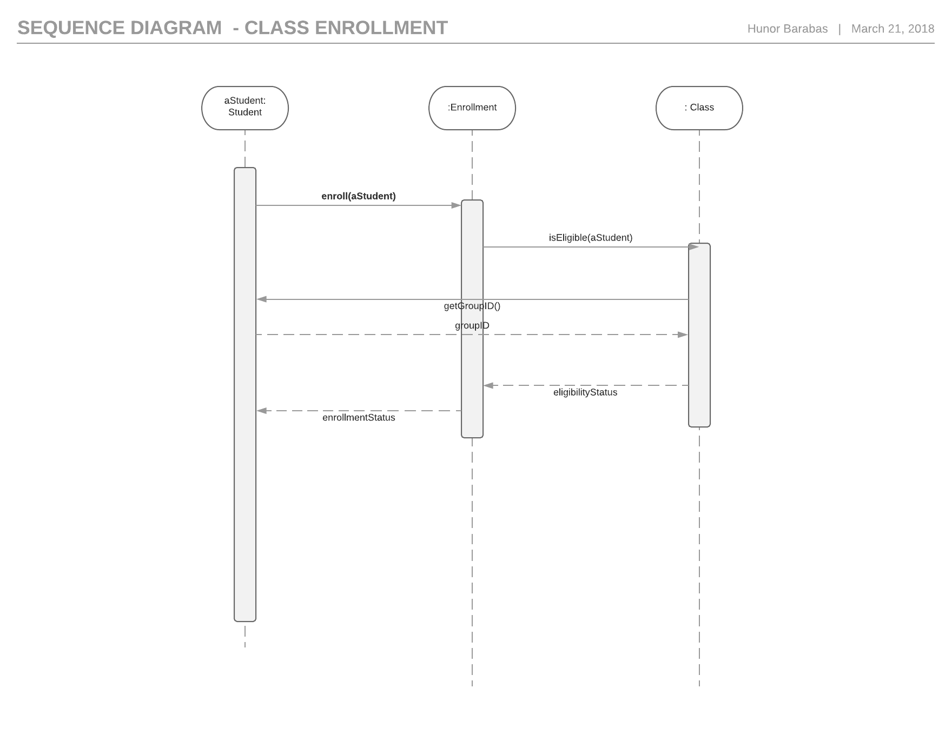
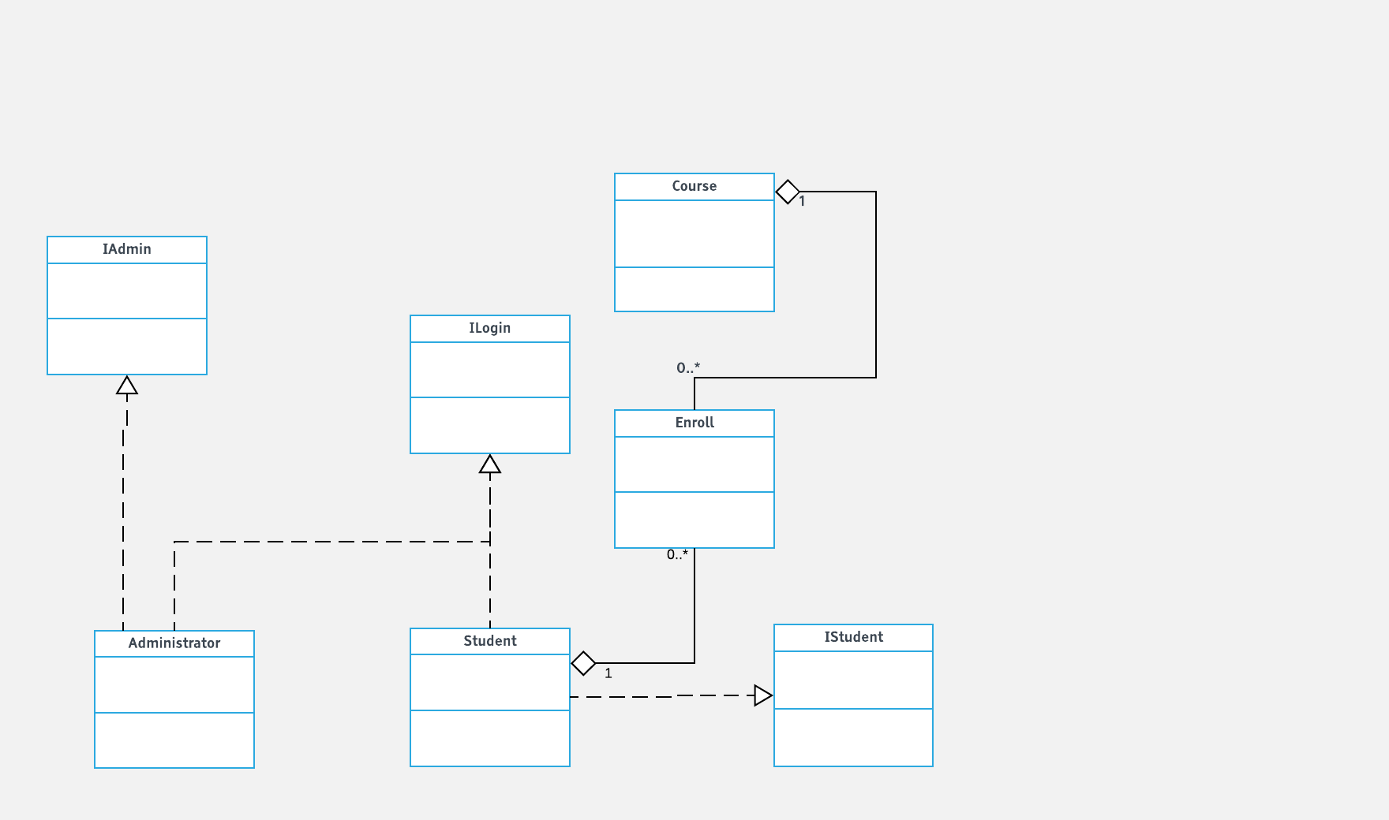
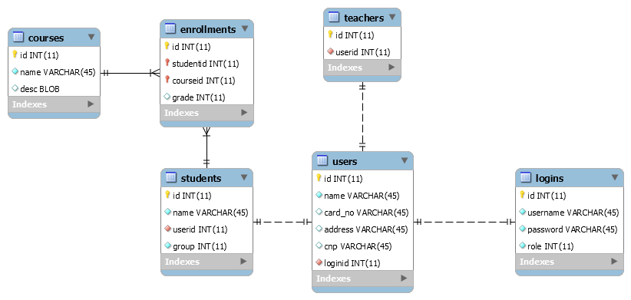
Assignment 1

Student: Barabas Hunor
Group: 30432

Table of Contents
Assignment 1 1
1
Student: Barabas Hunor 1
Table of Contents 2
1. Requirements Analysis 3
1.1Assignment Specification 3
1.2Functional Requirements 3
1.3Non-functional Requirements 3
2. Use-Case Model 3
Use case: Generate Report 3
Level: sub-function 3
Primary actor: teacher (as Administrator) 3
Main success scenario: 3
Extensions: 3
3. System Architectural Design 4
4. UML Sequence Diagrams 9
5. Class Design 9
6.Data Model 10
7.System Testing 11
8. Bibliography 11

1. Requirements Analysis

Assignment Specification
This assignment involves the design and implementation of a student management system for the CS Department at TUCN.

Functional Requirements
For Users, to be able to:
- Add/Update/View Client Information
- Create/View/Update/Delete Student Information
- Log in
- Process class enrollment

For Administrators ( Teachers), to be able to:
- Generate Reports
- Perform CRUD operations

Non-functional Requirements

Possible non-functional requirements could be:
- Security – To prevent malicious students from modifying data that they should not be able to modify
- Reliability – To have a system that the university can use and rely on.
- Availability – To have a system with an uptime as close as possible to 100% ( looking at you, sinu…)
- Usability – To have an application that is simple to use for students and teachers alike.

2. Use-Case Model

Use case: Generate Report

Level: sub-function

Primary actor: teacher (as Administrator)

Main success scenario:
- Teacher logs in to the Administrator panel
- Selects a student from the list
- Specifies time interval
- Presses Generate Report
- After a while the report will be generated as a separate file.

Extensions:
If there is a problem in the connection with the database, the operation might fail. Otherwise, even if there is no activity a report will be generated ( it will be blank, but it will be generated nonetheless).

3. System Architectural Design

3.1 Architectural Pattern Description

The utilized pattern will be the Layered Architectural Pattern. As the name suggests, our application will be structured into layers, each of them having a specific role. Higher level layers do not need to know how the layers below them perform their operations, making it easy to extend the system if need be.

Presentation Layer

Responsible for user interface logic. This layer deals with the core functionality of the system, and the communication between the UI and the database.

Business Layer

Responsible for business logic. Deals with the communication between the user interface and the database.

Data Access Layer

Provides access to the data.

3.2 Diagrams

Conceptual Architecture of the Application

Package Diagram

4. UML Sequence Diagrams
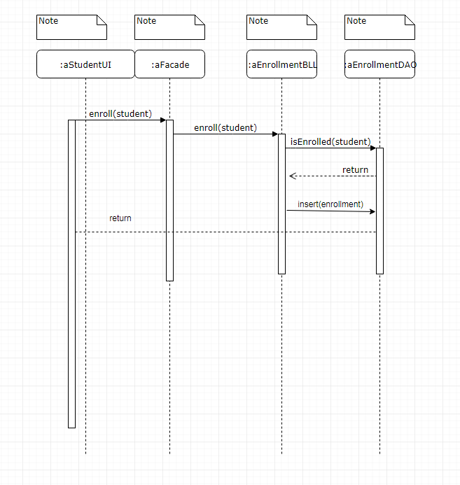

5. Class Design

5.1 Design Patterns Description
The business logic layer contains a Façade Design Pattern, which provides a unified, higher level interface for the business logic components

  - UML Class Diagram

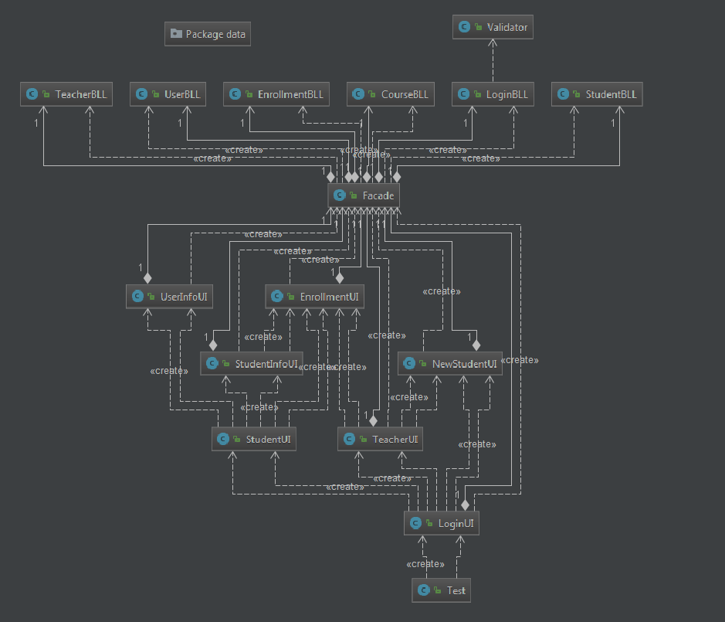

Data Model

The data model consists of a User which serves as parent class for the Administrator and the Student models, and it consists of functionalities such as logging in, which both the Administrator and Student should be able to do. The Enrollment Model servers as intermediary between students and courses.

7.System Testing

The testing strategy used is unit testing. The used tool is JUnit.

8. Bibliography

Microsoft Application Architecture Guide - https://msdn.microsoft.com/en-us/library/ff650706.aspx
- Layered Application Diagram
- Various pieces of knowledge
Tool used for diagram creation: - Lucidchart - https://www.lucidchart.com

