Assignment A1

Analysis and Design Document

Student: Nicolae-Florian Onica

**Group: 30432**

Table of Contents

1. Requirements Analysis 3

1.1 Assignment Specification 3

1.2 Functional Requirements 3

1.3 Non-functional Requirements 3

2. Use-Case Model 3

3. System Architectural Design 4

4. UML Sequence Diagrams 6

5. Class Design 6

6. Data Model 7

7. System Testing 7

8. Bibliography 8

# 1. Requirements Analysis

# Assignment Specification

The assignment consists of a Java application for the management of students in the CS Department at TUCN. The application will have two types of users (student and teacher/administrator user) which have to provide a username and a password in order to use the application.

# Functional Requirements

The application should allow the following user to do the following operations:

For the regular user:

- Add/update/view client information (name, identity card number, personal numerical code, address, etc.).

- Create/update/delete/view student profile (account information: identification number, group, enrolments, grades).

- Process class enrolment (enroll, exams, grades).

For the administrator:

- CRUD on students information.

- Generate reports for a particular period containing the activities performed by a student.

# Non-functional Requirements

# 2. Use-Case Model

Login: the user is logged in the application

Level: user-goal level

Primary actor: user

Main success scenario: the user inputs correct login data(username and password), is logged in and redirected to his personal page

Extensions: Failure case: the user inputs invalid data and is redirected to the login form

Use case diagram:

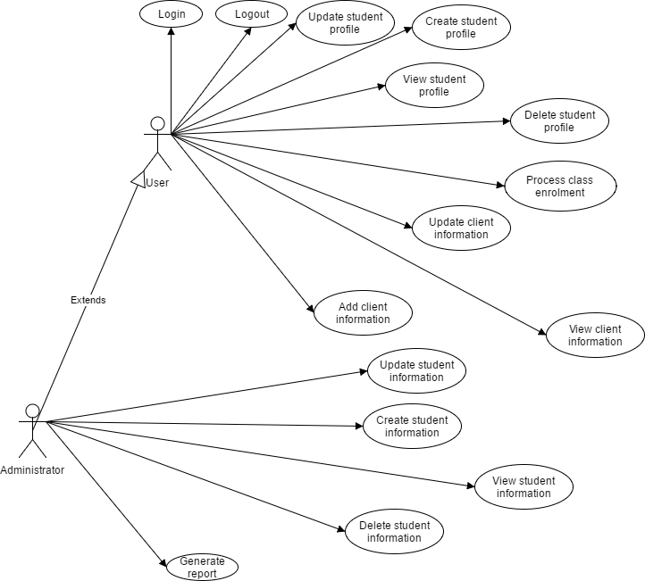

# 3. System Architectural Design

# 3.1 Architectural Pattern Description

The architectural pattern used for this application is the layered architecture pattern. The components within this pattern are organized into horizontal layers, each layer performing a specific role within the application (e.g., presentation logic or business logic). In this case three layers will be used: presentation, business and database layer.

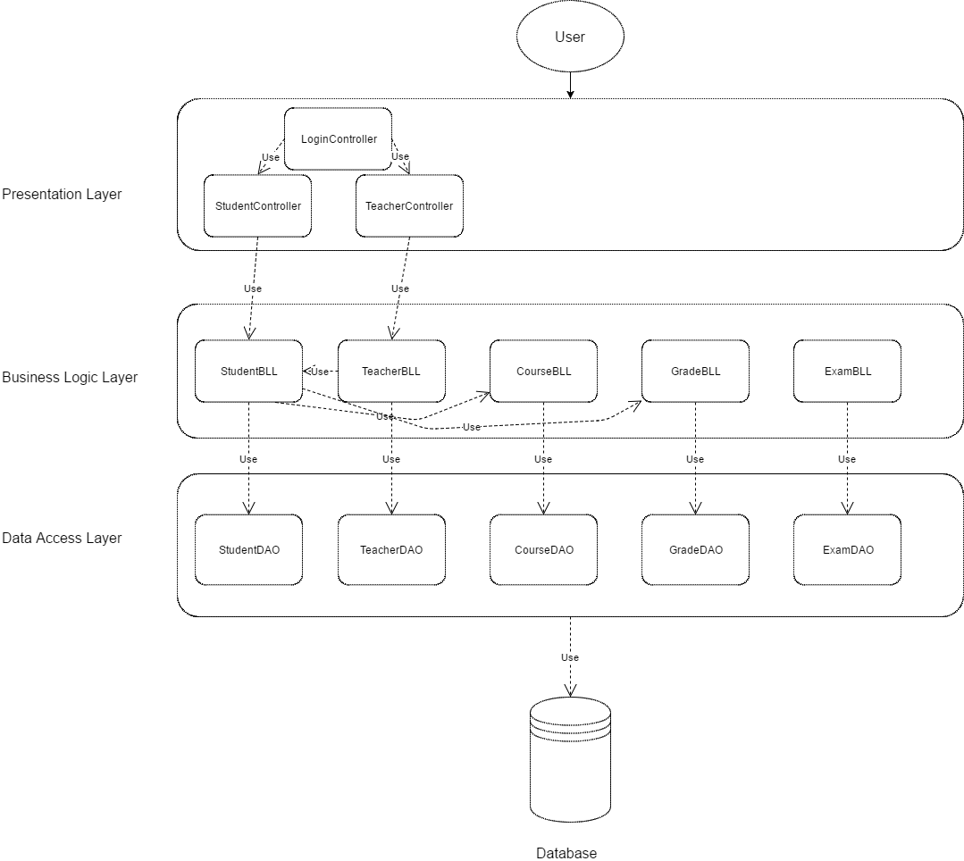

# 3.2 Diagrams

Package diagram

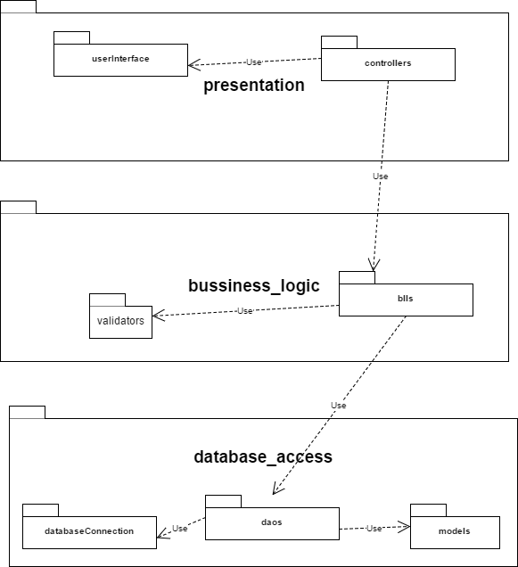

Deployment diagram

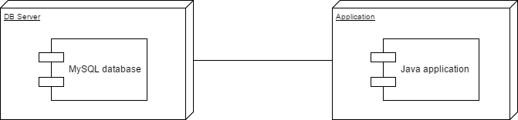

# 4. UML Sequence Diagrams

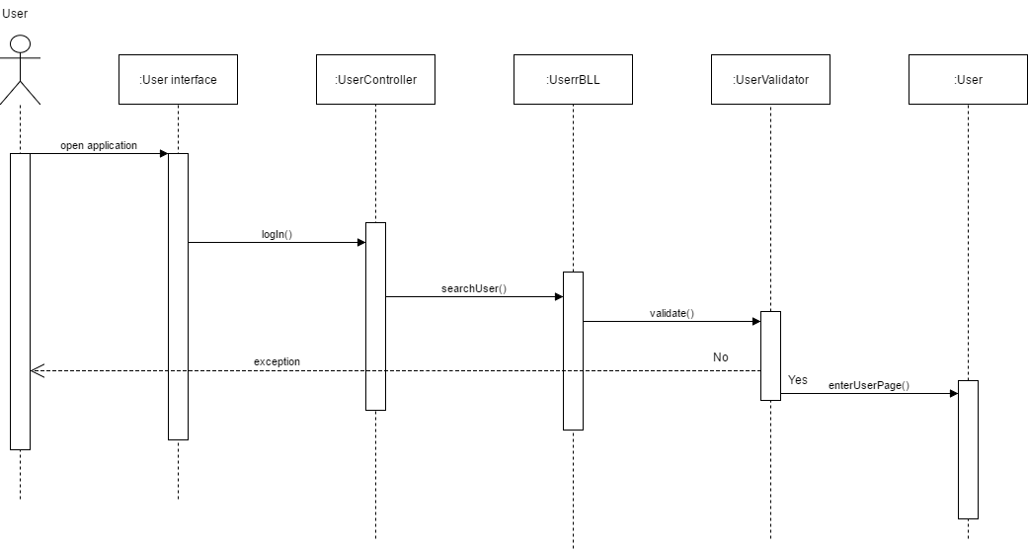

# 5. Class Design

# 5.1 Design Patterns Description

The design pattern used here is the DAO pattern. It is used to separate low level data accessing or operations from high level business services. The Data Access Object pattern consists of: an interface defines the standard operations to be performed on a model object, the concrete class which implements it and the model class which contains the get/set methods used to store data retrieved with the previous class.

# 5.2 UML Class Diagram

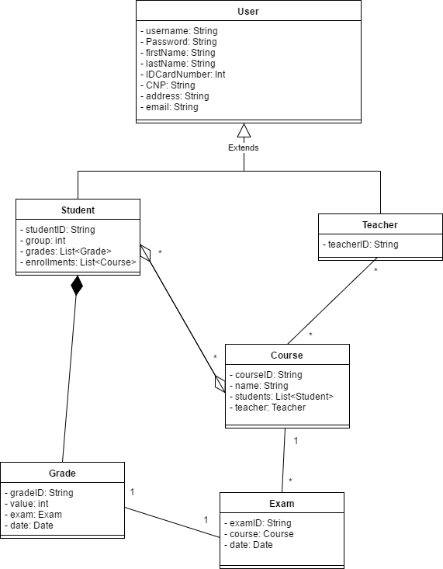

# 6. Data Model

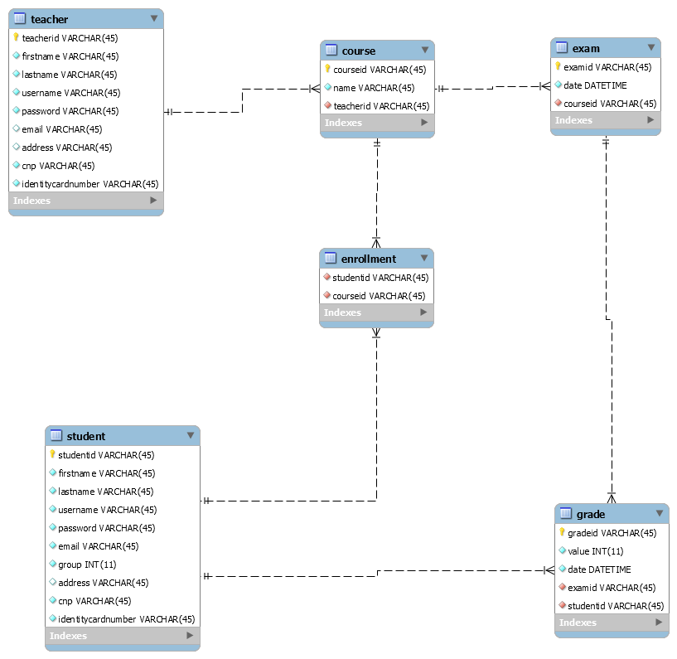

# 7. System Testing

The testing strategy used is unit testing which implies separating the code into unit and testing each unit to see if they meet the required functionality.

# 8. Bibliography