Suarez Alvaro

# Readme file.

## Instalation Guide.

* To install the application from eclipse we should press right click button over the project and click export as.

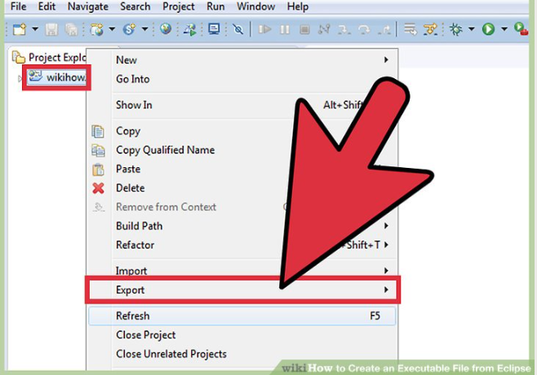

* Select Runnable Jar file

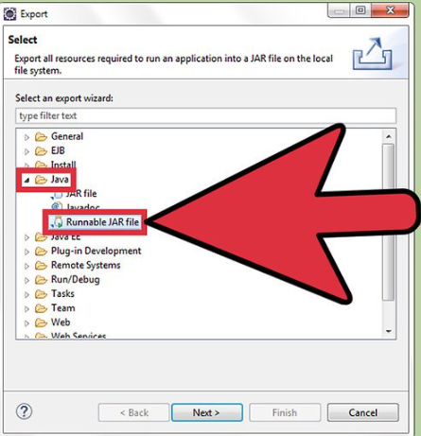

* The first thing you should do now is select the main class (class with the main method) from the drop down menu under "Launch configuration".
* Secondly, select the "Export destination" via the "Browse..." button or by manually typing the location.
* Lastly, ensure the "Extract required libraries into generated JAR" radio button is selected.

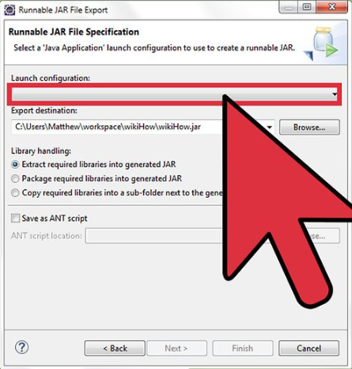

## Accessible Users.

I use Xammp as a SQL database manager (it can be downloaded from its main site).

Once we user the script (we go to SQL tab and copy paste the script content) the accessible Students are.

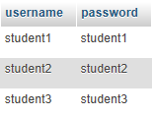

And the teachers:

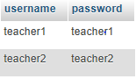

## Use Cases Implementation.

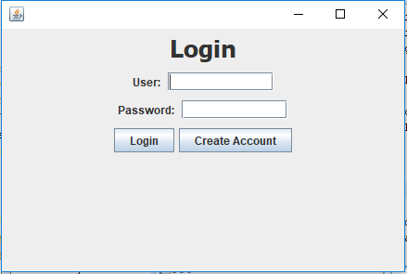

The main page will satisfy the login user case allowing the users (both teachers and students) to get into the system with their corresponding accounts.

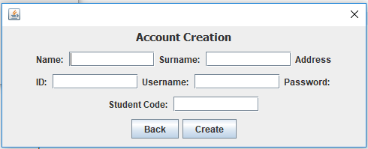

If a student has no account if he hits the create account button he will face this window and he will be able to create a profile satisfying the corresponding user case.

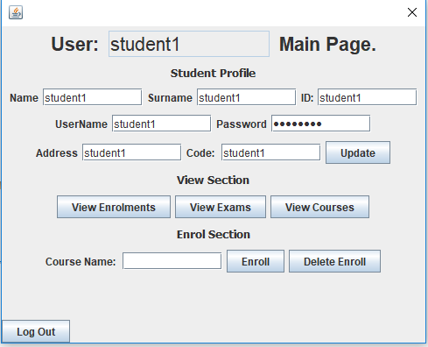

Here in the students window the following use cases are satisfied in each corresponding section:

* View,Update profile.
* View Exams, Enrolments, Courses.
* Enroll to a course or delete a enrolment.

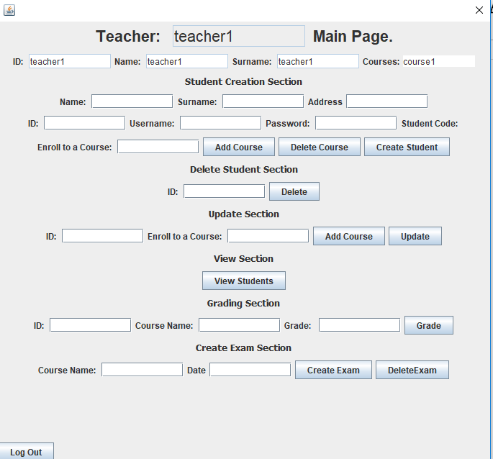

Here the teacher main window allows him to create, update, view and delete the students, also create exams and grade students, finally he can create a report with the corresponding button and a txt file will be created.