Analysis and Design Document

Student: Danila Vlad-Mihai
Group: 30432

Table of Contents

1. Requirements Analysis 3
1.1 Assignment Specification 3
1.2 Functional Requirements 3
1.3 Non-functional Requirements 3
2. Use-Case Model 3
3. System Architectural Design 4
4. UML Sequence Diagrams 6
5. Class Design 7
6. Data Model 7
7. System Testing 8
8. Bibliography 8

1. Requirements Analysis

Assignment Specification
This assignment aims to design, using Java API, a client-server application for a news agency. The application has 2 types of users: the readers and the writers. The readers can view a list of articles, read an article and do not need to login in order the use the application. The writers need to authenticate to create, update or delete articles. So, the writer accounts are preset by the application developer and cannot be altered. The application must support multiple concurrent users. If a writer posts a new article, the readers must see it in the list of articles in real time, without performing any refresh operation.

Functional Requirements
- Readers can: view a list of articles, read an article
- Writers can: login, create, update or delete profile, create, update or delete articles, choose related articles

Non-functional Requirements
- Availability: the system should be available all the time, except the planned maintenance periods
- Performance: the system should have a time response no longer than 5 seconds
- Security: clear distinction between readers and writers. Readers can not alter the database.
- Reusability: the system should be design as having components that could be reused by other systems if necessary
- Usability: the system will have a user-friendly interface and will be easy to use

2. Use-Case Model
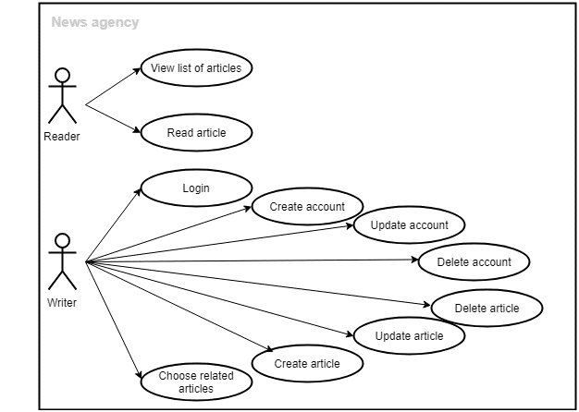

Use case: Writer creates an article
Level: User-goal level
Primary actor: Writer
Main success scenario:
- Writer selects Create Article button
- Writer enters the article content
- Writer selects the related articles
- Writer selects Publish Article button

Extensions:
- Writer selects Create Article button
- Writer enters the article content
- Writer selects Publish Article button
- Writer receives a message asking for related articles
- Writer selects the related articles
- Writer selects Publish Article button

3. System Architectural Design

3.1 Architectural Patterns Description
The system will be built using:

- Layers architectural pattern - Logically similar functionalities will be grouped from the technical point of view by dividing the entire program logic into three layers: Presentation Layer, Business Layer and Database Layer. Our goal is to minimize the number of overlapping functionalities across the entire application.

- MVC (Model-View-Controller) architectural pattern - divide the system intro three interconnected parts:
- Model represents the data and business logic of the application.
- View module is responsible to display data i.e. it represents the presentation.
- Controller module acts as an interface between view and model. It intercepts all the requests i.e. receives input and commands to Model / View to change accordingly.

- Client-Server architectural pattern - The client/server architectural style describes distributed systems that involve a separate client and server system, and a connecting network. Servers are the providers of services and clients are the ones that request a service. In our application, the data will be transferred in JSON format using sockets. JavaScript Object Notation (aka JSON) is a very popular alternative to XML for transmitting data to the web browser. Flexjson is a lightweight library for serializing and deserializing Java objects into and from JSON.

  - Diagrams

System’s conceptual architecture
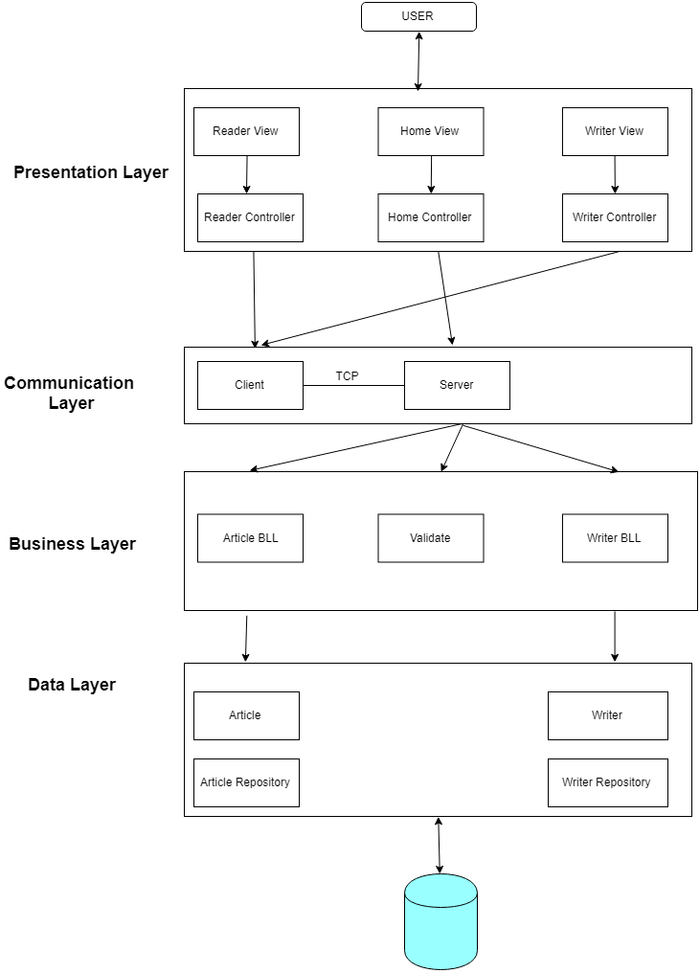

Package diagram
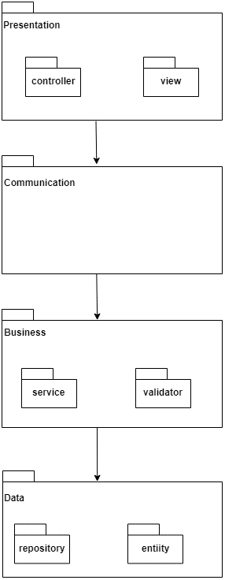

UML Sequence Diagrams

Scenario: add article

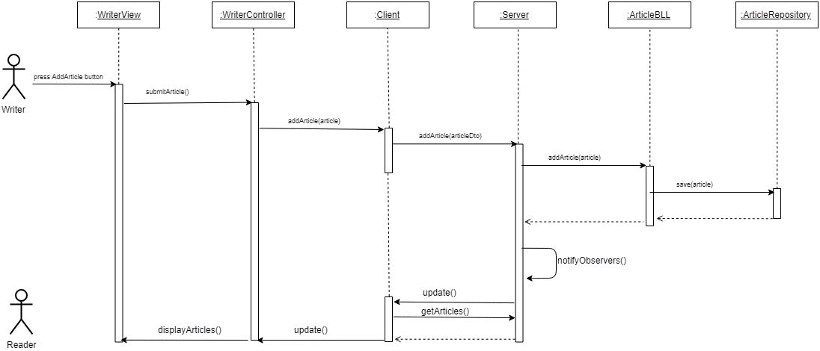

Deployment diagram
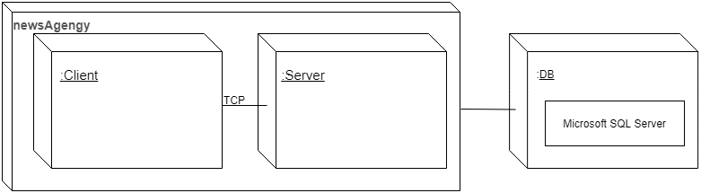

5. Class Design

  - Design Patterns Description

Observer Design Pattern – Used for situations where any change occurs to the list of articles seen by a reader(client). When a writer modifies an article, the readers will be notified about the change. Also, the list of articles seen by the readers must be updated automatically. The ReaderController implements the Observer interface and the ArticleService class extends the Observable.

  - UML Class Diagram
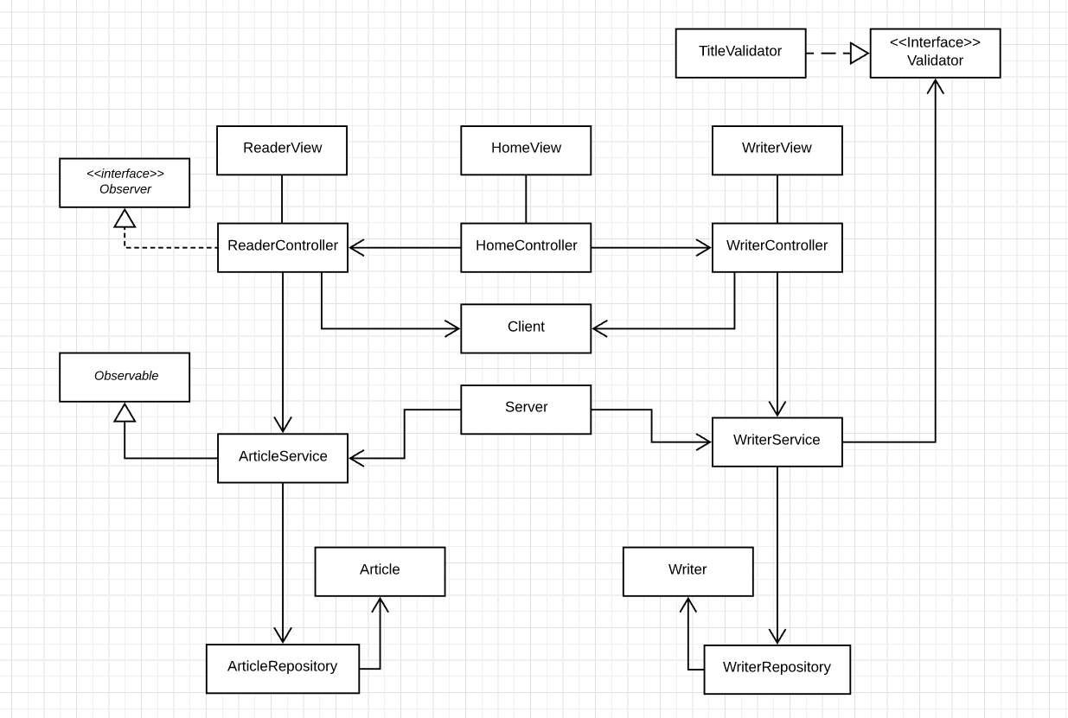

Data Model

DBMS: Microsoft SQL Server
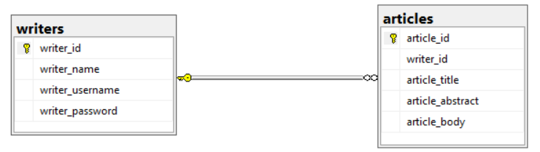

7. System Testing
- Unit Testing – write test to verify that a relatively small piece of code is doing what it is intended to do.
Junit will be used for testing at method or class level, by checking that the actual output matches the expected output.

8. Bibliography

stackoverflow.com
lucidchart.com
http://users.utcluj.ro/~dinso/PS2018/
https://docs.oracle.com/javase/tutorial/networking/sockets/definition.html
https://docs.oracle.com/javase/tutorial/networking/sockets/clientServer.html
https://docs.oracle.com/javase/tutorial/networking/sockets/readingWriting.html

