Álvaro Suárez del Cueto

Analysis and Design Document

Student:Alvaro Suarez del Cueto

**Group:Erasmus**

Revision History

|  |  |  |  |
| --- | --- | --- | --- |
| **Date** | **Version** | **Description** | **Author** |
| 04/04/2018 | 1.0 | Added specifications | Alvaro |
| 25/04/2018 | 1.1 | Iteration 1.2 | Álvaro |
|  |  |  |  |
|  |  |  |  |

Table of Contents

I. Project Specification 4

II. Elaboration – Iteration 1.1 4

1. Domain Model 4

2. Architectural Design 5

2.1 Conceptual Architecture 5

2.2 Package Design 6

2.3 Component and Deployment Diagrams 7

III. Elaboration – Iteration 1.2 7

1. Design Model 7

1.1 Dynamic Behavior 7

1.2 Class Design 7

2. Data Model 7

3. Unit Testing 7

IV. Elaboration – Iteration 2 7

1. Architectural Design Refinement 7

2. Design Model Refinement 7

V. Construction and Transition 8

1. System Testing 8

2. Future improvements 8

VI. Bibliography 8

# Project Specification

# Application for tracking suspicious behavior in online chats.

# Elaboration – Iteration 1.1

# Domain Model

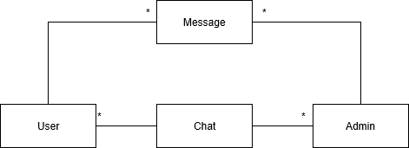

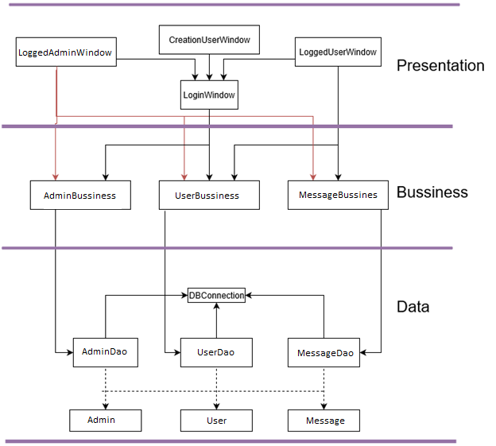

# Architectural Design

## Conceptual Architecture

The system will follow the Layered architecture:

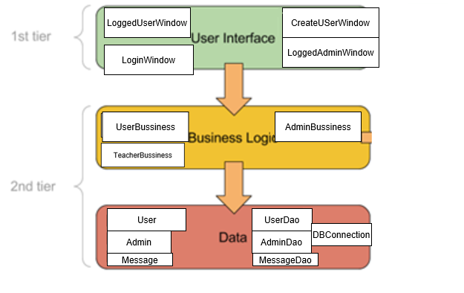

The user interface will be created using HTML webpages, the business logic the classes and their correspondent behavior which will be to allow the webpages access the data from the data layer, the business layer will access the services from the data layer which will perform CRUD operations.

## Package Design

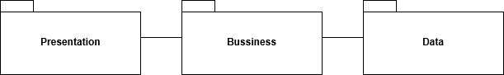

## Component and Deployment Diagrams

# 

# Elaboration – Iteration 1.2

# Design Model

## Dynamic Behavior

*[Create the interaction diagrams (1 sequence, 1 communication diagrams) for 2 relevant scenarios]*

Scenario Submit Message:

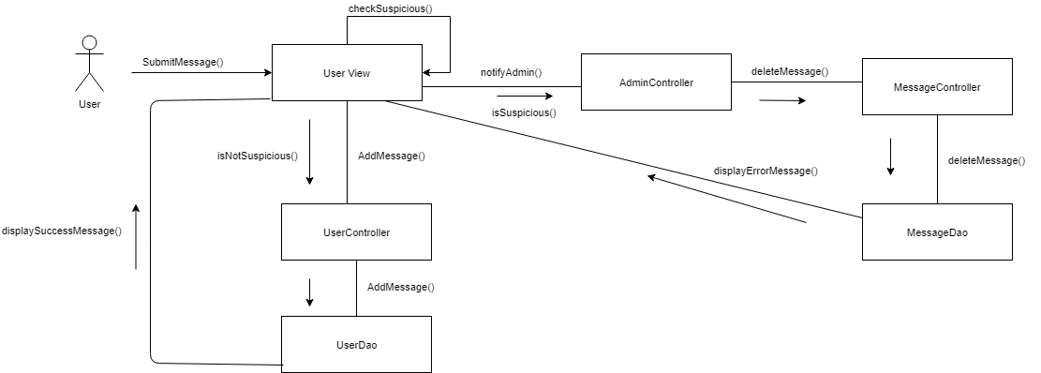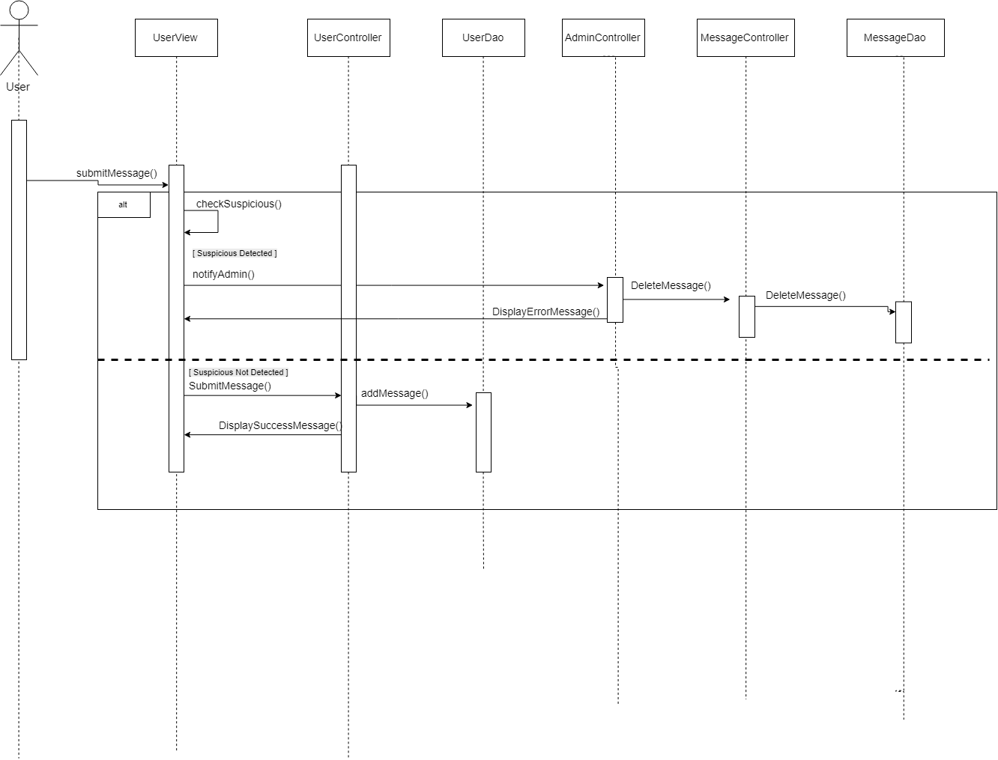

Scenario Send Email:

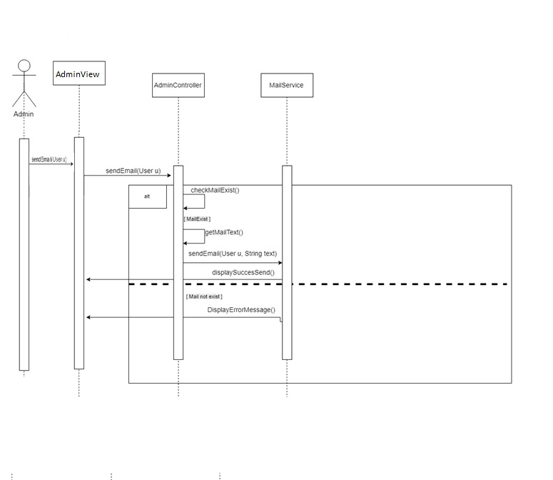

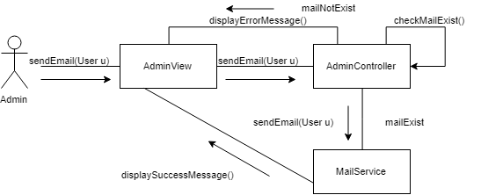

## Class Design

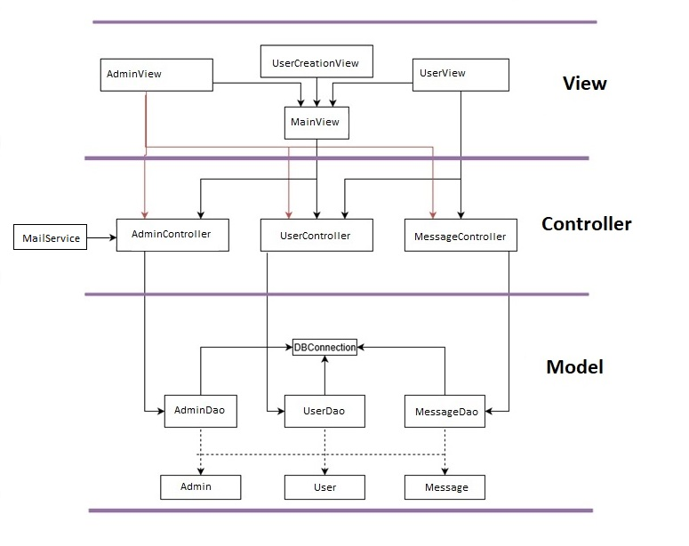

I will apply the Observer Design Pattern in order to notify the administrators (sending them an email) when a suspicious comment is made.

# Data Model

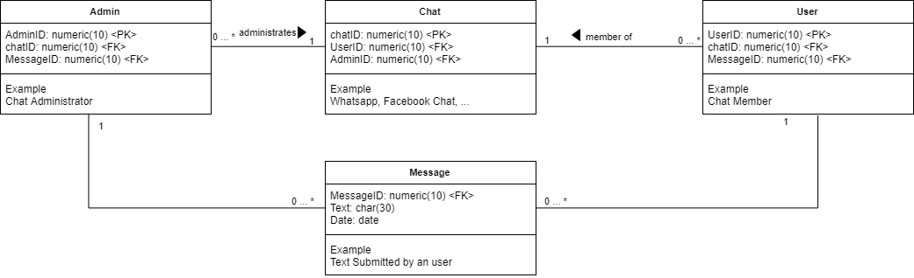

# Unit Testing

**Unit testing will be used.**

**Example:**

**Test Scenario: Validate the login page**

**Test Case 1: Enter a valid username and password**

**Test Case 2: create new account**

**Test Case 3: Enter invalid credentials**

# Elaboration – Iteration 2

# Architectural Design Refinement

*[Refine the architectural design: conceptual architecture, package design (consider package design principles), component and deployment diagrams. Motivate the changes that have been made.]*

# Design Model Refinement

## *[Refine the UML class diagram by applying class design principles and GRASP; motivate your choices. Deliver the updated class diagrams.]*

# Construction and Transition

# System Testing

*[Describe how you applied integration testing and present the associated test case scenarios.]*

# Future improvements

*[Present future improvements for the system]*

# Bibliography