Art Museum Application (AMA)

Analysis and Design Document

Student: Rednic Ana

**Group: 30432**

Revision History

|  |  |  |  |
| --- | --- | --- | --- |
| **Date** | **Version** | **Description** | **Author** |
| 19/04/2018 | 1.0 | Domain Model, Architectural Design, Deployment Diagram | Rednic Ana |
| 25/04/2018 | 1.1 | -added- Design Model, Data Model | Rednic Ana |
|  |  |  |  |
|  |  |  |  |

Table of Contents

I. Project Specification 4

II. Elaboration – Iteration 1.1 4

1. Domain Model 4

2. Architectural Design 4

2.1 Conceptual Architecture 4

2.2 Package Design 4

2.3 Deployment Diagram 4

III. Elaboration – Iteration 1.2 4

1. Design Model 4

1.1 Dynamic Behavior 4

1.2 Class Design 4

2. Data Model 4

3. Unit Testing 4

IV. Elaboration – Iteration 2 4

1. Architectural Design Refinement 4

2. Design Model Refinement 4

V. Construction and Transition 5

1. System Testing 5

2. Future improvements 5

VI. Bibliography 5

# Project Specification

The Art Museum Application (AMA) will be a stand-alone Android application that will provide a way for the visitors of the Art Museum of Baia Mare to easily find information about the works of art in the museum. The AMA could also be a support for the ones that cannot visit the museum in person: they can do a virtual tour using the application.

# Elaboration – Iteration 1.1

# Domain Model

The domain model is a conceptual model of the domain that incorporates both behavior and data.

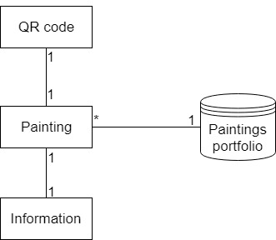

# Architectural Design

## Conceptual Architecture

I choose to implement the 3 Layers Architecture, composed of Presentation Layer, Business Logic Layer, and Data Layer, arranged as in the following schema:

In the Data Access Layer, I will make the connection to the Exhibition and Visitors databases. In the Business Logic Layer I will process the information. The Presentation Layer will be the Android interface.

I will also implement the Client-Server architecture:

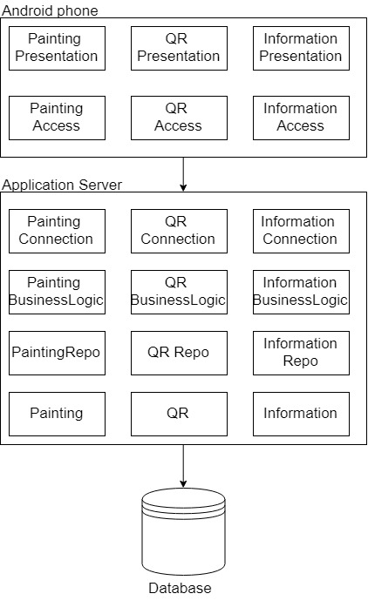

## Package Design

## *C:\Users\Ana\Downloads\Package Diagram (1).jpg*

## Deployment Diagram

# *C:\Users\Ana\Downloads\Deployment Diagram (1).jpg*

# Elaboration – Iteration 1.2

# Design Model

## Dynamic Behavior

**Sequence Diagram**

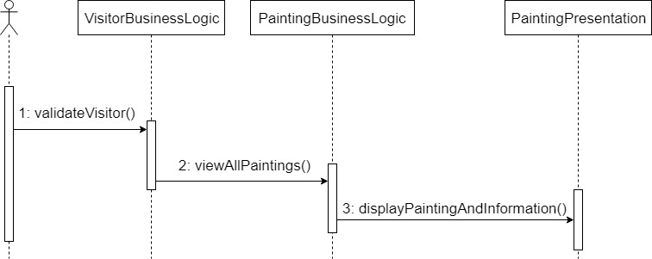

**Communication Diagram**

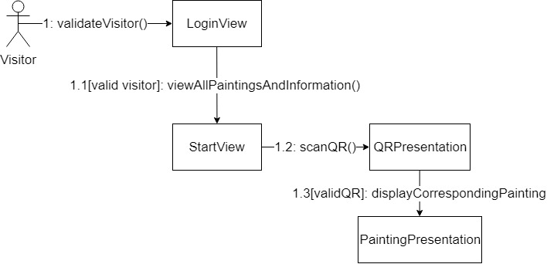

## Class Design

# C:\Users\Ana\Downloads\Class diagram project (1).jpg

# Data Model

# *C:\Users\Ana\Downloads\Data Model project.jpg*

# Unit Testing

Unit testing will be performed on each component of the system, validating it. The focus falls on the tests that impact the behavior of the system. This will be done using Dataflow testing.

In the Integration testing part, individual units will be combined and tested as a group. This will look forward to expose defects in the interfaces and in the interaction between integrated components.

The System testing part will verify if the whole application meets the specified requirements.

Validation testing will be performed to decide whether or not the application is ready to be made available to the end-users. The last three stages will be done using Black Box testing.

# Elaboration – Iteration 2

# Architectural Design Refinement

*[Refine the architectural design: conceptual architecture, package design (consider package design principles), component and deployment diagrams. Motivate the changes that have been made.]*

# Design Model Refinement

## *[Refine the UML class diagram by applying class design principles and GRASP; motivate your choices. Deliver the updated class diagrams.]*

# Construction and Transition

# System Testing

*[Describe how you applied integration testing and present the associated test case scenarios.]*

# Future improvements

*[Present future improvements for the system]*

# Bibliography

* <https://en.wikipedia.org/wiki/Domain_model>
* <http://softwaretestingfundamentals.com/>
* <https://www.tutorialspoint.com/software_testing_dictionary/data_flow_testing.htm>