Online Medieval Weapon and Armour Store

Analysis and Design Document

Nicolae-Florian Onica

**30432**

Revision History

|  |  |  |  |
| --- | --- | --- | --- |
| **Date** | **Version** | **Description** | **Author** |
| <4.04.2018 | 1.0 | Domain Model, Architectural Design, Component and Deployment diagrams | Nicolae-Florian Onica |
|  |  |  |  |
|  |  |  |  |
|  |  |  |  |

Table of Contents

I. Project Specification 4

II. Elaboration – Iteration 1.1 4

1. Domain Model 4

2. Architectural Design 4

2.1 Conceptual Architecture 4

2.2 Package Design 4

2.3 Component and Deployment Diagrams 4

III. Elaboration – Iteration 1.2 4

1. Design Model 4

1.1 Dynamic Behavior 4

1.2 Class Design 4

2. Data Model 4

3. Unit Testing 4

IV. Elaboration – Iteration 2 4

1. Architectural Design Refinement 4

2. Design Model Refinement 4

V. Construction and Transition 5

1. System Testing 5

2. Future improvements 5

VI. Bibliography 5

# Project Specification

This project is an online medieval weapon and armor store that has listings of various weapons along with their features. The project allows users to buy weapons, armor or parts of them online. They can check stats, read reviews and build their own custom weapon.

# Elaboration – Iteration 1.1

# Domain Model

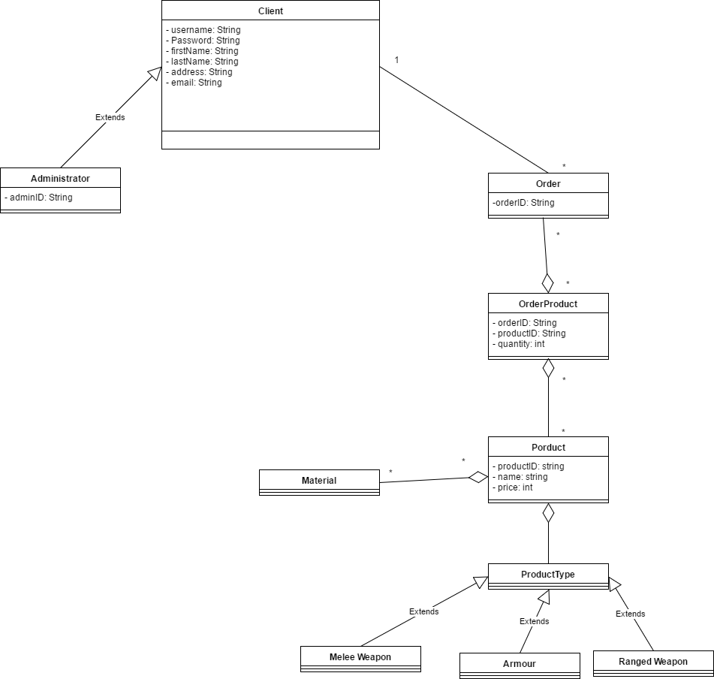

# Architectural Design

## Conceptual Architecture

The architectural pattern used for this application is the layered architecture pattern. The components within this pattern are organized into horizontal layers, each layer performing a specific role within the application (e.g., presentation logic or business logic). In this case three layers will be used: presentation, business and database layer.

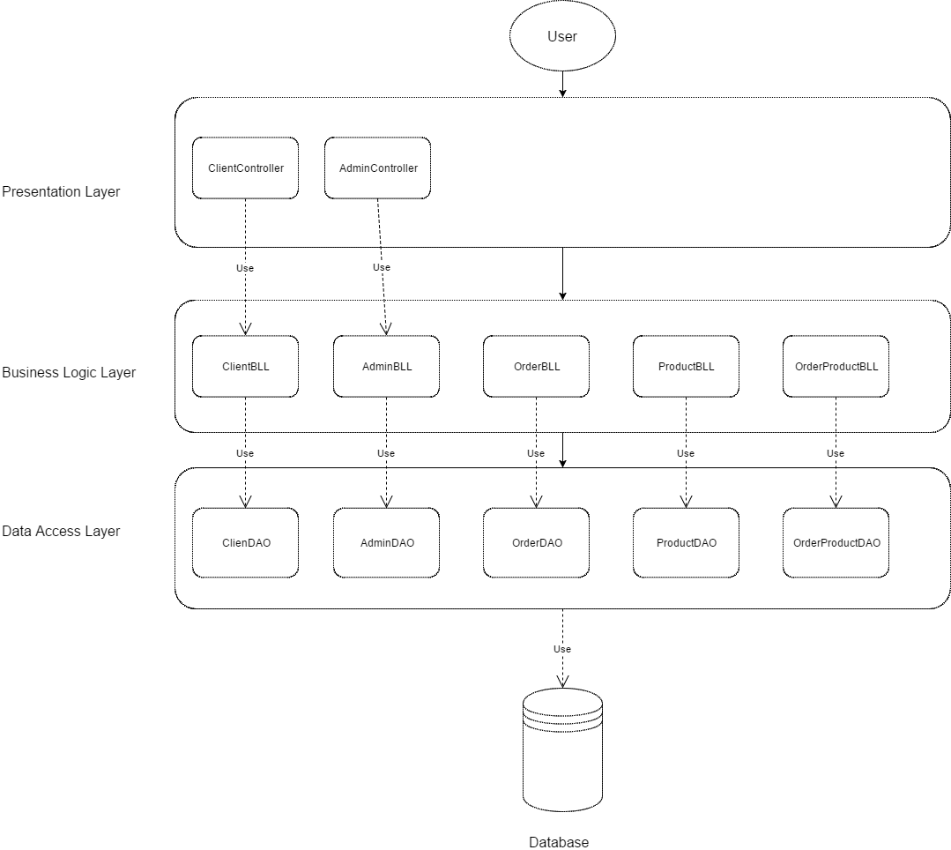

## Package Design

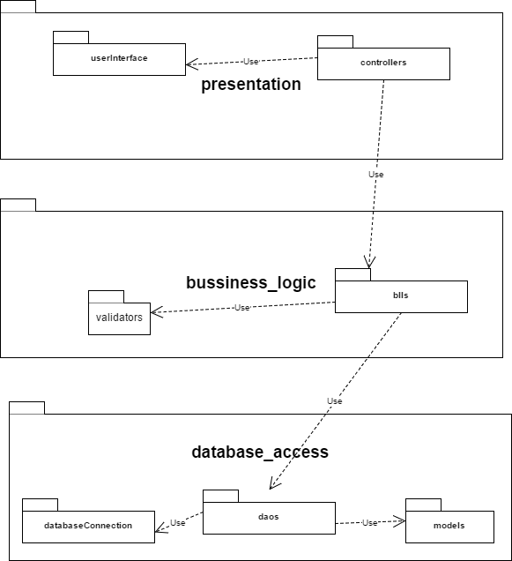

## Component and Deployment Diagrams

Component diagram

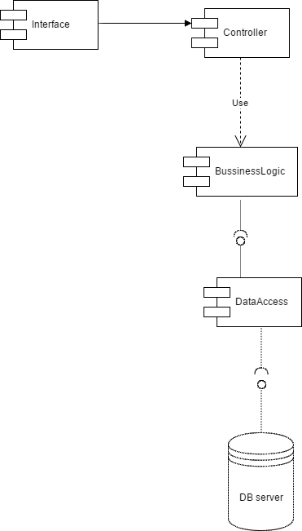

Deployment diagram

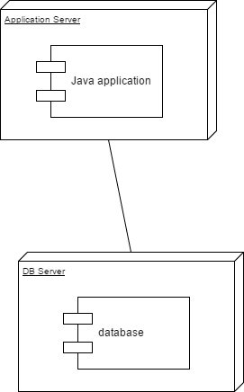

# Elaboration – Iteration 1.2

# Design Model

## Dynamic Behavior

*[Create the interaction diagrams (1 sequence, 1 communication diagrams) for 2 relevant scenarios]*

## Class Design

*[Create the UML class diagram; apply GoF patterns and motivate your choice]*

# Data Model

*[Create the data model for the system.]*

# Unit Testing

*[Present the used testing methods and the associated test case scenarios.]*

# Elaboration – Iteration 2

# Architectural Design Refinement

*[Refine the architectural design: conceptual architecture, package design (consider package design principles), component and deployment diagrams. Motivate the changes that have been made.]*

# Design Model Refinement

## *[Refine the UML class diagram by applying class design principles and GRASP; motivate your choices. Deliver the updated class diagrams.]*

# Construction and Transition

# System Testing

*[Describe how you applied integration testing and present the associated test case scenarios.]*

# Future improvements

*[Present future improvements for the system]*

# Bibliography