Online Medieval Weapon and Armour Store

Analysis and Design Document

Nicolae-Florian Onica

**30432**

Revision History

|  |  |  |  |
| --- | --- | --- | --- |
| **Date** | **Version** | **Description** | **Author** |
| 4.04.2018 | 1.0 | Domain Model, Architectural Design, Component and Deployment diagrams | Nicolae-Florian Onica |
| 21.05.2018 | 1.1 | Revamp of Architecture, Domain Model, Design Patterns and Class Diagram | Nicolae-Florian Onica |
|  |  |  |  |
|  |  |  |  |

Table of Contents

I. Project Specification 4

II. Elaboration – Iteration 1.1 4

1. Domain Model 4

2. Architectural Design 4

2.1 Conceptual Architecture 4

2.2 Package Design 4

2.3 Component and Deployment Diagrams 4

III. Elaboration – Iteration 1.2 4

1. Design Model 4

1.1 Dynamic Behavior 4

1.2 Class Design 4

2. Data Model 4

3. Unit Testing 4

IV. Elaboration – Iteration 2 4

1. Architectural Design Refinement 4

2. Design Model Refinement 4

V. Construction and Transition 5

1. System Testing 5

2. Future improvements 5

VI. Bibliography 5

# Project Specification

This project is an online medieval weapon and armor store that has listings of various weapons along with their features. The project allows users to buy weapons, armor or parts of them online. They can check stats, read reviews and build their own custom weapon.

# Elaboration – Iteration 1.1

# Domain Model

The domain model has 2 actors, the client and the administrator. The user places the order containing the products which he wants or create a customized item which will be added to the order. The administrator performs CRUD operations on products and checks user reviews.

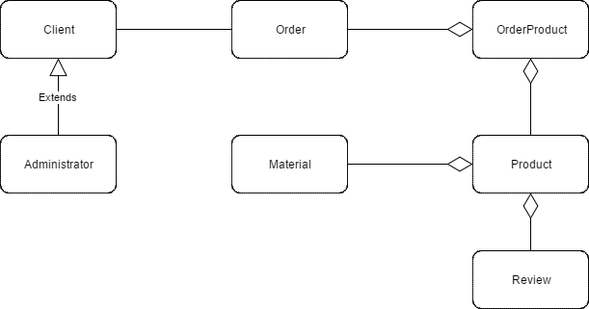

# Architectural Design

## Conceptual Architecture

The architectural pattern used for this application is the layered architecture pattern. The components within this pattern are organized into horizontal layers, each layer performing a specific role within the application (e.g., presentation logic or business logic). In this case three layers will be used: presentation, business and database layer.

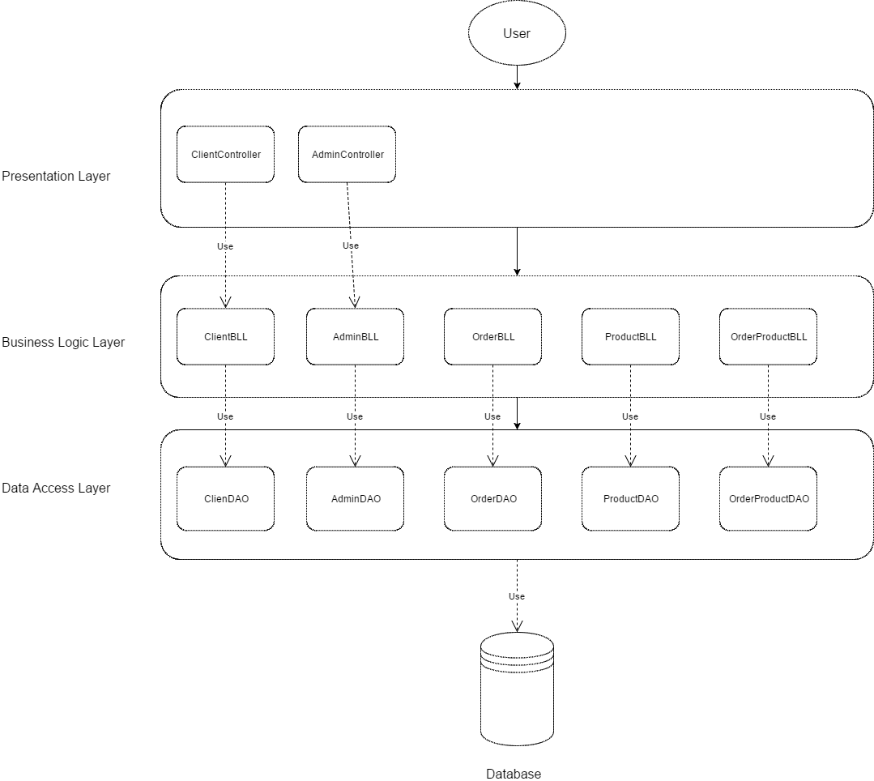

## Package Design

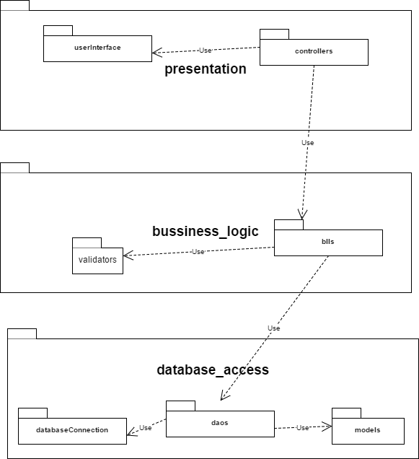

## Component and Deployment Diagrams

Component diagram

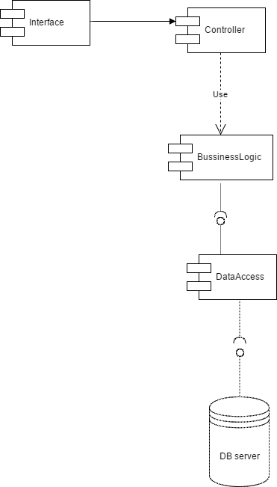

Deployment diagram

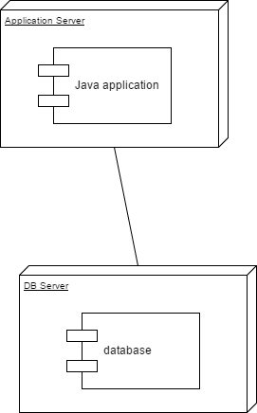

# Elaboration – Iteration 1.2

# Design Model

## Dynamic Behavior

Login

Sequence diagram

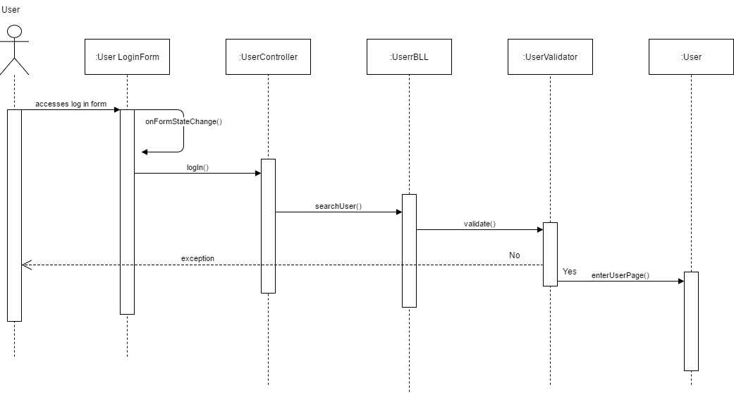

Communication diagram

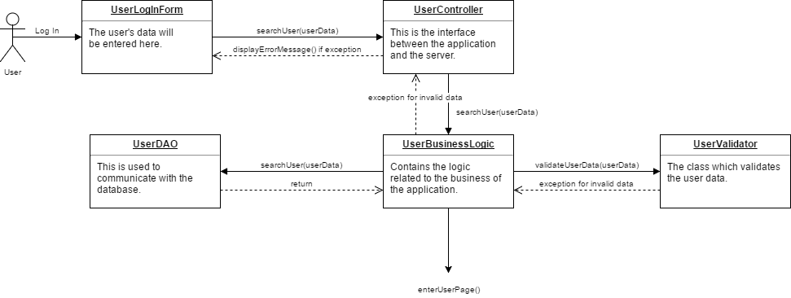

Create item

Sequence diagram

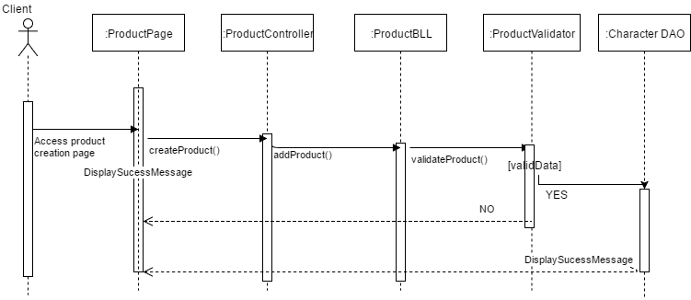

Communication diagram

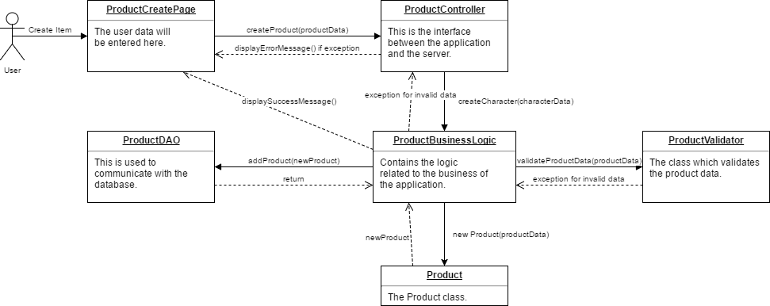

## Class Design

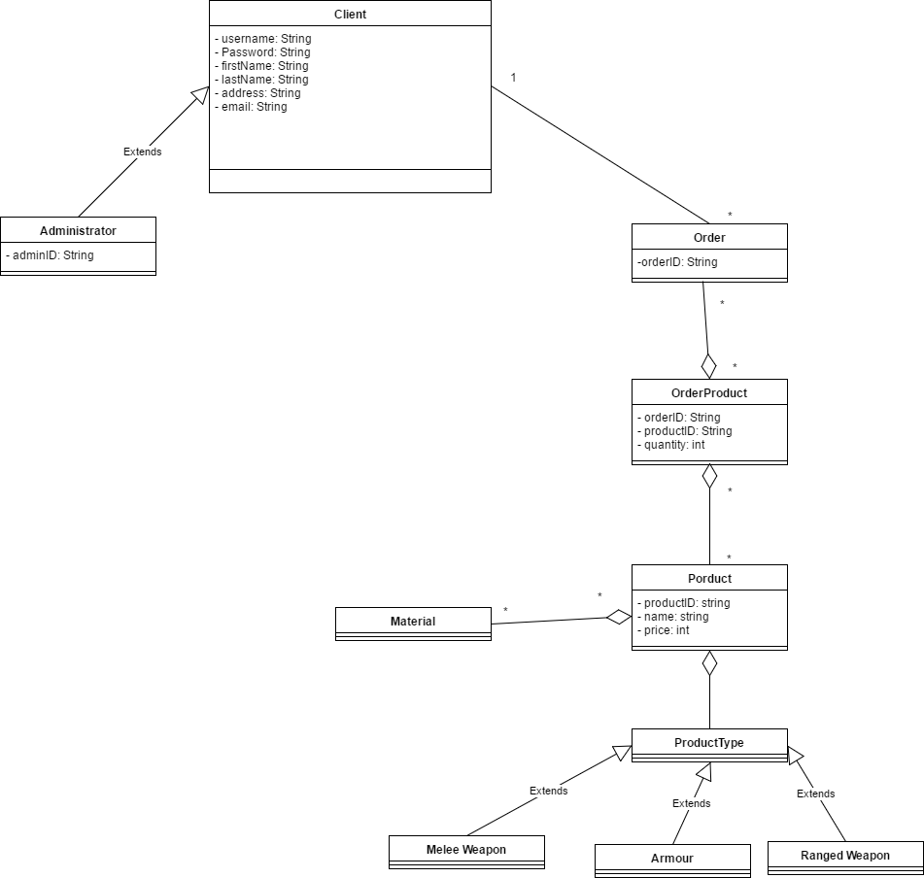

# Data Model

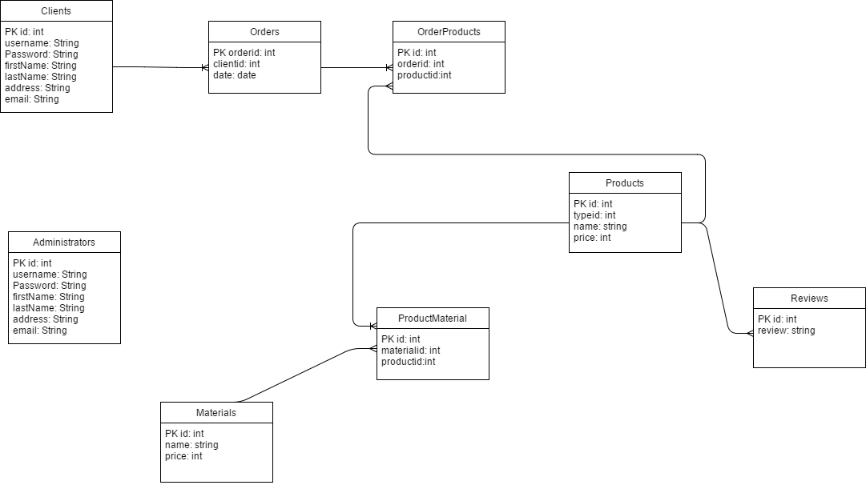

# Unit Testing

The testing strategy used is unit testing which implies separating the code into unit and testing

each unit to see if they meet the required functionality.

Test case scenarios:

* CRUD operations on products
* User login/logout
* Creating an order

# Elaboration – Iteration 2

# Architectural Design Refinement

The architectural pattern used for this application is the layered architecture pattern. The components within this pattern are organized into horizontal layers, each layer performing a specific role within the application (e.g., presentation logic or business logic). In this case three layers will be used: presentation, business and database layer.

**MVC pattern**

This architecture has the following components: the model, which consists of the classes which are used to store and manipulate state, typically in a database of some kind, the view, which contains the user interface bits necessary to render, the model to the user, and the controller, which is the brains of the application. The controller decides what the user's input was, how the model needs to change as a result of that input, and which resulting view should be used.

**Design patterns**

One design pattern used in this application is the Observer pattern. It has two main components, an Observable class(in our case the article) which will be the subject of observation for the Observer interface(in this case the admin which should view reviews flagged), which has an update method which is being called anytime the Observable updates.

Builder pattern builds a complex object using simple objects and using a step by step approach. It is used here for the create custom item use-case implementation.

Factory pattern is used to create an object without exposing the creation logic to the client and refer to newly created object using a common interface. Here it is used to generate admin accounts.

# Design Model Refinement

## 

# Construction and Transition

# System Testing

The testing strategy used is unit testing which implies separating the code into unit and testing

each unit to see if they meet the required functionality.

Test case scenarios:

1. CRUD operations on products
2. User login/logout
3. Creating an order

# Future improvements

# Bibliography