TV Time

Use-Case Model

Version <1.0>

Revision History

|  |  |  |  |
| --- | --- | --- | --- |
| **Date** | **Version** | **Description** | **Author** |
| <dd/mmm/yy> | <x.x> | <details> | <name> |
|  |  |  |  |
|  |  |  |  |
|  |  |  |  |

Table of Contents

1. Use-Cases Identification 4

2. UML Use-Case Diagrams

2.1 Admin available operations 4

2.2 User available operations 4

2.3 User adds a new TV show to their list 4

Use-Case Model

# Use-Cases Identification

**Use case:** Admin available operations

**Level:** summary-level

**Primary actor:** Admin

**Main success scenario:** Admin successfully adds a new TV show to the database; deletes a TV show or modifies the TV show status from running to ended and adds the end date.

**Extensions:** Admin cannot alter the information of the TV shows dates or the next episode’s date is not modified

**Use case:** User available operations

**Level:** summary-level

**Primary actor:** User

**Main success scenario:** The user logs in and then he/she can add or remove TV shows from his/hers following list; can mark episodes or seasons as seen; can search for more TV shows based on the number of criteria or no criteria at all

**Extensions:** The user forgot his/her password or username and is not able to login and selects the option “forgot password”

**Use case:** User adds a new TV show to its following list

**Level:** User-goal level

**Primary actor:** User

**Main success scenario:** The user logs in with his/her password and username.The user adds a new TV show to its following list and gets notifications about that TV show and he/she can mark episodes or seasons as seen

**Extensions:** The user adds the TV show but cannot mark the episodes or seasons as seen; the TV show keeps appearing to the recommended screen

# UML Use-Case Diagrams

## Admin available operations

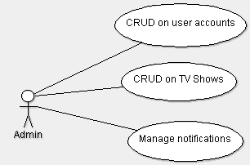

## User available operations

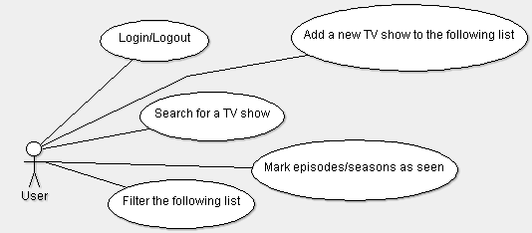

## User adds a new TV show to their list

