FaceBass – Facial Recognition-based Bus Pass

Analysis and Design Document

Student: Radu Petrisel

**Group: 30432**

Revision History

|  |  |  |  |
| --- | --- | --- | --- |
| **Date** | **Version** | **Description** | **Author** |
| 03/04/2018 | 1.0 | Domain model, Architectural design, component and deployment diagram | Radu Petrisel |
| 19/04/2018 | 2.0 | Fixed domain model; Added data model | Radu Petrisel |
| 21/04/2018 | 2.5 | Class diagram and sequence diagrams | Radu Petrisel |
| 21/05/2018 | 3.0 | Elaboration + updates | Radu Petrisel |

Table of Contents

I. Project Specification 4

II. Elaboration – Iteration 1.1 4

1. Domain Model 4

2. Architectural Design 4

2.1 Conceptual Architecture 4

2.2 Package Design 5

2.3 Component and Deployment Diagrams 6

III. Elaboration – Iteration 1.2 7

1. Design Model 7

1.1 Dynamic Behavior 7

1.2 Class Design 8

2. Data Model 9

3. Unit Testing 10

IV. Elaboration – Iteration 2 10

1. Architectural Design Refinement 10

2. Design Model Refinement 10

V. Construction and Transition 10

1. System Testing 10

2. Future improvements 10

VI. Bibliography 10

# Project Specification

The Facial-recognition based bus pass system presented in this vision aims to solve the problems with most of today’s bus passes – people need to carry IDs with them in order to identify themselves. By the new system, all they will need is their face. The system will be titled FaceBass (from bus and pass).

# Elaboration – Iteration 1.1

# Domain Model

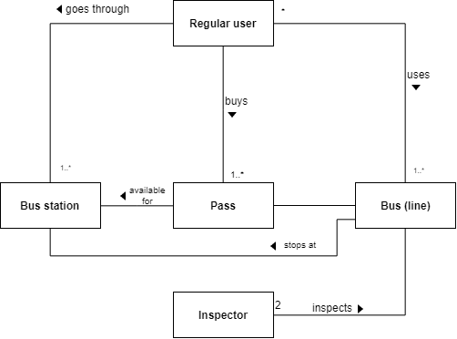

# Architectural Design

## Conceptual Architecture

The system will use a Client-Server, layered architecture. The iOS application is the client, and the server is a Python application. The client has the presentation layer and a part of the business logic, and the server has the data access and the rest of the business logic layer.

## Package Design

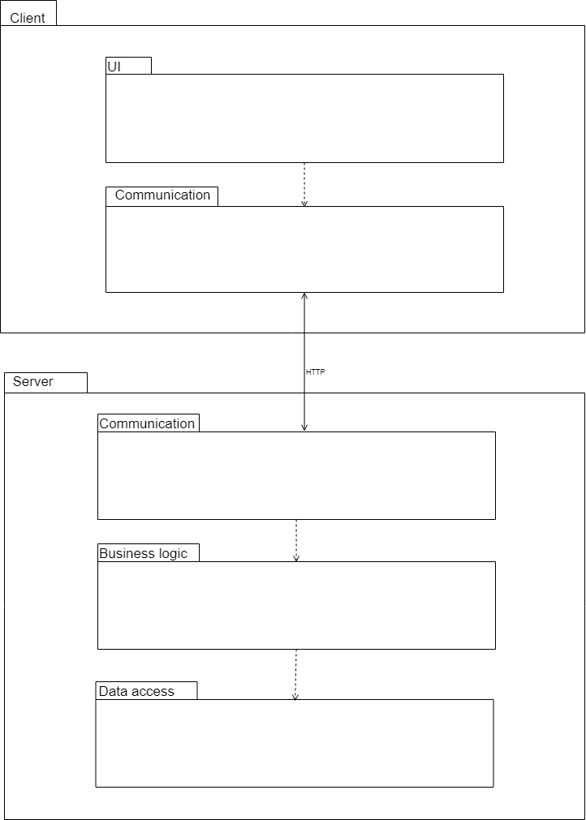

## Component and Deployment Diagrams

# Elaboration – Iteration 1.2

# Design Model

## Dynamic Behavior

* 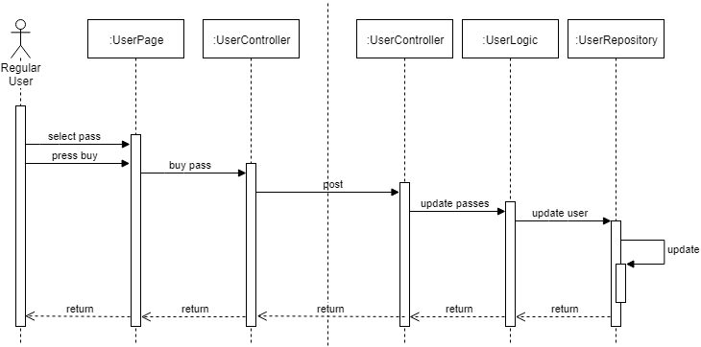buy pass
* 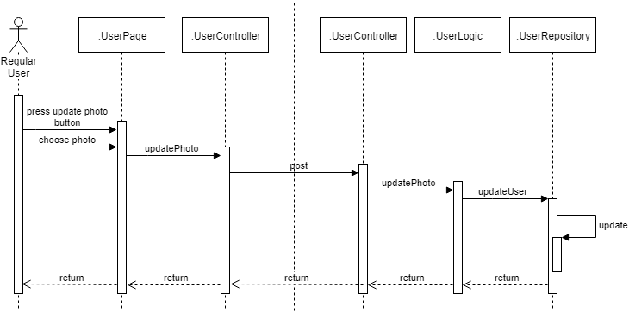update sample photo

## Class Design

* server

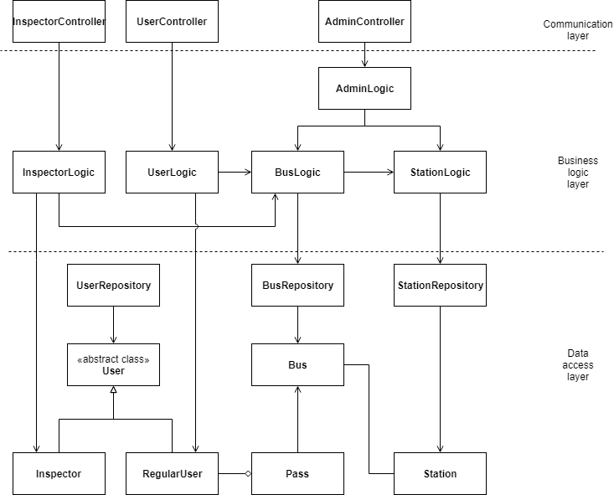

* clients

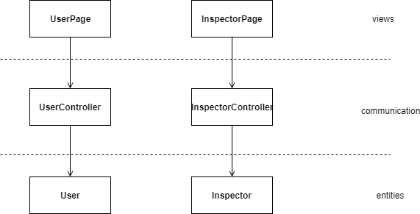

# Data Model

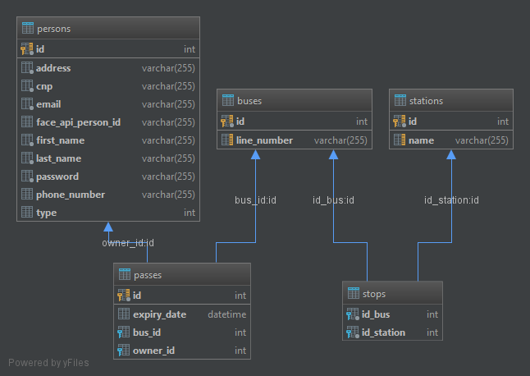

# Elaboration – Iteration 2

# Architectural Design Refinement

# Design Model Refinement

* server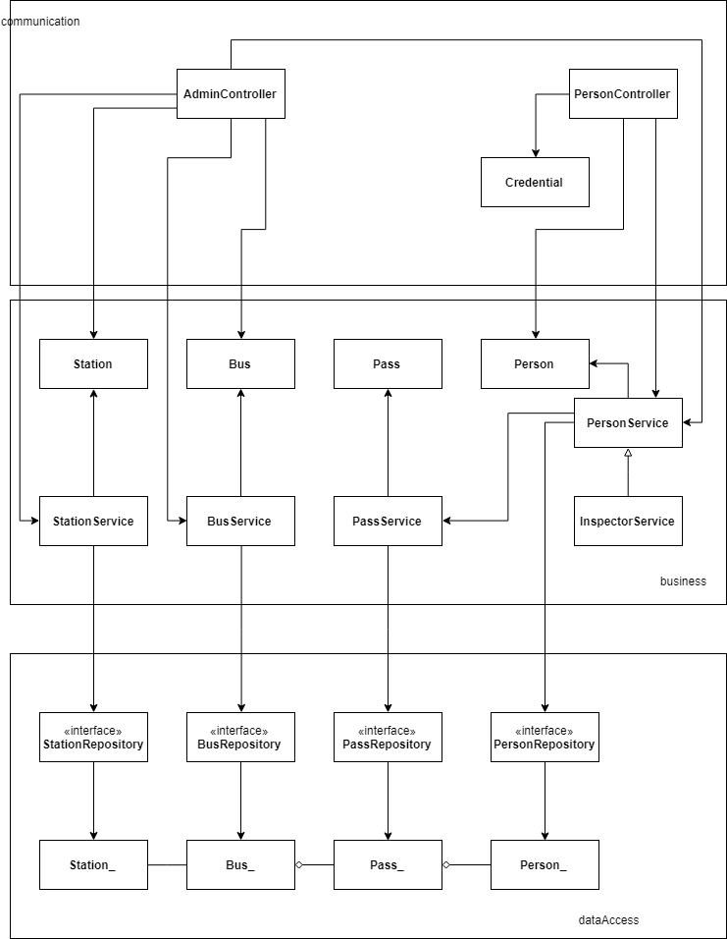
* client

# Construction and Transition

# Future improvements

* better user interface
* more complex station system

# Bibliography

[Stackoverflow](http://www.stackoverflow.com/)