College Portal

Analysis and Design Document

Student: Raul-Mihai Acu

**Group: 30432**

Revision History

|  |  |  |  |
| --- | --- | --- | --- |
| **Date** | **Version** | **Description** | **Author** |
| 21/03/2018 | 1.0 | Vision, Use-Case Model, Glossary, Supplementary Specificatio | Acu Raul-Mihai |
| 05/04/2018 | 2.0 | Domain Model, Architectural Design, Component diagram | Acu Raul-Mihai |
| 25/04/2018 | 3.0 | Design Model, Data model | Acu Raul-Mihai |
|  |  |  |  |

Table of Contents

I. Project Specification 4

II. Elaboration – Iteration 1.1 4

1. Domain Model 4

2. Architectural Design 4

2.1 Conceptual Architecture 4

2.2 Package Design 5

2.3 Component and Deployment Diagrams 5

III. Elaboration – Iteration 1.2 6

1. Design Model 6

1.1 Dynamic Behavior 6

1.2 Class Design 6

2. Data Model 7

3. Unit Testing 7

IV. Elaboration – Iteration 2 7

1. Architectural Design Refinement 7

2. Design Model Refinement 7

V. Construction and Transition 7

1. System Testing 7

2. Future improvements 8

VI. Bibliography 8

# Project Specification

# *The College Portal application will provide means of communication between students and teachers, announcements, information regarding activities or events related to their college, and also access to their profiles, grades or payments.*

# Elaboration – Iteration 1.1

# Domain Model

# Architectural Design

## Conceptual Architecture

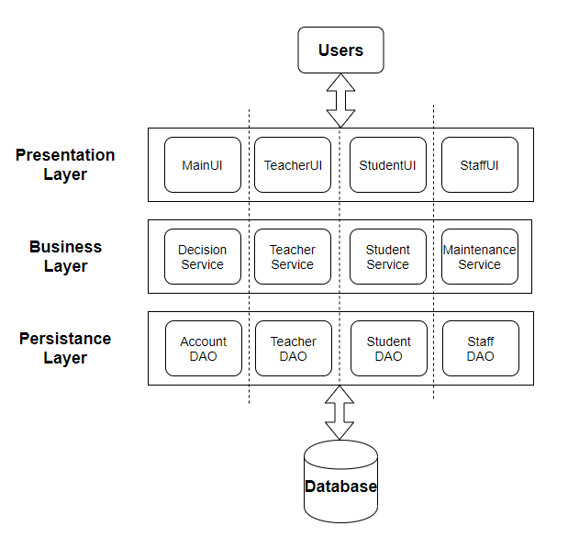

## Package Design

## 

## 

## Component and Deployment Diagrams

# 

# Elaboration – Iteration 1.2

# Design Model

## Dynamic Behavior

**Sequence Diagram**

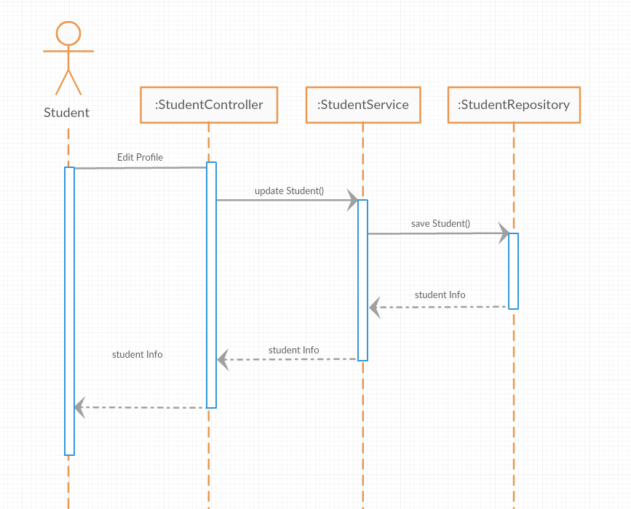

## Class Design

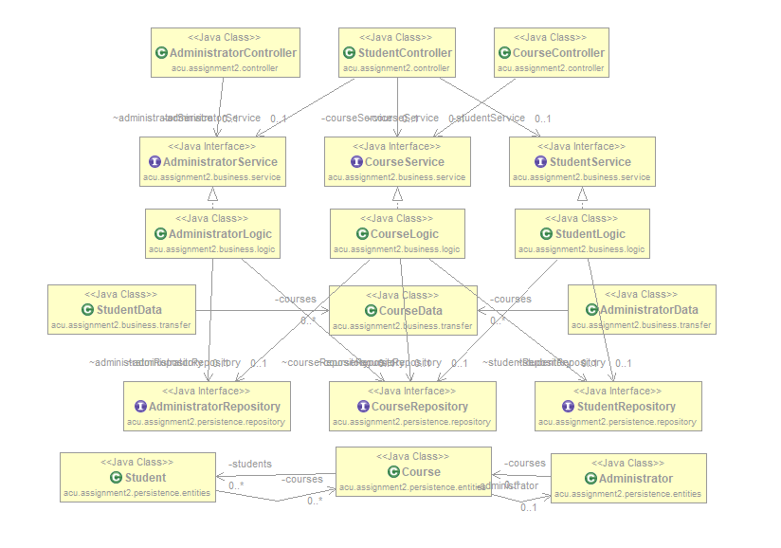

# Data Model

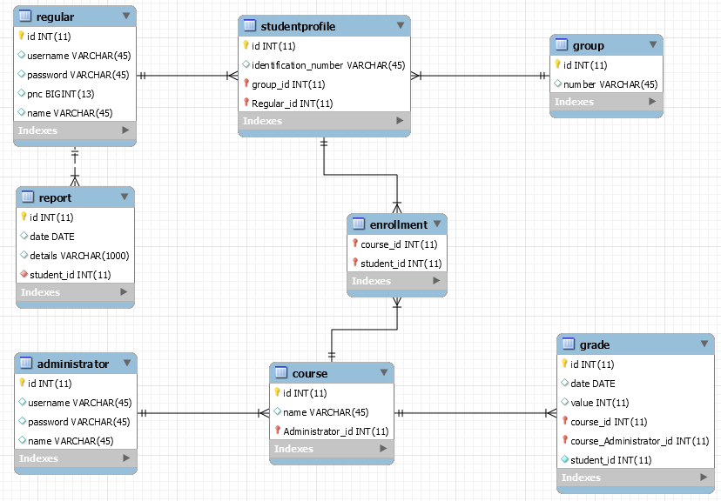

# Unit Testing

*[Present the used testing methods and the associated test case scenarios.]*

# Elaboration – Iteration 2

# Architectural Design Refinement

*[Refine the architectural design: conceptual architecture, package design (consider package design principles), component and deployment diagrams. Motivate the changes that have been made.]*

# Design Model Refinement

## *[Refine the UML class diagram by applying class design principles and GRASP; motivate your choices. Deliver the updated class diagrams.]*

# Construction and Transition

# System Testing

*[Describe how you applied integration testing and present the associated test case scenarios.]*

# Future improvements

*[Present future improvements for the system]*

# Bibliography