Analysis and Design Document

Student: Turcu Lucian Andrei

**Group: 30432**

Revision History

|  |  |  |  |
| --- | --- | --- | --- |
| **Date** | **Version** | **Description** | **Author** |
| <19/Apr/18> | <1.0> | First iteration. Domain Model, Architectural Design, Deployment diagram | Turcu Lucian Andrei |
|  |  |  |  |
|  |  |  |  |
|  |  |  |  |

Table of Contents

I. Project Specification 4

II. Elaboration – Iteration 1.1 4

1. Domain Model 4

2. Architectural Design 4

2.1 Conceptual Architecture 4

2.2 Package Design 4

2.3 Component and Deployment Diagrams 4

III. Elaboration – Iteration 1.2 4

1. Design Model 4

1.1 Dynamic Behavior 4

1.2 Class Design 4

2. Data Model 4

3. Unit Testing 4

IV. Elaboration – Iteration 2 4

1. Architectural Design Refinement 4

2. Design Model Refinement 4

V. Construction and Transition 5

1. System Testing 5

2. Future improvements 5

VI. Bibliography 5

# Project Specification

MedPat is a platform whose purpose is to facilitate the communication between medical staff and their patients. Using MedPat, a medic can offer basic medical consulting remotely and write prescriptions for a patient. It also gives specialized users the possibility to write articles on medical subjects, which may be of interest to both medical and non-medical users. The patients can book appointments to a specific doctor, keep track of prescriptions and request consulting from a doctor.

# Elaboration – Iteration 1.1

# Domain Model

This is the general representation of the relevant concepts that have to be modelled in the software application, including the relations between them and the multiplicity factors.

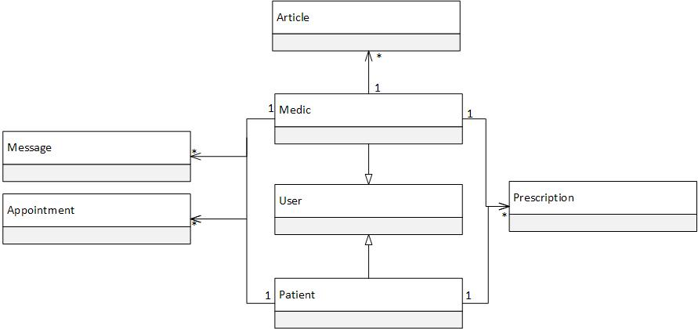

# Architectural Design

## Conceptual Architecture

The system is based on a client-server architecture. The client is the Android application, through which the users interact with the system. The desktop application acts as a server. It processes the client’s requests and retrieves data from the database. This way, multiple users can use the application at once, using a common data set.

The server application’s architecture is a layered one, to achieve separation between the different levels of functionality. The layers are given by the Spring framework: repository, service and controller. Between the layers, communication is only available from a layer to the one directly above or below.

## Package Design

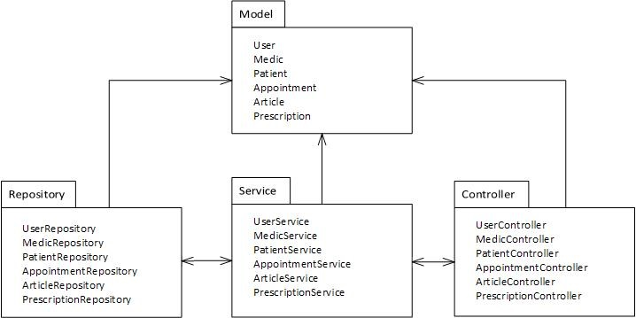

## Deployment Diagram

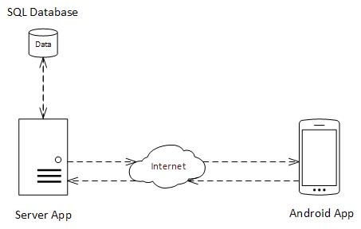

# Elaboration – Iteration 1.2

# Design Model

## Dynamic Behavior

*[Create the interaction diagrams (1 sequence, 1 communication diagrams) for 2 relevant scenarios]*

## Class Design

*[Create the UML class diagram; apply GoF patterns and motivate your choice]*

# Data Model

*[Create the data model for the system.]*

# Unit Testing

*[Present the used testing methods and the associated test case scenarios.]*

# Elaboration – Iteration 2

# Architectural Design Refinement

*[Refine the architectural design: conceptual architecture, package design (consider package design principles), component and deployment diagrams. Motivate the changes that have been made.]*

# Design Model Refinement

## *[Refine the UML class diagram by applying class design principles and GRASP; motivate your choices. Deliver the updated class diagrams.]*

# Construction and Transition

# System Testing

*[Describe how you applied integration testing and present the associated test case scenarios.]*

# Future improvements

*[Present future improvements for the system]*

# Bibliography