Deliverable 3
Overview:
The system we are building is made to help people set up appointments. The appointments are set to be for small businesses owners and customers that want to support these businesses. It is a good way to show users small businesses around them as well.
In deliverable 1, we set up requirements that we will base our system off of. As well as the people we are targeting.
In deliverable 2, we set up different ways we will deal with the architecture of the system, this helped us in making sure the workflow was consistent and efficient.

Development Process:
We used plan-driven phases, we started out with the front end to make the user interface somewhat friendly. We used the previous deliverables as a blueprint to divide tasks. We talked on iMessage in order to separate tasks. We had 2 people work on the back end while mostly one person made sure to do the front end. This would be just for the start as everyone eventually did their part.
In deliverable 1, we set out our initial parameters with requirements and who we were planning on helping. This was the footprint for what we were planning on implementing for our main program. This also stems from how we were thinking about making different approaches depending on the user, like regular customer, or a business owner. All while validating them so we know we are designing the system with the right intentions.
In deliverable 2, We set up the way we will start the architecture of our system. The diagrams like the sequence diagram were the ones we used to make the bone structure for interactions for the system. Process model for workflow, behavioral to plan the interactions across different components. Structural model will help us decide the classes we will make to control the data effectively. The 4+1 view model was done to have a better understanding of the way we will implement the system. The architectural patterns will be in mind when making the system bigger.

Design and Implementation Summary:
Requirements used:
Functional:
- The system shall let users search businesses by location, specialty, and next available time (Requirement 1)

- The system shall show a profile for each employer with specialties, experience, and a small portfolio. (Requirement 3)
- The system shall show a calendar for each appointment with open time slots. (Requirement 4)
- The system shall let a user book a slot by entering name, email, and phone number. (Requirement 5)
- The system shall create a unique appointment id for every booking. (Requirement 6)
- The system shall provide a message thread tied to the appointment so the customer and business can talk before the service. (Requirement 8)
- The system shall let the customer upload up to three photos for the appointment with a total size limit of twenty-five megabytes. (Requirement 9)
- The system shall allow businesses to approve or decline a pending booking and add a short note if needed. (Requirement 10)
- The system shall let the customer reschedule or cancel an appointment. (Requirement 11)

- The system shall let businesses mark an appointment as confirmed, completed, or no show. (Requirement 13)

Non-functional:
• Performance
The system shall complete 50% of page loads and actions within two seconds for at least ninety five percent of requests and within four seconds for at least ninety nine percent of requests.
• Availability
The system shall provide at least 99.5% uptime for booking and calendar features during posted shop hours.
• Upload limits
The system shall enforce a total upload limit of 25mb/appointment and shall reject files that exceed this limit with a clear message.

Implementation of architectural designs:
We are mainly using a repository design. We have a database to keep user and appointment information. All the data is centralized here and it is done using SQLlite and SQL alchemy.
Client-server design can be implemented if we have clients accessing through our main server with our database, handle all the operations.
Tools used:
fastAPI, SQLlite to connect to the local database, SQL alchemy

Development Environment:
For front end we decided to use HTML and CSS, for the back end we used python. Our main IDE was visual studio code. The code runs well on either a mac, windows, or linux.

Testing summary:
We used pytest for backend testing since the backend is Python. We created 33 unit tests covering authentication functions (JWT token creation, password hashing, customer/business authentication) and database migration scripts. The test suite includes 25 passing tests and 8 skipped due to library compatibility. We achieved 61% code coverage of the authentication module, focusing on security-critical functions. Tests use mocks for database dependent code, ensuring isolation and consistent behavior across development environments. The automated test suite helped catch errors early, prevent regressions, and maintain code quality throughout development.
Challenges Faced:
Teamwork: It was difficult to divide tasks as there was some conflict in schedules and there was not much constant communication. The communication was okay as some people were not able to respond at times.

Design Assumptions & Revisions:
Only in the event we upscale this project, will we be able to implement repository with client-server. Because it involves putting our program being implemented through web services to allow users to use our service. Making repository the only one we could implement for the scope of this project.
Our initial design assumptions were to have a notification system, but we had no way to actually implement it in a web system. So, we did not implement it.
Impact of Automated Testing:
Automated testing has been essential for maintaining code quality throughout development. Using pytest, we created 33 unit tests that validate the functionality in our authentication system and database migrations.
Key Benefits from this:
- Early Error Detection: The tests were able to catch any edge cases and bugs before they reached production, saving debugging time
- Regression Prevention: As we added features, tests ensured existing functionality remained intact
- Documentation: Test cases can be seen as documentation that shows expected behavior for each function
- Confidence in Refactoring: Having test coverage allowed us to improve code safely, knowing tests would catch any breaking changes

Test Coverage:
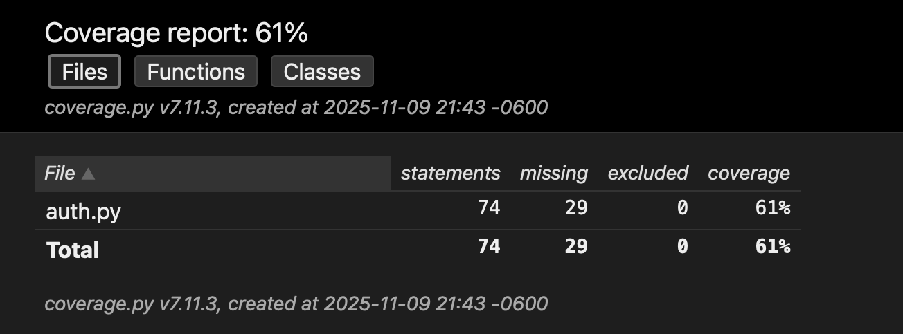
- 33 total unit tests (25 passing, 8 skipped due to library compatibility)
- 61% code coverage of authentication module
Why 61%:
We achieved 61% code coverage by focusing on unit-testable functions. The remaining 39% includes password hashing functions (8%), which are skipped due to library compatibility issues in the test environment but work in production, and FastAPI dependency functions (31%) like get_current_user, get_current_customer, and get_current_business, which require FastAPI's dependency injection, active database connections, and HTTP request context. These dependency functions are better tested through integration tests (covered in test_api.py) rather than unit tests. Our approach follows testing best practices: unit tests for isolated logic (61% coverage) and integration tests for components requiring the full application context. The 61% represents all code that can be meaningfully tested as unit tests, while the remaining code is validated through integration testing.

Specific Examples:
- Migration script tests validated that database columns are added correctly and handle existing columns gracefully
- Authentication tests verified that JWT tokens are created with proper expiration and cannot be decoded with wrong secret keys
- Customer and business authentication tests used mocks to test login logic without requiring database connections

In conclusion, automated testing has significantly improved how we maintain our appointment booking system. Focusing on major security functions and using proper testing techniques like mocking made sure that our authentication system is truly secure.
Screenshots & Evidence:
