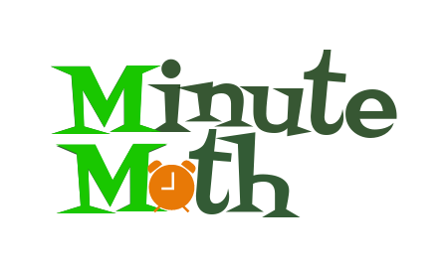

Iteration 1 Deliverables

**Summary of Changes:**

This marks the first iteration of our software. We had added the core functionality for the following classes/modules:

* User Profile (Placeholders for profile picture, name, and email)
* Example Tutorial
* Test Game 1 Framework

Though the framework for these classes has been implemented, much is left to do to ensure app stability and expand content throughout the app.

**Deliverable Content:**

The contents of this iteration file include the following:

* UML Class Diagrams for implemented classes (umlSWENG.pdf)
* Wireframes for the UI Classes (UI Wireframes.pptx)
* Requirements for implemented and future features (requirements.pdf)
* Basic list of use cases for the software (Use-Cases.pdf)
* The submitted proposal (Proposal-EducationalApp.pdf)
* Android application source code (MinuteMath Directory)
* Screenshots of the implemented screens

**Iteration 2 Plans:**

Changes for phase 2 include the following:

* Fully implementing game 1
* Expanding content in the tutorials section
* Adding sqlite support to persist user data
* Improved documentation and requirements

**Code Bases and Source Control:**

All of the code is stored on github at the following url:

<https://github.com/UTD-SE3354-MinuteMath>