In the execution of my code I parallelized it so it would split the work when doing the word count from each file. In this assignment I found it interesting when I ran the code and found out that from 1 thread to 2 threads the time increased by .5 seconds. Then when ran with 4 threads it reduced the time from 2 threads by about .15 seconds. Then when I ran the program with 8 threads it reduced the time from 4 threads by about .07 seconds.

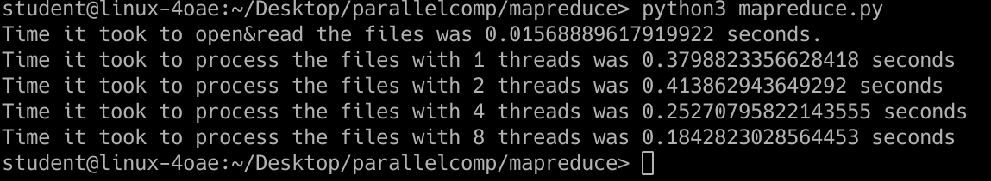

A problem I ran into when working on this assignment was when I was trying to figure out how to get ‘p.iterate()’ working. When iterating through the file list I found out through some online forums that in order to work with the iterator it needed to have the ‘.read()’. In the end when instead of passing the file descriptors and passing the ‘.read()’ data it worked, which seems a little unclear to me but alas it worked.

The results for the word count are as follows:

'hate' = 323

'love' = 2843

'death' = 966

'night' = 1362

'sleep' = 431

'time' = 1692

'henry' = 0

'hamlet' = 0

'you' = 20771

'my' = 12357

'blood' = 994

'poison' = 129

'macbeth' = 0

'king' = 1716

'heart' = 1443

'honest' = 418