Infant and Delivery Identification: Enrollment/Claim/Delivery Windows

Overview
Infants start from the DOB spine: every person with a single DOB on or after 2019-01-01. Claims are measured against that spine rather than defining it. Enrollment beginning within 12 months of the DOB is the entry requirement; two claim measures are then reported against that denominator:
- A newborn-code claim, within 7, 30, 60 or 90 days of the DOB.
- Any claim at all, within 30, 60 or 90 days of the DOB.
Deliveries are pseudo-episodes: claims collapsed on overlapping date spans, anchored on the CPT procedure date where one exists.

Infants

Cohort
Everyone with a single DOB in range, and how many of them enrol within 12 months of it. The denominator here is the birth cohort.
birth_year | n_spine | n_enrolled_in_window | pct_enrolled
2019 | 438,968 | 274,253 | 62.5%
2020 | 413,893 | 269,700 | 65.2%
2021 | 393,653 | 272,463 | 69.2%
2022 | 385,746 | 282,692 | 73.3%
2023 | 359,721 | 283,876 | 78.9%
2024 | 333,045 | 283,324 | 85.1%
2025 | 289,800 | 263,814 | 91.0%
2019-2024 | 2,325,026 | 1,666,308 | 71.7%

Claims after birth
Everything from here on drops the never-enrolled and the late enrollers: the denominator is n_enrolled_in_window from the table above, not the birth cohort.
birth_year | n_enrolled_in_window | n_nb_claim | pct_nb_claim | n_any_claim | pct_any_claim
2019 | 274,253 | 237,287 | 86.5% | 246,014 | 89.7%
2020 | 269,700 | 232,848 | 86.3% | 241,573 | 89.6%
2021 | 272,463 | 234,179 | 85.9% | 243,548 | 89.4%
2022 | 282,692 | 242,677 | 85.8% | 251,955 | 89.1%
2023 | 283,876 | 239,406 | 84.3% | 249,808 | 88.0%
2024 | 283,324 | 233,088 | 82.3% | 245,423 | 86.6%
2025 | 263,814 | 229,251 | 86.9% | 240,254 | 91.1%
2019-2024 | 1,666,308 | 1,419,485 | 85.2% | 1,478,321 | 88.7%
The same two measures split by payer follow. Total is all payers; the Other category is held back for now, so the named rows do not sum to it.

Newborn-code claims
year | ins | n_enrolled_in_window | n_nb_claim | pct_nb_claim
2,019 | Medicaid | 233,793 | 212,372 | 90.8%
2,019 | Commercial | 40,451 | 24,909 | 61.6%
2,019 | Total | 274,253 | 237,287 | 86.5%
2,020 | Medicaid | 227,250 | 207,692 | 91.4%
2,020 | Commercial | 42,443 | 25,153 | 59.3%
2,020 | Total | 269,700 | 232,848 | 86.3%
2,021 | Medicaid | 225,918 | 205,612 | 91.0%
2,021 | Commercial | 46,520 | 28,548 | 61.4%
2,021 | Total | 272,463 | 234,179 | 85.9%
2,022 | Medicaid | 234,682 | 214,063 | 91.2%
2,022 | Commercial | 48,002 | 28,610 | 59.6%
2,022 | Total | 282,692 | 242,677 | 85.8%
2,023 | Medicaid | 232,164 | 209,317 | 90.2%
2,023 | Commercial | 51,691 | 30,080 | 58.2%
2,023 | Total | 283,876 | 239,406 | 84.3%
2,024 | Medicaid | 228,268 | 202,632 | 88.8%
2,024 | Commercial | 55,042 | 30,446 | 55.3%
2,024 | Total | 283,324 | 233,088 | 82.3%
2,025 | Medicaid | 211,331 | 195,446 | 92.5%
2,025 | Commercial | 52,474 | 33,800 | 64.4%
2,025 | Total | 263,814 | 229,251 | 86.9%

Any claim
No code filter: any medical claim line under the infant’s own pers_id dated on or after the DOB counts.
year | ins | n_enrolled_in_window | pct_any_30d | pct_any_60d | pct_any_90d
2,019 | Medicaid | 233,793 | 92.7% | 93.5% | 94.5%
2,019 | Commercial | 40,451 | 72.3% | 76.7% | 81.0%
2,019 | Total | 274,253 | 89.7% | 91.0% | 92.5%
2,020 | Medicaid | 227,250 | 93.2% | 93.8% | 94.8%
2,020 | Commercial | 42,443 | 70.1% | 74.6% | 79.9%
2,020 | Total | 269,700 | 89.6% | 90.8% | 92.4%
2,021 | Medicaid | 225,918 | 92.8% | 93.4% | 94.3%
2,021 | Commercial | 46,520 | 72.7% | 77.5% | 82.3%
2,021 | Total | 272,463 | 89.4% | 90.7% | 92.2%
2,022 | Medicaid | 234,682 | 92.9% | 93.5% | 94.3%
2,022 | Commercial | 48,002 | 70.5% | 75.0% | 79.6%
2,022 | Total | 282,692 | 89.1% | 90.4% | 91.8%
2,023 | Medicaid | 232,164 | 92.1% | 92.7% | 93.7%
2,023 | Commercial | 51,691 | 69.7% | 74.3% | 78.8%
2,023 | Total | 283,876 | 88.0% | 89.4% | 91.0%
2,024 | Medicaid | 228,268 | 91.1% | 91.9% | 93.0%
2,024 | Commercial | 55,042 | 68.1% | 72.4% | 77.2%
2,024 | Total | 283,324 | 86.6% | 88.1% | 89.9%
2,025 | Medicaid | 211,331 | 94.6% | 95.3% | 96.3%
2,025 | Commercial | 52,474 | 76.7% | 80.5% | 84.2%
2,025 | Total | 263,814 | 91.1% | 92.4% | 93.9%
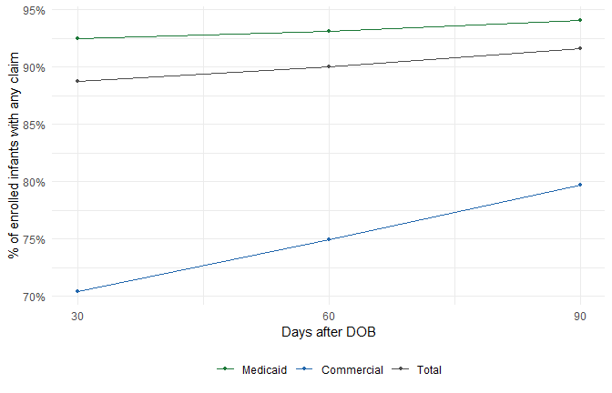
Figure 1

Time to first claim
The 30/60/90-day windows above are three points on a curve; this is the whole thing. Kaplan-Meier on any_claim_time / any_claim_event, so infants whose observation ends before day 400 are censored at that point rather than counted as claim-free. Same denominator as the tables above: infants enrolling within 12 months.
Read it as a validation curve rather than a utilisation result. Three things push it around and none are modelled here: day-0 claims are mostly the birth hospitalisation itself, so the curve starts with a large jump; enrollment can begin after the DOB, which left-truncates infants who had no coverage to bill against yet; and claims run-out makes the most recent births look slower than they were unless claims_thru in the SQL is set back far enough.
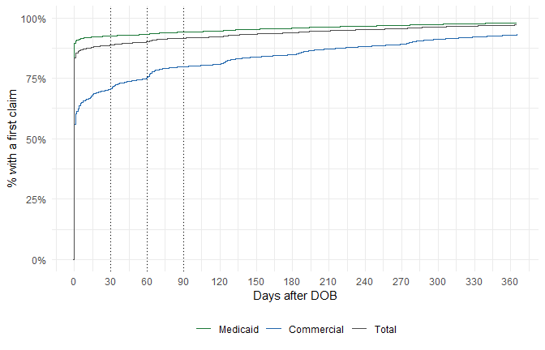
Figure 2

Combined newborn / any-claim windows
Excel-only: the newborn-code claim fixed at 30 days, alongside all three any-claim windows, in a single table. n_nb_claim_30d is independent of the nb_claim_window_days parameter used above.

Deliveries

Attrition
step | n_persons | dropped | pct_kept
1. Delivery code hits (any age, incl. infant claims) | 3,062,117 |  | 100.0%
2. Joined to claim dates in medical_adj | 3,062,117 | 0 | 100.0%
3. Age 12-50 at service, or no DOB on file | 1,400,986 | 1,661,131 | 45.8%
4. Collapsed into an episode | 1,400,986 | 0 | 45.8%
5. Episode dated within the analysis years | 1,400,433 | 553 | 45.7%

Episode dating
Episodes anchored on a CPT date rather than falling back to a diagnosis date. The date source drives the year assignment, so a large diagnosis share weakens the year-by-year counts.
year | cpt | diagnosis | pct_cpt
2,019 | 235,150 | 43,618 | 84.4%
2,020 | 233,955 | 50,476 | 82.3%
2,021 | 236,135 | 54,340 | 81.3%
2,022 | 244,156 | 52,520 | 82.3%
2,023 | 240,056 | 50,086 | 82.7%
2,024 | 233,641 | 51,637 | 81.9%
2,025 | 207,270 | 52,035 | 79.9%

Delivery counts
One instance per person per year, taking the maximum baby_count. n_mothers counts people; n_babies applies the baby count, so twins contribute 2.
year | ins | n_mothers | n_babies | n_episodes
2,019 | Medicaid | 200,538 | 203,454 | 216,776
2,019 | Commercial | 47,329 | 48,142 | 50,429
2,019 | Other | 10,964 | 11,209 | 11,563
2,019 | Total | 258,831 | 262,805 | 278,768
2,020 | Medicaid | 198,951 | 201,850 | 220,859
2,020 | Commercial | 48,659 | 49,471 | 52,629
2,020 | Other | 10,413 | 10,618 | 10,943
2,020 | Total | 258,023 | 261,939 | 284,431
2,021 | Medicaid | 195,892 | 198,725 | 218,992
2,021 | Commercial | 55,633 | 56,537 | 60,195
2,021 | Other | 10,739 | 10,972 | 11,288
2,021 | Total | 262,264 | 266,234 | 290,475
2,022 | Medicaid | 204,255 | 207,306 | 224,237
2,022 | Commercial | 57,757 | 58,657 | 61,730
2,022 | Other | 10,203 | 10,422 | 10,709
2,022 | Total | 272,215 | 276,385 | 296,676
2,023 | Medicaid | 194,308 | 197,182 | 210,403
2,023 | Commercial | 65,651 | 66,631 | 69,460
2,023 | Other | 9,845 | 10,044 | 10,279
2,023 | Total | 269,804 | 273,857 | 290,142
2,024 | Medicaid | 181,591 | 184,107 | 196,817
2,024 | Commercial | 77,559 | 78,665 | 81,844
2,024 | Other | 6,385 | 6,504 | 6,617
2,024 | Total | 265,535 | 269,276 | 285,278
2,025 | Medicaid | 164,139 | 166,440 | 178,114
2,025 | Commercial | 73,462 | 74,492 | 77,283
2,025 | Other | 3,733 | 3,805 | 3,908
2,025 | Total | 241,334 | 244,737 | 259,305

Length of stay versus CPT span
Three measures of how long the delivery event lasted:
- LOS: discharge_dt - admit_dt, only where an institutional claim is present.
- CPT span: cpt_dos_max - cpt_dos_min, how far the procedure lines spread.
- Episode length: episode_end - episode_start, the full derived span.
Distribution of the three measures, capped at 21 days.
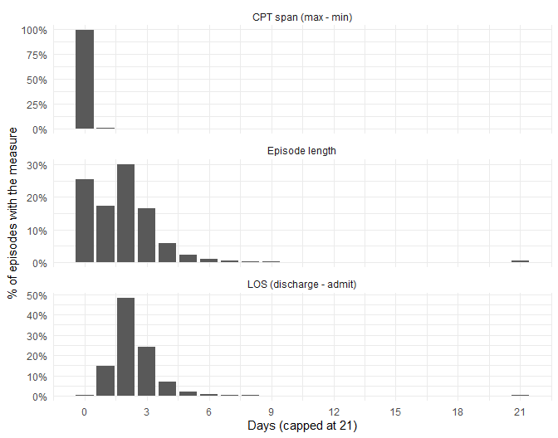
Figure 3
position | n_episodes | pct
CPT within the stay | 1,385,653 | 99.6%
CPT before admission | 5,055 | 0.4%
CPT after discharge | 837 | 0.1%

Delivery data quality

Pregnancies per person
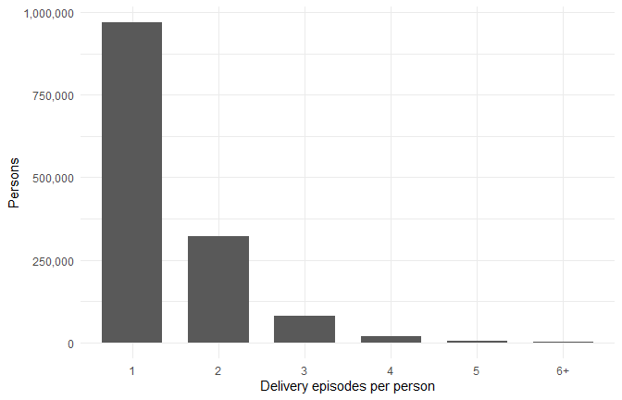
Figure 4
n_ep | n_persons | pct
1 | 969,080 | 69.2%
2 | 322,077 | 23.0%
3 | 81,204 | 5.8%
4 | 20,148 | 1.4%
5 | 4,919 | 0.4%
6 | 1,494 | 0.1%
7 | 535 | 0.0%
8 | 280 | 0.0%
9 | 189 | 0.0%
10 | 144 | 0.0%
11 | 108 | 0.0%
12 | 82 | 0.0%
13 | 58 | 0.0%
14 | 32 | 0.0%
15 | 27 | 0.0%

Gaps between pregnancies
Interval between consecutive delivery_dt values for people with more than one episode.
Full range, capped at five years.
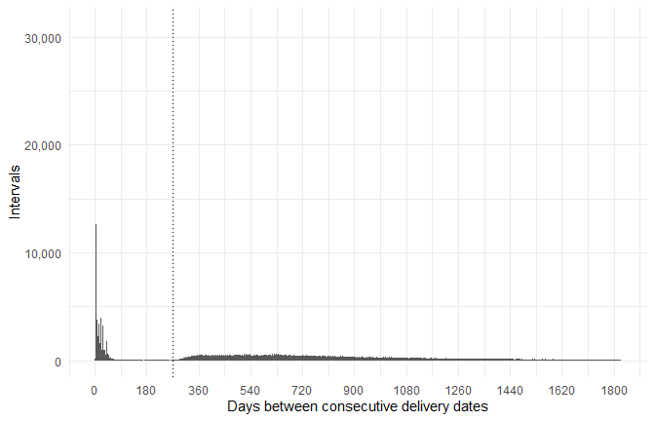
Figure 5
First year only, where the implausible intervals sit.
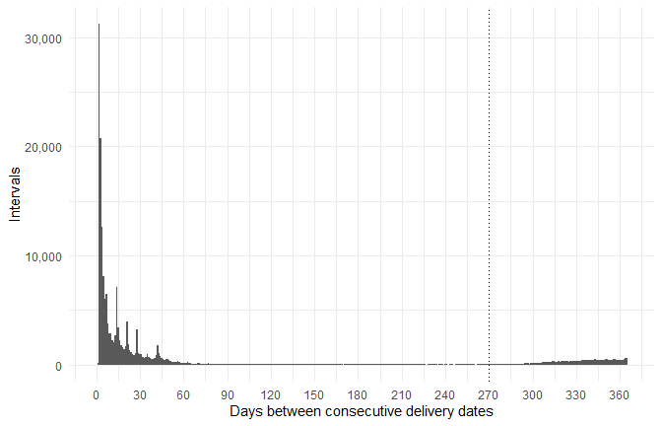
Figure 6
band | n_intervals | pct
Under 30 days | 136,591 | 23.4%
30-89 days | 20,275 | 3.5%
90-179 days | 3,086 | 0.5%
180-269 days | 2,283 | 0.4%
270+ days | 422,407 | 72.3%

If you only include CPT deliveries, does the weird gaps go away?
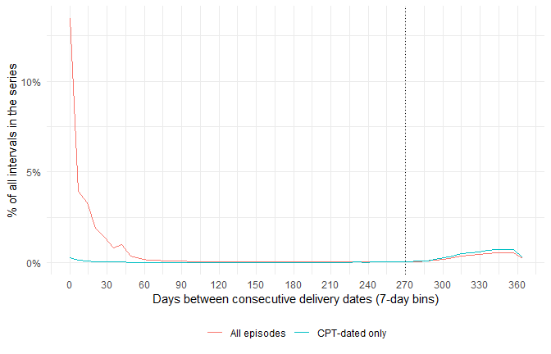
Figure 7

Vital statistics
pipeline | year | n | vital_n | diff | pct_diff
Deliveries (babies) | 2,019 | 262,805 | 377,599 | -114,794 | -30.4%
Deliveries (babies) | 2,020 | 261,939 | 368,190 | -106,251 | -28.9%
Deliveries (babies) | 2,021 | 266,234 | 373,594 | -107,360 | -28.7%
Deliveries (babies) | 2,022 | 276,385 | 389,741 | -113,356 | -29.1%
Deliveries (babies) | 2,023 | 273,857 | 387,945 | -114,088 | -29.4%
Deliveries (babies) | 2,024 | 269,276 | 390,828 | -121,552 | -31.1%
Deliveries (babies) | 2,025 | 244,737
Infants (30-day claim) | 2,019 | 237,287 | 377,599 | -140,312 | -37.2%
Infants (30-day claim) | 2,020 | 232,848 | 368,190 | -135,342 | -36.8%
Infants (30-day claim) | 2,021 | 234,179 | 373,594 | -139,415 | -37.3%
Infants (30-day claim) | 2,022 | 242,677 | 389,741 | -147,064 | -37.7%
Infants (30-day claim) | 2,023 | 239,406 | 387,945 | -148,539 | -38.3%
Infants (30-day claim) | 2,024 | 233,088 | 390,828 | -157,740 | -40.4%
Infants (30-day claim) | 2,025 | 229,251
Percent difference from vital statistics, by category.
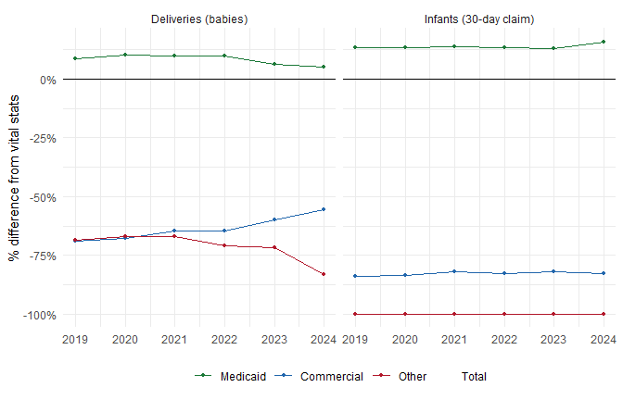
Figure 8

Excel export
Wrote O:/colour/analysis/infant_delivery_counts.xlsx

