POEM TX Paper 1

2025-08-05

This is after restricting enrollment to “Regular” using the me_code variable.

# Table 1

|  | **Overall** | **By Condition** | |
| --- | --- | --- | --- |
| **Characteristic** | **N = 144,2201** | **Diabetes, N = 68,3801** | **Hypertension, N = 97,2621** |
| Birth Outcome |  |  |  |
| LB | 143,020 (99%) | 67,784 (99%) | 96,405 (99%) |
| SB | 1,200 (0.8%) | 596 (0.9%) | 857 (0.9%) |
| Year |  |  |  |
| 2019 | 35,242 (24%) | 16,702 (24%) | 23,529 (24%) |
| 2020 | 39,143 (27%) | 18,777 (27%) | 26,219 (27%) |
| 2021 | 41,458 (29%) | 19,841 (29%) | 27,891 (29%) |
| 2022 | 28,377 (20%) | 13,060 (19%) | 19,623 (20%) |
| Race/Ethnicity |  |  |  |
| American Indian or Alaskan | 337 (0.2%) | 162 (0.2%) | 229 (0.2%) |
| Asian, Pacific Islander | 2,641 (1.8%) | 1,952 (2.9%) | 1,030 (1.1%) |
| Black, non-Hispanic | 29,667 (21%) | 9,745 (14%) | 24,076 (25%) |
| Hispanic | 74,309 (52%) | 41,107 (60%) | 45,088 (46%) |
| Unknown/Other | 6,470 (4.5%) | 2,745 (4.0%) | 4,666 (4.8%) |
| White, non-Hispanic | 30,796 (21%) | 12,669 (19%) | 22,173 (23%) |
| Age Group |  |  |  |
| 19-24 | 41,512 (29%) | 14,783 (22%) | 30,612 (31%) |
| 25-34 | 77,882 (54%) | 38,769 (57%) | 50,891 (52%) |
| 35-44 | 24,437 (17%) | 14,576 (21%) | 15,507 (16%) |
| 45-55 | 389 (0.3%) | 252 (0.4%) | 252 (0.3%) |
| Hispanic | 74,309 (52%) | 41,107 (60%) | 45,088 (46%) |
| Index SMM Weight | 18 (18, 29) | 18 (18, 29) | 18 (18, 30) |
| Index No Transfusion Weight | 12 (12, 19) | 12 (12, 19) | 12 (12, 19) |
| *1n (%); Median (IQR)* | | | |

# Outcomes

## Graphs

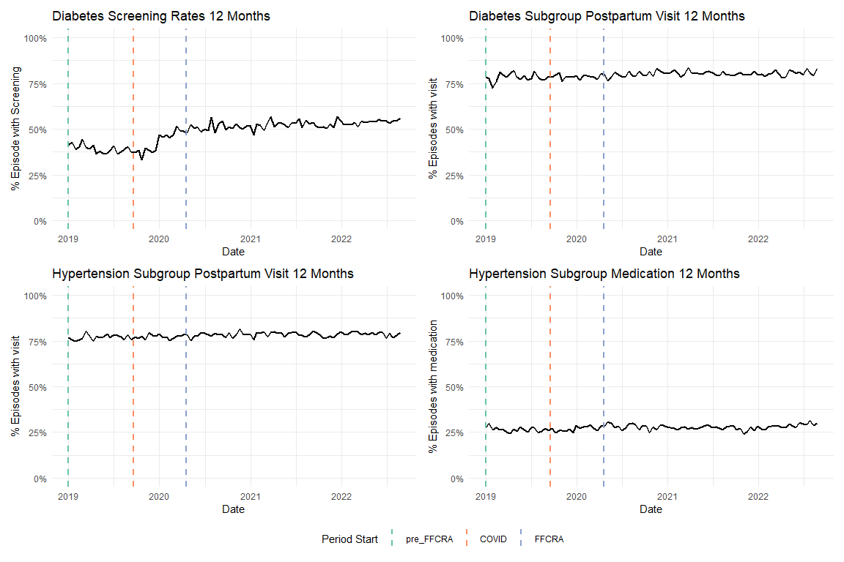

# Outpatient

## Share of Categories

This is based on the chart in the appendix we got the categories from

| **type_care** | **share_of_visits** |
| --- | --- |
| Other acute or chronic illness only | 58.7 |
| Contraceptive management only | 10.5 |
| Mental/behavioral health care only | 9.5 |
| Postpartum evaluation only | 8.0 |
| Preventive/well care only | 7.7 |
| Postpartum & Contraceptive | 3.3 |
| Preventive/well & Contraceptive | 1.0 |
| Contraceptive & Mental/behavioral health care | 0.5 |
| Postpartum & mental/behavioral health care | 0.3 |
| Other combination | 0.2 |
| Preventive/well & mental/behavioral health | 0.2 |
| Postpartum & Preventive/well | 0.1 |

## % Who had any visit (0/1 Indicator)

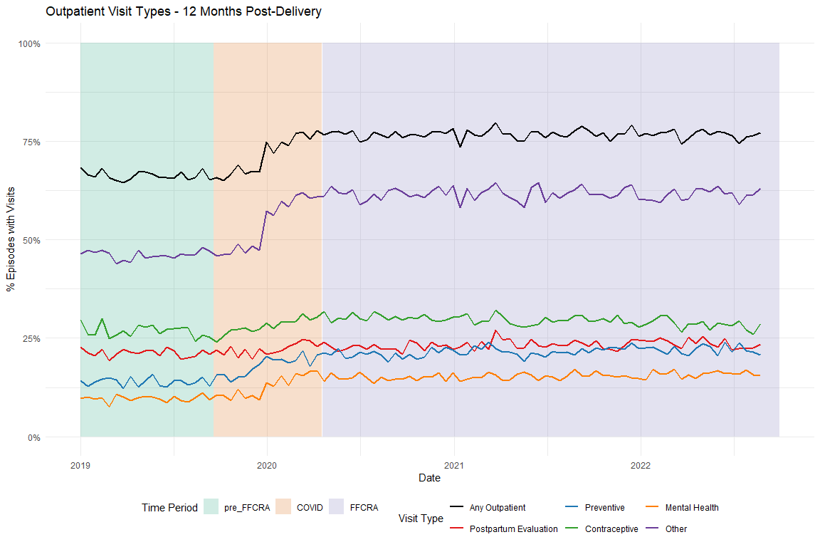

## Average Visits per Person

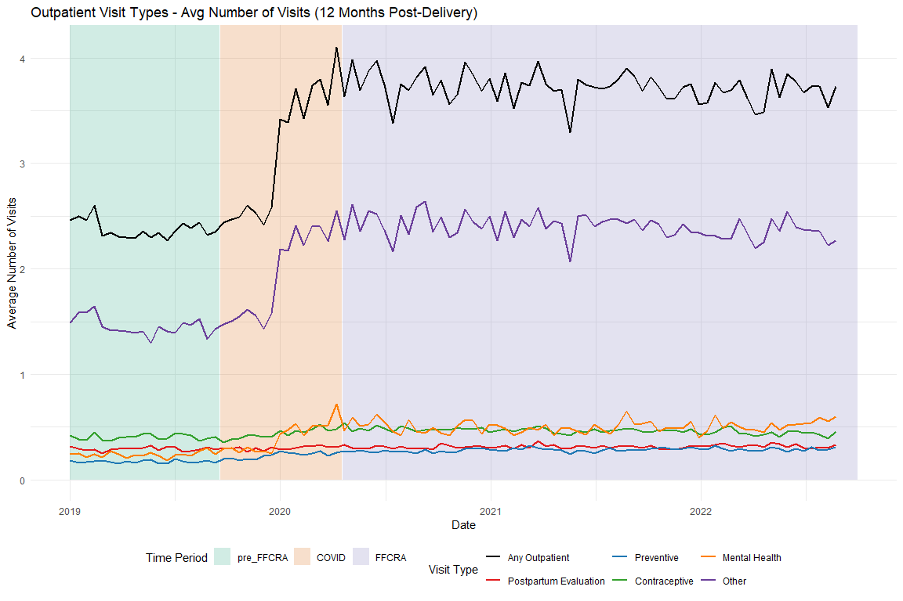

# Regression Models

## Diabetes Screening

Unadjusted

| Characteristic | Beta | 95% CI1 | p-value |
| --- | --- | --- | --- |
| (Intercept) | 0.4121 | 0.3924, 0.4317 | <0.001 |
| biweekly_counter | -0.0020 | -0.0036, -0.0003 | 0.022 |
| period_COVID | -0.2699 | -0.3330, -0.2069 | <0.001 |
| period_FFCRA | 0.0711 | 0.0450, 0.0973 | <0.001 |
| biweekly_counter * period_COVID | 0.0126 | 0.0098, 0.0154 | <0.001 |
| biweekly_counter * period_FFCRA | 0.0026 | 0.0009, 0.0043 | 0.003 |
| 1CI = Confidence Interval | | | |

Adjusted

| Characteristic | Beta | 95% CI1 | p-value |
| --- | --- | --- | --- |
| (Intercept) | 0.2892 | 0.2615, 0.3170 | <0.001 |
| biweekly_counter | -0.0033 | -0.0050, -0.0016 | <0.001 |
| period_COVID | -0.2874 | -0.3500, -0.2248 | <0.001 |
| period_FFCRA | 0.0550 | 0.0290, 0.0810 | <0.001 |
| Age | 0.0006 | 0.0000, 0.0013 | 0.055 |
| Index No Transfusion Weight | 0.0087 | 0.0081, 0.0092 | <0.001 |
| biweekly_counter * period_COVID | 0.0139 | 0.0111, 0.0166 | <0.001 |
| biweekly_counter * period_FFCRA | 0.0038 | 0.0022, 0.0055 | <0.001 |
| 1CI = Confidence Interval | | | |

## Diabetes Postpartum Visits

Unadjusted

| Characteristic | Beta | 95% CI1 | p-value |
| --- | --- | --- | --- |
| (Intercept) | 0.7789 | 0.7630, 0.7948 | <0.001 |
| biweekly_counter | 0.0005 | -0.0009, 0.0018 | 0.50 |
| period_COVID | 0.0106 | -0.0404, 0.0616 | 0.68 |
| period_FFCRA | 0.0159 | -0.0053, 0.0370 | 0.14 |
| biweekly_counter * period_COVID | -0.0006 | -0.0028, 0.0017 | 0.63 |
| biweekly_counter * period_FFCRA | -0.0003 | -0.0017, 0.0010 | 0.64 |
| 1CI = Confidence Interval | | | |

Adjusted

| Characteristic | Beta | 95% CI1 | p-value |
| --- | --- | --- | --- |
| (Intercept) | 0.7686 | 0.7460, 0.7912 | <0.001 |
| biweekly_counter | -0.0002 | -0.0016, 0.0011 | 0.74 |
| period_COVID | -0.0010 | -0.0519, 0.0499 | 0.97 |
| period_FFCRA | 0.0068 | -0.0143, 0.0279 | 0.53 |
| Age | -0.0013 | -0.0018, -0.0007 | <0.001 |
| Index No Transfusion Weight | 0.0040 | 0.0036, 0.0045 | <0.001 |
| biweekly_counter * period_COVID | 0.0002 | -0.0020, 0.0025 | 0.86 |
| biweekly_counter * period_FFCRA | 0.0003 | -0.0010, 0.0017 | 0.62 |
| 1CI = Confidence Interval | | | |

## HTN Medication

Unadjusted

| Characteristic | Beta | 95% CI1 | p-value |
| --- | --- | --- | --- |
| (Intercept) | 0.2731 | 0.2584, 0.2877 | <0.001 |
| biweekly_counter | -0.0007 | -0.0020, 0.0005 | 0.25 |
| period_COVID | -0.0473 | -0.0949, 0.0003 | 0.052 |
| period_FFCRA | 0.0012 | -0.0184, 0.0209 | 0.90 |
| biweekly_counter * period_COVID | 0.0024 | 0.0003, 0.0045 | 0.027 |
| biweekly_counter * period_FFCRA | 0.0008 | -0.0005, 0.0021 | 0.21 |
| 1CI = Confidence Interval | | | |

Adjusted

| Characteristic | Beta | 95% CI1 | p-value |
| --- | --- | --- | --- |
| (Intercept) | -0.2536 | -0.2731, -0.2341 | <0.001 |
| biweekly_counter | -0.0020 | -0.0032, -0.0008 | 0.001 |
| period_COVID | -0.0530 | -0.0990, -0.0069 | 0.024 |
| period_FFCRA | -0.0113 | -0.0303, 0.0077 | 0.24 |
| Age | 0.0154 | 0.0149, 0.0159 | <0.001 |
| Index No Transfusion Weight | 0.0078 | 0.0074, 0.0082 | <0.001 |
| biweekly_counter * period_COVID | 0.0031 | 0.0011, 0.0052 | 0.002 |
| biweekly_counter * period_FFCRA | 0.0020 | 0.0007, 0.0032 | 0.002 |
| 1CI = Confidence Interval | | | |

## HTN Postpartum Visits

Unadjusted

| Characteristic | Beta | 95% CI1 | p-value |
| --- | --- | --- | --- |
| (Intercept) | 0.7634 | 0.7499, 0.7770 | <0.001 |
| biweekly_counter | 0.0007 | -0.0005, 0.0018 | 0.27 |
| period_COVID | -0.0015 | -0.0456, 0.0426 | 0.95 |
| period_FFCRA | 0.0167 | -0.0014, 0.0349 | 0.071 |
| biweekly_counter * period_COVID | -0.0002 | -0.0022, 0.0017 | 0.81 |
| biweekly_counter * period_FFCRA | -0.0006 | -0.0018, 0.0006 | 0.34 |
| 1CI = Confidence Interval | | | |

Adjusted

| Characteristic | Beta | 95% CI1 | p-value |
| --- | --- | --- | --- |
| (Intercept) | 0.7821 | 0.7635, 0.8007 | <0.001 |
| biweekly_counter | -0.0004 | -0.0015, 0.0008 | 0.55 |
| period_COVID | -0.0183 | -0.0622, 0.0257 | 0.41 |
| period_FFCRA | 0.0046 | -0.0135, 0.0227 | 0.62 |
| Age | -0.0024 | -0.0028, -0.0019 | <0.001 |
| Index No Transfusion Weight | 0.0043 | 0.0039, 0.0046 | <0.001 |
| biweekly_counter * period_COVID | 0.0009 | -0.0011, 0.0028 | 0.38 |
| biweekly_counter * period_FFCRA | 0.0004 | -0.0008, 0.0016 | 0.50 |
| 1CI = Confidence Interval | | | |

# Sensitivity Analyses

## Time Periods

### Diabetes Screening (6-month)

|  | Original - Unadj | Alternative - Unadj | Original - Adj | Alternative - Adj |
| --- | --- | --- | --- | --- |
| Characteristic | Beta1 | Beta1 | Beta1 | Beta1 |
| (Intercept) | 0.412*** | 0.412*** | 0.289*** | 0.289*** |
| biweekly_counter | -0.002* | -0.002* | -0.003*** | -0.003*** |
| period_COVID | -0.270*** | -0.219*** | -0.287*** | -0.236*** |
| period_FFCRA | 0.071*** | 0.074*** | 0.055*** | 0.058*** |
| biweekly_counter * period_COVID | 0.013*** | 0.011*** | 0.014*** | 0.012*** |
| biweekly_counter * period_FFCRA | 0.003** | 0.003** | 0.004*** | 0.004*** |
| Age |  |  | 0.001 | 0.001 |
| Index No Transfusion Weight |  |  | 0.009*** | 0.009*** |
| 1*p<0.05; **p<0.01; ***p<0.001 | | | | |

### Diabetes Postpartum Visits (6-month)

|  | Original - Unadj | Alternative - Unadj | Original - Adj | Alternative - Adj |
| --- | --- | --- | --- | --- |
| Characteristic | Beta1 | Beta1 | Beta1 | Beta1 |
| (Intercept) | 0.779*** | 0.779*** | 0.769*** | 0.768*** |
| biweekly_counter | 0.000 | 0.000 | 0.000 | 0.000 |
| period_COVID | 0.011 | 0.000 | -0.001 | -0.011 |
| period_FFCRA | 0.016 | 0.021 | 0.007 | 0.012 |
| biweekly_counter * period_COVID | -0.001 | 0.000 | 0.000 | 0.001 |
| biweekly_counter * period_FFCRA | 0.000 | 0.000 | 0.000 | 0.000 |
| Age |  |  | -0.001*** | -0.001*** |
| Index No Transfusion Weight |  |  | 0.004*** | 0.004*** |
| 1*p<0.05; **p<0.01; ***p<0.001 | | | | |

### HTN Medication (6-month)

|  | Original - Unadj | Alternative - Unadj | Original - Adj | Alternative - Adj |
| --- | --- | --- | --- | --- |
| Characteristic | Beta1 | Beta1 | Beta1 | Beta1 |
| (Intercept) | 0.273*** | 0.273*** | -0.254*** | -0.253*** |
| biweekly_counter | -0.001 | -0.001 | -0.002** | -0.002** |
| period_COVID | -0.047 | -0.049** | -0.053* | -0.061*** |
| period_FFCRA | 0.001 | -0.008 | -0.011 | -0.018 |
| biweekly_counter * period_COVID | 0.002* | 0.002** | 0.003** | 0.003*** |
| biweekly_counter * period_FFCRA | 0.001 | 0.001 | 0.002** | 0.002** |
| Age |  |  | 0.015*** | 0.015*** |
| Index No Transfusion Weight |  |  | 0.008*** | 0.008*** |
| 1*p<0.05; **p<0.01; ***p<0.001 | | | | |

### HTN Postpartum Visits (6-month)

|  | Original - Unadj | Alternative - Unadj | Original - Adj | Alternative - Adj |
| --- | --- | --- | --- | --- |
| Characteristic | Beta1 | Beta1 | Beta1 | Beta1 |
| (Intercept) | 0.763*** | 0.763*** | 0.782*** | 0.782*** |
| biweekly_counter | 0.001 | 0.001 | 0.000 | 0.000 |
| period_COVID | -0.001 | -0.005 | -0.018 | -0.023 |
| period_FFCRA | 0.017 | 0.021* | 0.005 | 0.008 |
| biweekly_counter * period_COVID | 0.000 | 0.000 | 0.001 | 0.001 |
| biweekly_counter * period_FFCRA | -0.001 | -0.001 | 0.000 | 0.000 |
| Age |  |  | -0.002*** | -0.002*** |
| Index No Transfusion Weight |  |  | 0.004*** | 0.004*** |
| 1*p<0.05; **p<0.01; ***p<0.001 | | | | |

## Diabetes Subgroup Test Type Graphs

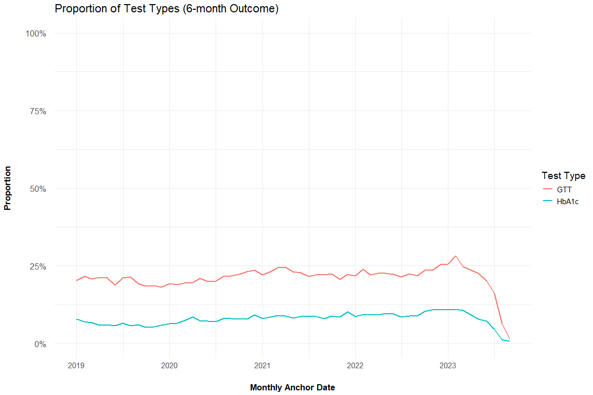

## Diabetes Test Type Models

### HbA1c Testing - Unadjusted

| HbA1c Test (6-month) - Unadjusted | Beta | 95% CI1 | p-value |
| --- | --- | --- | --- |
| (Intercept) | 0.1650 | 0.1487, 0.1814 | <0.001 |
| biweekly_counter | -0.0020 | -0.0034, -0.0006 | 0.005 |
| period_COVID | -0.2355 | -0.2879, -0.1832 | <0.001 |
| period_FFCRA | 0.0293 | 0.0076, 0.0510 | 0.008 |
| biweekly_counter * period_COVID | 0.0114 | 0.0090, 0.0137 | <0.001 |
| biweekly_counter * period_FFCRA | 0.0028 | 0.0014, 0.0042 | <0.001 |
| 1CI = Confidence Interval | | | |

### HbA1c Testing - Adjusted

| HbA1c Test (6-month) - Adjusted | Beta | 95% CI1 | p-value |
| --- | --- | --- | --- |
| (Intercept) | -0.0336 | -0.0566, -0.0106 | 0.004 |
| biweekly_counter | -0.0030 | -0.0044, -0.0016 | <0.001 |
| period_COVID | -0.2442 | -0.2961, -0.1924 | <0.001 |
| period_FFCRA | 0.0182 | -0.0033, 0.0398 | 0.10 |
| Age | 0.0036 | 0.0030, 0.0041 | <0.001 |
| Index No Transfusion Weight | 0.0076 | 0.0071, 0.0080 | <0.001 |
| biweekly_counter * period_COVID | 0.0122 | 0.0099, 0.0144 | <0.001 |
| biweekly_counter * period_FFCRA | 0.0038 | 0.0024, 0.0052 | <0.001 |
| 1CI = Confidence Interval | | | |

### GTT Testing - Unadjusted

| GTT Test (6-month) - Unadjusted | Beta | 95% CI1 | p-value |
| --- | --- | --- | --- |
| (Intercept) | 0.3860 | 0.3663, 0.4056 | <0.001 |
| biweekly_counter | -0.0016 | -0.0033, 0.0000 | 0.056 |
| period_COVID | -0.2620 | -0.3249, -0.1991 | <0.001 |
| period_FFCRA | 0.0788 | 0.0527, 0.1049 | <0.001 |
| biweekly_counter * period_COVID | 0.0122 | 0.0094, 0.0149 | <0.001 |
| biweekly_counter * period_FFCRA | 0.0022 | 0.0005, 0.0039 | 0.012 |
| 1CI = Confidence Interval | | | |

### GTT Testing - Adjusted

| GTT Test (6-month) - Adjusted | Beta | 95% CI1 | p-value |
| --- | --- | --- | --- |
| (Intercept) | 0.2662 | 0.2385, 0.2940 | <0.001 |
| biweekly_counter | -0.0029 | -0.0046, -0.0013 | <0.001 |
| period_COVID | -0.2793 | -0.3417, -0.2168 | <0.001 |
| period_FFCRA | 0.0630 | 0.0370, 0.0889 | <0.001 |
| Age | 0.0006 | -0.0001, 0.0012 | 0.074 |
| Index No Transfusion Weight | 0.0085 | 0.0080, 0.0090 | <0.001 |
| biweekly_counter * period_COVID | 0.0134 | 0.0106, 0.0162 | <0.001 |
| biweekly_counter * period_FFCRA | 0.0034 | 0.0017, 0.0051 | <0.001 |
| 1CI = Confidence Interval | | | |

## Combined Table Comparing All Models

|  | Overall (Unadj) | Overall (Adj) | HbA1c (Unadj) | HbA1c (Adj) | GTT (Unadj) | GTT (Adj) |
| --- | --- | --- | --- | --- | --- | --- |
| Characteristic | Beta1 | Beta1 | Beta1 | Beta1 | Beta1 | Beta1 |
| (Intercept) | 0.412*** | 0.289*** | 0.165*** | -0.034** | 0.386*** | 0.266*** |
| biweekly_counter | -0.002* | -0.003*** | -0.002** | -0.003*** | -0.002 | -0.003*** |
| period_COVID | -0.270*** | -0.287*** | -0.236*** | -0.244*** | -0.262*** | -0.279*** |
| period_FFCRA | 0.071*** | 0.055*** | 0.029** | 0.018 | 0.079*** | 0.063*** |
| biweekly_counter * period_COVID | 0.013*** | 0.014*** | 0.011*** | 0.012*** | 0.012*** | 0.013*** |
| biweekly_counter * period_FFCRA | 0.003** | 0.004*** | 0.003*** | 0.004*** | 0.002* | 0.003*** |
| Age |  | 0.001 |  | 0.004*** |  | 0.001 |
| Index No Transfusion Weight |  | 0.009*** |  | 0.008*** |  | 0.009*** |
| 1*p<0.05; **p<0.01; ***p<0.001 | | | | | | |

# Supplemental

