POEM TX Paper 1

2025-09-04

# Table 1

|  | **Overall** | **By Condition** | |
| --- | --- | --- | --- |
| **Characteristic** | **N = 187,3291** | **Diabetes, N = 88,1551** | **Hypertension, N = 127,1971** |
| Birth Outcome |  |  |  |
| LB | 185,895 (99%) | 87,444 (99%) | 126,177 (99%) |
| SB | 1,434 (0.8%) | 711 (0.8%) | 1,020 (0.8%) |
| Year |  |  |  |
| 2019 | 34,963 (19%) | 16,561 (19%) | 23,316 (18%) |
| 2020 | 38,875 (21%) | 18,642 (21%) | 26,031 (20%) |
| 2021 | 41,232 (22%) | 19,730 (22%) | 27,725 (22%) |
| 2022 | 43,391 (23%) | 20,102 (23%) | 29,926 (24%) |
| 2023 | 28,868 (15%) | 13,120 (15%) | 20,199 (16%) |
| Race/Ethnicity |  |  |  |
| American Indian or Alaskan | 449 (0.2%) | 208 (0.2%) | 310 (0.2%) |
| Asian, Pacific Islander | 3,428 (1.8%) | 2,507 (2.8%) | 1,380 (1.1%) |
| Black, non-Hispanic | 38,362 (20%) | 12,402 (14%) | 31,309 (25%) |
| Hispanic | 97,241 (52%) | 53,348 (61%) | 59,525 (47%) |
| Unknown/Other | 8,591 (4.6%) | 3,612 (4.1%) | 6,238 (4.9%) |
| White, non-Hispanic | 39,258 (21%) | 16,078 (18%) | 28,435 (22%) |
| Plan |  |  |  |
| FFS | 3,161 (1.7%) | 1,252 (1.4%) | 2,275 (1.8%) |
| STAR | 180,790 (97%) | 85,524 (97%) | 122,281 (96%) |
| STAR Health | 162 (<0.1%) | 49 (<0.1%) | 127 (<0.1%) |
| STAR Kids | 524 (0.3%) | 159 (0.2%) | 423 (0.3%) |
| STAR+PLUS | 2,692 (1.4%) | 1,171 (1.3%) | 2,091 (1.6%) |
| Dual | 0 (0%) | 0 (0%) | 0 (0%) |
| Age Group |  |  |  |
| 19-24 | 53,380 (28%) | 18,707 (21%) | 39,651 (31%) |
| 25-34 | 101,790 (54%) | 50,230 (57%) | 67,020 (53%) |
| 35-44 | 31,674 (17%) | 18,906 (21%) | 20,201 (16%) |
| 45-55 | 485 (0.3%) | 312 (0.4%) | 325 (0.3%) |
| Hispanic | 97,241 (52%) | 53,348 (61%) | 59,525 (47%) |
| Index SMM Weight | 18 (18, 30) | 18 (18, 29) | 18 (18, 30) |
| Index No Transfusion Weight | 12 (12, 19) | 12 (12, 19) | 12 (12, 19) |
| *1n (%); Median (IQR)* | | | |

# Outcomes

## Graphs

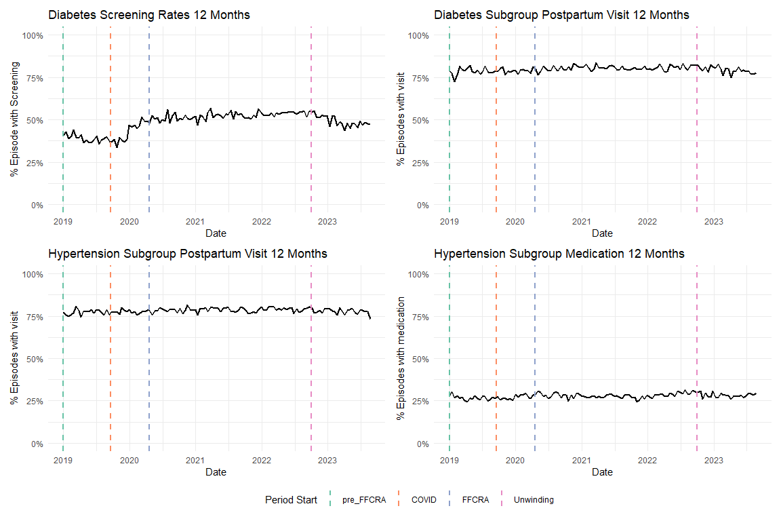

# Outpatient

## Share of Categories

This is based on the chart in the appendix we got the categories from

| **type_care** | **share_of_visits** |
| --- | --- |
| Other acute or chronic illness only | 58.2 |
| Contraceptive management only | 10.3 |
| Mental/behavioral health care only | 9.6 |
| Postpartum evaluation only | 8.4 |
| Preventive/well care only | 7.7 |
| Postpartum & Contraceptive | 3.3 |
| Preventive/well & Contraceptive | 1.0 |
| Contraceptive & Mental/behavioral health care | 0.5 |
| Postpartum & mental/behavioral health care | 0.3 |
| Other combination | 0.2 |
| Preventive/well & mental/behavioral health | 0.2 |
| Postpartum & Preventive/well | 0.1 |

## % Who had any visit (0/1 Indicator)

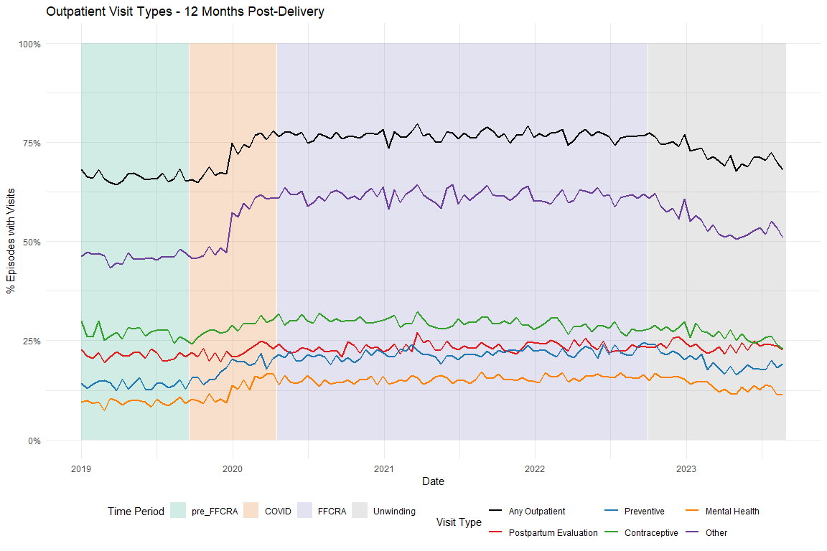

## Average Visits per Person

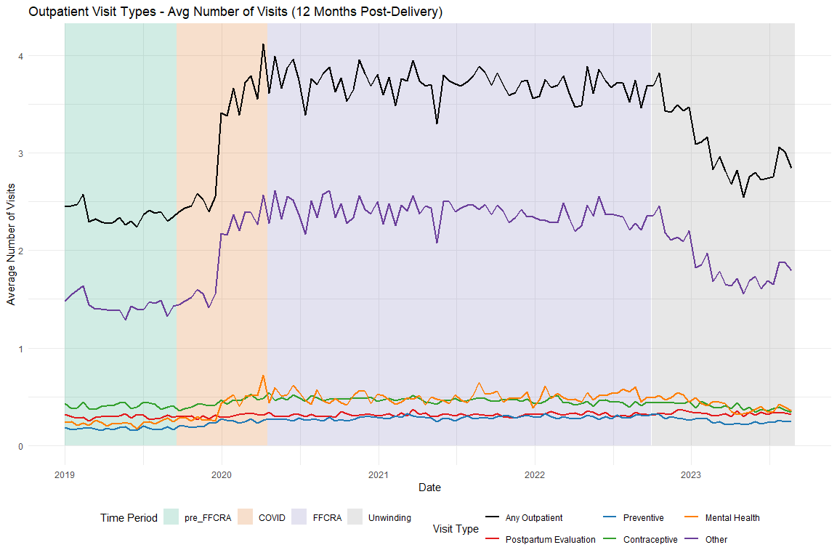

# Regression Models

## Diabetes Screening

Unadjusted

| Characteristic | Beta | 95% CI1 | p-value |
| --- | --- | --- | --- |
| (Intercept) | 0.4106 | 0.3908, 0.4304 | <0.001 |
| biweekly_counter | -0.0020 | -0.0036, -0.0003 | 0.023 |
| period_COVID | -0.2725 | -0.3358, -0.2091 | <0.001 |
| period_FFCRA | 0.0736 | 0.0477, 0.0995 | <0.001 |
| period_Unwinding | 0.4369 | 0.3228, 0.5510 | <0.001 |
| biweekly_counter * period_COVID | 0.0127 | 0.0099, 0.0155 | <0.001 |
| biweekly_counter * period_FFCRA | 0.0026 | 0.0009, 0.0043 | 0.003 |
| biweekly_counter * period_Unwinding | -0.0013 | -0.0032, 0.0007 | 0.21 |
| 1CI = Confidence Interval | | | |

Adjusted

| Characteristic | Beta | 95% CI1 | p-value |
| --- | --- | --- | --- |
| (Intercept) | 0.2897 | 0.2634, 0.3160 | <0.001 |
| biweekly_counter | -0.0033 | -0.0050, -0.0017 | <0.001 |
| period_COVID | -0.2903 | -0.3532, -0.2273 | <0.001 |
| period_FFCRA | 0.0563 | 0.0305, 0.0820 | <0.001 |
| period_Unwinding | 0.4243 | 0.3110, 0.5375 | <0.001 |
| Age | 0.0005 | 0.0000, 0.0011 | 0.061 |
| Index No Transfusion Weight | 0.0087 | 0.0083, 0.0092 | <0.001 |
| biweekly_counter * period_COVID | 0.0140 | 0.0112, 0.0168 | <0.001 |
| biweekly_counter * period_FFCRA | 0.0039 | 0.0022, 0.0056 | <0.001 |
| biweekly_counter * period_Unwinding | 0.0000 | -0.0019, 0.0020 | 0.99 |
| 1CI = Confidence Interval | | | |

## Diabetes Postpartum Visits

Unadjusted

| Characteristic | Beta | 95% CI1 | p-value |
| --- | --- | --- | --- |
| (Intercept) | 0.7799 | 0.7640, 0.7959 | <0.001 |
| biweekly_counter | 0.0005 | -0.0008, 0.0019 | 0.44 |
| period_COVID | 0.0098 | -0.0413, 0.0610 | 0.71 |
| period_FFCRA | 0.0145 | -0.0064, 0.0354 | 0.17 |
| period_Unwinding | 0.1806 | 0.0886, 0.2727 | <0.001 |
| biweekly_counter * period_COVID | -0.0006 | -0.0028, 0.0017 | 0.62 |
| biweekly_counter * period_FFCRA | -0.0004 | -0.0017, 0.0010 | 0.60 |
| biweekly_counter * period_Unwinding | -0.0020 | -0.0036, -0.0005 | 0.012 |
| 1CI = Confidence Interval | | | |

Adjusted

| Characteristic | Beta | 95% CI1 | p-value |
| --- | --- | --- | --- |
| (Intercept) | 0.7655 | 0.7442, 0.7868 | <0.001 |
| biweekly_counter | -0.0002 | -0.0016, 0.0011 | 0.75 |
| period_COVID | -0.0024 | -0.0535, 0.0486 | 0.93 |
| period_FFCRA | 0.0044 | -0.0165, 0.0252 | 0.68 |
| period_Unwinding | 0.1699 | 0.0781, 0.2617 | <0.001 |
| Age | -0.0013 | -0.0017, -0.0008 | <0.001 |
| Index No Transfusion Weight | 0.0044 | 0.0040, 0.0048 | <0.001 |
| biweekly_counter * period_COVID | 0.0002 | -0.0020, 0.0025 | 0.84 |
| biweekly_counter * period_FFCRA | 0.0004 | -0.0010, 0.0017 | 0.60 |
| biweekly_counter * period_Unwinding | -0.0013 | -0.0029, 0.0003 | 0.11 |
| 1CI = Confidence Interval | | | |

## HTN Medication

Unadjusted

| Characteristic | Beta | 95% CI1 | p-value |
| --- | --- | --- | --- |
| (Intercept) | 0.2758 | 0.2610, 0.2906 | <0.001 |
| biweekly_counter | -0.0008 | -0.0021, 0.0005 | 0.21 |
| period_COVID | -0.0464 | -0.0944, 0.0017 | 0.058 |
| period_FFCRA | -0.0029 | -0.0224, 0.0166 | 0.77 |
| period_Unwinding | 0.0281 | -0.0564, 0.1126 | 0.51 |
| biweekly_counter * period_COVID | 0.0024 | 0.0003, 0.0045 | 0.028 |
| biweekly_counter * period_FFCRA | 0.0009 | -0.0004, 0.0022 | 0.15 |
| biweekly_counter * period_Unwinding | 0.0006 | -0.0009, 0.0021 | 0.41 |
| 1CI = Confidence Interval | | | |

Adjusted

| Characteristic | Beta | 95% CI1 | p-value |
| --- | --- | --- | --- |
| (Intercept) | -0.2543 | -0.2728, -0.2358 | <0.001 |
| biweekly_counter | -0.0022 | -0.0034, -0.0009 | <0.001 |
| period_COVID | -0.0528 | -0.0993, -0.0064 | 0.026 |
| period_FFCRA | -0.0172 | -0.0360, 0.0017 | 0.075 |
| period_Unwinding | 0.0391 | -0.0426, 0.1208 | 0.35 |
| Age | 0.0154 | 0.0150, 0.0158 | <0.001 |
| Index No Transfusion Weight | 0.0082 | 0.0079, 0.0085 | <0.001 |
| biweekly_counter * period_COVID | 0.0032 | 0.0012, 0.0053 | 0.002 |
| biweekly_counter * period_FFCRA | 0.0022 | 0.0009, 0.0034 | <0.001 |
| biweekly_counter * period_Unwinding | 0.0016 | 0.0002, 0.0031 | 0.026 |
| 1CI = Confidence Interval | | | |

## HTN Postpartum Visits

Unadjusted

| Characteristic | Beta | 95% CI1 | p-value |
| --- | --- | --- | --- |
| (Intercept) | 0.7656 | 0.7520, 0.7792 | <0.001 |
| biweekly_counter | 0.0007 | -0.0005, 0.0018 | 0.27 |
| period_COVID | 0.0023 | -0.0419, 0.0465 | 0.92 |
| period_FFCRA | 0.0140 | -0.0040, 0.0319 | 0.13 |
| period_Unwinding | 0.0670 | -0.0108, 0.1448 | 0.091 |
| biweekly_counter * period_COVID | -0.0004 | -0.0023, 0.0016 | 0.69 |
| biweekly_counter * period_FFCRA | -0.0005 | -0.0017, 0.0006 | 0.37 |
| biweekly_counter * period_Unwinding | -0.0012 | -0.0025, 0.0002 | 0.10 |
| 1CI = Confidence Interval | | | |

Adjusted

| Characteristic | Beta | 95% CI1 | p-value |
| --- | --- | --- | --- |
| (Intercept) | 0.7798 | 0.7622, 0.7974 | <0.001 |
| biweekly_counter | -0.0004 | -0.0016, 0.0007 | 0.46 |
| period_COVID | -0.0157 | -0.0597, 0.0284 | 0.49 |
| period_FFCRA | 0.0005 | -0.0174, 0.0184 | 0.96 |
| period_Unwinding | 0.0493 | -0.0281, 0.1268 | 0.21 |
| Age | -0.0024 | -0.0028, -0.0020 | <0.001 |
| Index No Transfusion Weight | 0.0047 | 0.0044, 0.0050 | <0.001 |
| biweekly_counter * period_COVID | 0.0008 | -0.0012, 0.0027 | 0.43 |
| biweekly_counter * period_FFCRA | 0.0005 | -0.0007, 0.0017 | 0.38 |
| biweekly_counter * period_Unwinding | 0.0000 | -0.0014, 0.0013 | 0.97 |
| 1CI = Confidence Interval | | | |

# Sensitivity Analyses

## Time Periods

### Diabetes Screening

|  | Original - Unadj | Alternative - Unadj | Original - Adj | Alternative - Adj |
| --- | --- | --- | --- | --- |
| Characteristic | Beta1 | Beta1 | Beta1 | Beta1 |
| (Intercept) | 0.411*** | 0.411*** | 0.290*** | 0.289*** |
| biweekly_counter | -0.002* | -0.002* | -0.003*** | -0.003*** |
| period_COVID | -0.272*** | -0.221*** | -0.290*** | -0.238*** |
| period_FFCRA | 0.074*** | 0.076*** | 0.056*** | 0.060*** |
| period_Unwinding | 0.437*** | 0.437*** | 0.424*** | 0.424*** |
| biweekly_counter * period_COVID | 0.013*** | 0.011*** | 0.014*** | 0.012*** |
| biweekly_counter * period_FFCRA | 0.003** | 0.003** | 0.004*** | 0.004*** |
| biweekly_counter * period_Unwinding | -0.001 | -0.001 | 0.000 | 0.000 |
| Age |  |  | 0.001 | 0.001 |
| Index No Transfusion Weight |  |  | 0.009*** | 0.009*** |
| 1*p<0.05; **p<0.01; ***p<0.001 | | | | |

### Diabetes Postpartum Visits

|  | Original - Unadj | Alternative - Unadj | Original - Adj | Alternative - Adj |
| --- | --- | --- | --- | --- |
| Characteristic | Beta1 | Beta1 | Beta1 | Beta1 |
| (Intercept) | 0.780*** | 0.780*** | 0.765*** | 0.765*** |
| biweekly_counter | 0.001 | 0.001 | 0.000 | 0.000 |
| period_COVID | 0.010 | 0.000 | -0.002 | -0.012 |
| period_FFCRA | 0.015 | 0.019 | 0.004 | 0.009 |
| period_Unwinding | 0.181*** | 0.181*** | 0.170*** | 0.170*** |
| biweekly_counter * period_COVID | -0.001 | 0.000 | 0.000 | 0.001 |
| biweekly_counter * period_FFCRA | 0.000 | 0.000 | 0.000 | 0.000 |
| biweekly_counter * period_Unwinding | -0.002* | -0.002* | -0.001 | -0.001 |
| Age |  |  | -0.001*** | -0.001*** |
| Index No Transfusion Weight |  |  | 0.004*** | 0.004*** |
| 1*p<0.05; **p<0.01; ***p<0.001 | | | | |

### HTN Medication

|  | Original - Unadj | Alternative - Unadj | Original - Adj | Alternative - Adj |
| --- | --- | --- | --- | --- |
| Characteristic | Beta1 | Beta1 | Beta1 | Beta1 |
| (Intercept) | 0.276*** | 0.276*** | -0.254*** | -0.254*** |
| biweekly_counter | -0.001 | -0.001 | -0.002*** | -0.002*** |
| period_COVID | -0.046 | -0.049** | -0.053* | -0.061*** |
| period_FFCRA | -0.003 | -0.012 | -0.017 | -0.025* |
| period_Unwinding | 0.028 | 0.028 | 0.039 | 0.039 |
| biweekly_counter * period_COVID | 0.002* | 0.003** | 0.003** | 0.004*** |
| biweekly_counter * period_FFCRA | 0.001 | 0.001 | 0.002*** | 0.002*** |
| biweekly_counter * period_Unwinding | 0.001 | 0.001 | 0.002* | 0.002* |
| Age |  |  | 0.015*** | 0.015*** |
| Index No Transfusion Weight |  |  | 0.008*** | 0.008*** |
| 1*p<0.05; **p<0.01; ***p<0.001 | | | | |

### HTN Postpartum Visits

|  | Original - Unadj | Alternative - Unadj | Original - Adj | Alternative - Adj |
| --- | --- | --- | --- | --- |
| Characteristic | Beta1 | Beta1 | Beta1 | Beta1 |
| (Intercept) | 0.766*** | 0.766*** | 0.780*** | 0.780*** |
| biweekly_counter | 0.001 | 0.001 | 0.000 | 0.000 |
| period_COVID | 0.002 | -0.004 | -0.016 | -0.023 |
| period_FFCRA | 0.014 | 0.017 | 0.000 | 0.003 |
| period_Unwinding | 0.067 | 0.067 | 0.049 | 0.049 |
| biweekly_counter * period_COVID | 0.000 | 0.000 | 0.001 | 0.001 |
| biweekly_counter * period_FFCRA | -0.001 | -0.001 | 0.001 | 0.000 |
| biweekly_counter * period_Unwinding | -0.001 | -0.001 | 0.000 | 0.000 |
| Age |  |  | -0.002*** | -0.002*** |
| Index No Transfusion Weight |  |  | 0.005*** | 0.005*** |
| 1*p<0.05; **p<0.01; ***p<0.001 | | | | |

## Diabetes Subgroup Exclude Pre-existing

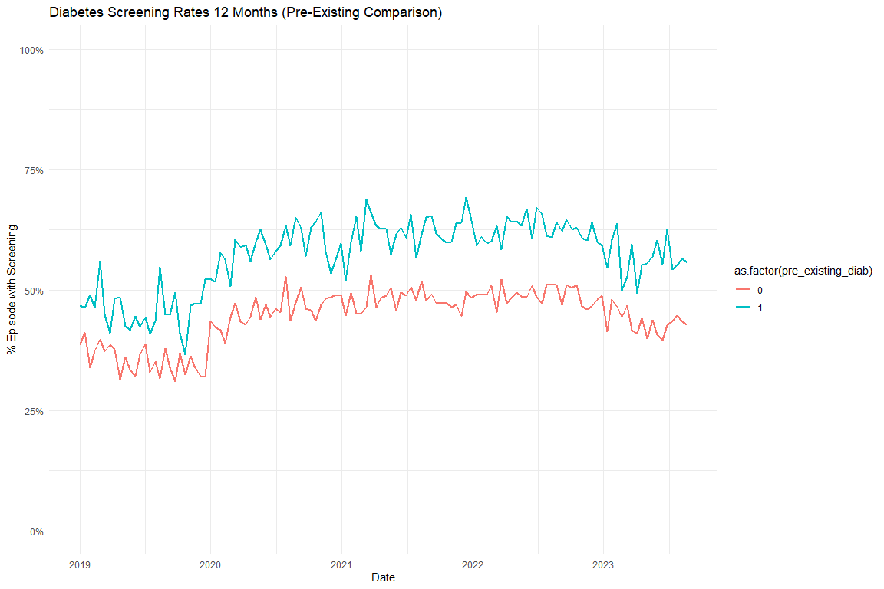

### Models

### Diabetes Screening Unadjusted

|  | Full Sample | Excluding Pre-Existing Diabetes |
| --- | --- | --- |
| Characteristic | Beta1 | Beta1 |
| (Intercept) | 0.411*** | 0.385*** |
| biweekly_counter | -0.002* | -0.003* |
| period_COVID | -0.272*** | -0.246*** |
| period_FFCRA | 0.074*** | 0.063*** |
| period_Unwinding | 0.437*** | 0.428*** |
| biweekly_counter * period_COVID | 0.013*** | 0.012*** |
| biweekly_counter * period_FFCRA | 0.003** | 0.003** |
| biweekly_counter * period_Unwinding | -0.001 | -0.001 |
| 1*p<0.05; **p<0.01; ***p<0.001 | | |

### Diabetes Screening Adjusted

|  | Full Sample | Excluding Pre-Existing Diabetes |
| --- | --- | --- |
| Characteristic | Beta1 | Beta1 |
| (Intercept) | 0.290*** | 0.320*** |
| biweekly_counter | -0.003*** | -0.004*** |
| period_COVID | -0.290*** | -0.263*** |
| period_FFCRA | 0.056*** | 0.047** |
| period_Unwinding | 0.424*** | 0.416*** |
| Age | 0.001 | 0.000 |
| Index No Transfusion Weight | 0.009*** | 0.007*** |
| biweekly_counter * period_COVID | 0.014*** | 0.013*** |
| biweekly_counter * period_FFCRA | 0.004*** | 0.004*** |
| biweekly_counter * period_Unwinding | 0.000 | 0.000 |
| 1*p<0.05; **p<0.01; ***p<0.001 | | |

## Diabetes Subgroup Test Type Graphs

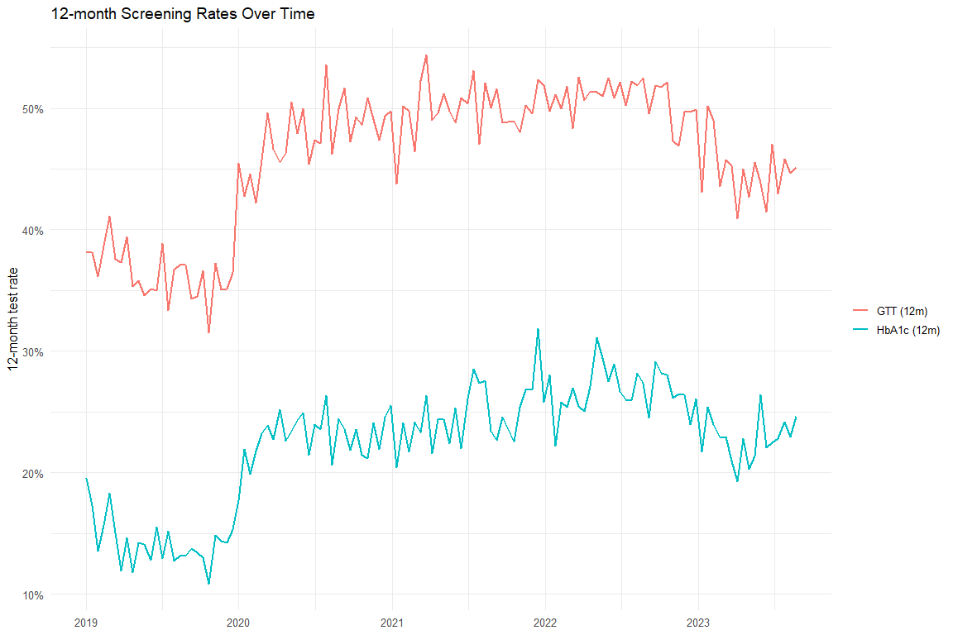

## Diabetes Test Type Models

|  | Overall (Unadj) | Overall (Adj) | HbA1c (Unadj) | HbA1c (Adj) | GTT (Unadj) | GTT (Adj) |
| --- | --- | --- | --- | --- | --- | --- |
| Characteristic | Beta1 | Beta1 | Beta1 | Beta1 | Beta1 | Beta1 |
| (Intercept) | 0.411*** | 0.290*** | 0.165*** | -0.032** | 0.385*** | 0.269*** |
| biweekly_counter | -0.002* | -0.003*** | -0.002** | -0.003*** | -0.002 | -0.003*** |
| period_COVID | -0.272*** | -0.290*** | -0.239*** | -0.248*** | -0.265*** | -0.283*** |
| period_FFCRA | 0.074*** | 0.056*** | 0.031** | 0.019 | 0.081*** | 0.064*** |
| period_Unwinding | 0.437*** | 0.424*** | 0.299*** | 0.297*** | 0.413*** | 0.400*** |
| biweekly_counter * period_COVID | 0.013*** | 0.014*** | 0.012*** | 0.012*** | 0.012*** | 0.014*** |
| biweekly_counter * period_FFCRA | 0.003** | 0.004*** | 0.003*** | 0.004*** | 0.002* | 0.003*** |
| biweekly_counter * period_Unwinding | -0.001 | 0.000 | 0.000 | 0.001 | -0.001 | 0.000 |
| Age |  | 0.001 |  | 0.004*** |  | 0.000 |
| Index No Transfusion Weight |  | 0.009*** |  | 0.008*** |  | 0.009*** |
| 1*p<0.05; **p<0.01; ***p<0.001 | | | | | | |

## Excluding COVID

[1] "diab_screen_unadj_nocovid_reidx"

[1] "diab_screen_adj_nocovid_reidx"

[1] "diab_postpartum_unadj_nocovid_reidx"

[1] "diab_postpartum_adj_nocovid_reidx"

[1] "htn_med_unadj_nocovid_reidx"

[1] "htn_med_adj_nocovid_reidx"

[1] "htn_postpartum_unadj_nocovid_reidx"

[1] "htn_postpartum_adj_nocovid_reidx"

### Diabetes Screening

|  | Original - Unadj | No-COVID (reindexed) - Unadj | Original - Adj | No-COVID (reindexed) - Adj |
| --- | --- | --- | --- | --- |
| Characteristic | Beta1 | Beta1 | Beta1 | Beta1 |
| (Intercept) | 0.411*** | 0.411*** | 0.290*** | 0.288*** |
| biweekly_counter | -0.002* | -0.002* | -0.003*** | -0.003*** |
| period_COVID | -0.272*** |  | -0.290*** |  |
| period_FFCRA | 0.074*** | 0.082*** | 0.056*** | 0.064*** |
| period_Unwinding | 0.437*** | 0.391*** | 0.424*** | 0.377*** |
| biweekly_counter * period_COVID | 0.013*** |  | 0.014*** |  |
| biweekly_counter * period_FFCRA | 0.003** | 0.003** | 0.004*** | 0.004*** |
| biweekly_counter * period_Unwinding | -0.001 | -0.001 | 0.000 | 0.000 |
| Age |  |  | 0.001 | 0.001 |
| Index No Transfusion Weight |  |  | 0.009*** | 0.009*** |
| 1*p<0.05; **p<0.01; ***p<0.001 | | | | |

# Diabetes Postpartum

|  | Original - Unadj | No-COVID (reindexed) - Unadj | Original - Adj | No-COVID (reindexed) - Adj |
| --- | --- | --- | --- | --- |
| Characteristic | Beta1 | Beta1 | Beta1 | Beta1 |
| (Intercept) | 0.780*** | 0.780*** | 0.765*** | 0.770*** |
| biweekly_counter | 0.001 | 0.001 | 0.000 | 0.000 |
| period_COVID | 0.010 |  | -0.002 |  |
| period_FFCRA | 0.015 | 0.017 | 0.004 | 0.007 |
| period_Unwinding | 0.181*** | 0.156*** | 0.170*** | 0.145*** |
| biweekly_counter * period_COVID | -0.001 |  | 0.000 |  |
| biweekly_counter * period_FFCRA | 0.000 | 0.000 | 0.000 | 0.000 |
| biweekly_counter * period_Unwinding | -0.002* | -0.002* | -0.001 | -0.001 |
| Age |  |  | -0.001*** | -0.001*** |
| Index No Transfusion Weight |  |  | 0.004*** | 0.004*** |
| 1*p<0.05; **p<0.01; ***p<0.001 | | | | |

# HTN Medication

|  | Original - Unadj | No-COVID (reindexed) - Unadj | Original - Adj | No-COVID (reindexed) - Adj |
| --- | --- | --- | --- | --- |
| Characteristic | Beta1 | Beta1 | Beta1 | Beta1 |
| (Intercept) | 0.276*** | 0.276*** | -0.254*** | -0.251*** |
| biweekly_counter | -0.001 | -0.001 | -0.002*** | -0.002*** |
| period_COVID | -0.046 |  | -0.053* |  |
| period_FFCRA | -0.003 | -0.001 | -0.017 | -0.017* |
| period_Unwinding | 0.028 | 0.022 | 0.039 | 0.028 |
| biweekly_counter * period_COVID | 0.002* |  | 0.003** |  |
| biweekly_counter * period_FFCRA | 0.001 | 0.001 | 0.002*** | 0.002*** |
| biweekly_counter * period_Unwinding | 0.001 | 0.001 | 0.002* | 0.002* |
| Age |  |  | 0.015*** | 0.015*** |
| Index No Transfusion Weight |  |  | 0.008*** | 0.008*** |
| 1*p<0.05; **p<0.01; ***p<0.001 | | | | |

# HTN Postpartum

|  | Original - Unadj | No-COVID (reindexed) - Unadj | Original - Adj | No-COVID (reindexed) - Adj |
| --- | --- | --- | --- | --- |
| Characteristic | Beta1 | Beta1 | Beta1 | Beta1 |
| (Intercept) | 0.766*** | 0.766*** | 0.780*** | 0.779*** |
| biweekly_counter | 0.001 | 0.001 | 0.000 | 0.000 |
| period_COVID | 0.002 |  | -0.016 |  |
| period_FFCRA | 0.014 | 0.016 | 0.000 | 0.002 |
| period_Unwinding | 0.067 | 0.058 | 0.049 | 0.041 |
| biweekly_counter * period_COVID | 0.000 |  | 0.001 |  |
| biweekly_counter * period_FFCRA | -0.001 | -0.001 | 0.001 | 0.001 |
| biweekly_counter * period_Unwinding | -0.001 | -0.001 | 0.000 | 0.000 |
| Age |  |  | -0.002*** | -0.002*** |
| Index No Transfusion Weight |  |  | 0.005*** | 0.005*** |
| 1*p<0.05; **p<0.01; ***p<0.001 | | | | |

# Supplemental

