POEM TX Paper 1

2025-09-26

# Main Analysis Tables and Figures

## Table 1

|  | **Overall** | **By Condition** | |
| --- | --- | --- | --- |
| **Characteristic** | **N = 187,3291** | **Diabetes, N = 88,1551** | **Hypertension, N = 127,1971** |
| Birth Outcome |  |  |  |
| LB | 185,895 (99%) | 87,444 (99%) | 126,177 (99%) |
| SB | 1,434 (0.8%) | 711 (0.8%) | 1,020 (0.8%) |
| Year |  |  |  |
| 2019 | 34,963 (19%) | 16,561 (19%) | 23,316 (18%) |
| 2020 | 38,875 (21%) | 18,642 (21%) | 26,031 (20%) |
| 2021 | 41,232 (22%) | 19,730 (22%) | 27,725 (22%) |
| 2022 | 43,391 (23%) | 20,102 (23%) | 29,926 (24%) |
| 2023 | 28,868 (15%) | 13,120 (15%) | 20,199 (16%) |
| Race/Ethnicity |  |  |  |
| American Indian or Alaskan | 449 (0.2%) | 208 (0.2%) | 310 (0.2%) |
| Asian, Pacific Islander | 3,428 (1.8%) | 2,507 (2.8%) | 1,380 (1.1%) |
| Black, non-Hispanic | 38,362 (20%) | 12,402 (14%) | 31,309 (25%) |
| Hispanic | 97,241 (52%) | 53,348 (61%) | 59,525 (47%) |
| Unknown/Other | 8,591 (4.6%) | 3,612 (4.1%) | 6,238 (4.9%) |
| White, non-Hispanic | 39,258 (21%) | 16,078 (18%) | 28,435 (22%) |
| Age Group |  |  |  |
| 19-24 | 53,380 (28%) | 18,707 (21%) | 39,651 (31%) |
| 25-34 | 101,790 (54%) | 50,230 (57%) | 67,020 (53%) |
| 35-44 | 31,674 (17%) | 18,906 (21%) | 20,201 (16%) |
| 45-55 | 485 (0.3%) | 312 (0.4%) | 325 (0.3%) |
| Index No Transfusion Weight | 12 (12, 19) | 12 (12, 19) | 12 (12, 19) |
| *1n (%); Median (IQR)* | | | |

## Figure 1: Biweekly graphs based on anchor date: outpatient utilization

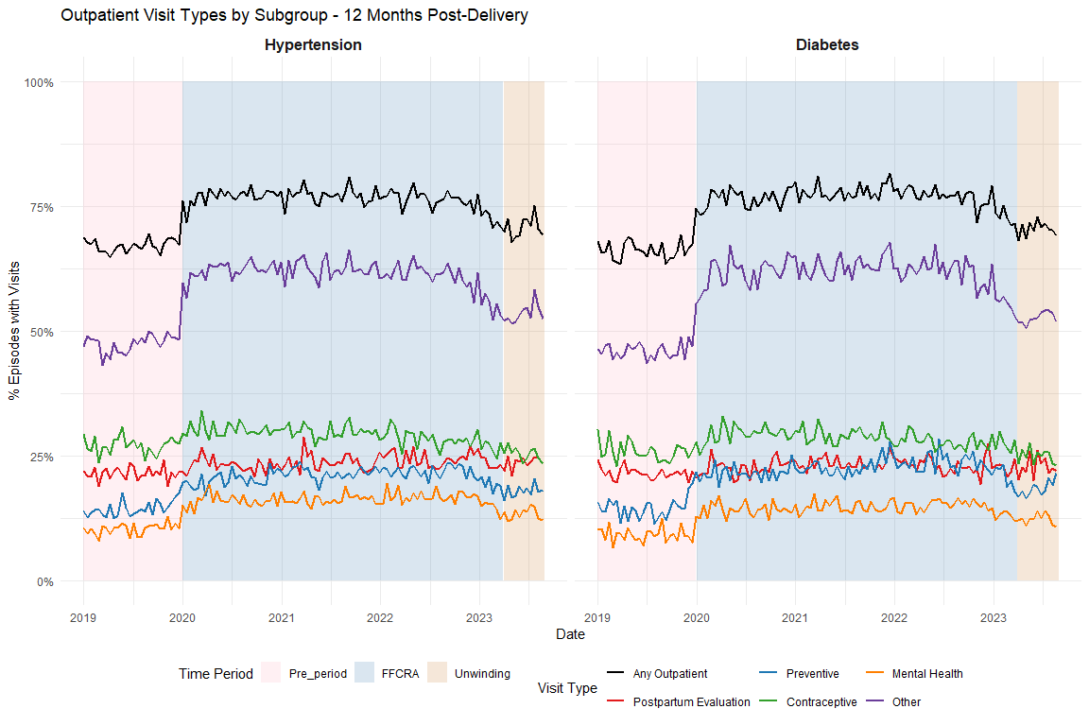

## Figure 2: Biweekly graphs based on anchor date: diabetes screening

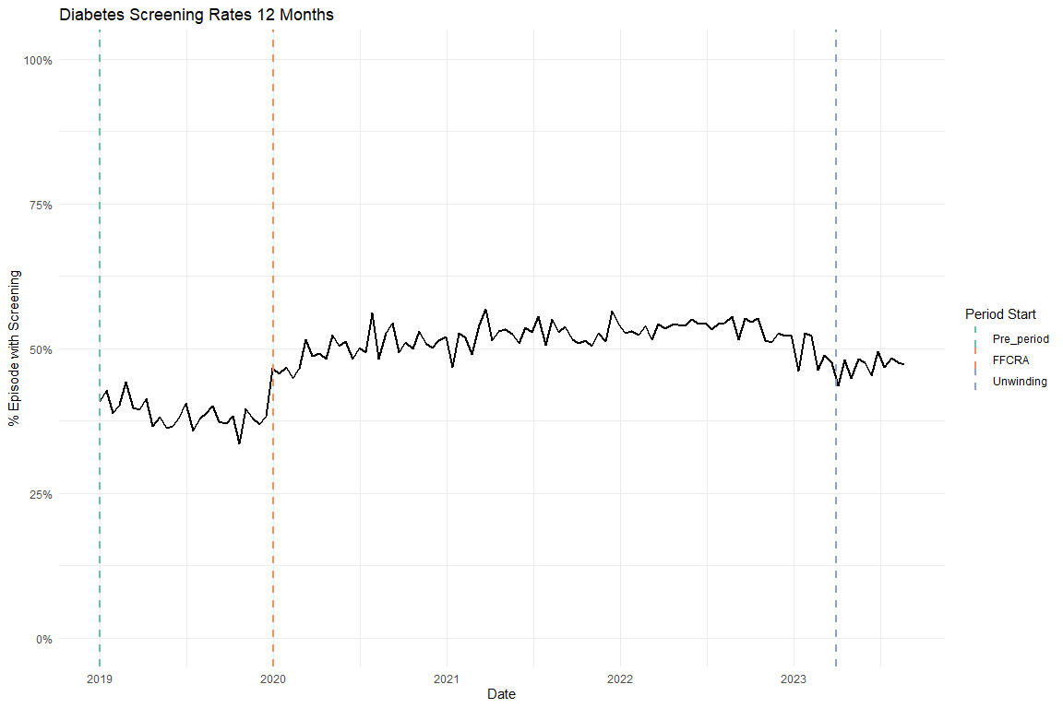

## Figure 3: Biweekly graphs based on anchor date: hypertensive medication

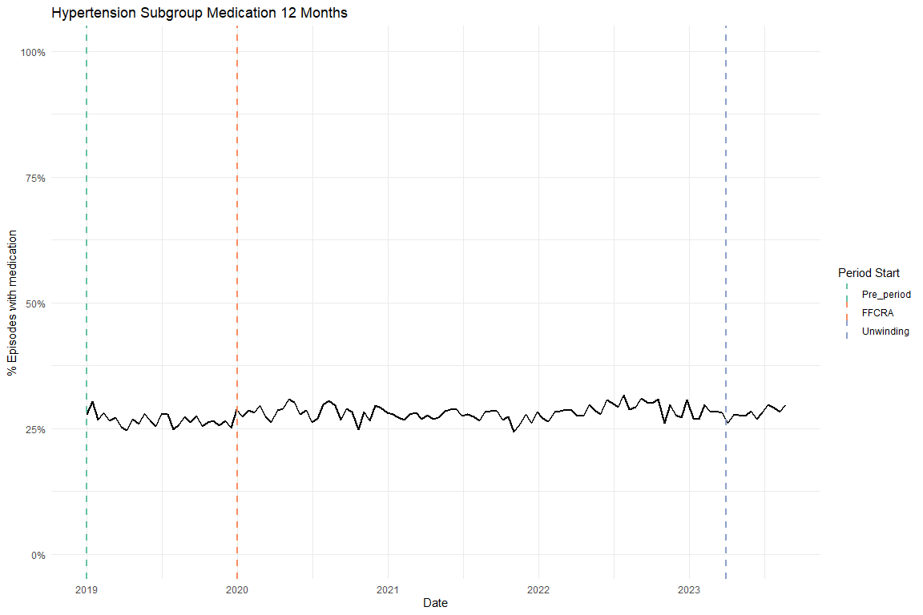

## Table 2: ITS results of all utilization outcomes, adjusted, main coefficients only

| Diabetes cohort | | | | |
| --- | --- | --- | --- | --- |
| Characteristic | Diabetes Screening Beta | 95% CI1 | Any outpatient utilization Beta | 95% CI1 |
| Pre-trend | -0.002 | -0.003, -0.001 | -0.001 | -0.002, 0.000 |
| Level Change, FFCRA | 0.072 | 0.052, 0.092 | 0.105 | 0.087, 0.122 |
| Level Change, Unwinding | -0.199 | -0.591, 0.193 | -0.030 | -0.374, 0.313 |
| Trend Change, FFCRA | 0.003 | 0.002, 0.004 | 0.000 | 0.000, 0.001 |
| Trend Change, Unwinding | 0.004 | 0.001, 0.008 | 0.001 | -0.002, 0.004 |
| 1CI = Confidence Interval | | | | |

| Hypertension cohort | | | | |
| --- | --- | --- | --- | --- |
| Characteristic | Antihypertensive medication Beta | 95% CI1 | Any outpatient utilization Beta | 95% CI1 |
| Pre-trend | -0.001 | -0.002, -0.001 | 0.000 | -0.001, 0.000 |
| Level Change, FFCRA | -0.011 | -0.026, 0.004 | 0.105 | 0.091, 0.120 |
| Level Change, Unwinding | -0.343 | -0.625, -0.062 | -0.208 | -0.489, 0.072 |
| Trend Change, FFCRA | 0.001 | 0.001, 0.002 | 0.000 | -0.001, 0.001 |
| Trend Change, Unwinding | 0.004 | 0.002, 0.007 | 0.002 | 0.000, 0.005 |
| 1CI = Confidence Interval | | | | |

# Supplemental Figures

## Flowchart

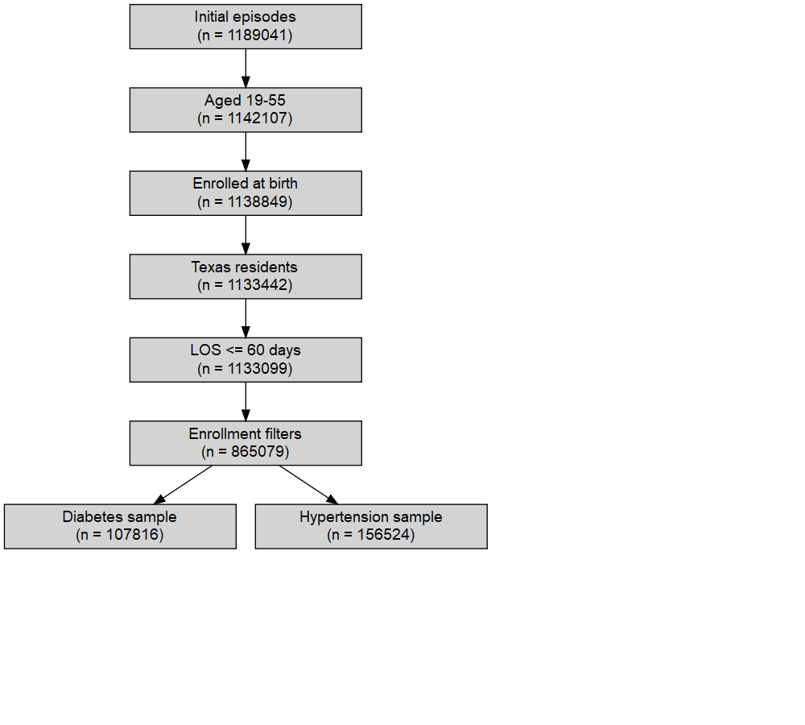

## Enrollment

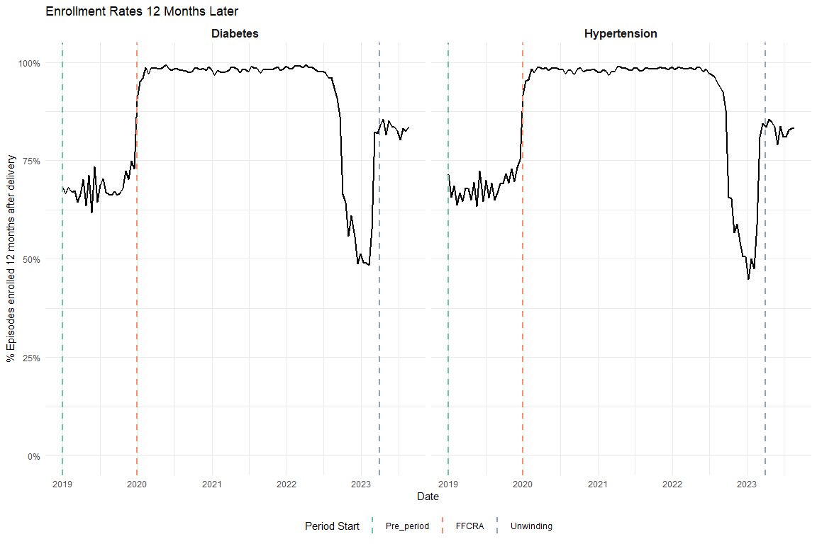

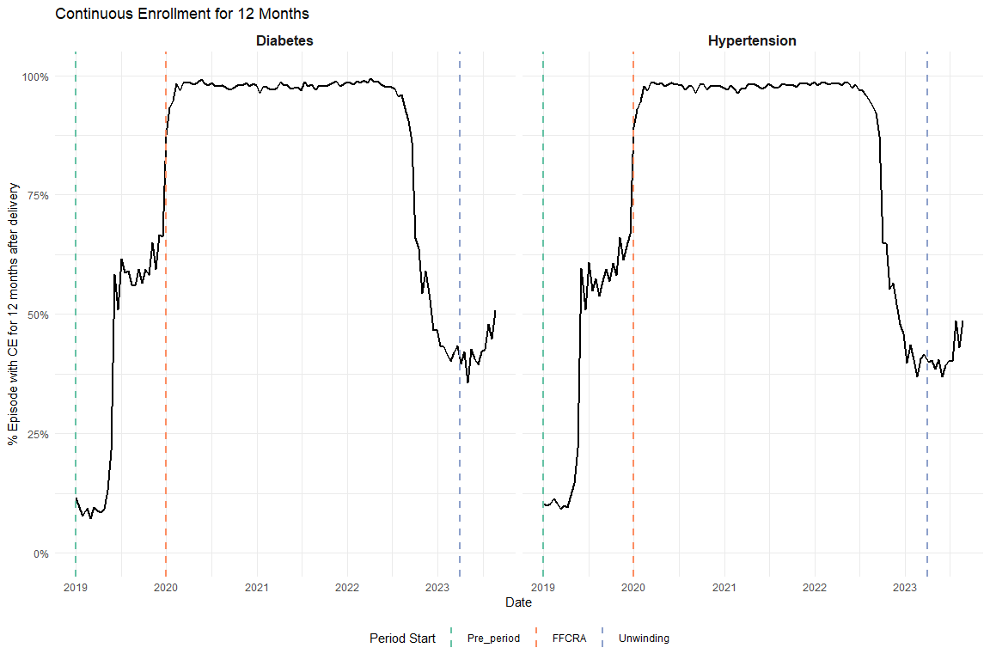

## Average Visits per Person

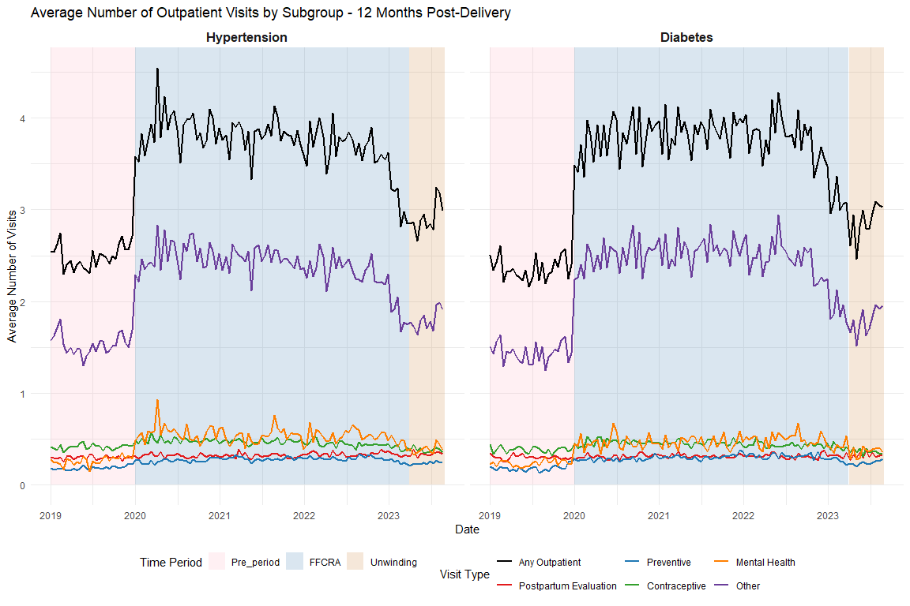

# Supplemental Tables

## Full ITS Results

### Diabetes Screening

Unadjusted

| Characteristic | Beta | 95% CI1 | p-value |
| --- | --- | --- | --- |
| (Intercept) | 0.4067 | 0.3902, 0.4232 | <0.001 |
| biweekly_counter | -0.0015 | -0.0026, -0.0005 | 0.004 |
| period_FFCRA | 0.0844 | 0.0641, 0.1047 | <0.001 |
| period_Unwinding | -0.1353 | -0.5301, 0.2595 | 0.50 |
| biweekly_counter * period_FFCRA | 0.0019 | 0.0009, 0.0030 | <0.001 |
| biweekly_counter * period_Unwinding | 0.0032 | -0.0003, 0.0068 | 0.072 |
| 1CI = Confidence Interval | | | |

Adjusted

| Characteristic | Beta | 95% CI1 | p-value |
| --- | --- | --- | --- |
| (Intercept) | 0.2816 | 0.2577, 0.3056 | <0.001 |
| biweekly_counter | -0.0023 | -0.0033, -0.0012 | <0.001 |
| period_FFCRA | 0.0718 | 0.0516, 0.0920 | <0.001 |
| period_Unwinding | -0.1992 | -0.5910, 0.1926 | 0.32 |
| Age | 0.0005 | -0.0001, 0.0011 | 0.081 |
| Index No Transfusion Weight | 0.0087 | 0.0083, 0.0092 | <0.001 |
| biweekly_counter * period_FFCRA | 0.0026 | 0.0016, 0.0036 | <0.001 |
| biweekly_counter * period_Unwinding | 0.0044 | 0.0009, 0.0078 | 0.015 |
| 1CI = Confidence Interval | | | |

### Diabetes Outpatient

Unadjusted

| Characteristic | Beta | 95% CI1 | p-value |
| --- | --- | --- | --- |
| (Intercept) | 0.6625 | 0.6481, 0.6769 | <0.001 |
| biweekly_counter | -0.0001 | -0.0010, 0.0008 | 0.90 |
| period_FFCRA | 0.1149 | 0.0972, 0.1327 | <0.001 |
| period_Unwinding | 0.0168 | -0.3285, 0.3622 | 0.92 |
| biweekly_counter * period_FFCRA | -0.0001 | -0.0010, 0.0008 | 0.89 |
| biweekly_counter * period_Unwinding | 0.0003 | -0.0028, 0.0034 | 0.86 |
| 1CI = Confidence Interval | | | |

Adjusted

| Characteristic | Beta | 95% CI1 | p-value |
| --- | --- | --- | --- |
| (Intercept) | 0.6040 | 0.5830, 0.6250 | <0.001 |
| biweekly_counter | -0.0006 | -0.0015, 0.0002 | 0.16 |
| period_FFCRA | 0.1047 | 0.0870, 0.1223 | <0.001 |
| period_Unwinding | -0.0302 | -0.3737, 0.3133 | 0.86 |
| Age | -0.0008 | -0.0013, -0.0003 | 0.002 |
| Index No Transfusion Weight | 0.0066 | 0.0061, 0.0070 | <0.001 |
| biweekly_counter * period_FFCRA | 0.0005 | -0.0004, 0.0014 | 0.28 |
| biweekly_counter * period_Unwinding | 0.0012 | -0.0019, 0.0042 | 0.46 |
| 1CI = Confidence Interval | | | |

### HTN Medication

Unadjusted

| Characteristic | Beta | 95% CI1 | p-value |
| --- | --- | --- | --- |
| (Intercept) | 0.2744 | 0.2621, 0.2867 | <0.001 |
| biweekly_counter | -0.0006 | -0.0014, 0.0002 | 0.12 |
| period_FFCRA | 0.0012 | -0.0140, 0.0164 | 0.88 |
| period_Unwinding | -0.2938 | -0.5848, -0.0028 | 0.048 |
| biweekly_counter * period_FFCRA | 0.0007 | -0.0001, 0.0015 | 0.074 |
| biweekly_counter * period_Unwinding | 0.0032 | 0.0006, 0.0058 | 0.016 |
| 1CI = Confidence Interval | | | |

Adjusted

| Characteristic | Beta | 95% CI1 | p-value |
| --- | --- | --- | --- |
| (Intercept) | -0.2613 | -0.2781, -0.2445 | <0.001 |
| biweekly_counter | -0.0013 | -0.0020, -0.0005 | <0.001 |
| period_FFCRA | -0.0108 | -0.0255, 0.0039 | 0.15 |
| period_Unwinding | -0.3434 | -0.6248, -0.0621 | 0.017 |
| Age | 0.0154 | 0.0150, 0.0158 | <0.001 |
| Index No Transfusion Weight | 0.0082 | 0.0078, 0.0085 | <0.001 |
| biweekly_counter * period_FFCRA | 0.0013 | 0.0005, 0.0020 | <0.001 |
| biweekly_counter * period_Unwinding | 0.0041 | 0.0015, 0.0066 | 0.002 |
| 1CI = Confidence Interval | | | |

### HTN Outpatient

Unadjusted

| Characteristic | Beta | 95% CI1 | p-value |
| --- | --- | --- | --- |
| (Intercept) | 0.6665 | 0.6546, 0.6784 | <0.001 |
| biweekly_counter | 0.0004 | -0.0004, 0.0011 | 0.31 |
| period_FFCRA | 0.1190 | 0.1043, 0.1338 | <0.001 |
| period_Unwinding | -0.1921 | -0.4745, 0.0903 | 0.18 |
| biweekly_counter * period_FFCRA | -0.0007 | -0.0014, 0.0001 | 0.086 |
| biweekly_counter * period_Unwinding | 0.0016 | -0.0009, 0.0041 | 0.21 |
| 1CI = Confidence Interval | | | |

Adjusted

| Characteristic | Beta | 95% CI1 | p-value |
| --- | --- | --- | --- |
| (Intercept) | 0.5944 | 0.5777, 0.6111 | <0.001 |
| biweekly_counter | -0.0004 | -0.0012, 0.0003 | 0.27 |
| period_FFCRA | 0.1055 | 0.0908, 0.1202 | <0.001 |
| period_Unwinding | -0.2084 | -0.4892, 0.0724 | 0.15 |
| Age | -0.0002 | -0.0006, 0.0002 | 0.42 |
| Index No Transfusion Weight | 0.0063 | 0.0060, 0.0066 | <0.001 |
| biweekly_counter * period_FFCRA | 0.0001 | -0.0006, 0.0009 | 0.76 |
| biweekly_counter * period_Unwinding | 0.0024 | -0.0001, 0.0049 | 0.058 |
| 1CI = Confidence Interval | | | |

## HEDIS Postpartum Visits

### Diabetes Postpartum Visits

Unadjusted

| Characteristic | Beta | 95% CI1 | p-value |
| --- | --- | --- | --- |
| (Intercept) | 0.7824 | 0.7691, 0.7957 | <0.001 |
| biweekly_counter | 0.0003 | -0.0006, 0.0011 | 0.51 |
| period_FFCRA | 0.0123 | -0.0040, 0.0287 | 0.14 |
| period_Unwinding | 0.0994 | -0.2192, 0.4179 | 0.54 |
| biweekly_counter * period_FFCRA | -0.0002 | -0.0010, 0.0007 | 0.73 |
| biweekly_counter * period_Unwinding | -0.0011 | -0.0040, 0.0017 | 0.44 |
| 1CI = Confidence Interval | | | |

Adjusted

| Characteristic | Beta | 95% CI1 | p-value |
| --- | --- | --- | --- |
| (Intercept) | 0.7655 | 0.7461, 0.7849 | <0.001 |
| biweekly_counter | -0.0001 | -0.0010, 0.0007 | 0.73 |
| period_FFCRA | 0.0050 | -0.0114, 0.0213 | 0.55 |
| period_Unwinding | 0.0687 | -0.2490, 0.3863 | 0.67 |
| Age | -0.0013 | -0.0017, -0.0008 | <0.001 |
| Index No Transfusion Weight | 0.0044 | 0.0040, 0.0048 | <0.001 |
| biweekly_counter * period_FFCRA | 0.0003 | -0.0006, 0.0011 | 0.55 |
| biweekly_counter * period_Unwinding | -0.0005 | -0.0034, 0.0023 | 0.72 |
| 1CI = Confidence Interval | | | |

### HTN Postpartum Visits

Unadjusted

| Characteristic | Beta | 95% CI1 | p-value |
| --- | --- | --- | --- |
| (Intercept) | 0.7663 | 0.7550, 0.7776 | <0.001 |
| biweekly_counter | 0.0005 | -0.0002, 0.0012 | 0.16 |
| period_FFCRA | 0.0145 | 0.0005, 0.0285 | 0.042 |
| period_Unwinding | 0.1765 | -0.0914, 0.4443 | 0.20 |
| biweekly_counter * period_FFCRA | -0.0004 | -0.0012, 0.0003 | 0.22 |
| biweekly_counter * period_Unwinding | -0.0019 | -0.0043, 0.0005 | 0.11 |
| 1CI = Confidence Interval | | | |

Adjusted

| Characteristic | Beta | 95% CI1 | p-value |
| --- | --- | --- | --- |
| (Intercept) | 0.7770 | 0.7611, 0.7929 | <0.001 |
| biweekly_counter | -0.0001 | -0.0009, 0.0006 | 0.69 |
| period_FFCRA | 0.0038 | -0.0102, 0.0177 | 0.60 |
| period_Unwinding | 0.1686 | -0.0982, 0.4354 | 0.22 |
| Age | -0.0024 | -0.0028, -0.0020 | <0.001 |
| Index No Transfusion Weight | 0.0047 | 0.0043, 0.0050 | <0.001 |
| biweekly_counter * period_FFCRA | 0.0002 | -0.0005, 0.0009 | 0.60 |
| biweekly_counter * period_Unwinding | -0.0013 | -0.0037, 0.0011 | 0.28 |
| 1CI = Confidence Interval | | | |

# Sensitivity Analyses

## Diabetes Subgroup Exclude Pre-existing

### Graph

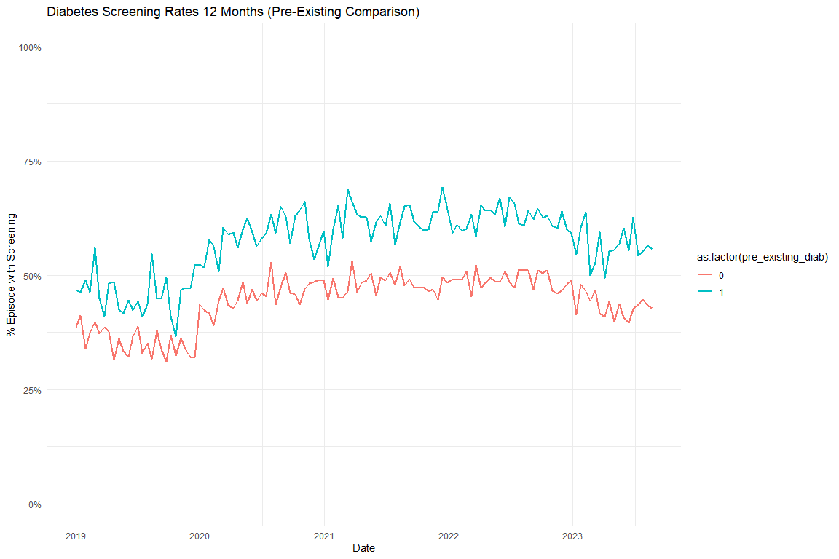

### Models

### Diabetes Screening Unadjusted

|  | Full Sample | Excluding Pre-Existing Diabetes |
| --- | --- | --- |
| Characteristic | Beta1 | Beta1 |
| (Intercept) | 0.407*** | 0.381*** |
| biweekly_counter | -0.002** | -0.002*** |
| period_FFCRA | 0.084*** | 0.069*** |
| period_Unwinding | -0.135 | -0.090 |
| biweekly_counter * period_FFCRA | 0.002*** | 0.002*** |
| biweekly_counter * period_Unwinding | 0.003 | 0.003 |
| 1*p<0.05; **p<0.01; ***p<0.001 | | |

### Diabetes Screening Adjusted

|  | Full Sample | Excluding Pre-Existing Diabetes |
| --- | --- | --- |
| Characteristic | Beta1 | Beta1 |
| (Intercept) | 0.282*** | 0.314*** |
| biweekly_counter | -0.002*** | -0.003*** |
| period_FFCRA | 0.072*** | 0.057*** |
| period_Unwinding | -0.199 | -0.139 |
| Age | 0.001 | 0.000 |
| Index No Transfusion Weight | 0.009*** | 0.007*** |
| biweekly_counter * period_FFCRA | 0.003*** | 0.003*** |
| biweekly_counter * period_Unwinding | 0.004* | 0.004 |
| 1*p<0.05; **p<0.01; ***p<0.001 | | |

## Diabetes Subgroup Test Type Graphs

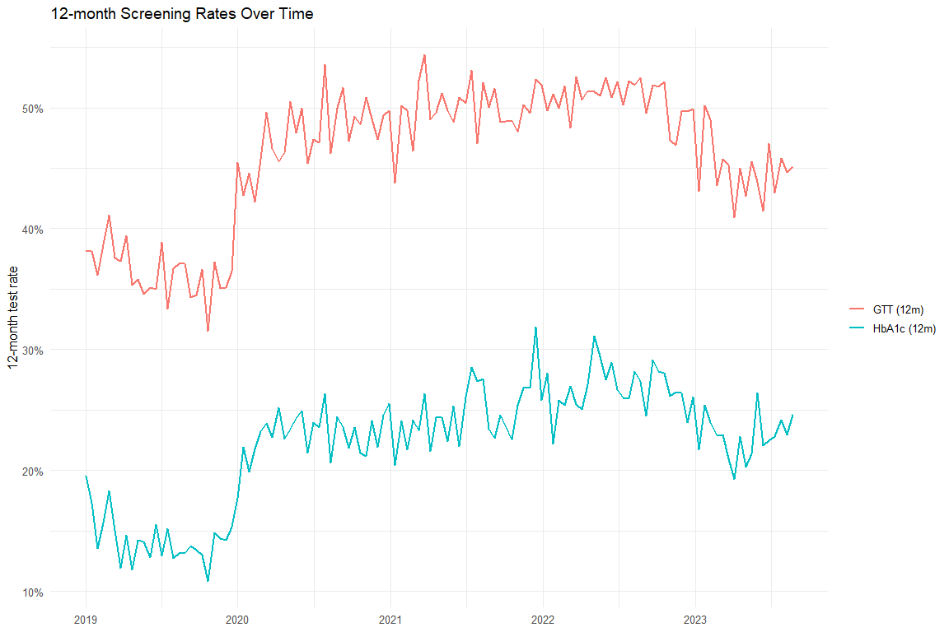

### Diabetes Test Type Models

|  | Overall (Unadj) | Overall (Adj) | HbA1c (Unadj) | HbA1c (Adj) | GTT (Unadj) | GTT (Adj) |
| --- | --- | --- | --- | --- | --- | --- |
| Characteristic | Beta1 | Beta1 | Beta1 | Beta1 | Beta1 | Beta1 |
| (Intercept) | 0.407*** | 0.282*** | 0.156*** | -0.044*** | 0.382*** | 0.262*** |
| biweekly_counter | -0.002** | -0.002*** | -0.001* | -0.002*** | -0.001* | -0.002*** |
| period_FFCRA | 0.084*** | 0.072*** | 0.056*** | 0.047*** | 0.092*** | 0.080*** |
| period_Unwinding | -0.135 | -0.199 | -0.295 | -0.352* | -0.120 | -0.182 |
| biweekly_counter * period_FFCRA | 0.002*** | 0.003*** | 0.002*** | 0.002*** | 0.002** | 0.002*** |
| biweekly_counter * period_Unwinding | 0.003 | 0.004* | 0.004** | 0.005*** | 0.003 | 0.004* |
| Age |  | 0.001 |  | 0.004*** |  | 0.000 |
| Index No Transfusion Weight |  | 0.009*** |  | 0.008*** |  | 0.009*** |
| 1*p<0.05; **p<0.01; ***p<0.001 | | | | | | |

## Excluding COVID

[1] "diab_screen_unadj_excluded_reidx"

[1] "diab_screen_adj_excluded_reidx"

[1] "diab_any_outpatient_unadj_excluded_reidx"

[1] "diab_any_outpatient_adj_excluded_reidx"

[1] "htn_med_unadj_excluded_reidx"

[1] "htn_med_adj_excluded_reidx"

[1] "htn_any_outpatient_unadj_excluded_reidx"

[1] "htn_any_outpatient_adj_excluded_reidx"

|  | Original - Unadj | Excluded COVID - Unadj | Original - Adj | Excluded COVID - Adj |
| --- | --- | --- | --- | --- |
| Characteristic | Beta1 | Beta1 | Beta1 | Beta1 |
| (Intercept) | 0.407*** | 0.404*** | 0.282*** | 0.316*** |
| biweekly_counter | -0.002** | 0.003 | -0.002*** | -0.009 |
| period_FFCRA | 0.084*** | 0.110*** | 0.072*** | 0.053* |
| period_Unwinding | -0.135 | -0.074 | -0.199 | -0.169 |
| biweekly_counter * period_FFCRA | 0.002*** | -0.002 | 0.003*** | 0.009 |
| biweekly_counter * period_Unwinding | 0.003 | -0.001 | 0.004* | 0.011 |
| Age |  |  | 0.001 | 0.001 |
| Index No Transfusion Weight |  |  | 0.009*** | 0.009*** |
| 1*p<0.05; **p<0.01; ***p<0.001 | | | | |

|  | Original - Unadj | Excluded COVID - Unadj | Original - Adj | Excluded COVID - Adj |
| --- | --- | --- | --- | --- |
| Characteristic | Beta1 | Beta1 | Beta1 | Beta1 |
| (Intercept) | 0.663*** | 0.681*** | 0.604*** | 0.654*** |
| biweekly_counter | 0.000 | -0.006 | -0.001 | -0.014** |
| period_FFCRA | 0.115*** | 0.099*** | 0.105*** | 0.057** |
| period_Unwinding | 0.017 | -0.008 | -0.030 | -0.076 |
| biweekly_counter * period_FFCRA | 0.000 | 0.005 | 0.000 | 0.014** |
| biweekly_counter * period_Unwinding | 0.000 | 0.006 | 0.001 | 0.015** |
| Age |  |  | -0.001** | -0.001** |
| Index No Transfusion Weight |  |  | 0.007*** | 0.007*** |
| 1*p<0.05; **p<0.01; ***p<0.001 | | | | |

|  | Original - Unadj | Excluded COVID - Unadj | Original - Adj | Excluded COVID - Adj |
| --- | --- | --- | --- | --- |
| Characteristic | Beta1 | Beta1 | Beta1 | Beta1 |
| (Intercept) | 0.274*** | 0.291*** | -0.261*** | -0.210*** |
| biweekly_counter | -0.001 | -0.004 | -0.001*** | -0.011** |
| period_FFCRA | 0.001 | -0.014 | -0.011 | -0.056*** |
| period_Unwinding | -0.294* | -0.265* | -0.343* | -0.338** |
| biweekly_counter * period_FFCRA | 0.001 | 0.004 | 0.001*** | 0.011** |
| biweekly_counter * period_Unwinding | 0.003* | 0.007 | 0.004** | 0.014** |
| Age |  |  | 0.015*** | 0.015*** |
| Index No Transfusion Weight |  |  | 0.008*** | 0.008*** |
| 1*p<0.05; **p<0.01; ***p<0.001 | | | | |

|  | Original - Unadj | Excluded COVID - Unadj | Original - Adj | Excluded COVID - Adj |
| --- | --- | --- | --- | --- |
| Characteristic | Beta1 | Beta1 | Beta1 | Beta1 |
| (Intercept) | 0.666*** | 0.694*** | 0.594*** | 0.653*** |
| biweekly_counter | 0.000 | -0.006 | 0.000 | -0.014*** |
| period_FFCRA | 0.119*** | 0.092*** | 0.105*** | 0.048** |
| period_Unwinding | -0.192 | -0.176 | -0.208 | -0.221* |
| biweekly_counter * period_FFCRA | -0.001 | 0.005 | 0.000 | 0.014** |
| biweekly_counter * period_Unwinding | 0.002 | 0.008 | 0.002 | 0.016*** |
| Age |  |  | 0.000 | 0.000 |
| Index No Transfusion Weight |  |  | 0.006*** | 0.006*** |
| 1*p<0.05; **p<0.01; ***p<0.001 | | | | |