POEM TX Paper 1
2026-04-23

Main Analysis Tables and Figures

Table 1
(This is the older version)
 | Overall | By Condition
Characteristic | N = 187,328¹ | Diabetes  N = 88,155¹ | Hypertension  N = 127,196¹
Birth Outcome
LB | 185,894 (99%) | 87,444 (99%) | 126,176 (99%)
SB | 1,434 (0.8%) | 711 (0.8%) | 1,020 (0.8%)
Year
2019 | 34,963 (19%) | 16,561 (19%) | 23,316 (18%)
2020 | 38,875 (21%) | 18,642 (21%) | 26,031 (20%)
2021 | 41,232 (22%) | 19,730 (22%) | 27,725 (22%)
2022 | 43,391 (23%) | 20,102 (23%) | 29,926 (24%)
2023 | 28,867 (15%) | 13,120 (15%) | 20,198 (16%)
Race/Ethnicity
American Indian or Alaskan | 449 (0.2%) | 208 (0.2%) | 310 (0.2%)
Asian, Pacific Islander | 3,428 (1.8%) | 2,507 (2.8%) | 1,380 (1.1%)
Black, non-Hispanic | 38,362 (20%) | 12,402 (14%) | 31,309 (25%)
Hispanic | 97,241 (52%) | 53,348 (61%) | 59,525 (47%)
Unknown/Other | 8,591 (4.6%) | 3,612 (4.1%) | 6,238 (4.9%)
White, non-Hispanic | 39,257 (21%) | 16,078 (18%) | 28,434 (22%)
Age Group
19-24 | 53,379 (28%) | 18,707 (21%) | 39,650 (31%)
25-34 | 101,790 (54%) | 50,230 (57%) | 67,020 (53%)
35-44 | 31,674 (17%) | 18,906 (21%) | 20,201 (16%)
45-55 | 485 (0.3%) | 312 (0.4%) | 325 (0.3%)
Index No Transfusion Weight | 27 (19, 41) | 26 (18, 38) | 33 (24, 45)
Preexisting Diabetes | 28,711 (15%) | 28,711 (33%) | 12,793 (10%)
Gestational Diabetes | 82,194 (44%) | 82,194 (93%) | 25,550 (20%)
Chronic Hypertension | 57,509 (31%) | 16,778 (19%) | 57,509 (45%)
Gestational Hypertension | 92,407 (49%) | 18,091 (21%) | 92,407 (73%)
Preeclampsia | 13,632 (7.3%) | 4,608 (5.2%) | 13,632 (11%)
Pulmonary Hypertension | 390 (0.2%) | 97 (0.1%) | 390 (0.3%)
¹n (%); Median (Q1, Q3)

Pre Post

This is the newer version with pre and post
Characteristic | Diabetes - Pre  N = 16,561¹ | Diabetes - FFCRA  N = 43,166¹ | Hypertension - Pre  N = 23,316¹ | Hypertension - FFCRA  N = 60,893¹
Birth Outcome
LB | 16,454 (99%) | 42,822 (99%) | 23,147 (99%) | 60,419 (99%)
SB | 107 (0.6%) | 344 (0.8%) | 169 (0.7%) | 474 (0.8%)
Year
2019 | 16,561 (100%) | 0 (0%) | 23,316 (100%) | 0 (0%)
2020 | 0 (0%) | 18,642 (43%) | 0 (0%) | 26,031 (43%)
2021 | 0 (0%) | 19,730 (46%) | 0 (0%) | 27,725 (46%)
2022 | 0 (0%) | 4,794 (11%) | 0 (0%) | 7,137 (12%)
Race/Ethnicity
American Indian or Alaskan | 39 (0.2%) | 99 (0.2%) | 41 (0.2%) | 144 (0.2%)
Asian, Pacific Islander | 441 (2.7%) | 1,238 (2.9%) | 209 (0.9%) | 637 (1.0%)
Black, non-Hispanic | 2,443 (15%) | 6,048 (14%) | 5,919 (25%) | 15,053 (25%)
Hispanic | 9,883 (60%) | 26,133 (61%) | 10,420 (45%) | 28,473 (47%)
Unknown/Other | 606 (3.7%) | 1,683 (3.9%) | 1,075 (4.6%) | 2,757 (4.5%)
White, non-Hispanic | 3,149 (19%) | 7,965 (18%) | 5,652 (24%) | 13,829 (23%)
Age Group
19-24 | 3,735 (23%) | 9,388 (22%) | 7,682 (33%) | 19,163 (31%)
25-34 | 9,271 (56%) | 24,505 (57%) | 11,940 (51%) | 31,932 (52%)
35-44 | 3,491 (21%) | 9,115 (21%) | 3,632 (16%) | 9,644 (16%)
45-55 | 64 (0.4%) | 158 (0.4%) | 62 (0.3%) | 154 (0.3%)
Index No Transfusion Weight | 23 (14, 35) | 26 (18, 38) | 30 (21, 42) | 33 (24, 45)
Preexisting Diabetes | 5,277 (32%) | 13,794 (32%) | 2,192 (9.4%) | 6,055 (9.9%)
Gestational Diabetes | 15,459 (93%) | 40,398 (94%) | 4,525 (19%) | 12,533 (21%)
Chronic Hypertension | 2,916 (18%) | 8,014 (19%) | 10,251 (44%) | 27,256 (45%)
Gestational Hypertension | 3,166 (19%) | 8,904 (21%) | 17,017 (73%) | 44,618 (73%)
Preeclampsia | 769 (4.6%) | 2,219 (5.1%) | 2,435 (10%) | 6,478 (11%)
Pulmonary Hypertension | 16 (<0.1%) | 43 (<0.1%) | 85 (0.4%) | 181 (0.3%)
¹n (%); Median (Q1, Q3)

Multiple Post Periods
Characteristic | Diabetes - Pre  N = 16,561¹ | Diabetes - FFCRA  N = 43,166¹ | Diabetes - Unwinding  N = 28,428¹ | Hypertension - Pre  N = 23,316¹ | Hypertension - FFCRA  N = 60,893¹ | Hypertension - Unwinding  N = 42,987¹
Birth Outcome
LB | 16,454 (99%) | 42,822 (99%) | 28,168 (99%) | 23,147 (99%) | 60,419 (99%) | 42,610 (99%)
SB | 107 (0.6%) | 344 (0.8%) | 260 (0.9%) | 169 (0.7%) | 474 (0.8%) | 377 (0.9%)
Year
2019 | 16,561 (100%) | 0 (0%) | 0 (0%) | 23,316 (100%) | 0 (0%) | 0 (0%)
2020 | 0 (0%) | 18,642 (43%) | 0 (0%) | 0 (0%) | 26,031 (43%) | 0 (0%)
2021 | 0 (0%) | 19,730 (46%) | 0 (0%) | 0 (0%) | 27,725 (46%) | 0 (0%)
2022 | 0 (0%) | 4,794 (11%) | 15,308 (54%) | 0 (0%) | 7,137 (12%) | 22,789 (53%)
2023 | 0 (0%) | 0 (0%) | 13,120 (46%) | 0 (0%) | 0 (0%) | 20,198 (47%)
Race/Ethnicity
American Indian or Alaskan | 39 (0.2%) | 99 (0.2%) | 70 (0.2%) | 41 (0.2%) | 144 (0.2%) | 125 (0.3%)
Asian, Pacific Islander | 441 (2.7%) | 1,238 (2.9%) | 828 (2.9%) | 209 (0.9%) | 637 (1.0%) | 534 (1.2%)
Black, non-Hispanic | 2,443 (15%) | 6,048 (14%) | 3,911 (14%) | 5,919 (25%) | 15,053 (25%) | 10,337 (24%)
Hispanic | 9,883 (60%) | 26,133 (61%) | 17,332 (61%) | 10,420 (45%) | 28,473 (47%) | 20,632 (48%)
Unknown/Other | 606 (3.7%) | 1,683 (3.9%) | 1,323 (4.7%) | 1,075 (4.6%) | 2,757 (4.5%) | 2,406 (5.6%)
White, non-Hispanic | 3,149 (19%) | 7,965 (18%) | 4,964 (17%) | 5,652 (24%) | 13,829 (23%) | 8,953 (21%)
Age Group
19-24 | 3,735 (23%) | 9,388 (22%) | 5,584 (20%) | 7,682 (33%) | 19,163 (31%) | 12,805 (30%)
25-34 | 9,271 (56%) | 24,505 (57%) | 16,454 (58%) | 11,940 (51%) | 31,932 (52%) | 23,148 (54%)
35-44 | 3,491 (21%) | 9,115 (21%) | 6,300 (22%) | 3,632 (16%) | 9,644 (16%) | 6,925 (16%)
45-55 | 64 (0.4%) | 158 (0.4%) | 90 (0.3%) | 62 (0.3%) | 154 (0.3%) | 109 (0.3%)
Index No Transfusion Weight | 23 (14, 35) | 26 (18, 38) | 26 (19, 40) | 30 (21, 42) | 33 (24, 45) | 33 (25, 47)
Preexisting Diabetes | 5,277 (32%) | 13,794 (32%) | 9,640 (34%) | 2,192 (9.4%) | 6,055 (9.9%) | 4,546 (11%)
Gestational Diabetes | 15,459 (93%) | 40,398 (94%) | 26,337 (93%) | 4,525 (19%) | 12,533 (21%) | 8,492 (20%)
Chronic Hypertension | 2,916 (18%) | 8,014 (19%) | 5,848 (21%) | 10,251 (44%) | 27,256 (45%) | 20,002 (47%)
Gestational Hypertension | 3,166 (19%) | 8,904 (21%) | 6,021 (21%) | 17,017 (73%) | 44,618 (73%) | 30,772 (72%)
Preeclampsia | 769 (4.6%) | 2,219 (5.1%) | 1,620 (5.7%) | 2,435 (10%) | 6,478 (11%) | 4,719 (11%)
Pulmonary Hypertension | 16 (<0.1%) | 43 (<0.1%) | 38 (0.1%) | 85 (0.4%) | 181 (0.3%) | 124 (0.3%)
¹n (%); Median (Q1, Q3)

Figure 1: Biweekly graphs based on anchor date: outpatient utilization
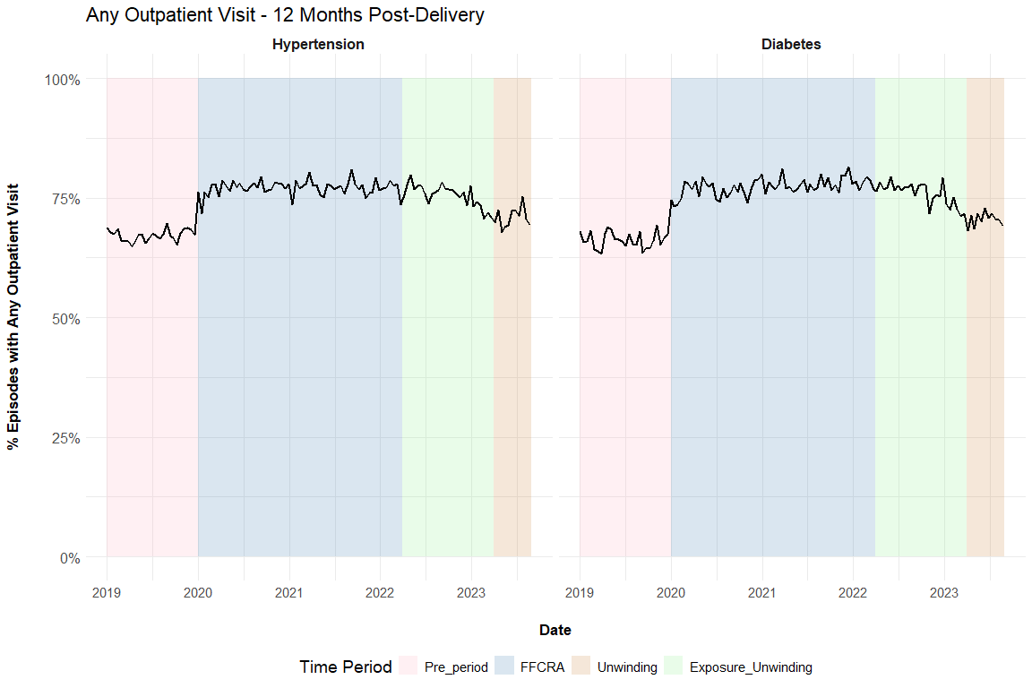

Figure 2: Biweekly graphs based on anchor date: diabetes screening
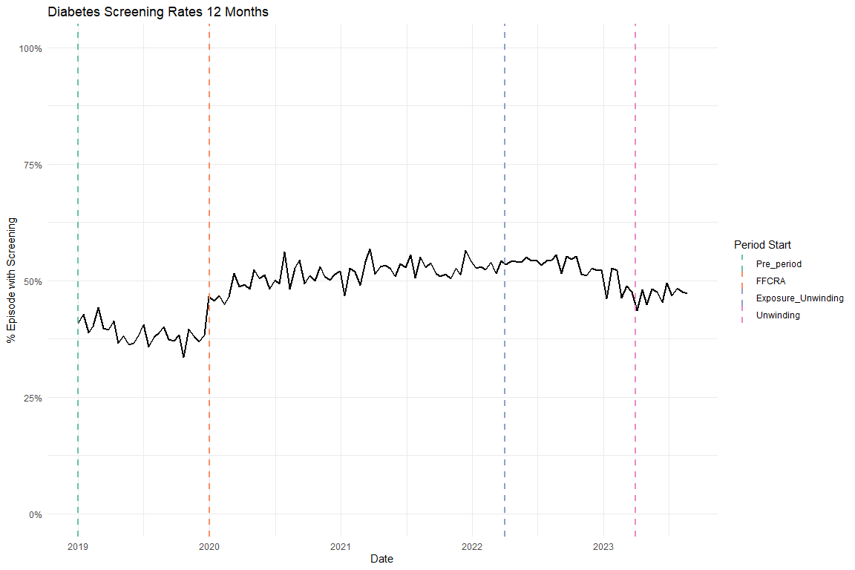

Figure 3: Biweekly graphs based on anchor date: hypertensive medication
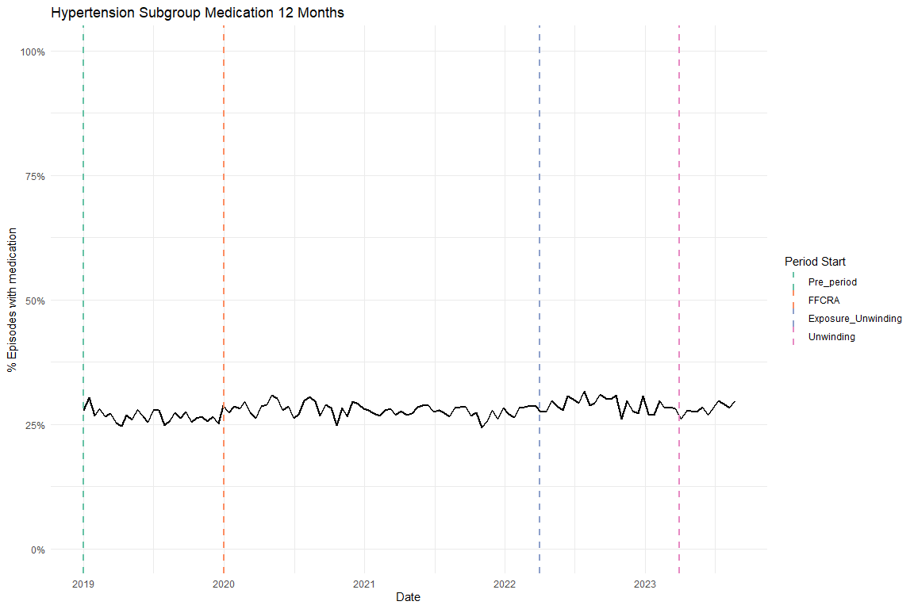

Table 2: ITS results of all utilization outcomes, adjusted, main coefficients only
Diabetes cohort
Characteristic | Diabetes Screening Beta | 95% CI | Any outpatient utilization Beta | 95% CI
Pre-trend | -0.003 | -0.004, -0.002 | -0.001 | -0.002, 0.000
Level Change, FFCRA | 0.131 | 0.114, 0.149 | 0.104 | 0.089, 0.120
Level Change, Exposure to Unwinding | 0.152 | 0.127, 0.176 | 0.108 | 0.086, 0.130
Trend Change, FFCRA | 0.003 | 0.002, 0.004 | 0.001 | 0.000, 0.002
Trend Change, Exposure to Unwinding | -0.003 | -0.004, -0.003 | -0.003 | -0.003, -0.002
Abbreviation: CI = Confidence Interval
Hypertension cohort
Characteristic | Antihypertensive medication Beta | 95% CI | Any outpatient utilization Beta | 95% CI
Pre-trend | -0.002 | -0.003, -0.001 | -0.001 | -0.001, 0.000
Level Change, FFCRA | 0.036 | 0.023, 0.049 | 0.099 | 0.086, 0.113
Level Change, Exposure to Unwinding | 0.055 | 0.037, 0.073 | 0.109 | 0.091, 0.128
Trend Change, FFCRA | 0.002 | 0.001, 0.002 | 0.001 | 0.000, 0.001
Trend Change, Exposure to Unwinding | 0.000 | 0.000, 0.000 | -0.002 | -0.003, -0.002
Abbreviation: CI = Confidence Interval

Table 3: ITS results for average outpatient visit count, adjusted, main coefficients only
Diabetes cohort
Characteristic | Avg Outpatient Visits Beta | 95% CI
Pre-trend | -0.012 | -0.022, -0.003
Level Change, FFCRA | 1.466 | 1.301, 1.630
Level Change, Exposure to Unwinding | 1.678 | 1.447, 1.908
Trend Change, FFCRA | 0.014 | 0.004, 0.024
Trend Change, Exposure to Unwinding | -0.040 | -0.045, -0.034
Abbreviation: CI = Confidence Interval
Hypertension cohort
Characteristic | Avg Outpatient Visits Beta | 95% CI
Pre-trend | -0.009 | -0.017, -0.001
Level Change, FFCRA | 1.428 | 1.288, 1.567
Level Change, Exposure to Unwinding | 1.550 | 1.356, 1.744
Trend Change, FFCRA | 0.006 | -0.002, 0.015
Trend Change, Exposure to Unwinding | -0.027 | -0.032, -0.023
Abbreviation: CI = Confidence Interval

Supplemental Figures

Flowchart
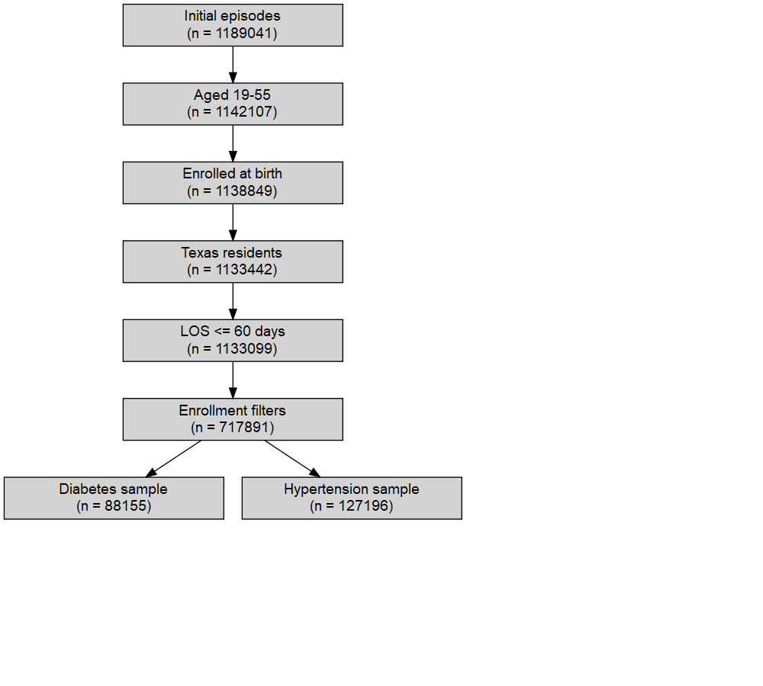

Enrollment
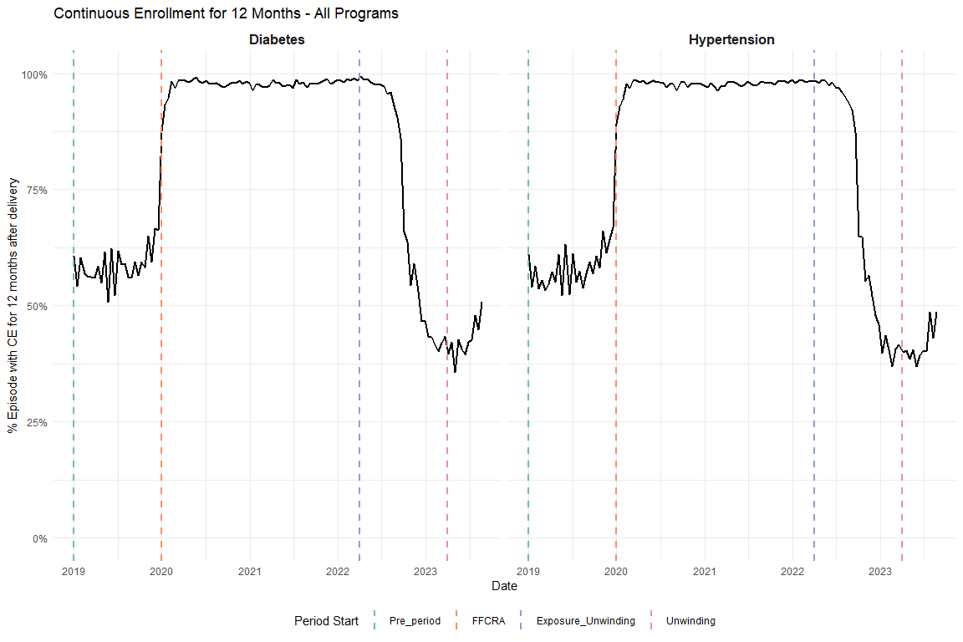
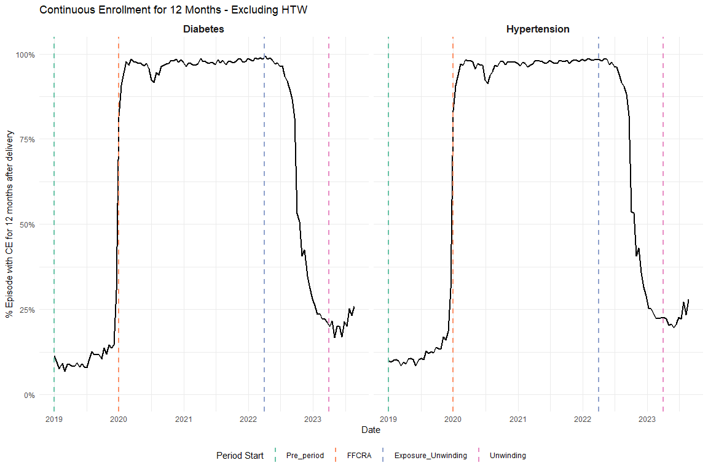
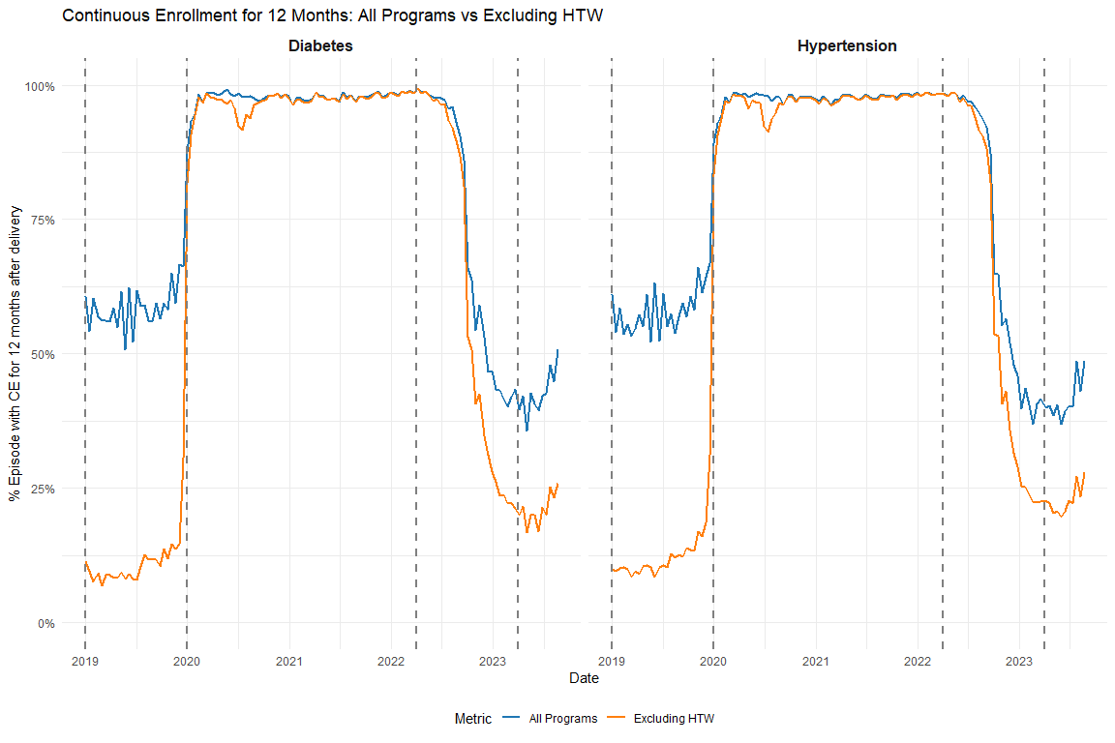

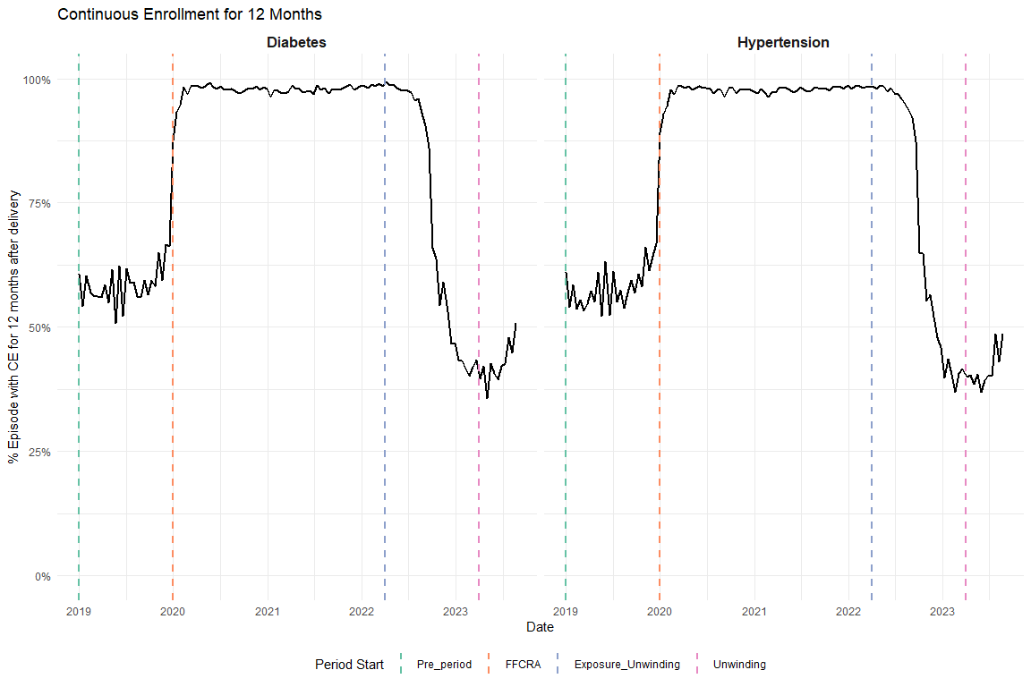

OGT vs A1C
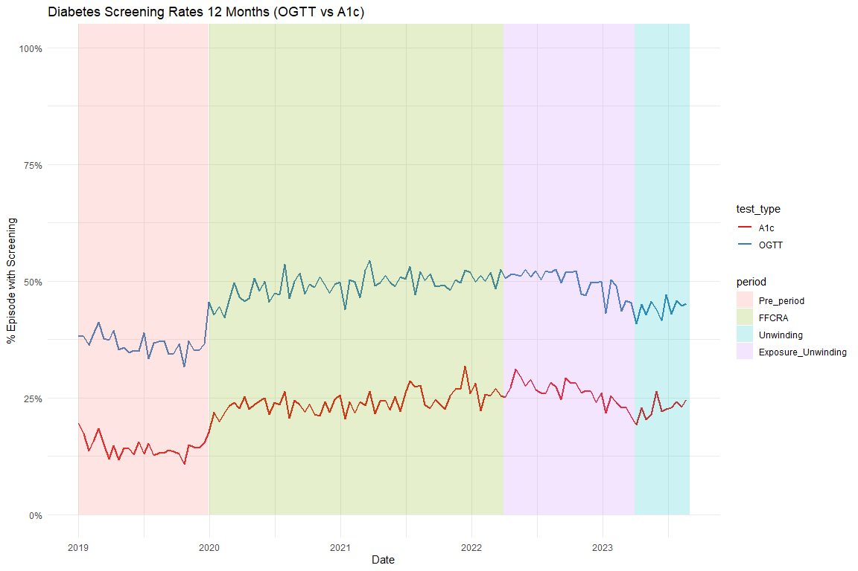

Average Visits per Person
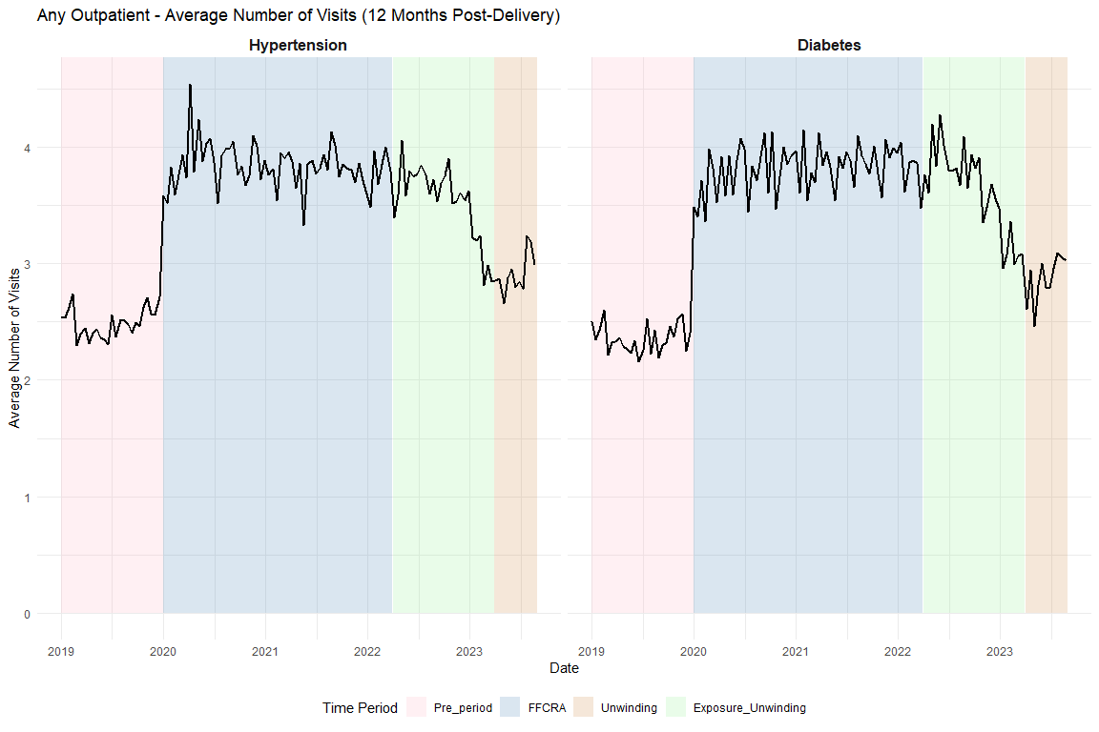

Supplemental Tables

Share of Visits for outpatient
This is based on the chart in the appendix we got the categories from
type_care | share_of_visits
Other acute or chronic illness only | 58.2
Contraceptive management only | 10.3
Mental/behavioral health care only | 9.6
Postpartum evaluation only | 8.4
Preventive/well care only | 7.7
Postpartum & Contraceptive | 3.3
Preventive/well & Contraceptive | 1.0
Contraceptive & Mental/behavioral health care | 0.5
Postpartum & mental/behavioral health care | 0.3
Other combination | 0.2
Preventive/well & mental/behavioral health | 0.2
Postpartum & Preventive/well | 0.1

Full ITS Results

Diabetes Screening
Unadjusted
Characteristic | Beta | 95% CI | p-value
(Intercept) | 0.4052 | 0.3896, 0.4207 | <0.001
t | -0.0015 | -0.0026, -0.0005 | 0.004
period_FFCRA | 0.1234 | 0.1054, 0.1413 | <0.001
period_Exposure_Unwinding | 0.1438 | 0.1186, 0.1690 | <0.001
t_after_FFCRA | 0.0024 | 0.0013, 0.0035 | <0.001
t_after_Exposure | -0.0035 | -0.0041, -0.0029 | <0.001
Abbreviation: CI = Confidence Interval
Adjusted
Characteristic | Beta | 95% CI | p-value
(Intercept) | 0.2863 | 0.2634, 0.3092 | <0.001
t | -0.0027 | -0.0037, -0.0016 | <0.001
period_FFCRA | 0.1313 | 0.1136, 0.1490 | <0.001
period_Exposure_Unwinding | 0.1516 | 0.1268, 0.1764 | <0.001
t_after_FFCRA | 0.0034 | 0.0024, 0.0045 | <0.001
t_after_Exposure | -0.0035 | -0.0041, -0.0029 | <0.001
Age | 0.0002 | -0.0004, 0.0007 | 0.60
Index No Transfusion Weight | 0.0047 | 0.0045, 0.0048 | <0.001
Abbreviation: CI = Confidence Interval

Diabetes Outpatient
Unadjusted
Characteristic | Beta | 95% CI | p-value
(Intercept) | 0.6624 | 0.6488, 0.6761 | <0.001
t | -0.0001 | -0.0010, 0.0008 | 0.90
period_FFCRA | 0.0984 | 0.0827, 0.1141 | <0.001
period_Exposure_Unwinding | 0.1025 | 0.0805, 0.1246 | <0.001
t_after_FFCRA | 0.0005 | -0.0004, 0.0015 | 0.26
t_after_Exposure | -0.0030 | -0.0035, -0.0025 | <0.001
Abbreviation: CI = Confidence Interval
Adjusted
Characteristic | Beta | 95% CI | p-value
(Intercept) | 0.6149 | 0.5947, 0.6351 | <0.001
t | -0.0008 | -0.0017, 0.0000 | 0.064
period_FFCRA | 0.1042 | 0.0886, 0.1198 | <0.001
period_Exposure_Unwinding | 0.1082 | 0.0864, 0.1301 | <0.001
t_after_FFCRA | 0.0013 | 0.0003, 0.0022 | 0.008
t_after_Exposure | -0.0029 | -0.0035, -0.0024 | <0.001
Age | -0.0009 | -0.0014, -0.0004 | <0.001
Index No Transfusion Weight | 0.0031 | 0.0029, 0.0032 | <0.001
Abbreviation: CI = Confidence Interval

HTN Medication
Unadjusted
Characteristic | Beta | 95% CI | p-value
(Intercept) | 0.2737 | 0.2621, 0.2854 | <0.001
t | -0.0006 | -0.0014, 0.0002 | 0.12
period_FFCRA | 0.0270 | 0.0134, 0.0406 | <0.001
period_Exposure_Unwinding | 0.0467 | 0.0278, 0.0656 | <0.001
t_after_FFCRA | 0.0004 | -0.0004, 0.0012 | 0.31
t_after_Exposure | -0.0001 | -0.0006, 0.0003 | 0.66
Abbreviation: CI = Confidence Interval
Adjusted
Characteristic | Beta | 95% CI | p-value
(Intercept) | -0.3078 | -0.3237, -0.2919 | <0.001
t | -0.0020 | -0.0028, -0.0013 | <0.001
period_FFCRA | 0.0359 | 0.0230, 0.0487 | <0.001
period_Exposure_Unwinding | 0.0550 | 0.0372, 0.0728 | <0.001
t_after_FFCRA | 0.0016 | 0.0009, 0.0024 | <0.001
t_after_Exposure | 0.0000 | -0.0004, 0.0004 | 0.94
Age | 0.0141 | 0.0137, 0.0145 | <0.001
Index No Transfusion Weight | 0.0061 | 0.0060, 0.0062 | <0.001
Abbreviation: CI = Confidence Interval

HTN Outpatient
Unadjusted
Characteristic | Beta | 95% CI | p-value
(Intercept) | 0.6669 | 0.6556, 0.6782 | <0.001
t | 0.0004 | -0.0004, 0.0011 | 0.31
period_FFCRA | 0.0915 | 0.0783, 0.1047 | <0.001
period_Exposure_Unwinding | 0.1020 | 0.0836, 0.1203 | <0.001
t_after_FFCRA | -0.0003 | -0.0011, 0.0005 | 0.46
t_after_Exposure | -0.0023 | -0.0028, -0.0019 | <0.001
Abbreviation: CI = Confidence Interval
Adjusted
Characteristic | Beta | 95% CI | p-value
(Intercept) | 0.5869 | 0.5707, 0.6031 | <0.001
t | -0.0005 | -0.0013, 0.0002 | 0.16
period_FFCRA | 0.0994 | 0.0863, 0.1125 | <0.001
period_Exposure_Unwinding | 0.1095 | 0.0913, 0.1277 | <0.001
t_after_FFCRA | 0.0005 | -0.0002, 0.0013 | 0.17
t_after_Exposure | -0.0022 | -0.0027, -0.0018 | <0.001
Age | -0.0005 | -0.0009, -0.0001 | 0.017
Index No Transfusion Weight | 0.0031 | 0.0030, 0.0033 | <0.001
Abbreviation: CI = Confidence Interval

Average Outpatient Visit Count (total_visit_days_12)

Diabetes Visit Count
Unadjusted
Characteristic | Beta | 95% CI | p-value
(Intercept) | 2.3436 | 2.1976, 2.4896 | <0.001
t | 0.0007 | -0.0090, 0.0103 | 0.89
period_FFCRA | 1.3749 | 1.2066, 1.5432 | <0.001
period_Exposure_Unwinding | 1.5884 | 1.3521, 1.8248 | <0.001
t_after_FFCRA | 0.0022 | -0.0078, 0.0122 | 0.67
t_after_Exposure | -0.0403 | -0.0460, -0.0345 | <0.001
Abbreviation: CI = Confidence Interval
Adjusted
Characteristic | Beta | 95% CI | p-value
(Intercept) | 0.8521 | 0.6389, 1.0652 | <0.001
t | -0.0124 | -0.0218, -0.0029 | 0.010
period_FFCRA | 1.4658 | 1.3014, 1.6301 | <0.001
period_Exposure_Unwinding | 1.6777 | 1.4469, 1.9085 | <0.001
t_after_FFCRA | 0.0140 | 0.0042, 0.0238 | 0.005
t_after_Exposure | -0.0398 | -0.0454, -0.0341 | <0.001
Age | 0.0051 | -0.0001, 0.0103 | 0.056
Index No Transfusion Weight | 0.0547 | 0.0530, 0.0563 | <0.001
Abbreviation: CI = Confidence Interval

HTN Visit Count
Unadjusted
Characteristic | Beta | 95% CI | p-value
(Intercept) | 2.4244 | 2.3027, 2.5461 | <0.001
t | 0.0053 | -0.0028, 0.0134 | 0.20
period_FFCRA | 1.3109 | 1.1682, 1.4535 | <0.001
period_Exposure_Unwinding | 1.4395 | 1.2414, 1.6375 | <0.001
t_after_FFCRA | -0.0066 | -0.0150, 0.0018 | 0.12
t_after_Exposure | -0.0290 | -0.0337, -0.0242 | <0.001
Abbreviation: CI = Confidence Interval
Adjusted
Characteristic | Beta | 95% CI | p-value
(Intercept) | 0.3256 | 0.1528, 0.4984 | <0.001
t | -0.0091 | -0.0170, -0.0011 | 0.025
period_FFCRA | 1.4278 | 1.2882, 1.5674 | <0.001
period_Exposure_Unwinding | 1.5500 | 1.3561, 1.7439 | <0.001
t_after_FFCRA | 0.0063 | -0.0019, 0.0146 | 0.13
t_after_Exposure | -0.0274 | -0.0321, -0.0228 | <0.001
Age | 0.0199 | 0.0156, 0.0243 | <0.001
Index No Transfusion Weight | 0.0509 | 0.0495, 0.0523 | <0.001
Abbreviation: CI = Confidence Interval

HEDIS Postpartum Visits

Diabetes Postpartum Visits
Unadjusted
Characteristic | Beta | 95% CI | p-value
(Intercept) | 0.7827 | 0.7701, 0.7953 | <0.001
t | 0.0003 | -0.0006, 0.0011 | 0.51
period_FFCRA | 0.0055 | -0.0090, 0.0200 | 0.46
period_Exposure_Unwinding | 0.0150 | -0.0054, 0.0353 | 0.15
t_after_FFCRA | 0.0000 | -0.0009, 0.0008 | 0.92
t_after_Exposure | -0.0012 | -0.0017, -0.0007 | <0.001
Abbreviation: CI = Confidence Interval
Adjusted
Characteristic | Beta | 95% CI | p-value
(Intercept) | 0.7894 | 0.7706, 0.8081 | <0.001
t | 0.0000 | -0.0008, 0.0008 | 0.98
period_FFCRA | 0.0078 | -0.0067, 0.0223 | 0.29
period_Exposure_Unwinding | 0.0172 | -0.0031, 0.0375 | 0.10
t_after_FFCRA | 0.0002 | -0.0006, 0.0011 | 0.61
t_after_Exposure | -0.0012 | -0.0017, -0.0007 | <0.001
Age | -0.0011 | -0.0015, -0.0006 | <0.001
Index No Transfusion Weight | 0.0010 | 0.0009, 0.0012 | <0.001
Abbreviation: CI = Confidence Interval

HTN Postpartum Visits
Unadjusted
Characteristic | Beta | 95% CI | p-value
(Intercept) | 0.7668 | 0.7562, 0.7775 | <0.001
t | 0.0005 | -0.0002, 0.0012 | 0.16
period_FFCRA | -0.0021 | -0.0146, 0.0104 | 0.74
period_Exposure_Unwinding | -0.0010 | -0.0184, 0.0164 | 0.91
t_after_FFCRA | -0.0003 | -0.0010, 0.0005 | 0.47
t_after_Exposure | -0.0008 | -0.0012, -0.0004 | <0.001
Abbreviation: CI = Confidence Interval
Adjusted
Characteristic | Beta | 95% CI | p-value
(Intercept) | 0.7918 | 0.7763, 0.8073 | <0.001
t | 0.0001 | -0.0006, 0.0008 | 0.74
period_FFCRA | 0.0016 | -0.0109, 0.0141 | 0.80
period_Exposure_Unwinding | 0.0026 | -0.0148, 0.0199 | 0.77
t_after_FFCRA | 0.0001 | -0.0006, 0.0008 | 0.80
t_after_Exposure | -0.0008 | -0.0012, -0.0003 | <0.001
Age | -0.0021 | -0.0025, -0.0017 | <0.001
Index No Transfusion Weight | 0.0012 | 0.0010, 0.0013 | <0.001
Abbreviation: CI = Confidence Interval

Sensitivity Analyses

Diabetes Subgroup Exclude Pre-existing

Graph
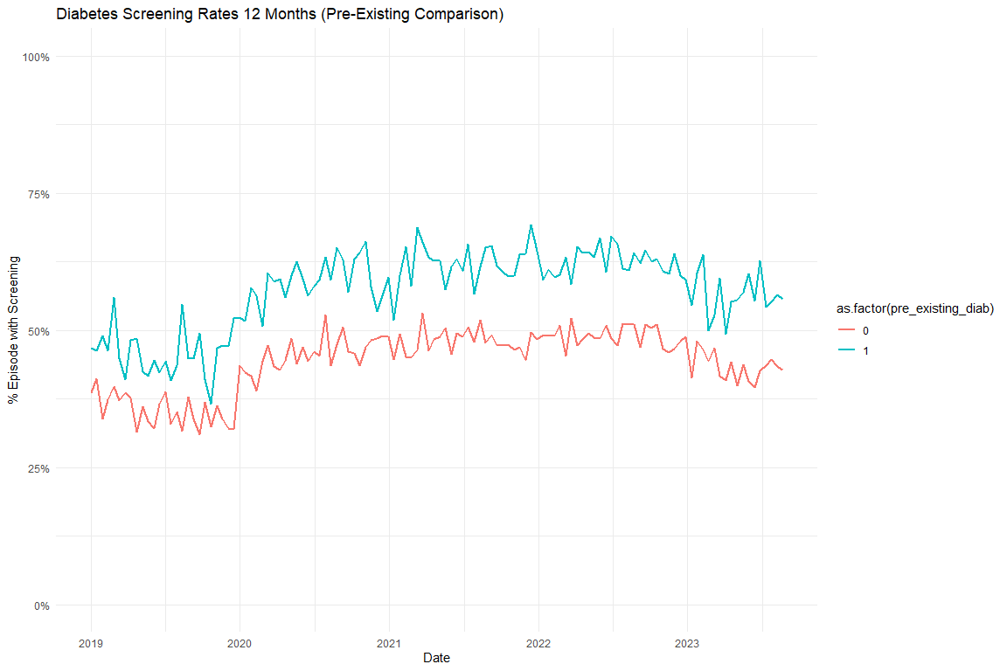

Models

Diabetes Screening Unadjusted
 | Full Sample | Excluding Pre-Existing Diabetes
Characteristic | Beta¹ | Beta¹
(Intercept) | 0.405*** | 0.379***
t | -0.002** | -0.002***
period_FFCRA | 0.123*** | 0.121***
period_Exposure_Unwinding | 0.144*** | 0.136***
t_after_FFCRA | 0.002*** | 0.003***
t_after_Exposure | -0.004*** | -0.003***
¹*p<0.05; **p<0.01; ***p<0.001

Diabetes Screening Adjusted
 | Full Sample | Excluding Pre-Existing Diabetes
Characteristic | Beta¹ | Beta¹
(Intercept) | 0.286*** | 0.306***
t | -0.003*** | -0.003***
period_FFCRA | 0.131*** | 0.129***
period_Exposure_Unwinding | 0.152*** | 0.144***
t_after_FFCRA | 0.003*** | 0.004***
t_after_Exposure | -0.003*** | -0.003***
Age | 0.000 | -0.001
Index No Transfusion Weight | 0.005*** | 0.004***
¹*p<0.05; **p<0.01; ***p<0.001

Diabetes Subgroup Test Type Graphs
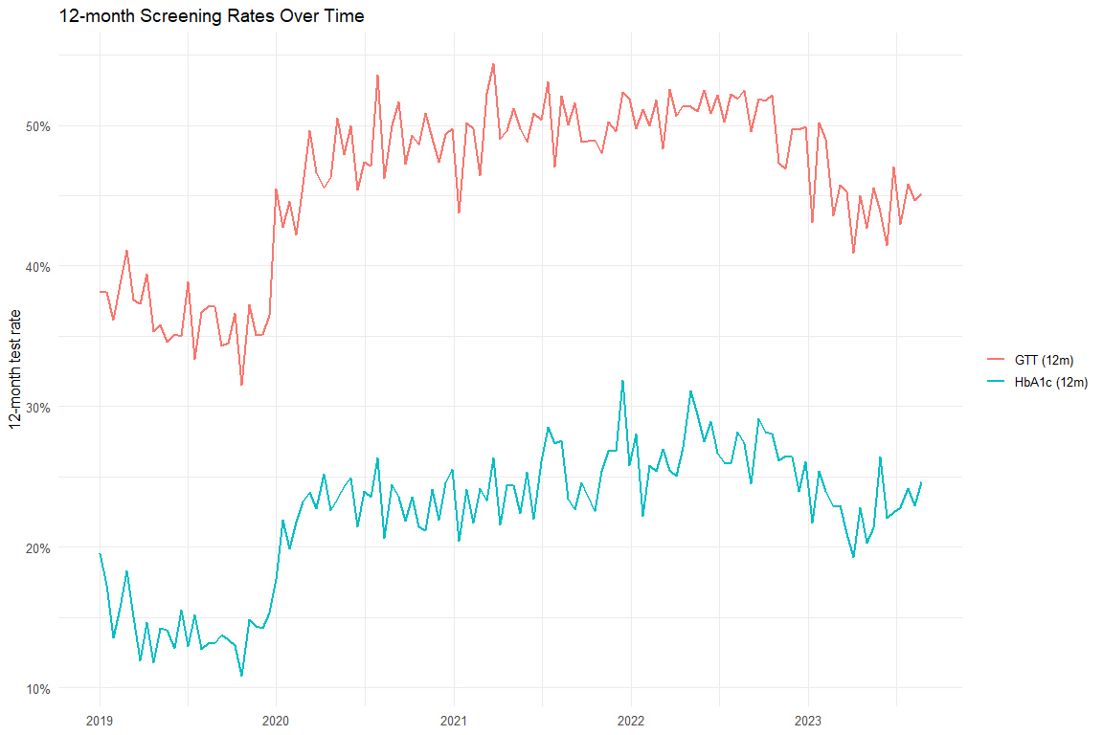

Diabetes Test Type Models
 | Overall (Unadj) | Overall (Adj) | HbA1c (Unadj) | HbA1c (Adj) | GTT (Unadj) | GTT (Adj)
Characteristic | Beta¹ | Beta¹ | Beta¹ | Beta¹ | Beta¹ | Beta¹
(Intercept) | 0.405*** | 0.286*** | 0.155*** | -0.031** | 0.380*** | 0.265***
t | -0.002** | -0.003*** | -0.001* | -0.002*** | -0.001* | -0.002***
period_FFCRA | 0.123*** | 0.131*** | 0.091*** | 0.095*** | 0.122*** | 0.130***
period_Exposure_Unwinding | 0.144*** | 0.152*** | 0.116*** | 0.120*** | 0.141*** | 0.149***
t_after_FFCRA | 0.002*** | 0.003*** | 0.002*** | 0.002*** | 0.002*** | 0.003***
t_after_Exposure | -0.004*** | -0.003*** | -0.003*** | -0.003*** | -0.004*** | -0.003***
Age |  | 0.000 |  | 0.003*** |  | 0.000
Index No Transfusion Weight |  | 0.005*** |  | 0.003*** |  | 0.005***
¹*p<0.05; **p<0.01; ***p<0.001

Excluding COVID
[1] "diab_screen_unadj_excluded_reidx"
[1] "diab_screen_adj_excluded_reidx"
[1] "diab_any_outpatient_unadj_excluded_reidx"
[1] "diab_any_outpatient_adj_excluded_reidx"
[1] "htn_med_unadj_excluded_reidx"
[1] "htn_med_adj_excluded_reidx"
[1] "htn_any_outpatient_unadj_excluded_reidx"
[1] "htn_any_outpatient_adj_excluded_reidx"
 | Original - Unadj | Excluded COVID - Unadj | Original - Adj | Excluded COVID - Adj
Characteristic | Beta¹ | Beta¹ | Beta¹ | Beta¹
(Intercept) | 0.405*** | 0.411*** | 0.286*** | 0.294***
t | -0.002** | 0.001 | -0.003*** | 0.001
period_FFCRA | 0.123*** | 0.088*** | 0.131*** | 0.061***
period_Exposure_Unwinding | 0.144*** | 0.114*** | 0.152*** | 0.090***
t_after_FFCRA | 0.002*** | 0.000 | 0.003*** | -0.001
t_after_Exposure | -0.004*** | -0.003*** | -0.003*** | -0.003***
Age |  |  | 0.000 | 0.000
Index No Transfusion Weight |  |  | 0.005*** | 0.005***
¹*p<0.05; **p<0.01; ***p<0.001
 | Original - Unadj | Excluded COVID - Unadj | Original - Adj | Excluded COVID - Adj
Characteristic | Beta¹ | Beta¹ | Beta¹ | Beta¹
(Intercept) | 0.662*** | 0.661*** | 0.615*** | 0.618***
t | 0.000 | 0.000 | -0.001 | 0.000
period_FFCRA | 0.098*** | 0.101*** | 0.104*** | 0.084***
period_Exposure_Unwinding | 0.103*** | 0.105*** | 0.108*** | 0.089***
t_after_FFCRA | 0.001 | 0.000 | 0.001** | 0.000
t_after_Exposure | -0.003*** | -0.003*** | -0.003*** | -0.003***
Age |  |  | -0.001*** | -0.001***
Index No Transfusion Weight |  |  | 0.003*** | 0.003***
¹*p<0.05; **p<0.01; ***p<0.001
 | Original - Unadj | Excluded COVID - Unadj | Original - Adj | Excluded COVID - Adj
Characteristic | Beta¹ | Beta¹ | Beta¹ | Beta¹
(Intercept) | 0.274*** | 0.280*** | -0.308*** | -0.290***
t | -0.001 | -0.001* | -0.002*** | -0.001**
period_FFCRA | 0.027*** | 0.015 | 0.036*** | -0.017
period_Exposure_Unwinding | 0.047*** | 0.031** | 0.055*** | 0.002
t_after_FFCRA | 0.000 | 0.001 | 0.002*** | 0.001
t_after_Exposure | 0.000 | 0.000 | 0.000 | 0.000
Age |  |  | 0.014*** | 0.014***
Index No Transfusion Weight |  |  | 0.006*** | 0.006***
¹*p<0.05; **p<0.01; ***p<0.001
 | Original - Unadj | Excluded COVID - Unadj | Original - Adj | Excluded COVID - Adj
Characteristic | Beta¹ | Beta¹ | Beta¹ | Beta¹
(Intercept) | 0.667*** | 0.675*** | 0.587*** | 0.601***
t | 0.000 | 0.000 | -0.001 | 0.000
period_FFCRA | 0.091*** | 0.100*** | 0.099*** | 0.082***
period_Exposure_Unwinding | 0.102*** | 0.113*** | 0.109*** | 0.096***
t_after_FFCRA | 0.000 | 0.000 | 0.001 | 0.000
t_after_Exposure | -0.002*** | -0.002*** | -0.002*** | -0.002***
Age |  |  | 0.000* | -0.001*
Index No Transfusion Weight |  |  | 0.003*** | 0.003***
¹*p<0.05; **p<0.01; ***p<0.001

Other Break Analysis

Percent Change in DSHS Numbers
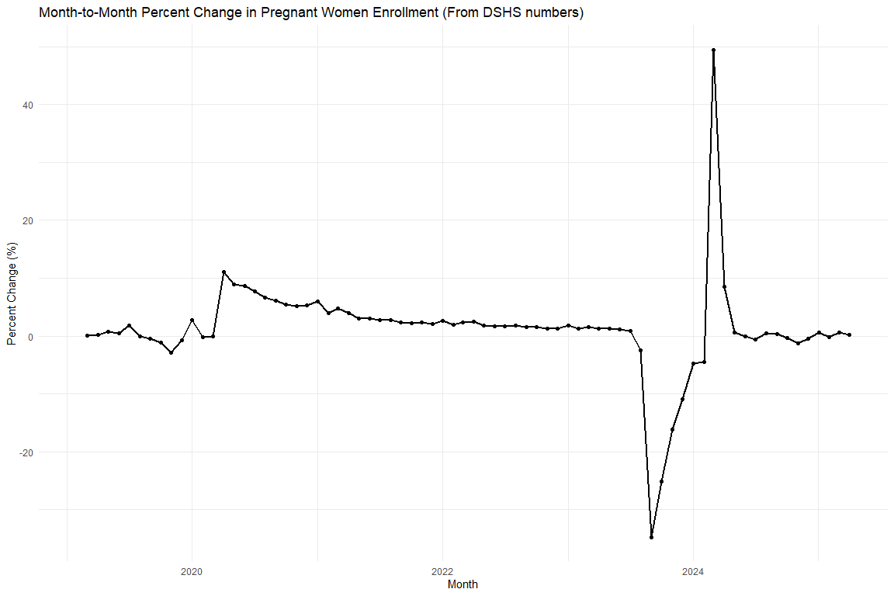
Month | Pregnant Women (Count) | Percent Change (%)
2023-01-01 | 476,205 | 1.77%
2023-02-01 | 482,037 | 1.22%
2023-03-01 | 489,284 | 1.50%
2023-04-01 | 495,541 | 1.28%
2023-05-01 | 501,614 | 1.23%
2023-06-01 | 507,057 | 1.09%
2023-07-01 | 511,183 | 0.81%
2023-08-01 | 498,392 | -2.50%
2023-09-01 | 325,121 | -34.77%
2023-10-01 | 243,231 | -25.19%
2023-11-01 | 204,057 | -16.11%
2023-12-01 | 181,646 | -10.98%
2024-01-01 | 173,116 | -4.70%
2024-02-01 | 165,441 | -4.43%
2024-03-01 | 247,371 | 49.52%
2024-04-01 | 268,508 | 8.54%
2024-05-01 | 269,962 | 0.54%
2024-06-01 | 269,712 | -0.09%

Change in CE (from cohort)
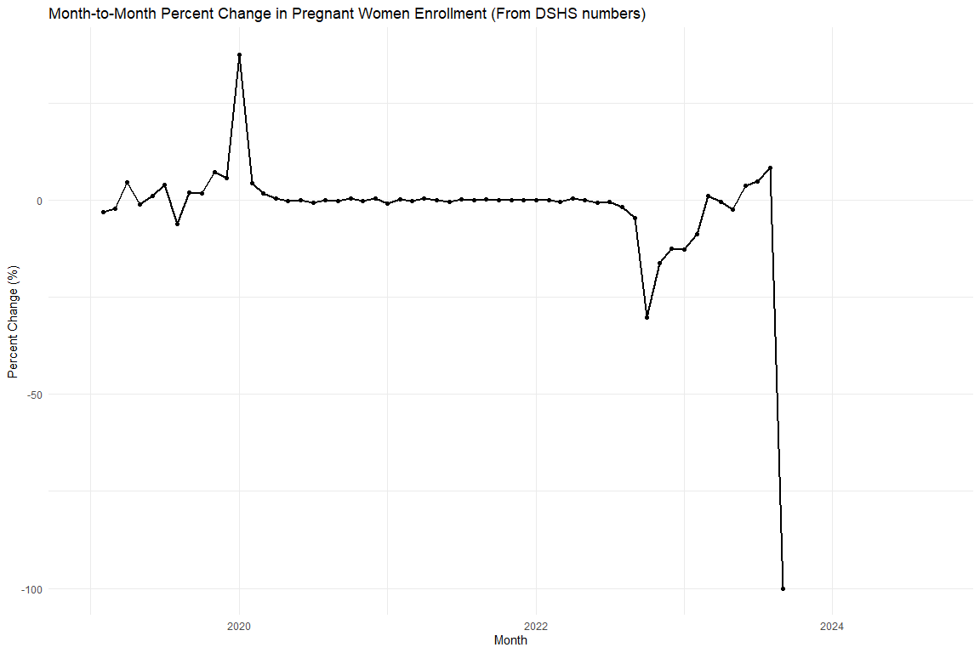
Month | CE After 12 (Level, %) | MoM Change (%)
2019-01-01 | 58.65%
2019-02-01 | 56.90% | -2.99%
2019-03-01 | 55.71% | -2.09%
2019-04-01 | 58.26% | 4.58%
2019-05-01 | 57.69% | -0.97%
2019-06-01 | 58.29% | 1.04%
2019-07-01 | 60.55% | 3.86%
2019-08-01 | 56.78% | -6.22%
2019-09-01 | 57.94% | 2.04%
2019-10-01 | 58.95% | 1.75%
2019-11-01 | 63.24% | 7.28%
2019-12-01 | 66.85% | 5.70%
2020-01-01 | 91.98% | 37.59%
2020-02-01 | 96.13% | 4.51%
2020-03-01 | 97.88% | 1.83%
2020-04-01 | 98.25% | 0.38%
2020-05-01 | 98.11% | -0.15%
2020-06-01 | 98.19% | 0.08%
2020-07-01 | 97.56% | -0.64%
2020-08-01 | 97.56% | 0.00%
2020-09-01 | 97.37% | -0.19%
2020-10-01 | 97.78% | 0.42%
2020-11-01 | 97.58% | -0.20%
2020-12-01 | 97.99% | 0.42%
2021-01-01 | 97.22% | -0.78%
2021-02-01 | 97.38% | 0.16%
2021-03-01 | 97.24% | -0.14%
2021-04-01 | 97.78% | 0.55%
2021-05-01 | 97.91% | 0.13%
2021-06-01 | 97.52% | -0.39%
2021-07-01 | 97.76% | 0.24%
2021-08-01 | 97.75% | -0.02%
2021-09-01 | 98.02% | 0.28%
2021-10-01 | 98.14% | 0.12%
2021-11-01 | 98.15% | 0.01%
2021-12-01 | 98.27% | 0.12%
2022-01-01 | 98.40% | 0.13%
2022-02-01 | 98.44% | 0.04%
2022-03-01 | 98.14% | -0.31%
2022-04-01 | 98.51% | 0.38%
2022-05-01 | 98.45% | -0.06%
2022-06-01 | 97.74% | -0.72%
2022-07-01 | 97.28% | -0.47%
2022-08-01 | 95.56% | -1.77%
2022-09-01 | 91.20% | -4.56%
2022-10-01 | 63.57% | -30.30%
2022-11-01 | 53.32% | -16.12%
2022-12-01 | 46.67% | -12.47%
2023-01-01 | 40.74% | -12.70%
2023-02-01 | 37.19% | -8.72%
2023-03-01 | 37.61% | 1.14%
2023-04-01 | 37.46% | -0.41%
2023-05-01 | 36.53% | -2.48%
2023-06-01 | 37.87% | 3.68%
2023-07-01 | 39.75% | 4.95%
2023-08-01 | 43.10% | 8.43%
2023-09-01 | 0.00% | -100.00%

Scratch (check predicted values)
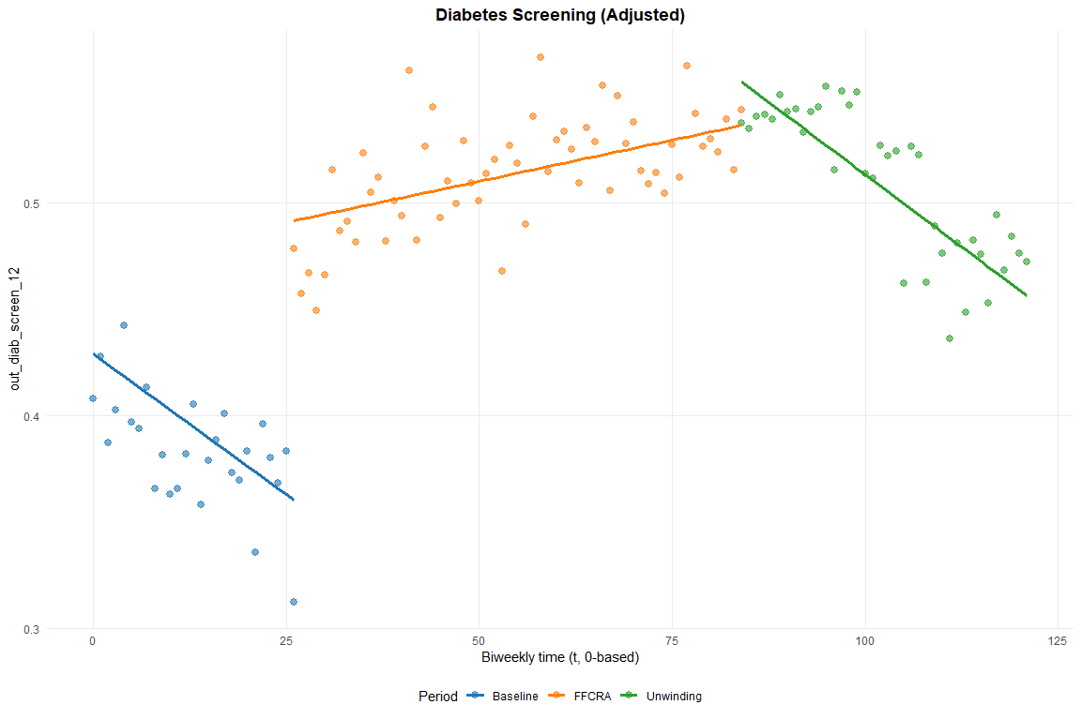

Export Excel

