POEM TX Paper 2 (APCD Data) - Mental Health
2026-04-06

Cohort
Right now, APCD data goes until Aug 2025, so filtered anchor dates for 1 year before then. This will soon be updated to include more data, though. At this point, it is not filtered to “Regular” Medicaid.
Characteristic | N = 1,053,542¹
Mental Health Sample | 138,737 (13%)
Birth Outcome
LB | 1,046,367 (99%)
SB | 7,175 (0.7%)
Year
2019 | 189,522 (18%)
2020 | 186,347 (18%)
2021 | 184,435 (18%)
2022 | 192,551 (18%)
2023 | 185,053 (18%)
2024 | 115,634 (11%)
Age Group
19-24 | 357,222 (34%)
25-34 | 553,993 (53%)
35-44 | 140,403 (13%)
45-55 | 1,924 (0.2%)
Enrollment Category
Emergency | 240,278 (23%)
Healthy Texas Women | 42 (<0.1%)
Other | 36 (<0.1%)
Regular | 797,227 (76%)
Three months prior | 4,131 (0.4%)
Unknown | 11,828 (1.1%)
¹n (%)

Diagnoses & Outcomes by Mental Health Sample
 | Overall | MH Sample
Characteristic | Overall¹ | MH Sample¹
Prior: Anxiety and fear-related disorders | 85,411 (8.1%) | 85,411 (62%)
Prior: Depressive disorders | 74,869 (7.1%) | 74,869 (54%)
Prior: Suicidal ideation/attempt/self-harm | 3,867 (0.4%) | 3,867 (2.8%)
Prior: Schizophrenia spectrum/psychotic disorders | 4,180 (0.4%) | 4,180 (3.0%)
Prior: Trauma- and stressor-related disorders | 23,708 (2.3%) | 23,708 (17%)
Prior: Bipolar and related disorders | 20,460 (1.9%) | 20,460 (15%)
Prior: Neurodevelopmental disorders | 56 (<0.1%) | 56 (<0.1%)
Prior: Other disorders | 10,540 (1.0%) | 10,540 (7.6%)
Postpartum: Any MH diagnosis (0-12 months) | 140,629 (13%) | 63,129 (46%)
Postpartum: Anxiety and fear-related disorders | 75,243 (7.1%) | 38,820 (28%)
Postpartum: Depressive disorders | 63,626 (6.0%) | 34,336 (25%)
Postpartum: Suicidal ideation/attempt/self-harm | 6,126 (0.6%) | 3,244 (2.3%)
Postpartum: Schizophrenia spectrum/psychotic disorders | 4,541 (0.4%) | 3,182 (2.3%)
Postpartum: Trauma- and stressor-related disorders | 32,135 (3.1%) | 17,038 (12%)
Postpartum: Bipolar and related disorders | 19,297 (1.8%) | 13,812 (10.0%)
Postpartum: Neurodevelopmental disorders | 62 (<0.1%) | 33 (<0.1%)
Postpartum: Other disorders | 43,177 (4.1%) | 15,806 (11%)
Continuously enrolled 12 months post-delivery | 609,930 (58%) | 95,947 (69%)
Enrolled at 12 months post-delivery | 714,996 (68%) | 108,158 (78%)
MH prescription (0-12 months) | 77,339 (7.3%) | 37,001 (27%)
Therapy session (0-12 months) | 29,497 (2.8%) | 16,096 (12%)
¹n (%)

Outcome Graphs

Postpartum MH Diagnoses Over Time - Overall
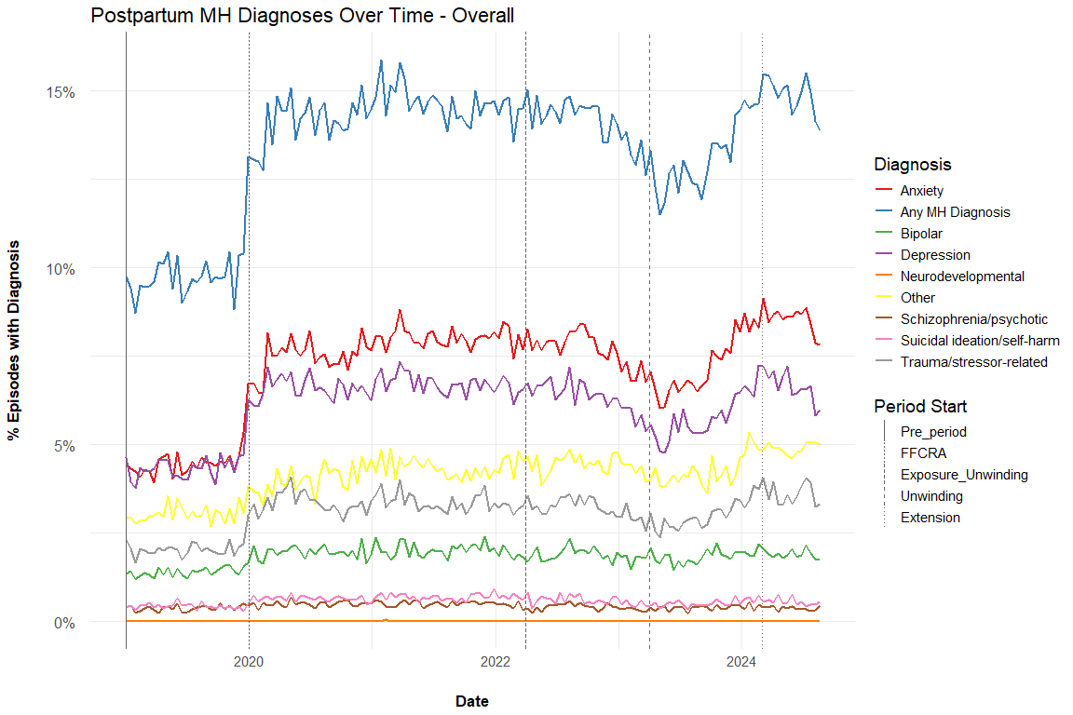

Postpartum MH Diagnoses Over Time - MH Sample
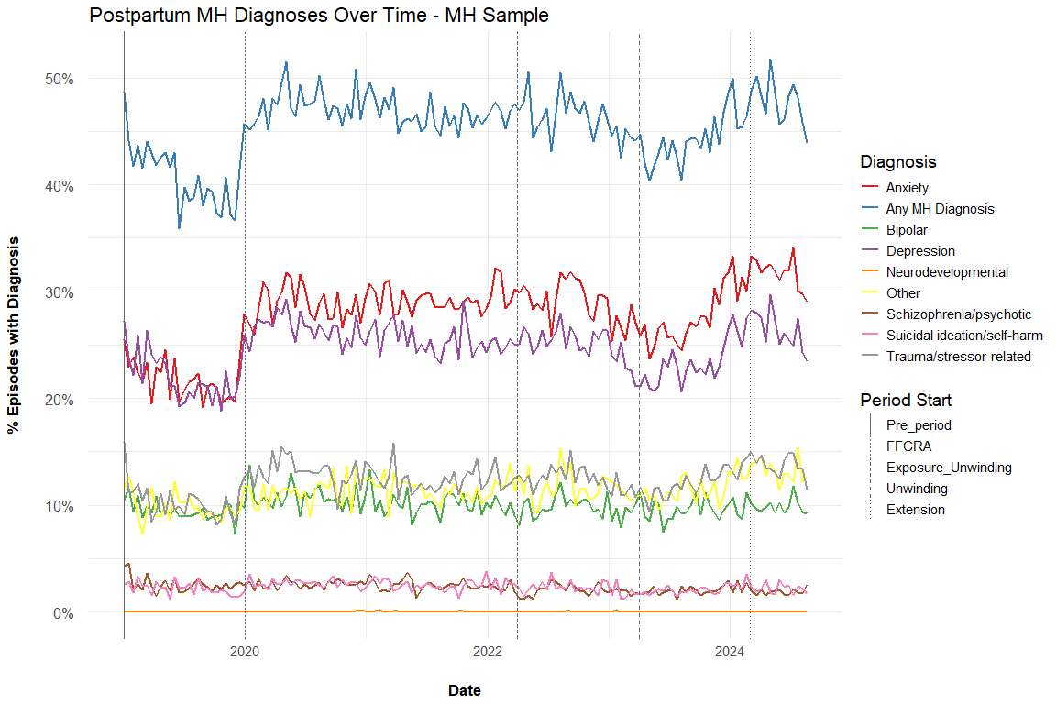

MH Prescriptions 0-12 Months Postpartum
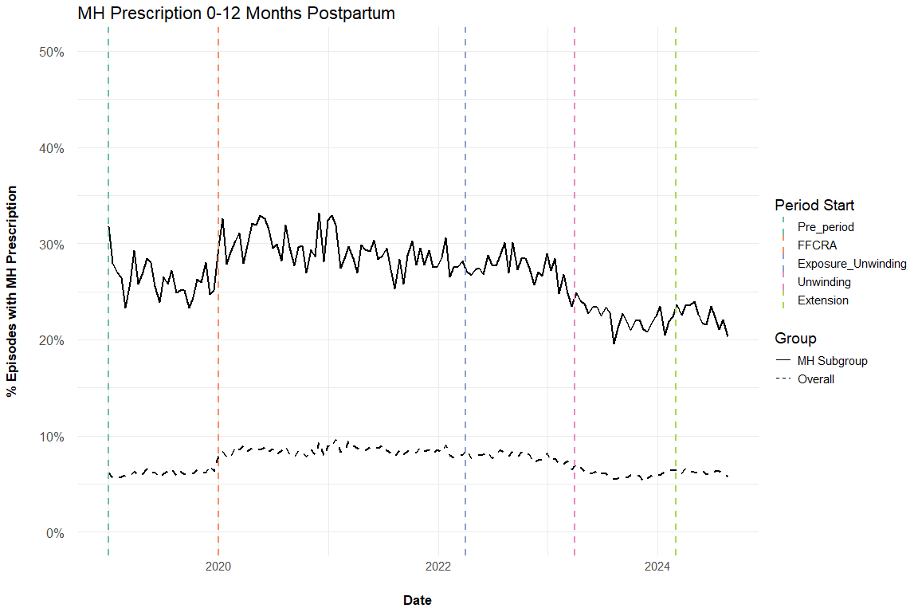

Therapy Sessions 0-12 Months Postpartum
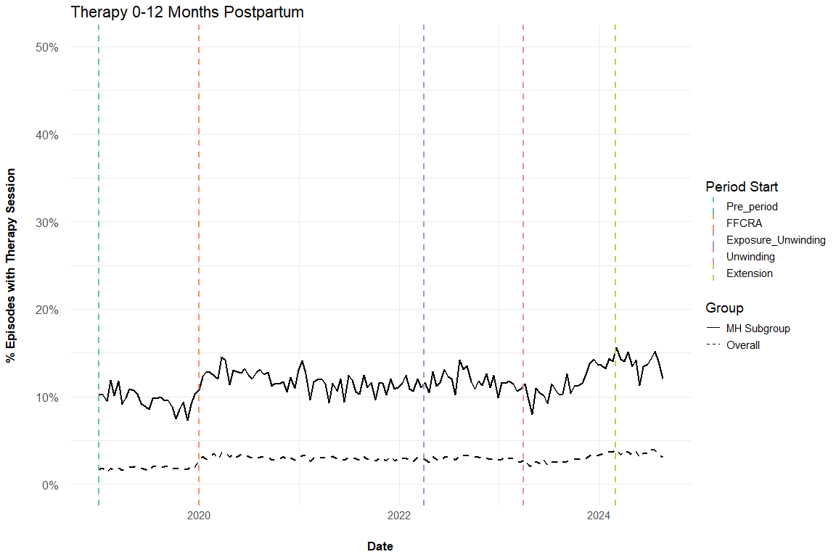

Tables

Postpartum MH Diagnoses by Time Period

Overall
Characteristic | 1. Pre, N = 189,522¹ | 2. FFCRA, N = 416,693¹ | 3. Exposure to Unwinding, N = 360,347¹ | 4. Extension onwards, N = 86,449¹
Any MH diagnosis (0-12 months) | 18,444 (9.7%) | 59,999 (14%) | 49,244 (14%) | 12,851 (15%)
Anxiety and fear-related disorders | 8,448 (4.5%) | 32,406 (7.8%) | 26,956 (7.5%) | 7,388 (8.5%)
Depressive disorders | 8,218 (4.3%) | 27,731 (6.7%) | 21,908 (6.1%) | 5,727 (6.6%)
Suicidal ideation/attempt/self-harm | 819 (0.4%) | 2,802 (0.7%) | 2,021 (0.6%) | 479 (0.6%)
Schizophrenia spectrum/psychotic disorders | 717 (0.4%) | 2,072 (0.5%) | 1,423 (0.4%) | 326 (0.4%)
Trauma- and stressor-related disorders | 3,846 (2.0%) | 13,923 (3.3%) | 11,216 (3.1%) | 3,117 (3.6%)
Bipolar and related disorders | 2,652 (1.4%) | 8,270 (2.0%) | 6,705 (1.9%) | 1,654 (1.9%)
Neurodevelopmental disorders | 9 (<0.1%) | 30 (<0.1%) | 19 (<0.1%) | 4 (<0.1%)
Other disorders | 5,760 (3.0%) | 17,484 (4.2%) | 15,668 (4.3%) | 4,235 (4.9%)
¹n (%)

MH Sample
Characteristic | 1. Pre, N = 19,116¹ | 2. FFCRA, N = 56,908¹ | 3. Exposure to Unwinding, N = 50,659¹ | 4. Extension onwards, N = 11,972¹
Any MH diagnosis (0-12 months) | 7,698 (40%) | 26,716 (47%) | 22,951 (45%) | 5,725 (48%)
Anxiety and fear-related disorders | 4,112 (22%) | 16,545 (29%) | 14,344 (28%) | 3,797 (32%)
Depressive disorders | 4,128 (22%) | 14,731 (26%) | 12,295 (24%) | 3,161 (26%)
Suicidal ideation/attempt/self-harm | 412 (2.2%) | 1,470 (2.6%) | 1,093 (2.2%) | 267 (2.2%)
Schizophrenia spectrum/psychotic disorders | 482 (2.5%) | 1,436 (2.5%) | 1,031 (2.0%) | 231 (1.9%)
Trauma- and stressor-related disorders | 1,933 (10%) | 7,217 (13%) | 6,225 (12%) | 1,645 (14%)
Bipolar and related disorders | 1,795 (9.4%) | 5,906 (10%) | 4,910 (9.7%) | 1,193 (10.0%)
Neurodevelopmental disorders | 3 (<0.1%) | 19 (<0.1%) | 10 (<0.1%) | 1 (<0.1%)
Other disorders | 1,862 (9.7%) | 6,480 (11%) | 5,873 (12%) | 1,583 (13%)
¹n (%)

Therapy & MH Prescriptions by Time Period

Overall
Characteristic | 1. Pre, N = 189,522¹ | 2. FFCRA, N = 416,693¹ | 3. Exposure to Unwinding, N = 360,347¹ | 4. Extension onwards, N = 86,449¹
Therapy session (0-12 months) | 3,454 (1.8%) | 12,534 (3.0%) | 10,402 (2.9%) | 3,079 (3.6%)
MH prescription (0-12 months) | 11,585 (6.1%) | 35,261 (8.5%) | 25,068 (7.0%) | 5,390 (6.2%)
¹n (%)

MH Sample
Characteristic | 1. Pre, N = 19,116¹ | 2. FFCRA, N = 56,908¹ | 3. Exposure to Unwinding, N = 50,659¹ | 4. Extension onwards, N = 11,972¹
Therapy session (0-12 months) | 1,821 (9.5%) | 6,685 (12%) | 5,906 (12%) | 1,667 (14%)
MH prescription (0-12 months) | 4,975 (26%) | 16,634 (29%) | 12,677 (25%) | 2,697 (23%)
¹n (%)

Changelog:
- 3/23/2026: Added derived (non-overlapping) time period variable. Added graphs and tables for postpartum DX over time
- 3/17/2026: Added “Extension” time period (starting March 1, 2024). Added DX after delivery too
- 3/10/2026: Added postpartum MH DX outcomes and clarified language on prior labels.

