POEM TX Paper 2 (APCD Data) - Mental Health
2026-04-20

Cohort
Right now, APCD data goes until Dec 2025, so filtered anchor dates for 1 year before then. At this point, it is not filtered to “Regular” Medicaid.
Characteristic | N = 1,107,154¹
Mental Health Sample | 143,064 (13%)
Birth Outcome
LB | 1,099,947 (99%)
SB | 7,207 (0.7%)
Year
2019 | 185,999 (17%)
2020 | 185,988 (17%)
2021 | 183,952 (17%)
2022 | 191,858 (17%)
2023 | 184,558 (17%)
2024 | 174,799 (16%)
Age Group
19-24 | 375,155 (34%)
25-34 | 582,429 (53%)
35-44 | 147,526 (13%)
45-55 | 2,044 (0.2%)
Enrollment Category
Emergency | 254,328 (23%)
Healthy Texas Women | 30 (<0.1%)
Other | 32 (<0.1%)
Regular | 835,980 (76%)
Three months prior | 4,412 (0.4%)
Unknown | 12,372 (1.1%)
¹n (%)

Diagnoses & Outcomes by Mental Health Sample
 | Overall | MH Sample
Characteristic | Overall¹ | MH Sample¹
Prior: Anxiety and fear-related disorders | 88,220 (8.0%) | 88,220 (62%)
Prior: Depressive disorders | 76,902 (6.9%) | 76,902 (54%)
Prior: Suicidal ideation/attempt/self-harm | 3,929 (0.4%) | 3,929 (2.7%)
Prior: Schizophrenia spectrum/psychotic disorders | 4,221 (0.4%) | 4,221 (3.0%)
Prior: Trauma- and stressor-related disorders | 24,683 (2.2%) | 24,683 (17%)
Prior: Bipolar and related disorders | 20,856 (1.9%) | 20,856 (15%)
Prior: Neurodevelopmental disorders | 57 (<0.1%) | 57 (<0.1%)
Prior: Other disorders | 10,829 (1.0%) | 10,829 (7.6%)
Prior: Other postpartum disorder (F53x) | 2,947 (0.3%) | 2,947 (2.1%)
Postpartum: Any MH diagnosis (0-12 months) | 148,464 (13%) | 65,579 (46%)
Postpartum: Anxiety and fear-related disorders | 79,923 (7.2%) | 40,588 (28%)
Postpartum: Depressive disorders | 67,096 (6.1%) | 35,709 (25%)
Postpartum: Suicidal ideation/attempt/self-harm | 6,419 (0.6%) | 3,381 (2.4%)
Postpartum: Schizophrenia spectrum/psychotic disorders | 4,719 (0.4%) | 3,277 (2.3%)
Postpartum: Trauma- and stressor-related disorders | 34,134 (3.1%) | 17,914 (13%)
Postpartum: Bipolar and related disorders | 20,188 (1.8%) | 14,318 (10%)
Postpartum: Neurodevelopmental disorders | 59 (<0.1%) | 30 (<0.1%)
Postpartum: Other disorders | 45,679 (4.1%) | 16,504 (12%)
Postpartum: Other postpartum disorder (F53x, 0-12 months) | 39,445 (3.6%) | 12,628 (8.8%)
Continuously enrolled 12 months post-delivery | 668,549 (60%) | 102,250 (71%)
Enrolled at 12 months post-delivery | 773,775 (70%) | 114,292 (80%)
MH prescription (0-12 months) | 80,450 (7.3%) | 37,892 (26%)
Therapy session (0-12 months) | 31,457 (2.8%) | 17,035 (12%)
Any outpatient visit (0-12 months) | 700,638 (63%) | 111,252 (78%)
Total outpatient visit days (0-12 months) | 1 (0, 3) | 2 (1, 6)
¹n (%); Median (Q1, Q3)

Outcome Graphs

Postpartum MH Diagnoses Over Time - Overall
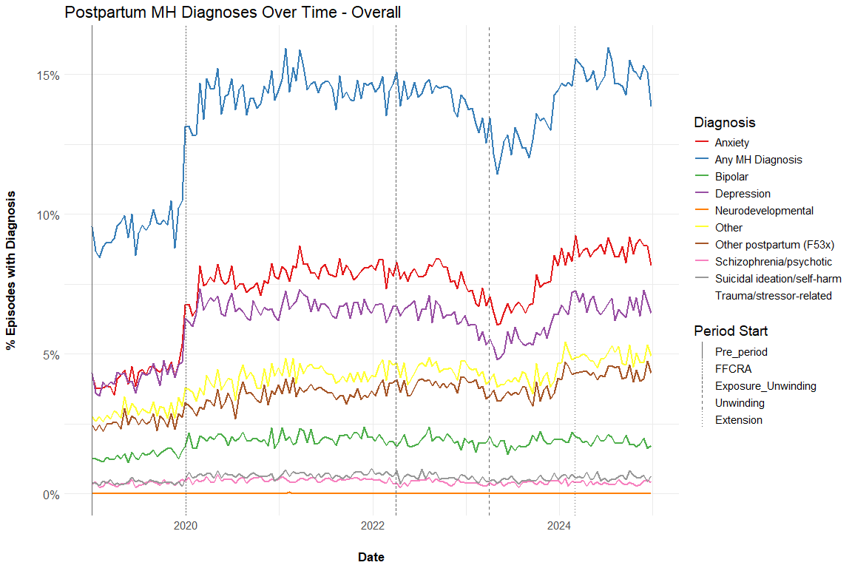

Postpartum MH Diagnoses Over Time - MH Sample
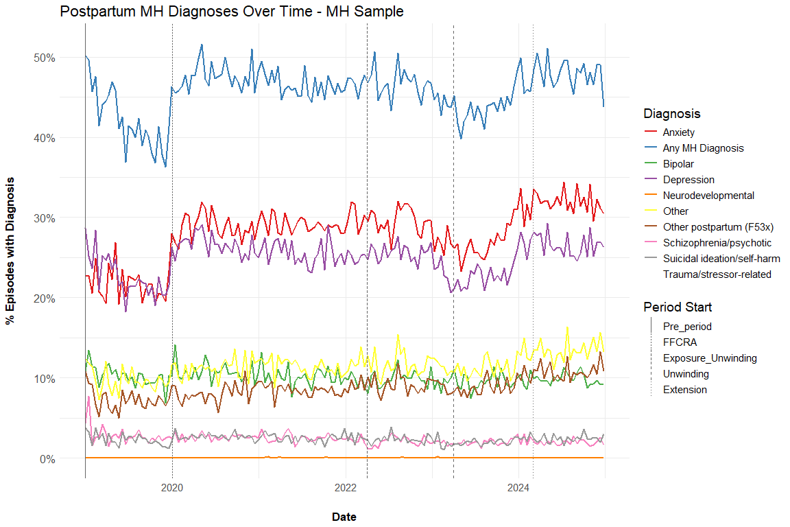

MH Prescriptions 0-12 Months Postpartum
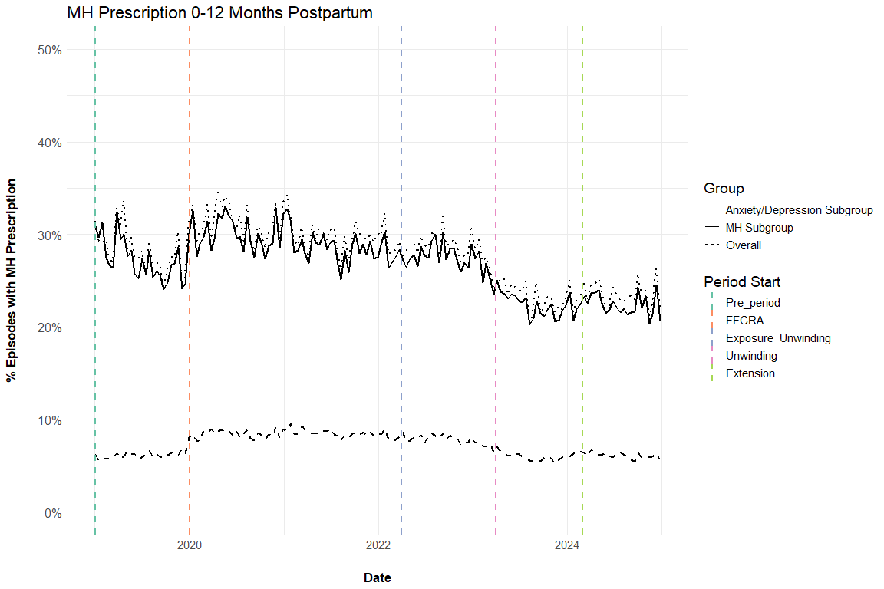

Therapy Sessions 0-12 Months Postpartum
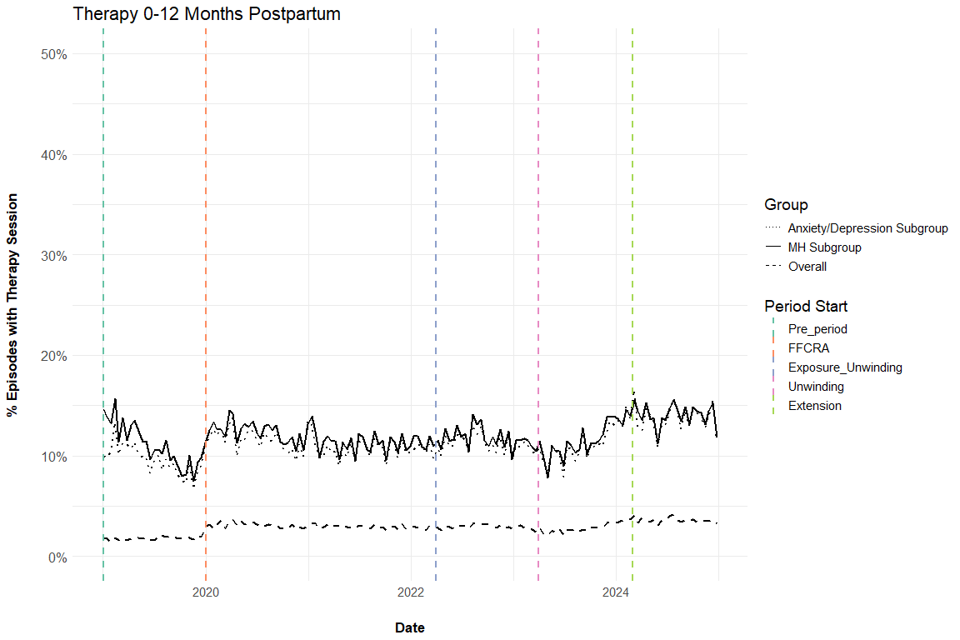

Any Outpatient Visit 0-12 Months Postpartum
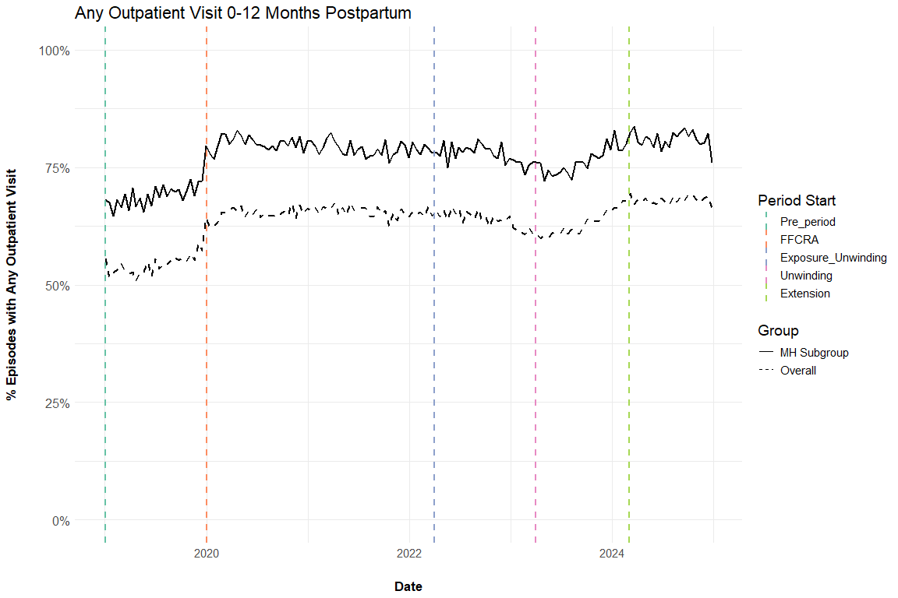

Average Outpatient Visit Days 0-12 Months Postpartum
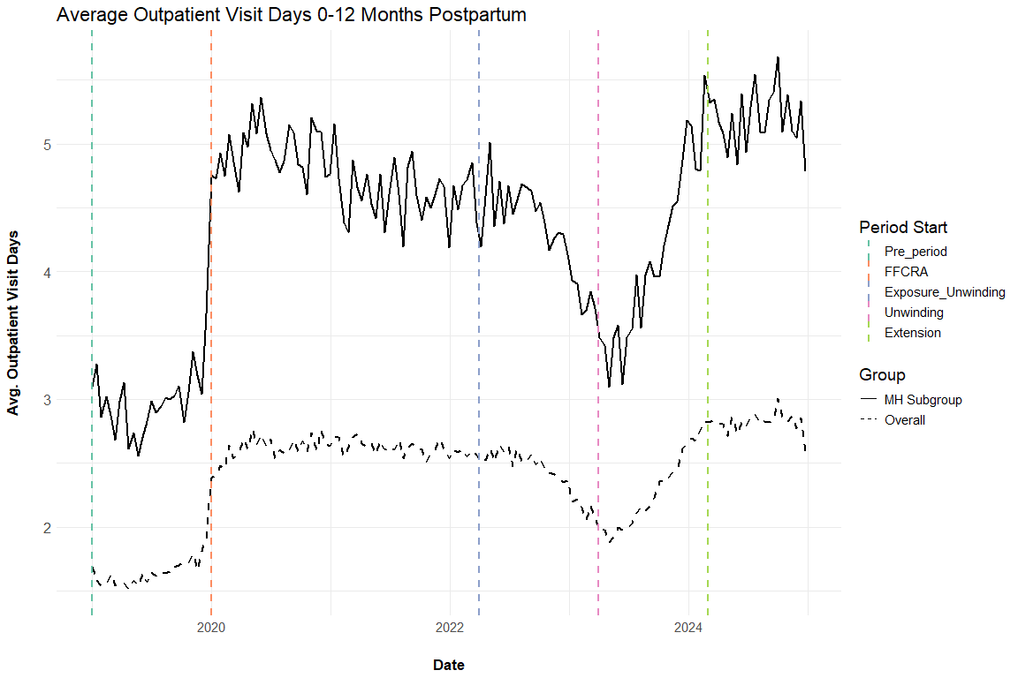

Average MH Prescription Days Supply 0-12 Months Postpartum
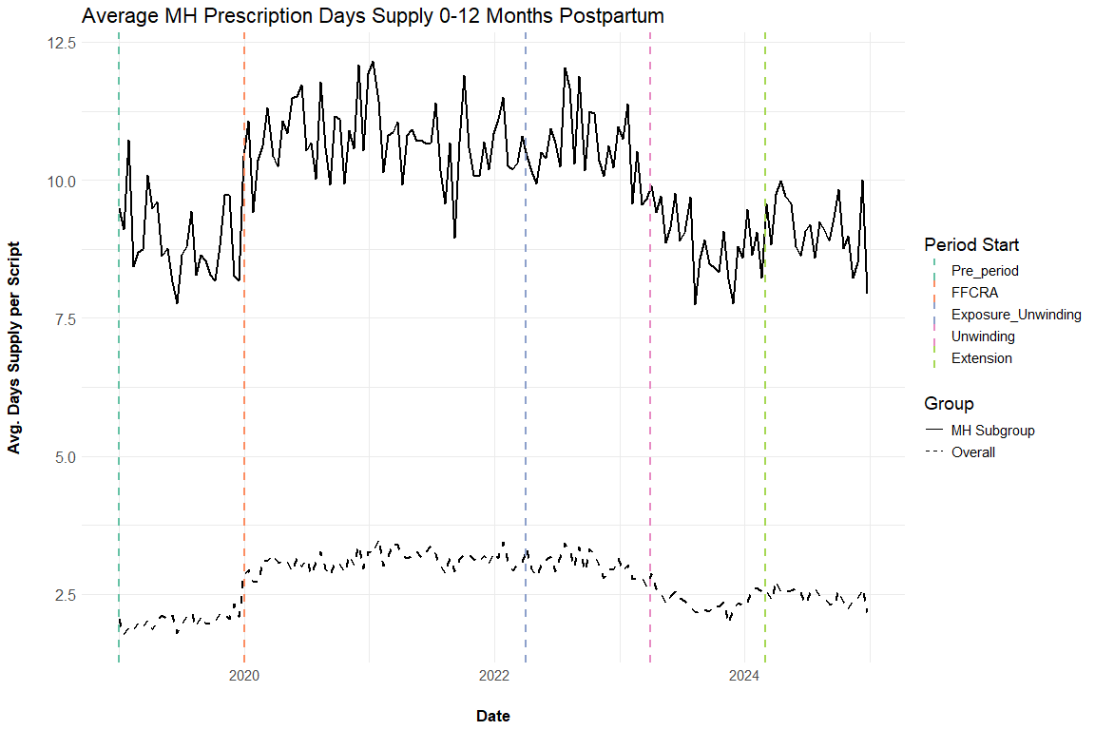

Average MH Prescription Days Supply 0-12 Months Postpartum (Among Those with a Prescription)
Restricted to episodes where out_mh_drug_avg_days_supply_12 > 0, aka those who had at least one MH prescription.
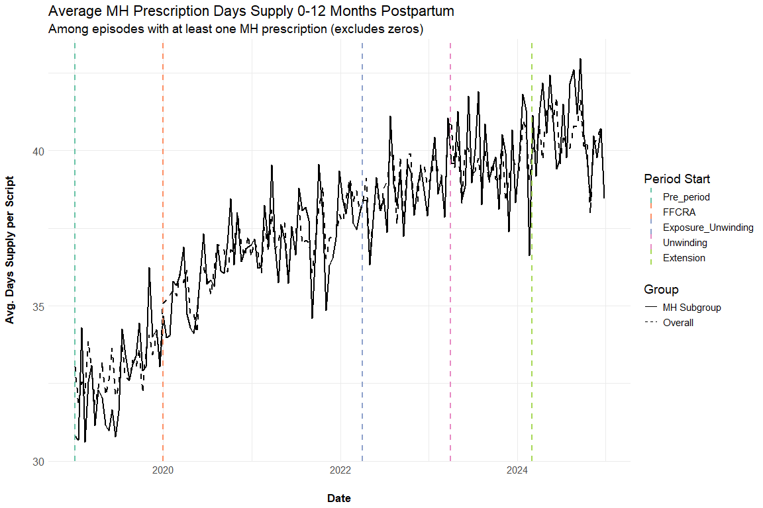

Tables

Postpartum MH Diagnoses by Time Period

Overall
Characteristic | 1. Pre  N = 185,999¹ | 2. FFCRA  N = 415,735¹ | 3. Exposure to Unwinding  N = 359,086¹ | 4. Extension onwards  N = 145,787¹
Any MH diagnosis (0-12 months) | 17,669 (9.5%) | 59,796 (14%) | 49,053 (14%) | 21,855 (15%)
Anxiety and fear-related disorders | 7,951 (4.3%) | 32,297 (7.8%) | 26,875 (7.5%) | 12,753 (8.7%)
Depressive disorders | 7,786 (4.2%) | 27,647 (6.7%) | 21,806 (6.1%) | 9,813 (6.7%)
Suicidal ideation/attempt/self-harm | 754 (0.4%) | 2,793 (0.7%) | 2,012 (0.6%) | 856 (0.6%)
Schizophrenia spectrum/psychotic disorders | 680 (0.4%) | 2,062 (0.5%) | 1,417 (0.4%) | 556 (0.4%)
Trauma- and stressor-related disorders | 3,732 (2.0%) | 13,872 (3.3%) | 11,168 (3.1%) | 5,333 (3.7%)
Bipolar and related disorders | 2,537 (1.4%) | 8,217 (2.0%) | 6,683 (1.9%) | 2,738 (1.9%)
Neurodevelopmental disorders | 7 (<0.1%) | 29 (<0.1%) | 19 (<0.1%) | 4 (<0.1%)
Other disorders | 5,487 (3.0%) | 17,408 (4.2%) | 15,601 (4.3%) | 7,154 (4.9%)
Other postpartum disorder (F53x) | 4,775 (2.6%) | 14,667 (3.5%) | 13,665 (3.8%) | 6,310 (4.3%)
¹n (%)

MH Sample
Characteristic | 1. Pre  N = 15,778¹ | 2. FFCRA  N = 56,677¹ | 3. Exposure to Unwinding  N = 50,465¹ | 4. Extension onwards  N = 20,062¹
Any MH diagnosis (0-12 months) | 6,481 (41%) | 26,589 (47%) | 22,843 (45%) | 9,628 (48%)
Anxiety and fear-related disorders | 3,401 (22%) | 16,469 (29%) | 14,284 (28%) | 6,412 (32%)
Depressive disorders | 3,469 (22%) | 14,663 (26%) | 12,233 (24%) | 5,321 (27%)
Suicidal ideation/attempt/self-harm | 348 (2.2%) | 1,459 (2.6%) | 1,087 (2.2%) | 486 (2.4%)
Schizophrenia spectrum/psychotic disorders | 425 (2.7%) | 1,424 (2.5%) | 1,026 (2.0%) | 399 (2.0%)
Trauma- and stressor-related disorders | 1,715 (11%) | 7,193 (13%) | 6,196 (12%) | 2,796 (14%)
Bipolar and related disorders | 1,570 (10.0%) | 5,860 (10%) | 4,895 (9.7%) | 1,988 (9.9%)
Neurodevelopmental disorders | 1 (<0.1%) | 18 (<0.1%) | 10 (<0.1%) | 1 (<0.1%)
Other disorders | 1,510 (9.6%) | 6,433 (11%) | 5,846 (12%) | 2,707 (13%)
Other postpartum disorder (F53x) | 1,124 (7.1%) | 4,745 (8.4%) | 4,581 (9.1%) | 2,170 (11%)
¹n (%)

Therapy & MH Prescriptions by Time Period

Overall
Characteristic | 1. Pre  N = 185,999¹ | 2. FFCRA  N = 415,735¹ | 3. Exposure to Unwinding  N = 359,086¹ | 4. Extension onwards  N = 145,787¹
Therapy session (0-12 months) | 3,369 (1.8%) | 12,477 (3.0%) | 10,354 (2.9%) | 5,231 (3.6%)
MH prescription (0-12 months) | 11,379 (6.1%) | 35,115 (8.4%) | 24,994 (7.0%) | 8,926 (6.1%)
¹n (%)

MH Sample
Characteristic | 1. Pre  N = 15,778¹ | 2. FFCRA  N = 56,677¹ | 3. Exposure to Unwinding  N = 50,465¹ | 4. Extension onwards  N = 20,062¹
Therapy session (0-12 months) | 1,654 (10%) | 6,655 (12%) | 5,883 (12%) | 2,830 (14%)
MH prescription (0-12 months) | 4,218 (27%) | 16,522 (29%) | 12,630 (25%) | 4,503 (22%)
¹n (%)

Changelog:
- 4/15/2026: Added anxiety/depression subgroup (prenatal) with therapy and prescription graphs. Added F53x postpartum disorder indicator to DX tables and summary. Added avg MH prescription days supply graph. Added outpatient variables to summary table.
- 4/13/2026: Updated data through Dec 2025. Added outpatient outcome graphs (% any visit, avg visit days) with Overall and MH subgroup.
- 3/23/2026: Added derived (non-overlapping) time period variable. Added graphs and tables for postpartum DX over time
- 3/17/2026: Added “Extension” time period (starting March 1, 2024). Added DX after delivery too
- 3/10/2026: Added postpartum MH DX outcomes and clarified language on prior labels.

